3 July 2026
Planning Application Ref: PL/26/0632
Officer: Catrin Davies
Application Type: Full planning permission
Address: 120 KENDRICK ROAD, RG1 5DP
Proposal: Change of use of the existing property from Class C3
(Dwellinghouse) to Class C2 (Residential Children’s Care Home) for up to two children.

The site is located within Zone 2 (Primary Core Area) of the Revised Parking Standards and Reading Design SPD. This zone surrounds the Central Core and extends to approximately 2 kilometres walking distance from Reading town centre. It is well served by public transport, with frequent bus services operating to and from the Central Core through this area.

The application proposes a change of use from a dwellinghouse (Use Class C3) to a children’s care home (Use Class C2). The facility would accommodate up to two children.

There are no specific parking standards for this type of development within the SPD. Therefore, in line with other C2 uses, the Highway Authority considers it appropriate to apply the standards for nursing homes. These require provision at a rate of one space per full-time equivalent (FTE) staff member and one space per four residents. However, given the nature of the proposed use as a children’s care facility, it is not considered appropriate to provide dedicated parking for residents. Instead, visitor parking should be provided at an equivalent ratio (i.e. one space per four residents). Double yellow lines run along the frontage of the site with shared user bays located on the opposite side of the carriageway that allow non permit holders a maximum of 2 hours between 8 am and 5.30pm Monday to Sunday.

The submitted application form states that there will be 5 full time staff and 2 part time staff, shift patterns have not been provided. Based on these staffing numbers 6 parking spaces would be required. Submitted parking plan illustrates 3 parking spaces and makes reference to on street parking.

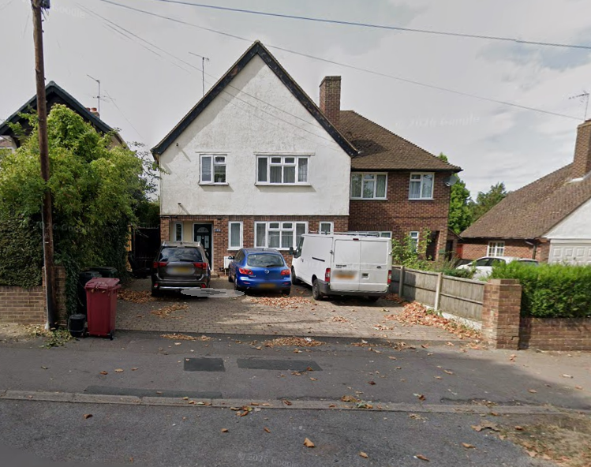

The proposed 3 parking spaces falls below the required standards and we the on street parking is time restricted and reverts to permit holders only after 5.30pm. The Councils Residential Permit Parking Scheme operates in this area and therefore conditions and informatives would be applied to ensure that future occupants are not eligible to apply for permits. It is noted that healthcare professionals may be eligible for healthcare permits, which are issued by the Council’s Permits Team in accordance with their specific eligibility criteria.

In accordance with the Council’s Parking Standards and Design SPD, secure and covered cycle storage should be provided for C2 uses at a ratio of one space per three members of staff. This has not been illustrated on plans. Plans are therefore required demonstrating compliant cycle storage. The layout should also clearly illustrate the opening of any access doors to ensure that cycle parking spaces can be accessed without obstruction.

Refuse storage should be located within 15 metres of the site access to minimise the need for service vehicles to remain on the carriageway for extended periods. Provision should accord with the guidance set out in Manual for Streets and BS 5906:2005 (Waste Management in Buildings). Bins storage and collection areas have not been illustrated on plans.

Whilst it is acknowledged that the proposed change of use is unlikely to result in a material increase in trip generation, the matters outlined above must be addressed to ensure the development is acceptable in highways terms. The applicant is therefore requested to provide confirmation of shift patterns, along with revised plans addressing cycle storage and bin storage and collection arrangements.

N. Hussain
Transport Development Control Advisor

