08/10/2026
Planning Application Ref: PL/26/1242
Officer: Marcelina Rejwerska
Application Type: Full planning permission
Address: 12 ST RONANS ROAD, READING, RG30 2QE
Proposal: C3 Residential Dwelling to C2 Residential Care Home
This application is for the change of use of the dwelling at 12 St Ronans Road, from Class C3 to use Class C2 (residential institution), to facilitate its operation as a small residential children's home for up to 2 looked-after children. There is no specific C2 classification for a children’s care home facility, therefore C2 nursing home requirements have been applied to assess this application.
In accordance with the adopted Parking Standards and Design SPD, a C2 development would be required to provide parking provision of 1 parking space per FTE staff and 1 per 4 residents; given that this is a children’s facility parking spaces for residents would not be appropriate.
Submitted planning statement states that at any given time, typically two members of staff will be present in the home. Therefore, as a minimum 2 parking spaces should be provided. The applicant has stated that the home will accommodate one off-street parking space.
Image below is of the frontage of the site. The site currently benefits form a shared access leading to a single garage, it is not clear where the proposed parking space would be accommodated as no site plan illustrating access and parking space has been submitted.
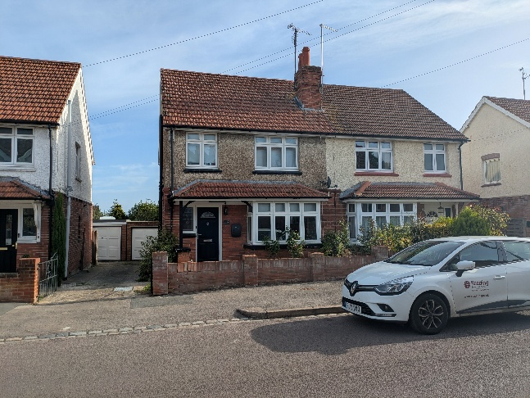

In accordance with the Council’s Parking Standards and Design SPD, secure and covered cycle storage should be provided for C2 uses at a ratio of one space per three members of staff. Submitted Planning Statement states that the home will be provided with three cycle storage spaces. This has not been illustrated on plans.
Please ask the applicant to illustrate parking.

N. Hussain
Transport Development Control Advisor

