21/10/26

Planning Application Ref: PL/26/1275
Officer: Gary Miles
Application Type: Householder planning permission
Address: 3 DOWNSHIRE SQUARE, RG1 6NJ
Proposal: Alterations to the existing front garden and access
arrangements, comprising the formation of a new driveway and associated vehicular crossover with new entrance gates to facilitate internal vehicular circulation; installation of a separate pedestrian access gate; erection of a structural glass entrance porch; installation of photovoltaic (PV) panels on the side and rear roof slopes of the existing dwelling; installation of an electric vehicle (EV) charging point; and associated works.

The site is located within the Downshire Square Conservation Area, to the west of Reading town centre, and falls within Zone 2 (Primary Core Area) of the Council's adopted Parking Standards and Design SPD.
The application seeks to create an additional vehicular access, as shown on the submitted plans, in order to provide separate ingress and egress arrangements.

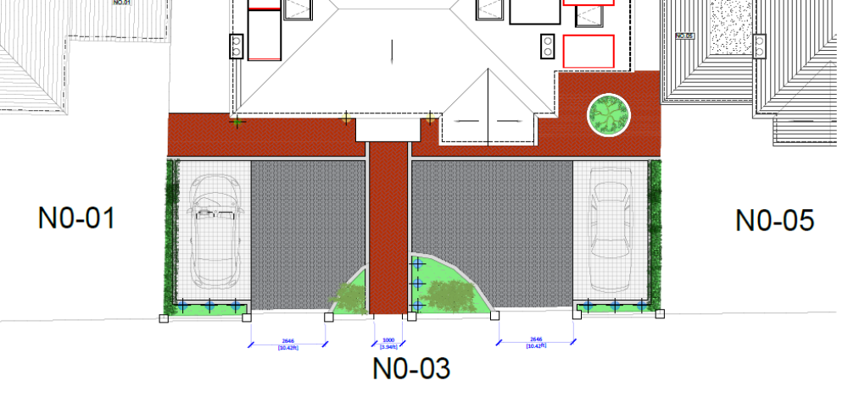

The proposed layout does not appear to provide sufficient space for vehicles to conveniently manoeuvre into and out of the proposed parking spaces. The inclusion of gates would further restrict vehicle manoeuvrability and may prevent efficient use of the parking provision. Should gates be proposed, they must be set back a minimum of 5 metres from the back edge of the carriageway to allow a vehicle to stand clear of the highway whilst the gates are opened.
The introduction of a new vehicular access and pedestrian entrance would necessitate the removal of a section of the existing boundary wall. Given the site's location within a Conservation Area, this may raise heritage concerns which should be considered by the relevant officers.
Downshire Square experiences high levels of on-street parking demand from residents and visitors, owing in part to the unrestricted parking arrangements. The provision of an additional vehicle crossing would result in the loss of on-street parking capacity available to the public. On this basis, the proposed access arrangement cannot be supported.
Furthermore, should the Local Planning Authority be minded to approve the application, further details of the existing tree location and root protection area should be provided and assessed by the Natural Environment Officer to ensure that construction of the access does not adversely affect the existing tree.
The submitted visibility splays do not demonstrate the full extent of the required visibility envelope. As the road forms part of a 20 mph zone, visibility splays of 2.4 metres x 25 metres should be demonstrated in both directions from the proposed access in accordance with Manual for Streets guidance. Any assessment should take account of the existing trees and other street furniture within the highway boundary to ensure the required visibility can be achieved and maintained.
The applicant should address the above concerns and provide revised drawings and supporting information for further assessment.
N. Hussain
Transport Development Control Advisor

