CONSERVATION

Memo
To: Marcelina Rejwerska
From: Buju Can Cetin, Conservation Officer
Date: 19/10/2026
Re: Conservation Officer response
Application Number: PL/26/1295
Application Type: Listed building consent
Address: 3 GRAVEL HILL COTTAGES, BLAGRAVE LANE, READING, RG4 7DY
Proposal: PROPOSED 1.5 STOREY REAR EXTENSION & THE REINSTATEMENT OF AN INTERNAL WALL

Summary
Objection – Suggested Reasons for Refusal – The proposed extension, by reason of its substantial footprint, scale, roof form and design, would compete with and visually dominate the Grade II listed cottage, diminishing its architectural significance and the legibility of its historic form. The relocation of principal domestic functions into the extension would further undermine the cottage’s functional importance, relegating it to a subordinate residential wing. The proposal would therefore harm the special architectural and historic interest of the listed building and its setting.
Insufficient detail has also been provided regarding the treatment of the garden and curtilage, and removal of existing kitchen and associated services, including repair and making good of affected historic fabric. The claimed public and heritage benefits would not outweigh the identified harm. The proposal would not accord with the requirement to preserve the special interest of the listed building in Sections of the Planning (Listed Buildings and Conservation Areas) Act 1990. It would also not meet Policies HE4, HE5 and HE6 of the NPPF 2026, and Policies EN1 and EN6 of the Reading Borough Local Plan 2019.

Relevant policies and legislation
From the point of view of the historic environment, the main statutory tests are set out within the Planning (Listed Buildings and Conservation Areas) Act 1990. Sections 16(2) and 66 require that special regard be given to the desirability of preserving listed buildings, their settings or any features of special architectural or historic interest which they possess.

National Planning Policy and Guidance
The NPPF (2026) outlines government policy, including its policy in respect of the historic environment. Chapter 20 of the NPPF 'Conserving and enhancing the historic environment' sets out the Government's high-level policies securing the conservation of heritage assets and making decisions on development proposals.
Policy HE4: Securing the conservation of heritage assets recognises heritage assets as irreplaceable resources and requires their conservation, including any contribution made by their setting in a manner appropriate to their significance. A heritage asset or its setting should be supported with a use consistent with their conservation together with the asset’s contribution to sustainable communities, local economies, and local character and distinctiveness. Proposals should avoid harm to heritage significance wherever possible and, where harm cannot be avoided, minimise it. Any harm to or loss of a designated heritage asset’s significance, including harm arising from development within its setting, must be supported by a clear and convincing justification.

Policy HE5: Assessing effects on heritage assets requires the potential impacts of the development proposals on the significance of the assets to be identified with regard to positive effects, no effect, harm and total loss of significance, and decision-makers’ satisfaction that assessments accurately reflect the effects as stated below:
“a. Have a positive effect, which is where the significance of a heritage asset would be enhanced, or better revealed; or
b. Have no effect on the significance of a heritage asset; or
c. Result in harm to the significance of a heritage asset, either from work affecting the asset itself or from development within its setting. The degree of harm should be identified: substantial harm would occur where the development proposal would seriously affect a key element of the asset’s significance; or
d. Cause the total loss of the significance of a heritage asset.”
This policy also requires development proposals with heritage impacts to be accompanied by an assessment of significance and potential impacts.

For the Proposals affecting designated heritage assets, Policy HE6 states:
“1. When considering the potential effect of a development proposal on the significance of a designated heritage asset, substantial weight should be given to the asset’s conservation (and the more important the asset, the greater the weight should be). This is irrespective of whether any potential effect amounts to a positive effect, harm, substantial harm, or total loss of its significance.”
2. Development proposals which would have a positive effect on a designated heritage asset should be supported.
3. Any harm to a designated heritage asset will be a matter of considerable importance and weight. which should be dealt with in accordance with paragraphs 4 to 6 of this policy.
4. Where a development proposal would harm the significance of a designated heritage asset the effect on the asset and its significance should be weighed against any public benefits resulting from the proposal.
5. Where a development proposal would cause substantial harm to, or the total loss of, the significance of a designated heritage asset, consent should be refused unless it can be demonstrated that the harm is necessary to achieve substantial public benefits that outweigh the harm or loss.”

Local Planning Policy and Guidance
Policy EN1 ‘Protection and enhancement of the historic environment’ of the Reading Borough Local Plan 2019 sets out the Council’s aspirations for the historic environment. The policy requires that all proposals to protect and, where possible, enhance the significance of heritage assets and their settings, historic character and local distinctiveness of the area in which they are located. It echoes the NPPF by stating, “Applications which affect Listed Buildings will not have an adverse impact on those elements which contribute to their special architectural or historic interest including, where appropriate, their settings.”
Policy EN6 ‘New Development in a Historic Context’ also requires new development to contribute to, respect and enhance the architectural and visual qualities of the historic environment characterised by heritage assets.
“When determining planning applications for new development, the following factors will be taken into consideration:
a. The positive contribution of the development to the existing historic townscape (scale, height, mass, proportion, plot size, street form, materials, significant vistas and views, and open space);
b. Sensitivity to historic context;
c. Reflection of borough-wide major heritage themes that contribute to local distinctiveness (e.g. patterned brickwork or former worker terraced housing);
d. Whether development promotes and/or improves access to previously undiscovered or neglected historic significance.”

Other Guidance
Historic England Advice Note 2 – Making changes to Heritage Assets illustrates the application of policies set out in the NPPF in determining applications for Planning Permission and Listed Building Consent.
English Heritage’s “Conservation Principles” provides policy and guidance for the “sustainable
management of the historic environment”.

Relevant heritage assets
This application relates to a two-storey Grade II listed detached building, 3 Blagrave Lane (3, BLAGRAVE LANE, Non Civil Parish - 1113399 | Historic England) located to the west of Blagrave Lane in Caversham Heights. The application site is not within a conservation area, as illustrated below.
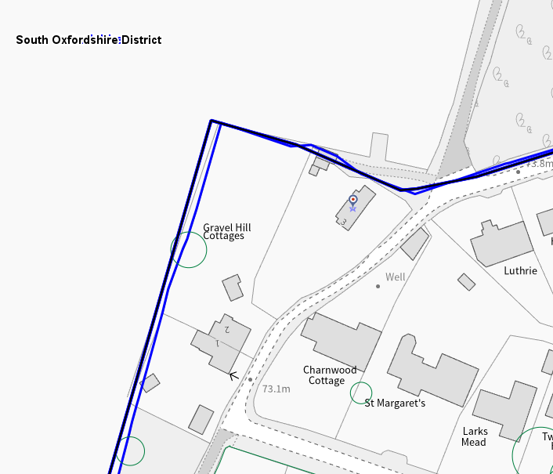
The Application Site is circled in red

Significance of heritage assets
The NPPF defines significance as the “value of a heritage asset to this and future generations because of its heritage interest.”

The interest may be architectural or historic, as set out in the Town and Country Planning (Listed Building and Conservation Areas) Act 1990 Section 1.

“Significance derives not only from a heritage asset’s physical presence, but also from its setting.” (NPPF, 2023)

Historic England assesses significance in a similar manner, referring to evidential, historic, aesthetic and communal values of a place.

The official listing description of 3 Blagrave Lane is read as below:
“Details
BLAGRAVE LANE 1. 5128 No 3 (Formerly listed as Old Gravelhill Cottages in the Rural District of Henley) SU 67 NE 14/408 9.2.59. II 2. Late C17. 1 1/2 storey cottage (probably a pair originally). Square frame timber frame, formerly thatched. 4 bays. Brick infill. Modern tile roof with off- ridge gable end chimneys, left hand chimney stack external and has gabled socle. 2 modern dormers with 3 light casement windows. Outer lean-to porches.
Listing NGR: SU6936175498”

The historic maps of the application site show that the subject property has an ‘L’ shape footprint from the Victorian Period to the 1920s. Given its date, location, and architectural features, it has preserved its rural vernacular house characteristics since the 17th century. Map regression also shows that the footprint (and scale) of the listed building and rural characteristics of the curtilage have been conserved since the official listing of the property on 9 February 1959. As such, there is a historically established and surviving listed curtilage with the dominant main building reflecting the vernacular architecture in the countryside.
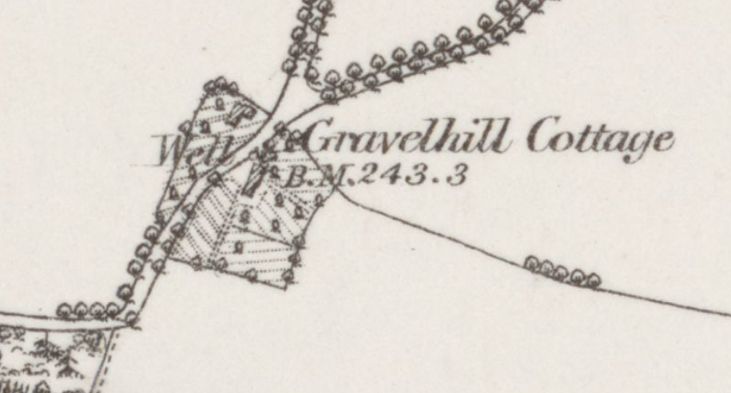
The Ordnance Survey (OS) Map dated 1877 to 1878 (published in 1882) – original footprint

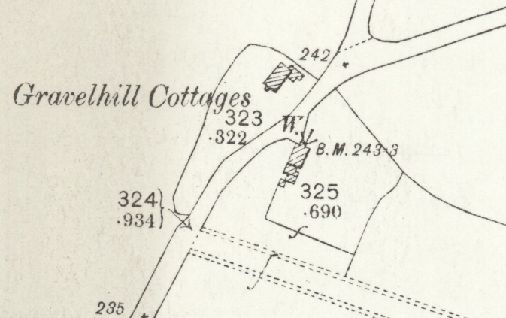
The OS Map dated 1879 (pub. 1899)

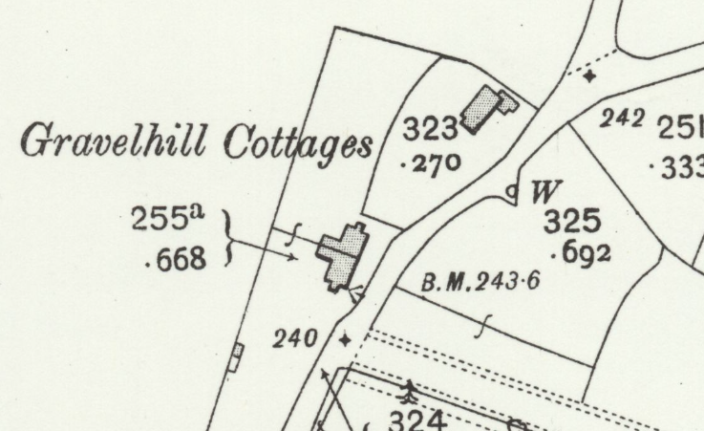
The OS Map dated 1910 (pub. 1913)

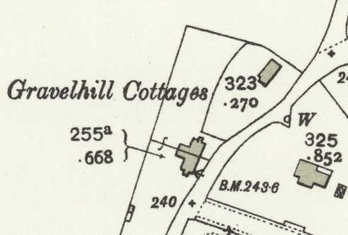
The OS Map dated 1932 (pub. 1934) – existing footprint appears

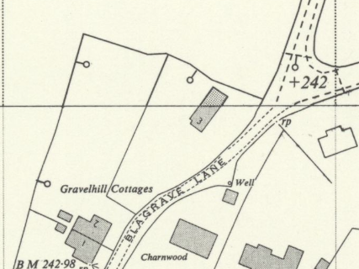
The OS Map dated 1958 to 1964 (pub. 1965) – the date of listing is 1959

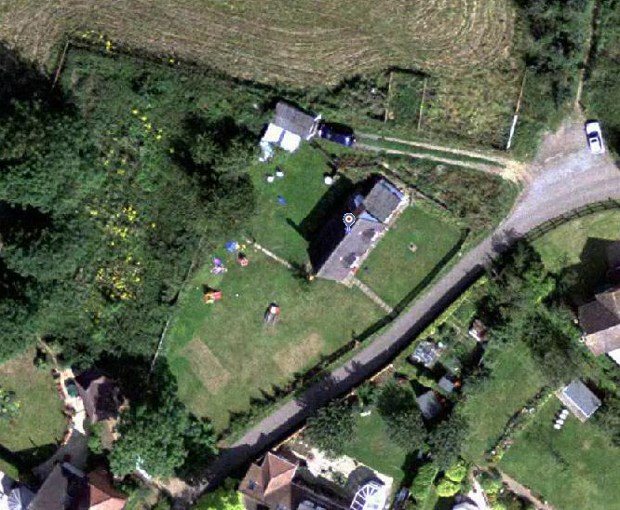
2002 Aerial Photograph (above) and existing (below)
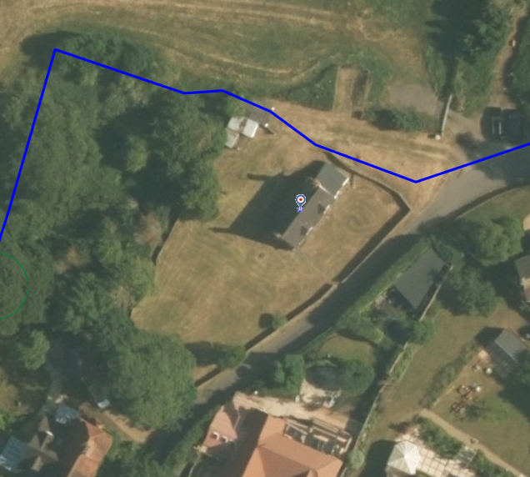
Impact of proposal upon heritage asset(s)
The application is for a new building within the listed curtilage of the heritage asset that would be connected via a glazed link. Following the related pre-application response, I expected an extension with lower height, scale and massing that would ‘serve’ the main listed building. However, I noted that the proposed extension/building with regards to its size, scale, massing, design and appearance still raises concerns which I explain below along with my comments for the pre app scheme (in blue).
First of all, I would like to remind that each heritage asset has its own distinct history, architectural character and significance, which inform sensitivity to change. Consequently, development proposals must be considered on their individual merits, having regard to the particular significance of the asset concerned and the potential impact of the proposed works upon that significance. The acceptability of similar works elsewhere does not, in itself, establish that such works would be appropriate in this instance.
According to my rough calculations, the surviving original footprint of the listed cottage is approximately 55 sqm, with a modest modern extension of approx. 13 sqm, making a total of 68sqm built area in the curtilage, which has not been altered significantly. The proposed glazed link would have approx. 19sqm footprint, and the new building would cover approx. 61 sqm. As such, compared with the original footprint and elements within the listed curtilage, non-original elements would consist of a substantial footprint.
Regarding the proposed link, from the Design and Access Statement I noted that “3.32 In accordance with Historic England's guidance for extending listed buildings in ‘A Guide for Owners of Listed Buildings’ (Historic England 2016), the glazed link acts as an architectural 'visual break’ that ensures the extension is separate, subservient and clearly ‘reads’ as different to the historic cottage. Its complete transparency ensures that the original, plaster-rendered external envelope of the cottage remains fully visible and legible. A viewer can therefore instantly distinguish between the 17th-century timber-framed building and the 21st-century addition.” which I welcome and support.
However, while this link would be of contemporary character, the proposed building, due to its scale, height, form and appearance, would still look like pastiche. Whilst I appreciate the use of large glazing, due to the half-hipped roof form – which is a complex roof form when compared with the listed cottage and three dormers, it would be perceived as a conversion of a barn or another historic building in the curtilage, not a new development. The problem with creating the link is that the connection could be cut anytime internally, and the proposal could not function as subordinate or subservient to the host one. On the contrary, introducing a half-hipped roof would result in 2 storeys, not 1 and a half, a larger footprint, many architectural elements in the design and placing the main living room and kitchen facilities in the new building would mean that the listed building would lose its dominance and its historic relationship with its curtilage/its garden. The new building would function as the main dwelling that could be used as a separate unit, which is not acceptable on heritage grounds.
The submitted statement further says that “Low-Impact Use: The extension will absorb the heavy demands of modern family living (main living and kitchen hub). Through the relocation of the kitchen and sensitive removal of all plumbing inlets and outlets, the historic cottage can be put into a quiet, low-impact residential use (see appendix 2).” confirming my concerns above. I am wondering whether a historic cottage(s) does not have a kitchen? Or any service use within itself? This increases the existing functioning residential use to be taken from the listed building and makes it a secondary living unit which could not be in use in the future without providing any service to the occupiers. There is no any descriptive work provided for the interior of the listed building as a result of kitchen removal either. The focus of the application is only for the new building/extensions.
I am unable to fully understand “3.7 Comparison of the Approved Garage and Proposed Extension” as the garage, when looked at, is legible as a garage or ancillary use (on drawings). But the proposed development would not. If it is the scale and height – the proposal is considerably larger, higher and massier.
About Material Palette it is stated “This restrained palette establishes a clear relationship between the approved garage and the proposed extension whilst maintaining a deliberate distinction from the traditional materials of the cottage. The materials and colour palette enable the new building to form a modest backdrop against the old in the limited views in which it is experienced from the public realm, ensuring it remains subordinate. Historic England advocates the use of contrasting materials in a modern design in its guide for owners of listed buildings, whilst the timber-clad nature of the extension is also appropriately reflective of the historic context of barns and agricultural outbuildings set within the north and northwestern curtilage of the cottage on 18th- and 19th-century maps (i.e. BBHC 2026, Figs 4-6).” – As far as I know the proposal is not for reinstatement of a lost ancillary building. Without evidence, just based on one map, this justification is considered weak. I am unable to identify any service building within the original footprint of the building.
In addition, the following diagram or AI-generated image is not acceptable. There is no proposed site plan, and no clear information about the alterations to the listed curtilage or garden of the building.
Lastly, the heat pump is proposed for the new building, so I cannot understand its benefit to the listed building. There is not sufficient information about the works to the listed building.

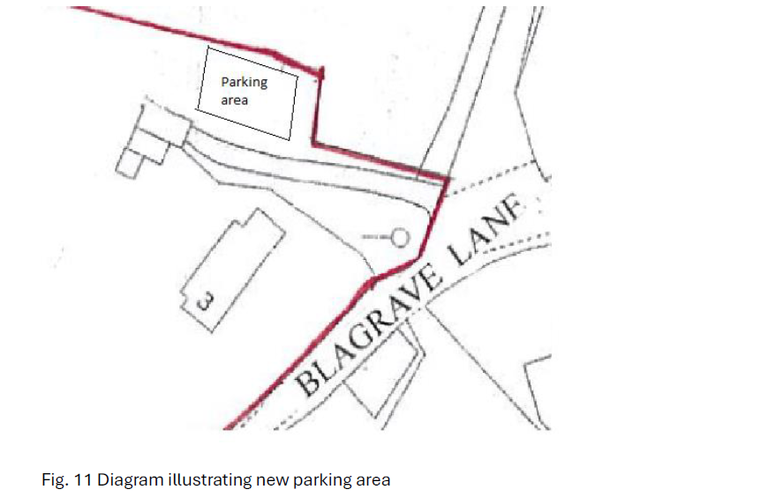
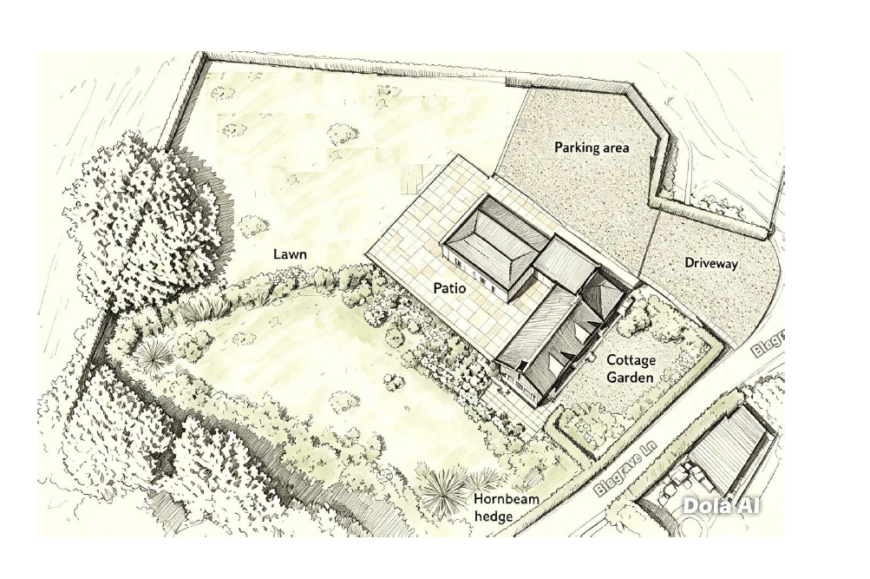
My comments for the pre-app
- As seen on the existing aerial photograph, the application site lies at the edge of the countryside and the boundaries of Reading. The main building, which is a vernacular building with modest scale, reflects its traditional structural system and architecture of the 17th century, preserving its original garden and curtilage integrated with nature (and the countryside). The proposal would be a two-storey new building located to the rear of the listed building, linked via a new one-storey extension. Compared with the original footprint of the listed building, the proposal would occupy a larger space in the rear garden, as given below. As such, it would not be a subservient addition.

- The proposal would be placed, leaving approximately 4m from the rear elevation of the listed building, blocking and competing with this original elevation as appears below. Whilst this elevation is not fully visible from the public realm, it still has high significance that the two-storey extension would not be a subordinate element to the main dwelling. Therefore, due to its footprint, height, scale and massing, the proposal cannot be supported on heritage grounds.

- The proposal have half hipped roof and gable ends that would again compete with the architecture of the listed building. Not only on the rear/north west elevation as illustrated above, but the dominance of the new forms and elements, such as link extension with porch character or the two gables, which are also larger than the existing dormers of the main dwelling proposed for other elevations, would be highly noticeable.

- I understand the proposed extension/building would have timber cladding, which is generally acceptable for listed curtilages. However, with the proposed roof form and scale, it would also appear as a converted barn. Therefore, in terms of the appearance and architecture of the proposal, it would conceal the form, character and architecture of the heritage asset. As a result, this would also result in visual harm and disruption.

- From the submitted statement, I note and comment
“The extension & alterations proposal is to retain the listed building unchanged, with a link that follows the profile of the existing side lean-to extension, & to provide additional rooms to a separate structure to the rear.” – The proposed layout shows that the proposed two-storey extension would function as a new separate building, not an additional or ancillary function to the main dwelling.
“The current rooms & facilities of the building are extremely moderate & the proposal will improve the future use of the listed building while retaining its original form & integrity.” – for the reasons I provided above, I conclude that the proposal would not respect the original form and architecture of the heritage asset. In addition, due to the proposed footprint, it would dominate the listed curtilage.
“The proposed extension will be timber-clad to give a vernacular barn-like appearance. Currently, there are a number of timber buildings approximately where the proposed extension would be.” – There are no timber buildings seen on aerial photographs or from the planning history of the site. Therefore, this requires a site visit or clarification. Erection of a barn-like structure would not be supported as it would not reinstate a lost value; it would bring a pastiche element to the listed curtilage.

- The Council would like to suggest any extension for this listed building to have a modest scale – single storey, contemporary appearance, width and depth not longer than half of the main building and forms not dominating or competing with the existing features of the heritage asset.
The main argument of the submitted heritage statement relates to the views. In the executive summary it is stated “The key view of the principal southeastern elevation of the building from Blagrave Lane which best conveys its heritage significance will not be affected by the proposals, which also offer potential for enhancement of oblique views from the same lane, in which the existing garage building(s) detracts from the cottage’s setting, by replacing it with a higher quality building which better frames these views.”
It is further stated “The increased scale and massing of the proposed new building will, however, result in some adverse visual effects due to partial loss of the existing green backdrop to the cottage which can be seen beyond the visual clutter of the extant garage building in the oblique views from Blagrave Lane. However, the backdrops to these views appear very likely to have featured the historic agricultural outbuildings shown on the 18th-century and mid-19th-century maps referred to above (further detail can be found in Section 3), and therefore there is a historic precedent for built form featuring in these views.” – As I mentioned before, based on only one map, there is no evidence suggesting that there were agricultural outbuildings. If there were, the proposal is completely different from the historic ones. Therefore, the proposal creates a pastiche outbuilding and an incorrect history for the listed curtilage. This justification is not acceptable.
The following benefits are provided in the application:
- Introduction of an Air Source Heap Pump, enabling energy efficiency and low carbon heating measures to be employed (to which measures substantial weight is to be afforded under the NPPF (2026); - I understand that this is proposed for the new building not the listed building. As such, I find this irrelevant to the heritage benefit. There is not any proposed energy efficiency measures described for the historic fabric.
- Moving the kitchen/dining room from within the principal listed building to the new extension, thereby reducing or removing associated risks (such as damage through condensation, fire or flood) to the heritage asset; - Is there any investigation that show this or any existing condition problem? There is no information submitted about the existing condition or problems of the listed building. No information is submitted how the removal of the kitchen would have an impact on the retained historic fabric.
- Securing the optimum viable use of the heritage asset in support of its long-term conservation by reducing the future burden of services upon, and the role of, the principal listed building, which will revert to a living area and bedrooms only; - As I stated before, I am unable to understand this argument, as once the main family service is removed from the listed cottage, there is a risk of the building not being in use. Contrary to the example of ‘thatched cottage’, the subject listed building is in use with its most viable use. I disagree with this as I see a risk. The case of Thatched Cottage, which was not in use, the adaptive reuse and relevant conservation works cannot be a precedent for the subject building. ‘Thatch Method Statement’ and many other conservation works are defined to save that cottage.
- By doing all of the above, sustaining and enhancing the significance of the heritage asset, including its setting (the replacement of existing garage structures with a higher quality building offsetting the negative effects of additional built form and loss of green backdrop to the listed building in certain views). – With insufficient information about the works on the historic fabric of the works and with the approved garage scheme, I cannot note any benefit of the proposed extension. All benefit is for the future users of the proposed new building with the main residential use.
To conclude, the proposed extension would compete with, rather than remain subordinate to the listed cottage. Its substantial footprint, roof massing and prominent dormer windows would introduce a disproportionately assertive addition, obscuring the rear elevation and diminishing the cottage’s modest historic form. The lower ridge and glazed link do not adequately address these effects. Furthermore, relocating the kitchen and principal family accommodation into the extension would shift the functional focus of the dwelling away from the heritage asset. Combined with the extension’s visual dominance, this would undermine the cottage’s primacy within its plot, relegating it to a residential wing.
Although an indicative landscape sketch is provided, the submission lacks a coordinated, sufficiently detailed scheme demonstrating how the garden, hard landscaping and immediate surroundings would preserve the contribution of the setting to the listed building’s significance.
The submitted schedule includes general measures, but does not adequately specify the removal of the existing kitchen and associated services, or subsequent repair and making good of affected historic fabric. The reclaimed conservation benefits are therefore insufficiently substantiated.
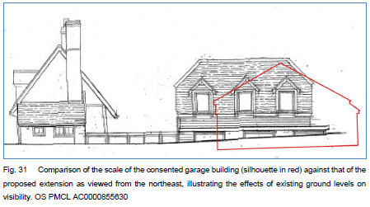
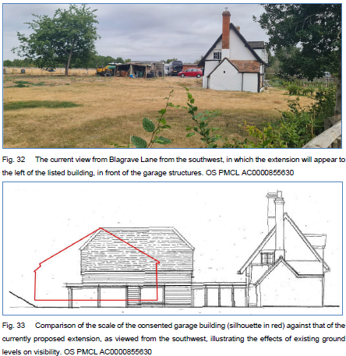

REASON FOR REFUSAL
The proposed extension, by reason of its substantial footprint, scale, roof form and design, would compete with and visually dominate the Grade II listed cottage, diminishing its architectural significance and the legibility of its historic form. The relocation of principal domestic functions into the extension would further undermine the cottage’s functional importance, relegating it to a subordinate residential wing. The proposal would therefore harm the special architectural and historic interest of the listed building and its setting.
Insufficient detail has also been provided regarding the treatment of the garden and curtilage, and removal of existing kitchen and associated services, including repair and making good of affected historic fabric. The claimed public and heritage benefits would not outweigh the identified harm. The proposal would not accord with the requirement to preserve the special interest of the listed building in Sections of the Planning (Listed Buildings and Conservation Areas) Act 1990. It would also not meet Policies HE4, HE5 and HE6 of the NPPF 2026, and Policies EN1 and EN6 of the Reading Borough Local Plan 2019.

Conservation response
No objections
No objections subject to conditions attached
Clarification required
Object

Contact details
Buju Can Cetin, Conservation Officer
Burcu.CanCetin@reading.gov.uk

