19/10/26

Planning Application Ref: PL/26/1220
Application Type: Prior approval Part 3 Class MA: Commercial,
business and service uses to dwellinghouses
Address: FLAT 2, 54 NORCOT ROAD, TILEHURST, RG30 6BU
Proposal: Change of use of from Class E (offices) to C3 (dwelling
houses) to comprise 2 flats. Prior Notification under Class MA, Part 3 of Schedule 2 of the Town and Country Planning (General Permitted Development) Order 2015.

The proposed development comprises two 1-bedroom residential units within an established residential area. The site is located on the classified C401 Norcot Road, which is subject to the Council's Design Guidance for Residential Accesses onto Classified Roads, and is also designated as a Red Route.

The site falls within Zone 3 (Secondary Core Area) of the Council's adopted Parking Standards and Design SPD. The maximum parking requirement for the proposed development is 1.5 spaces per unit, equating to three parking spaces, in addition to the retention of parking provision for the existing first-floor unit(s).

The submitted plans indicate the provision of only two parking spaces, which is below the adopted parking standard. However, car ownership data identifies an average of 1.17 vehicles per 1-bedroom dwelling, and therefore the provision of one parking space per unit is considered acceptable in this instance. Notwithstanding this, parking provision for the existing first-floor unit(s) should be retained and clearly illustrated on the submitted plans.

Images below illustrate proposed parking layout Vs Street view image.

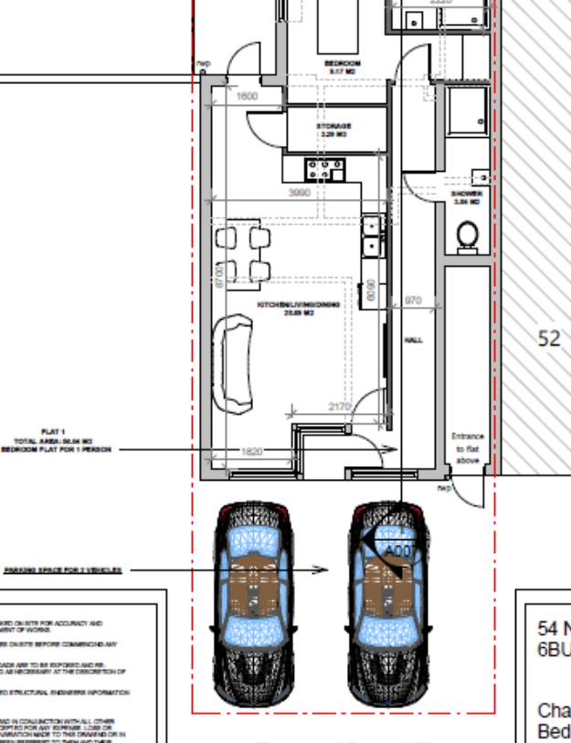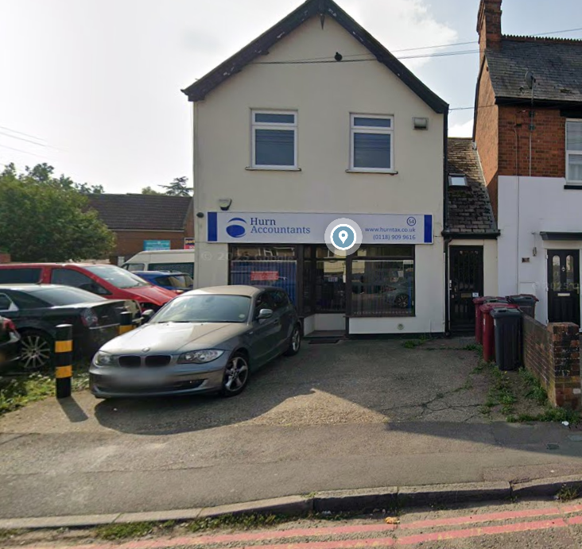

To facilitate parking for more than one vehicle, the existing vehicle crossing would need to be widened. Any works within the public highway would require the applicant to obtain the necessary licence/consent from the Highway Authority, and the extent of the proposed vehicle crossing should be clearly illustrated on revised plans. Furthermore, aerial imagery appears to indicate the presence of a rear access serving an area of hardstanding to the rear of the site. Clarification is required as to whether this area is currently used for parking in connection with the existing first-floor unit. If so, details should be provided demonstrating how parking for the existing unit will be retained following implementation of the proposed development.
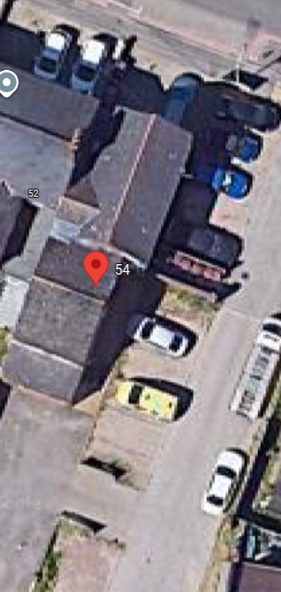

As this is a GPD application we would not comment on cycle or refuse provision however it is noted that cycle storage being provided at the rear of the site, however it is not covered. Bin storage should comply with Reading Borough Council's Waste Management Guidelines for Property Developers. The bin storage areas must be located at a point where the collection vehicle can safely stop for loading.

Please ask the applicant to confirm the parking provision for the existing 1st floor residential unit(s) so that the level of parking provision required for the development can be calculated.

N. Hussain
Transport Development Control Advisor

