30/09/2026
Planning Application Ref: PL/26/0866
Officer: Marcelina Rejwerska
Application Type: Full planning permission
Address: RUSSELL HALL, OXFORD ROAD, READING
Proposal: Proposed conversion, alteration and extension of
existing former commercial building (Use Class E) to 6 no flats (Use Class C3) with associated works and operations

The site lies within the Russell Street / Castle Hill / Oxford Road Conservation Area, specifically the Oxford Road Character Area and is located in Zone 2, Primary Core Area, of the Revised Parking Standards and Design SPD. The site is situated in close proximity to the A329 Oxford Road, which is the main transport corridor between central Reading and the west. This zone is well served by public transport, with buses continuing either into or out of the Central Core Area via this zone. The eastbound bus services provide access to Reading Town Centre whilst the westbound bus services provide access to Calcot, Tilehurst and Purley on Thames. Reading West Railway Station is located circa 700m walk to the east of the site.

The application proposes to convert the existing Class E use to provide 6 x 1 and 2 bedroom C3 units. The site is located at the rear part of 117–119 Oxford Road, known as Russell Hall, The site benefits from a shared access from Zinzan Street.

Policy TR5 of the Local Plan states “Development should provide car parking and cycle parking that is appropriate to the accessibility of locations within the Borough to sustainable transport facilities, particularly public transport”.

In accordance with the adopted SPD, the development would be required to provide a parking provision of 1 space for each unit, it is not clear if parking is proposed as no parking layout has been provided but reference has been made to on-site parking provision. The image below shows the access form Zin Zan street and parking within the site vs submitted location plan.

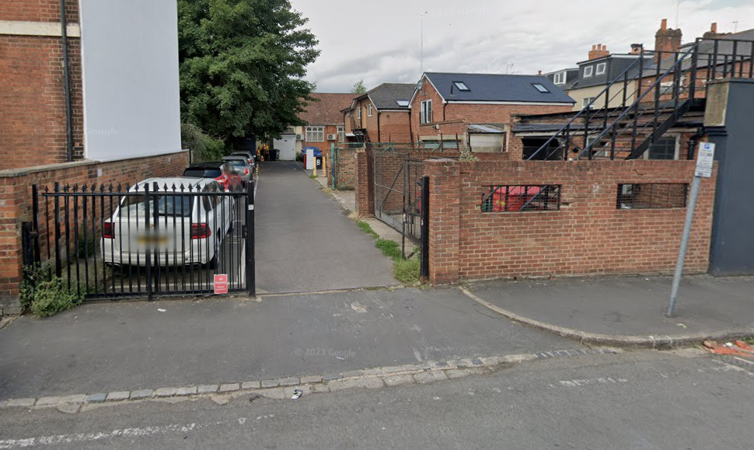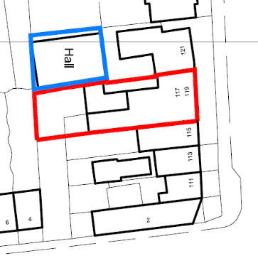

The submitted block plan (see below) identifies areas for bin storage/collection and cycle storage. However, available street-view imagery (see above) indicates that these areas have previously been used for parking.
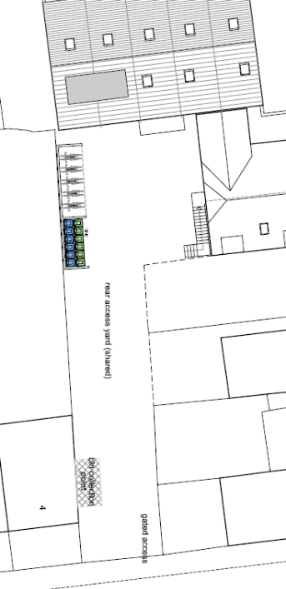

The applicant is therefore requested to provide confirmation of the existing parking arrangements within the site, including who currently parks within the site, together with clarification of the parking provision associated with the proposed development. Highways would not support a proposal that results in existing parking being displaced onto the public highway.

Given the site's sustainable location, a car-free development could be considered. The site is located within an area covered by the Council's residential parking permit scheme. Should the application be approved on a car-free basis, appropriate conditions and/or informatives should be applied to ensure that future occupants of the proposed units are not eligible for resident or visitor parking permits, thereby protecting the amenity of existing residents and preventing additional parking pressure on surrounding streets.

A Construction Management Statement (CMS) will also be required should planning permission be granted.

Please ask the applicant to address the points above so that this application can be fully determined.

N. Hussain
Transport Development Control Advisor

