Delegated report
PL/26/0744
925 Oxford Road, Reading
Single storey side extension and internal alterations
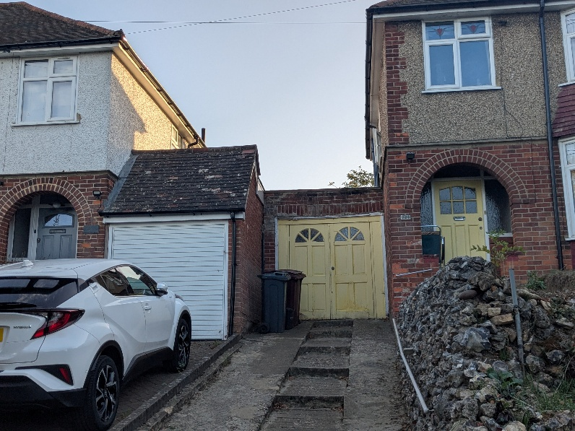
Introduction
The application site is the right-hand semi-detached inter-war property shown above, ie the left of a pair. The house is one in a row of same, set back from the A329 Oxford Road on higher ground. The front gardens are separated from the road by a generous green/treed verge (with some parking) and then a footpath.
Proposal
A small single storey side extension and other related alterations, formed by adapting and extended an existing side extension.
Relevant planning history
There is no recent relevant planning history
Consultations
Public consultation – a site notice was displayed on the front gate of the property by RE on 24/6/26 (photo on file). One letter of objection has been received from the non-attached neighbouring property, raising the following issues:
I request that any approval includes a condition confirming that the existing 70 mm gap between the two detached buildings on the shared boundary between 923A and 925 Oxford Road is retained following construction. The proposed works should not reduce this existing separation or allow the new wall to encroach upon it.
The proposal for 925 extends the garage to the front building line of the entire property, however my property at 923A is set back from 925. I request that the proposed extension to the garage is designed to sit flush with my garage front rather than protrude it. This reflects the established pattern of development along our road and preserves the character of the street scene. A new structure projecting directly in front of our property building line would adversely affect our sight lines and the visual appearance of our property’s frontage. I ask that these design and street scene considerations are taken into account when determining the application.
Planning policy
Reading Borough Local Plan (2019) policies:
H9, CC7, CC8
SPD – A Design Guide to House Extensions 2021.
LP Partial Update-the policies above not proposed to be majorly affected by the update, which is gaining weight in decision-making, is expected to be adopted in January 2027.

APPRAISAL
Design
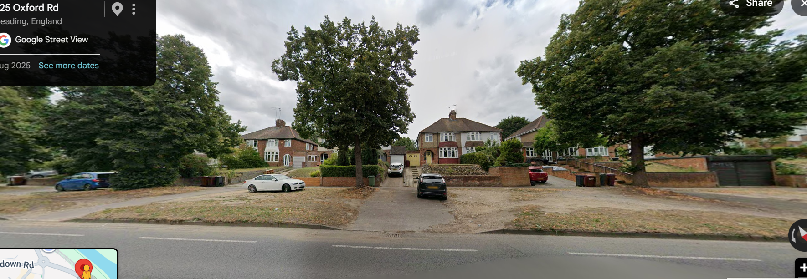
The proposal appears to be showing retention of the existing rear 2/3 of the current side extension. Whether or not this is possible in a construction sense is debateable, but not material, in a planning sense.
In terms of design and impact on the streetscene, the proposal is considered to be very minor, well-designed and sympathetic to the main property. The frontal extension brings the new extension approximately in line with the front building line of the main house, but with the false-pitch roof and single storey nature (the height of the false pitch, despite the land level being higher than 923a, would only just be higher than the neighbouring garage’s false pitch), it will remain subservient in design. Subject to matching materials, the design is suitable in terms of policies CC7, H9 and the SPD.
Amenity and privacy
There would be a slight increase in height over the existing situation and the extension to the front. Neither factor would affect neighbour amenity and Policy CC8 is complied with.
Parking
Although the extension is coming forward, there would still appear to be space to park up to 3x cars on site. No concerns are raised.
Issues raised in objections
The proposed plans are suitable. There is no need for a requirement for a gap, as requested, although the development must be constructed to the approved plans, which will be the subject of a planning condition.
The plans do not indicate any encroachment onto neighbouring land, nor is there the requisite Notice served on any owner to do so. Any related ‘boundary’ issues would be a Civil matter between the respective owners.
The neighbour is probably correct in saying that more than the very slight set-back of the front extension would have been a more suitable design, thereby leaving a ‘shadow’ in relation to the front of the host property and also stepping or closely matching with the neighbouring garage. However, in any event, the relationship would be extremely similar to the neighbouring arrangement and the overall effect, in a streetscene/design sense, perfectly suitable.
Equality Act – no implications for any of the protected characteristics under the Act.
Recommendation:
GRANT conditional planning permission
Conditions:
TL1 3 years
AP1 approved plans:
Location plan: AL 01710 Drg No. 01 Rev – Location Plan dated May 2026
Block plan/site plan: AL 01710 Drg No. 02 Rev – Block Plan dated May 2026
Proposed plans: AL 0710 Drg NO. 4 Rev – Proposed Plan, Section and Elevations date May 2026
M1 materials to match
Informatives – std, incl.
Positive and proactice, Ts and Cs, no encroachment, B Regs approval required.

