PLANNING STATEMENT
Proposed Front Garden Wall
11 Whiteknights Road, Reading RG6 7BY

BACKGROUND
A previous Planning application for a front garden wall was approved by Reading Borough Council under application ref.PL/20/1166 on 18 February 2022.
A further part retrospective application was subsequently made under application ref.PL23/1797.
This was refused permission on 1 March 2024.
Reading Borough Council then issued an enforcement notice requiring the part of the wall that had already been constructed to be removed on 20 September 2024.
This was the subject of an enforcement appeal ref.APP/E0345/C/24/3354104.
This appeal was dismissed on, the decision date being 12 November 2025.
The latest application for this development was submitted on 10 July 2026 (ref.PL/26/0910).
Your council issued a Decline to Determine Notice on 27 July 2026 as had not been shown that the previous enforcement notice (see above) had been complied with.
Following an enforcement inspection on 18 August 2026 Mr.Phillip Hammond confirmed by email on 22 September 2026 that the requirements of the enforcement had been complied with.

CURRENT PROPOSALS
The application now submitted seeks to resurrect the scheme previously granted approval on
18 February 2022 with two minor amendments.
The applicant has advised that she has discussed this matter with a member of the Planning team, but unfortunately, she did not keep a record of who she spoke to.
That previous approval was the result of lengthy negotiations with the case officer, Julie Williams.
It is worth noting the conclusion in her case officer’s report, that ‘the proposed amended design would not be harmful to the character or appearance of the site or its surroundings and would not have a detrimental impact on the amenities of the original building or those of neighbouring properties. As such the proposals is found to be in accordance with Policies CC7 (Design and the Public Realm), CC8 (Safeguarding amenity and H9 (House Extensions and Ancilliary Accommodation) of the Reading Borough Local Plan (2019) and the Council’s Supplementary Planning Guidance ‘’A Design Guide for House Extensions’’.
The level of information provided on the submitted drawings is the same as that submitted in February 2022.

Amendments to the Previously Approved Scheme
- The approved scheme included a pair of gates 3600mm wide (2 x 1800mm gates).
When the wall was constructed, this width was increased to 4000mm (2 x 2000mm gates).
The applicant’s rationale for this modest increase width was to improve vehicle manoeuvering, avoid waiting times on the highway and reduce the risk of vehicle colliding with the piers.
The proposals now submitted include this slight increase in width.
- The three piers either side of the main gates and the personnel gate had a specified width of 327 x 327mm as approved, but these were increased to 450 x 450mm on site.
The scheme now submitted proposes to rebuild these three piers to dimensions of
450 x 450mm.
The remaining three piers will still be 327 x 327mm.
It is submitted that this revised width is acceptable.

Indeed, we would take this opportunity to point out that the front wall to
17B Whiteknights Road has piers of a similar size, whilst the recently constructed wall to the front of 129 Whiteknights Road has 552.5 x 552.5mm piers (see image below).

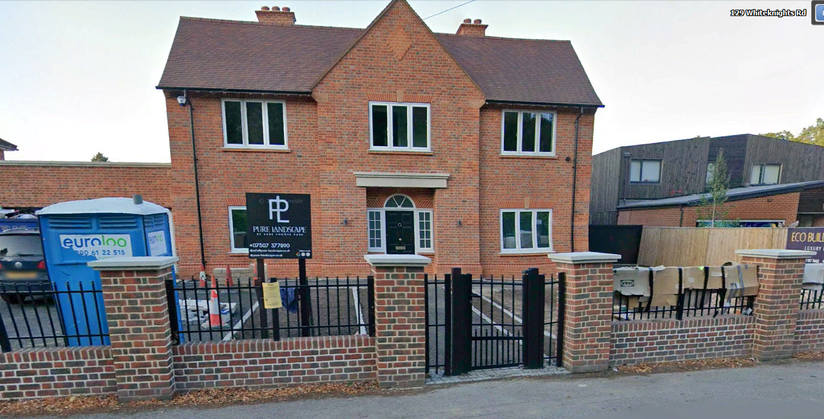

- The width of the remaining panels have been reduced to offset the additional amendments set out above.

Conclusions
It is submitted that the proposals now before your Council still fully accord with the policies set out in the previous case officer’s report (see above) and Planning approval should, therefore, be granted.
My clients are anxious to resolve the long-standing issues relating to the front garden wall of their property by demolishing it, as required by the Planning Inspector, and replacing it as quickly as possible.
They are happy to accept a condition requiring brick samples to be submitted for approval.

Should the case officer have any concerns about granting permission I would be grateful any concerns could be raised and discussed with myself before a final determination is made.

