CONSERVATION

Memo
To: Marcelina Rejwerska
From: Buju Can Cetin, Conservation Officer
Date: 21/09/2026
Re: Conservation Officer response
Application Number: PL/26/0866
Application Type: Full planning permission
Address: RUSSELL HALL, OXFORD ROAD, READING
Proposal: Proposed conversion, alteration and extension of existing former commerical building (Use Class E) to 6 no flats (Use Class C3) with associated works and operations

Summary
Objection – Revisions are recommended
To conclude, the proposed alterations to the scale, height, roof and design of the NDHA would cause loss in originality/authenticity of the building. Because the building’s traditional appearance and historic rhythm substantially lie within its undisturbed roof and unusual decorative leaded glass in its windows, there would be harm to the character of the NDHA and the Russell Street/Castle Hill/Oxford Road Conservation Area. Whilst proposed change of use could be supported with increase in height of the building and the impact on the appearance, due to the location and position of the building, could be negligible, the design of the roof, conservation of original windows and material specification for the new elements should be clearly reconsidered and described. I think there is potential to meet Policies HE4, HE5, HE6, HE7 and HE9 of the NPPF (2026), and Policies EN1, EN3, EN4, and EN6 of the Reading Borough Local Plan. Unless the harm is reduced, the application cannot be acceptable on heritage grounds.

Relevant policies and legislation
From the point of view of the historic environment, the main statutory tests are set out within the Planning (Listed Buildings and Conservation Areas) Act 1990. Section 72(1) of the Planning (Listed Buildings and Conservation Areas) Act 1990 also requires the Council to pay special attention to the desirability of preserving or enhancing the character and appearance of designated Conservation Areas.

National Planning Policy and Guidance
The NPPF (2026) outlines government policy, including its policy in respect of the historic environment. Chapter 20 of the NPPF 'Conserving and enhancing the historic environment' sets out the Government's high-level policies securing the conservation of heritage assets and making decisions on development proposals.
Policy HE4: Securing the conservation of heritage assets recognises heritage assets as irreplaceable resources and requires their conservation, including any contribution made by their setting in a manner appropriate to their significance. A heritage asset or its setting should be supported with a use consistent with their conservation together with the asset’s contribution to sustainable communities, local economies, and local character and distinctiveness. Proposals should avoid harm to heritage significance wherever possible and, where harm cannot be avoided, minimise it. Any harm to or loss of a designated heritage asset’s significance, including harm arising from development within its setting, must be supported by a clear and convincing justification.

Policy HE5: Assessing effects on heritage assets requires the potential impacts of the development proposals on the significance of the assets to be identified with regard to positive effects, no effect, harm and total loss of significance, and decision-makers’ satisfaction that assessments accurately reflect the effects as stated below:
“a. Have a positive effect, which is where the significance of a heritage asset would be enhanced, or better revealed; or
b. Have no effect on the significance of a heritage asset; or
c. Result in harm to the significance of a heritage asset, either from work affecting the asset itself or from development within its setting. The degree of harm should be identified: substantial harm would occur where the development proposal would seriously affect a key element of the asset’s significance; or
d. Cause the total loss of the significance of a heritage asset.”
This policy also requires development proposals with heritage impacts to be accompanied by an assessment of significance and potential impacts.

For the Proposals affecting designated heritage assets, Policy HE6 states:
“1. When considering the potential effect of a development proposal on the significance of a designated heritage asset, substantial weight should be given to the asset’s conservation (and the more important the asset, the greater the weight should be). This is irrespective of whether any potential effect amounts to a positive effect, harm, substantial harm, or total loss of its significance.”
2. Development proposals which would have a positive effect on a designated heritage asset should be supported.
3. Any harm to a designated heritage asset will be a matter of considerable importance and weight. which should be dealt with in accordance with paragraphs 4 to 6 of this policy.
4. Where a development proposal would harm the significance of a designated heritage asset the effect on the asset and its significance should be weighed against any public benefits resulting from the proposal.
5. Where a development proposal would cause substantial harm to, or the total loss of, the significance of a designated heritage asset, consent should be refused unless it can be demonstrated that the harm is necessary to achieve substantial public benefits that outweigh the harm or loss.”

For the Decisions on non-designated heritage assets, PolicyHE7 states:
“1. Development proposals which would have a positive effect on a non-designated heritage asset should be supported.
2. Where a development proposal would harm the significance of a non-designated heritage asset, this should be weighed against the benefits of the proposal and a balanced judgement made, having regard to the scale of any harm or loss and the significance of the non-designated heritage asset.
3. Where a development proposal would cause substantial harm to, or the total loss of, the significance of a non-designated heritage asset, it should only be supported where the harm or loss is outweighed by the benefits of the proposal, having regard to the scale of the harm or loss and the significance of the non-designated heritage asset.”

Similarly, for Conservation areas, Policy HE9 states
“1. Development proposals within or affecting the significance of conservation areas should:
a. Retain and conserve buildings and other features which make a positive contribution to the character or appearance of the conservation area where possible; and
b. Consider the area’s special architectural or historic interest (as identified as part of the designation of the conservation area) in the design of development.
2. Not all elements of a conservation area will necessarily contribute to its significance. Where a development proposal would result in the loss of a building or other element which contributes to the character or appearance of a conservation area that is desirable to conserve, the assessment of impact should take into account the relative significance of the element affected and its contribution to the significance of the conservation area as a whole, and the effects of this considered in accordance with policies HE5 and HE6.”
National Planning Practice Guidance (NPPG) on Historic Environment provides context to the NPPF.

Local Planning Policy and Guidance
Policy EN1 ‘Protection and enhancement of the historic environment’ of the Reading Borough Local Plan sets out the Council’s aspirations for the historic environment. The policy requires that all proposals to protect and, where possible, enhance the significance of heritage assets and their settings, historic character and local distinctiveness of the area in which they are located. It echoes the NPPF by stating, “Proposals should seek to avoid harm in the first instance. Any harm to or loss of a heritage asset should require clear and convincing justification, usually in the form of public benefits”.
Policy EN3 ‘Enhancement of conservation areas’ of the Reading Borough Local Plan requires that development proposals within Conservation Areas contribute positively to local character and distinctiveness. This policy states, “Development proposals within Conservation Areas must make a positive contribution to local character and distinctiveness. Positive consideration will be given to proposals which take opportunities to enhance the character of conservation areas.”
Policy EN4 ‘Locally important heritage assets’ requires “Planning permission may be granted in cases where a proposal could result in harm to or loss of a locally important heritage asset only where it can be demonstrated that the benefits of the development significantly outweigh the asset’s significance.”
Policy EN6 ‘New development in a historic context’ also requires “New development will make a contribution to the historic character of the area by respecting and enhancing its architectural and visual qualities and considering how heritage considerations can influence the design of new development. When determining planning applications for new development, the following factors will be taken into consideration:
a. The positive contribution of the development to the existing historic townscape (scale, height, mass, proportion, plot size, street form, materials, significant vistas and views, and open space);
b. Sensitivity to historic context;
c. Reflection of borough-wide major heritage themes that contribute to local distinctiveness (e.g. patterned brickwork or former worker terraced housing);
d. Whether development promotes and/or improves access to previously undiscovered or neglected historic significance.”
Russell Street/Castle Hill/Oxford Road Conservation Area Appraisal (2020) is also a material consideration in determining applications for development.

Other Guidance
English Heritage’s “Conservation Principles” provides policy and guidance for the “sustainable
management of the historic environment”.

Relevant heritage assets
The application site occupies a part one part two storey detached 1920s building, known as Russell Hall, described as a non-designated heritage asset (NDHA) by the Council in 2021. Located behind the property at 121 Oxford Road, it lies within the Russell Street/Castle Hill/Oxford Road Conservation Area, as given below.

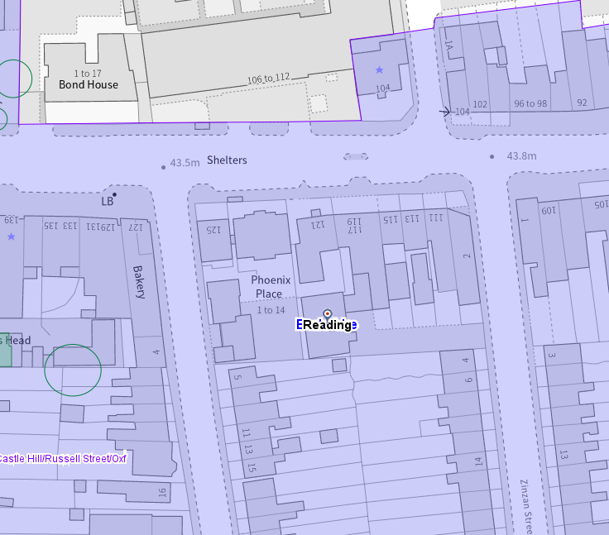
Application Site (red circle), conservation areas shown in purple, listed buildings with stars on them, and buildings of townscape merit are green

Significance of heritage assets
The NPPF defines significance as the “value of a heritage asset to this and future generations because of its heritage interest.”

The interest may be architectural or historic, as set out in the Town and Country Planning (Listed Building and Conservation Areas) Act 1990 Section 1.

“Significance derives not only from a heritage asset’s physical presence, but also from its setting.” (NPPF, 2026)

Historic England assesses significance in a similar manner, referring to evidential, historic, aesthetic and communal values of a place.

The subject building appears on the Ordnance Survey (OS) Map dated 1931 to 1932, constructed in the rear garden of ‘Essex Villa’ in the 1920s (possibly).
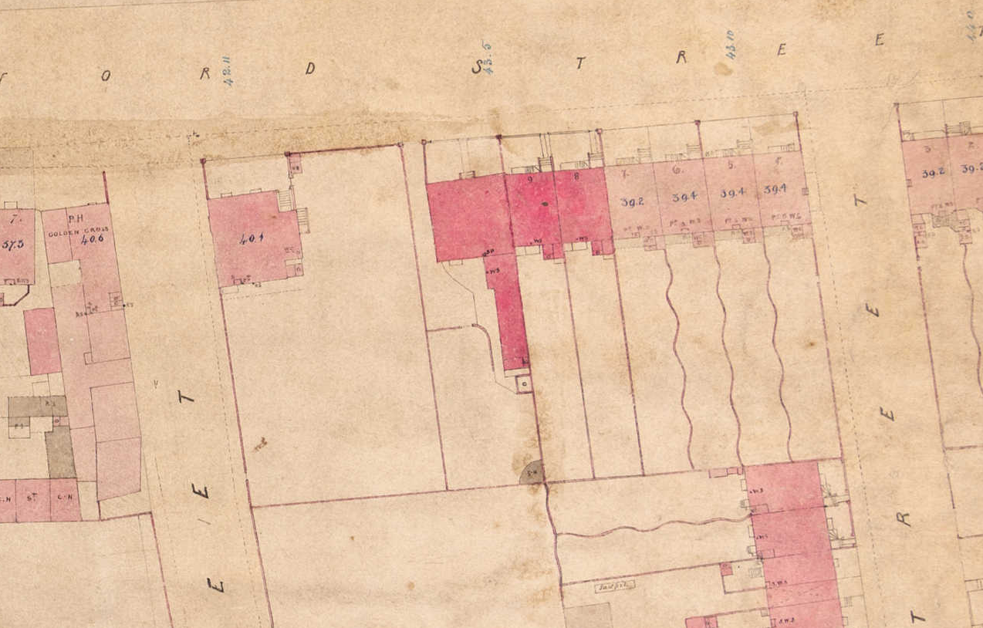
Reading Board of Health Map dated 1853 with undeveloped rear garden of No. 121 Oxford Road (above) and on the OS Map dated 1877 (published in 1879) (below)

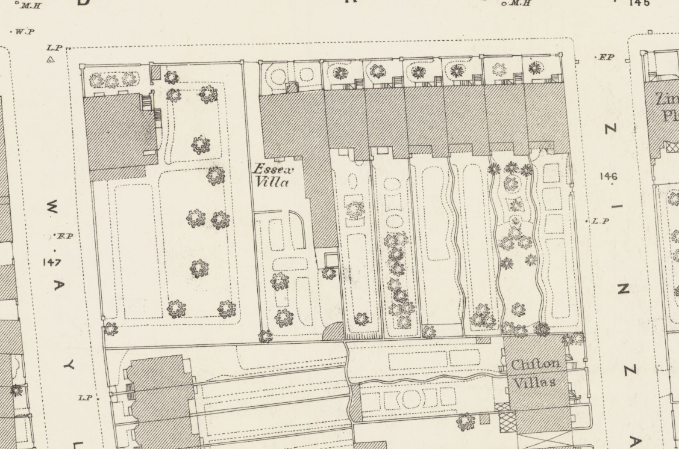

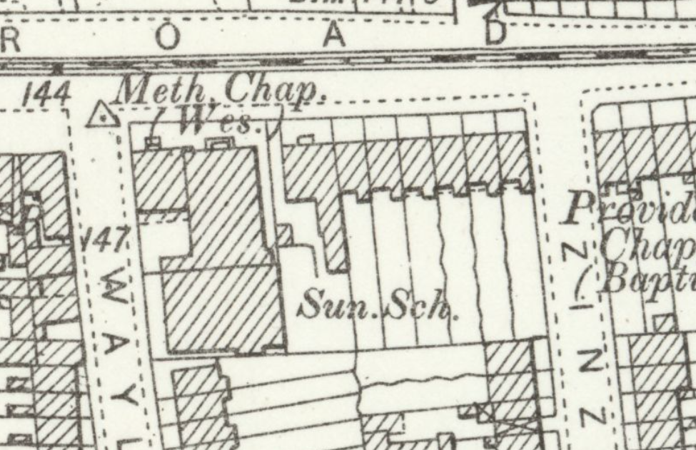
The OS Map of 1898 (published in 1900) – Oxford Road Methodist Church/Wesleyan Methodist Chapel and its Sunday School, which was demolished in 1996, appear on the Map, adjacent to the application site

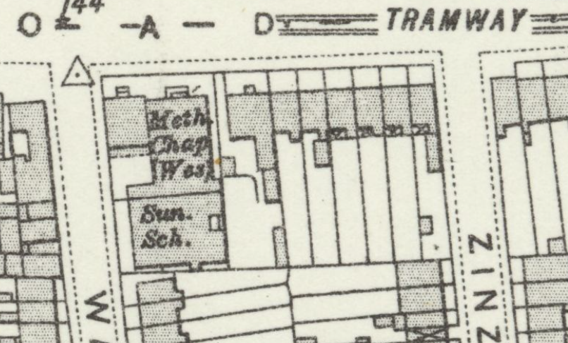
The OS Map dated 1909 to 1910 (published in 1912)

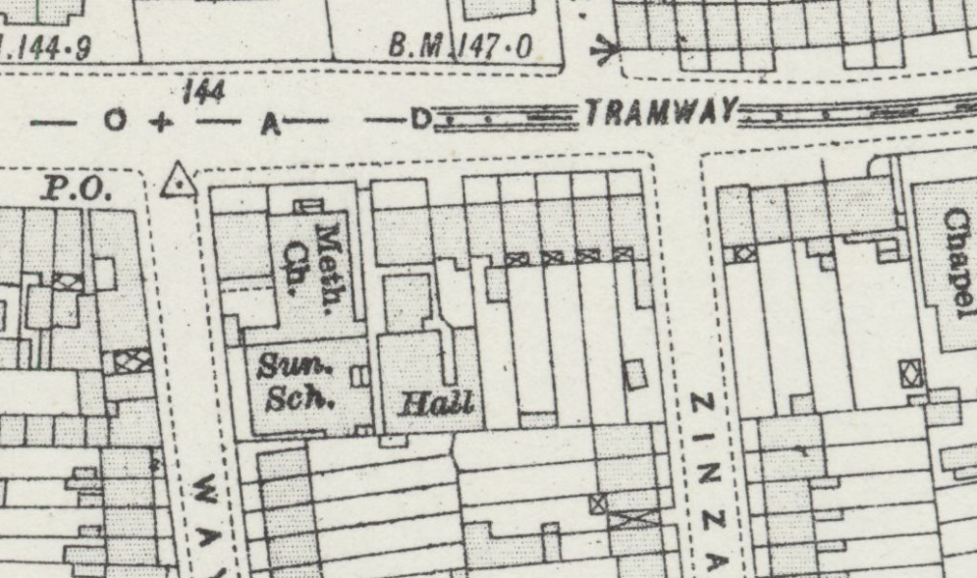
The OS Map dated 1931 to 1932 (published in 1934) – Subject NDHA – Russell Hall is noted

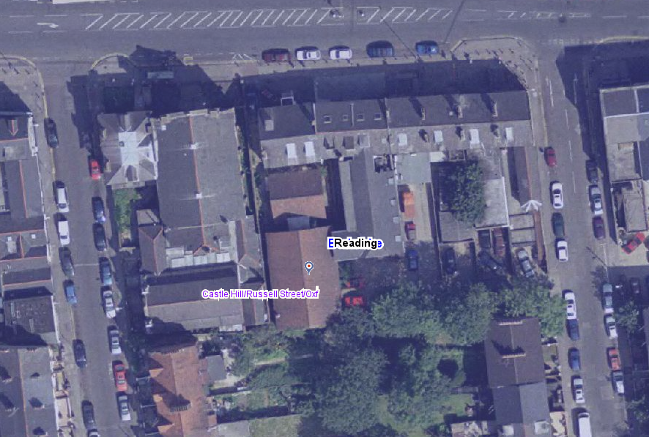
Aerial view of 2002 (above) and of 2006 (below) (from the Council’s Historic Mapping Tool) showing the Hall and historic link (?) to No. 121 Oxford Road since the 1920s

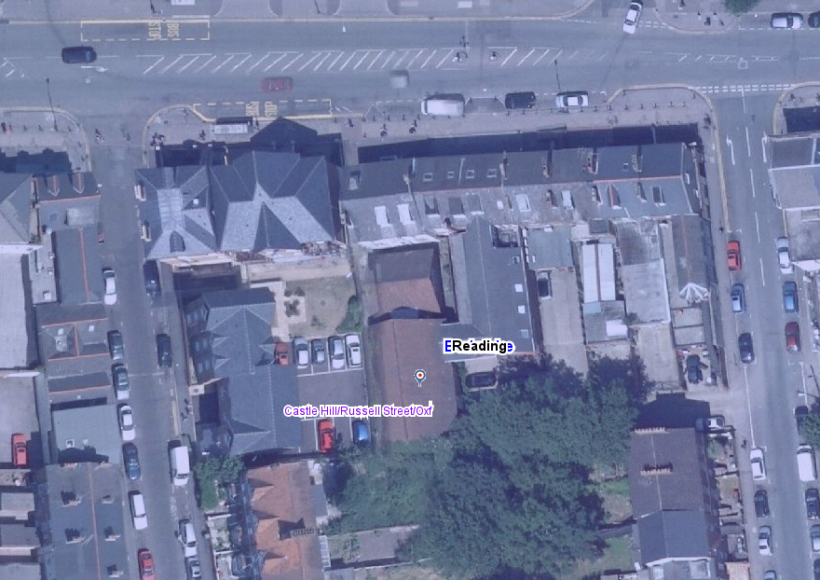

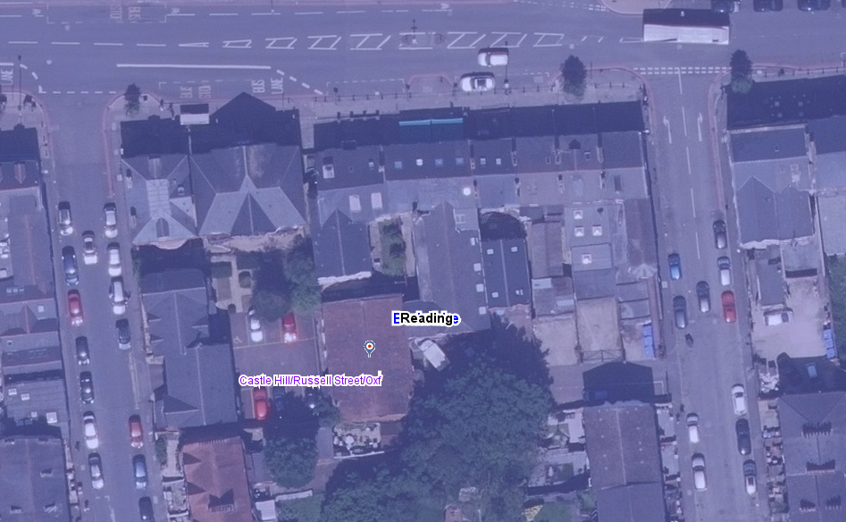
Existing Aerial view with replacement rear extension of No. 121 and modern development in the place of church and Sunday school adjacent – The building appears to have conserved its footprint and external features mostly

The subject NDHA is an early 20th-century building with Edwardian and Arts and Crafts influence. Although surrounded by other buildings, it is modest in nature, with traditionally constructed brick walls under the pitched clay-tiled roof; it contributes to the significance of Russell Street/Castle Hill/Oxford Road Conservation Area. The windows are the most distinctive elements of the building. They are timber-framed, mullioned windows incorporating leaded decorative glazing. The windows are arranged as three tall lights (and five on a gable end), and they contain circular and curved geometric motifs similar to Arts and Crafts/late Art Nouveau character, which is found in domestic and institutional buildings of the early 20th century, as seen in the following photographs.

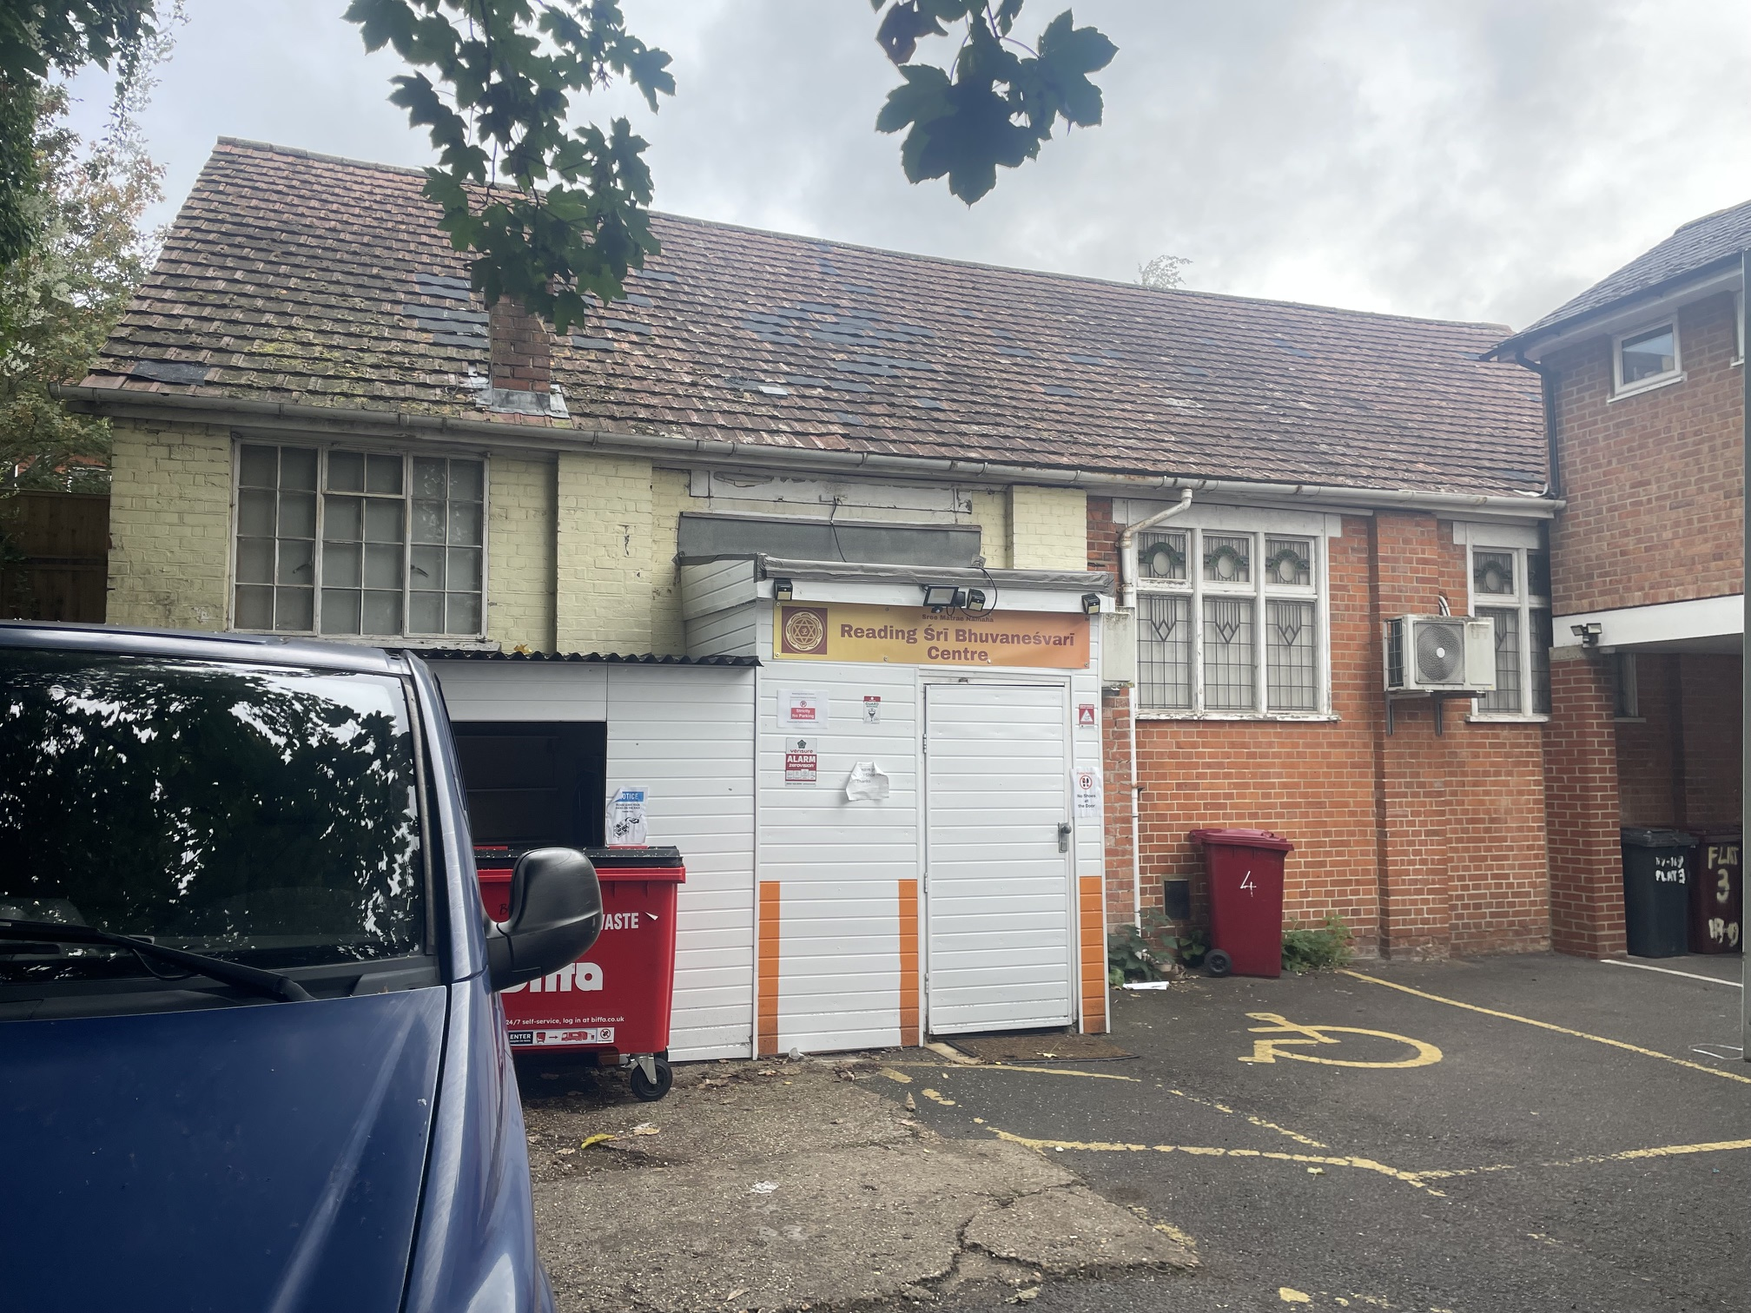

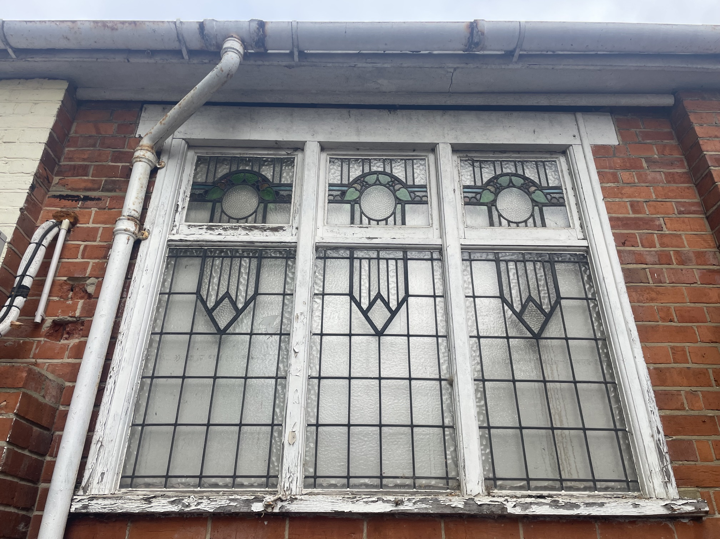

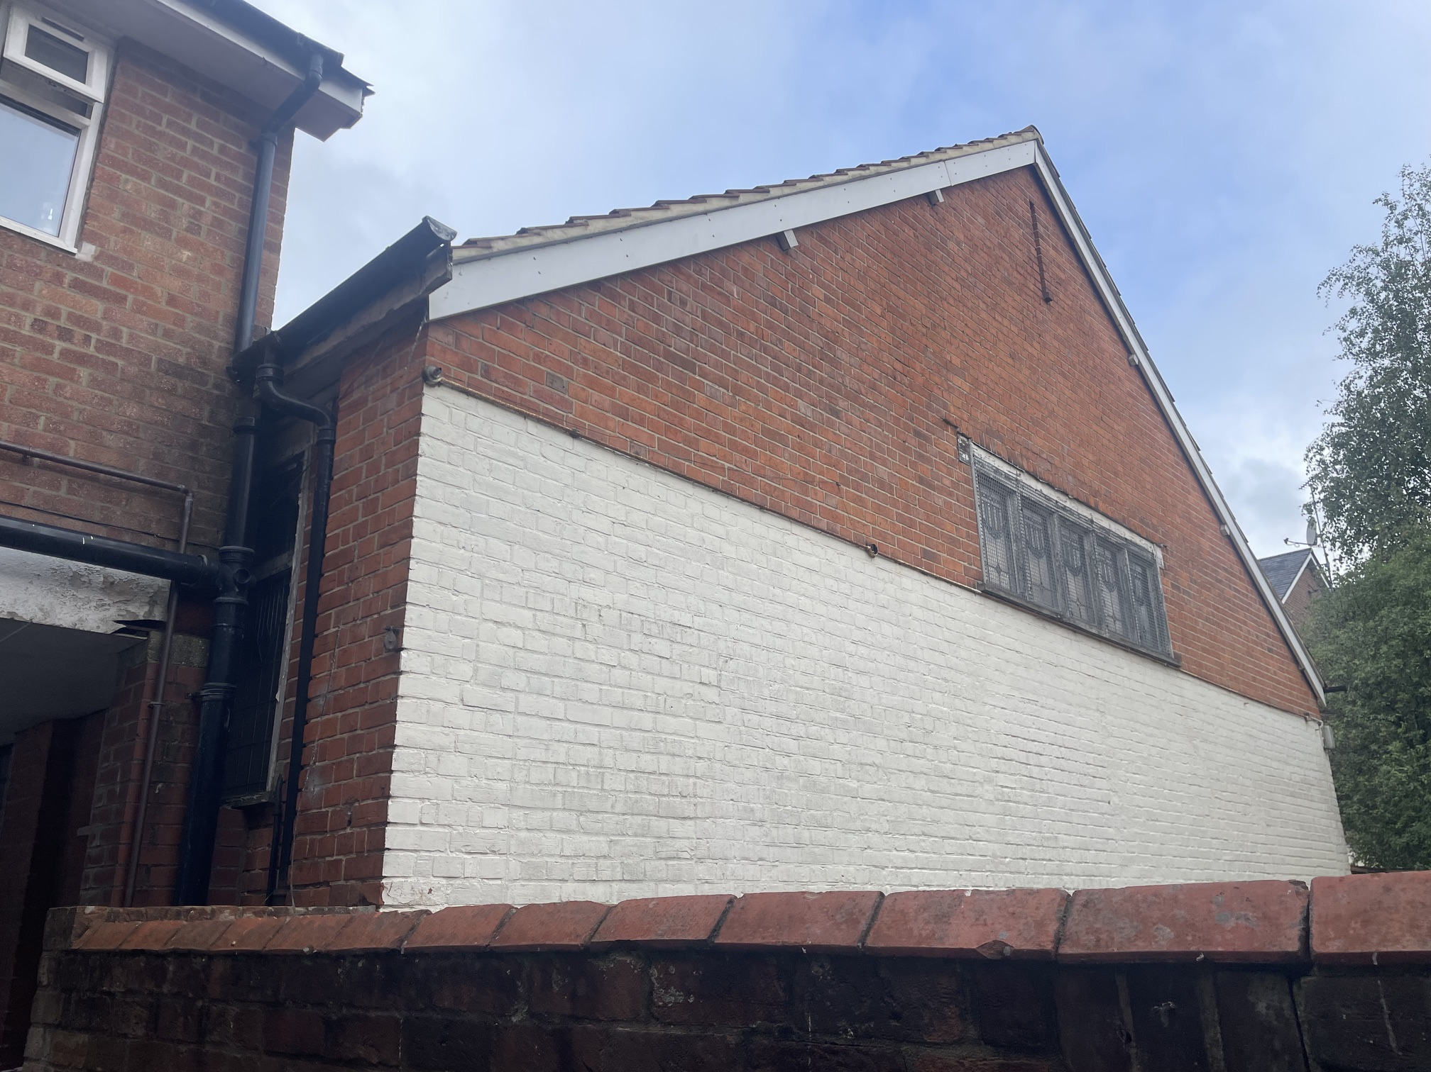

The application site lies within the Character Area 2 – Oxford Road of the conservation area. About this character area, it is noted that early 19th-century maps indicate that shops with residential accommodation above extended westwards from the town centre, particularly between Alfred Street and Eaton Place, and between Russell Street and Waylen Street. Over time, the range of shops and services has evolved in response to successive waves of immigration. Today’s businesses continue the Oxford Road’s long-established tradition of providing a varied and adaptable range of retail and community services.

The appraisal also states:
“Regrettably, a combination of modern ad-hoc alterations with the poorly maintained public realm along the road strikes a distracting discordance. Many modern alterations are out of keeping with the historic environment. Some modern builds have failed to respect the Conservation Area’s character. Much of the residential accommodation, including above the shops, tends to be poorly maintained. Along with the exciting and vibrant nature of the Oxford Road, the clash of modern and historic materials and poor maintenance makes it difficult to fully appreciate the street’s historic character.”

“To the rear of the south side of Oxford Road there have historically been many yards and businesses most of which have now been redeveloped (..)”

Whilst the subject NDHA is legible through its roof form, footprint and architectural detailing, it is noted that it has some external additions of low design and materials along with a much altered interior. Nevertheless, its contribution to the character of the conservation area still remains.

Impact of proposal upon heritage asset(s)
The proposal is for the conversion of the existing building to residential units, along with external alterations to the building that constitute an increase in height, addition of dormers and roof lights, introduction of balconies and terraces and refuse and cycle storage on the site. I noted from the block plan that the existing entrance and gates, as seen below, would not be altered. There are no details submitted for the proposed refuse and cycle storage.
Whilst the proposal could be acceptable in principle, I think it needs revisions on the basis below:
- The front/east elevation of the building is noted as a principal elevation, and the existing unsympathetic entrance porch is proposed to be removed, with the entrance to be positioned with a new porch in the middle, while the existing original window is to be reinstated on the side. I think this work could be acceptable only if the original windows are repaired and retained.
- On page 22 of the Heritage Statement, it is said that “If demolished, the windows of quality will be retained and reinstated as part of the replacement building.” I would like to remind you that demolition cannot be suggested and cannot be an option. I do not understand why this is stated in the statement.
- There would be a new flat-roofed dormer with two windows introduced, which I suggest consideration of traditional roof form, as the original roof would be removed and replaced; the impact of the loss of original elements should be balanced with the design and materials of the new ones, such as dormers and roof lights. As approx. 1.5m increase to the roof would also generate some harm, I think revisions are required.
- Although I assume the proposed windows/fenestration would match the existing, I am unable to find confirmation of the proposed materials. The application form states ‘No’ and the following paragraph from the Planning Statement does not clarify the materials “4.7 The design approach is heritage-led and seeks to retain the existing hall volume and its simple gabled form. The height is subtly increased to create viable residential floorspace while respecting the surrounding scale. High-quality, contextual materials such as brick and slate or tiles are used to ensure the building sits comfortably within the Conservation Area. Unsympathetic later accretions are removed, and more coherent elevations are reinstated. The Heritage Impact Assessment emphasises that the scheme enhances the building’s long-term viability through residential conversion while reinstating original materials where appropriate.”
- I would also suggest all historic original windows to be retained on eastern, western and northern elevation. If they are not retained as they are, leaded glazing should be reused, or strong justification should be provided, as the submitted drawings for the proposed elevation show the original windows only on the eastern elevation.

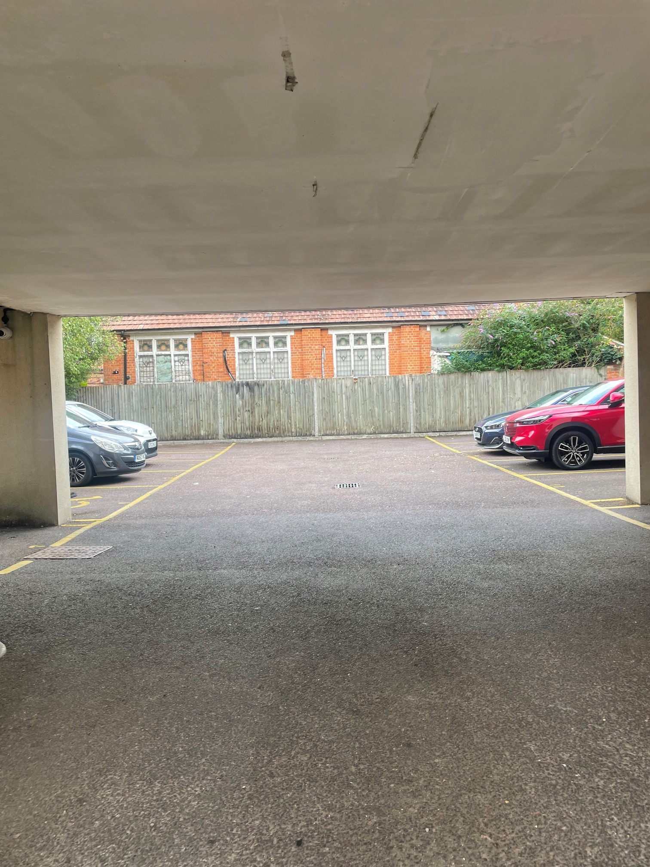
Original windows of the NDHA on the western elevation

To conclude, the proposed alterations to the scale, height, roof and design of the NDHA would cause loss in originality/authenticity of the building. Because the building’s traditional appearance and historic rhythm substantially lie within its undisturbed roof and unusual decorative leaded glass in its windows, there would be harm to the character of the NDHA and the Russell Street/Castle Hill/Oxford Road Conservation Area. Whilst proposed change of use could be supported with increase in height of the building and the impact on the appearance, due to the location and position of the building, could be negligible, the design of the roof, conservation of original windows and material specification for the new elements should be clearly reconsidered and described. I think there is potential to meet Policies HE4, HE5, HE6, HE7 and HE9 of the NPPF (2026), and Policies EN1, EN3, EN4, and EN6 of the Reading Borough Local Plan. Unless the harm is reduced, the application cannot be acceptable on heritage grounds.

Conservation response
No objections
No objections subject to conditions attached
Clarification required
Object

Contact details
Buju Can Cetin, Conservation Officer
Burcu.CanCetin@reading.gov.uk

