Planning Department
Reading Borough Council
Civic Offices
Bridge Street
Reading
RG1 2LU
20 September 2026
Dear Sirs,
RE: ERECTION OF REPLACEMENT DWELLING
RIVER VIEW MANOR, SCOURS LANE, TILEHURST, READING
Please find attached completed planning application forms, plans and supporting information in respect of the above-mentioned proposal.
DESIGN AND ACCESS STATEMENT
Site Location
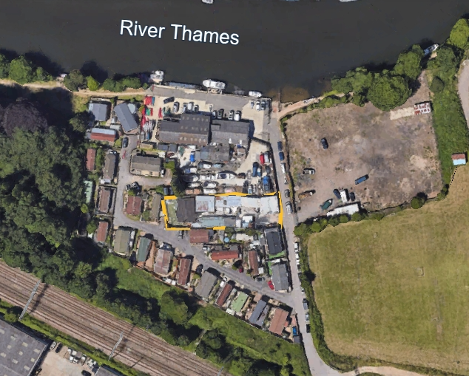
Figure 1

The application site is located along the western side of Scours Lane, as shown edged yellow on the aerial photograph shown above. The site is bounded to the north by a boatyard, and by Riverside Park Homes Site to the south and east. There is a further mobile home site along the opposite side of Scours Lane.
Site History
The site has planning permission as a commercial dog kennels, with on-site residential accommodation consisting of a detached 2 bedroom bungalow. Planning permission was granted on 16 January 1991, under application number PL/90/1082, for “Erection of new pitched roof bungalow”. Planning permission for the bungalow was granted subject to a condition limiting occupation to a person employed in the existing commercial kennels. The premises previously traded as ‘Cosy Kennels’, and was used primarily for dog breeding and grooming.
Lawful Use
The lawful use is a mixed use of commercial kennels and as a dwelling house. These are both primary uses of the land. The description of development for application No. PL/90/1082 was “Erection of new pitched roof bungalow” and, although its occupation is limited by condition, its use is not “ordinarily ancillary or incidental” to use of the land as a commercial boarding kennels.

Whether a secondary activity forms part of an established use is ultimately governed by the statutory question whether its introduction effects a material change of use. The assessment is generally made by reference to activities ordinarily associated with the relevant use class, rather than the particular occupier’s preferences or requirements. A novel activity is not automatically excluded, but if it falls outside the ordinary ancillary use, planning permission is required (Harrods Limited v Secretary of State for the Environment & Anor [2002] EWCA Civ 412).
In order to be “ancillary” the residential use of the existing bungalow would have to be “ordinarily incidental” to use as a boarding kennels. Clearly, that is not the case.
The applicant has cleared the kennel buildings, eradicated an infestation of vermin, and has moved onto the land with a mobile home whilst awaiting replacement of the existing bungalow, as shown on Figure 2 below.
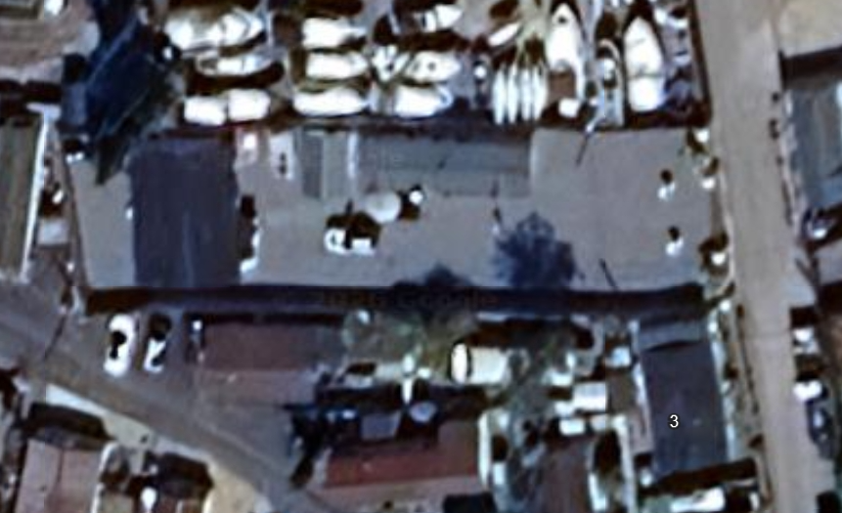
Figure 2
Use, Scale and Layout
The proposed development would consist of the change of use of land from a mixed use as commercial kennels and as a tied dwelling, to C3 use, including erection of a detached, chalet- style, 4 bedroom dwelling following the demolition of the existing tied bungalow. Proposals would also include the installation of a cycle and refuse/recycle bin store, and a Package Sewage Treatment Plant. There is an existing hard-standing which would provide parking and turning space for 3 vehicles.
The existing bungalow has a ground area of 7.58 metres x 11.24 metres and, a height of 3.5 metres. The proposed dwelling is two-storey, with maximum dimensions of 11.24 metres x 13.715 metres, and a height of 8.15 metres.
The existing bungalow is of non-standard construction, is in poor repair and, has a finished floor level of 39.0 metres AOD, which is below the 1 in 100 + climate change flood level of 39.26 metres AOD. The existing bungalow is, therefore, at high risk of flooding from the nearby river and, cannot be made

flood resilient. The proposed dwelling would be raised above a void beneath the dwelling and, would have a finished floor level on the ground floor of 39.86 metres AOD. Thus, not only would the new dwelling be safe from flooding, it would also provide additional on-site storage of flood water.
The proposed dwelling would be in the approximate location of the bungalow it is to replace, leaving a 3 – 5 metre-long garden at the rear and, space for the parking and manoeuvring of vehicles at the front. New planting would be introduced within the front yard, to soften the appearance of the proposed development when seen from Scours Lane.
Appearance
The design of the proposed dwelling reflects the advice set out within the Reading Borough Local Plan and, incorporates the requirements set out in Policy H5 – Standards for New Housing, the Sustainable Design and Construction Document (SPD) and Revised Parking Standards Design Supplementary Planning Document (SPD). The dwelling would also be built to BREEAM standards.
The pitch of the roof has been kept to the minimum necessary to allow for headroom within bedrooms. However, due to the need to incorporate measures to alleviate flood risk, including flood storage compensation, the ridge will be at a maximum overall height of 8150mm. The roof has been hipped in order to ensure that the dwelling will have no substantial impact on adjoining properties, by reason of overlooking, over-shadowing or loss of privacy. The design is simple but attractive, particularly when compared with the quality of surrounding development.
Landscaping
There were no trees or hedges present on the site prior to purchase by the applicant and, the site was of little or no value for biodiversity. Some planting has already been undertaken within brick planters located either side of the entrance gates. It is intended to carry out further planting of indigenous trees and shrubs within newly created brick planters, located as shown on the

attached Site Layout Plan. This planting will enhance the residential environment for the applicant and his family, soften and improve the appearance of the locality and, enhance biodiversity.
Access
Access will be from Scours Lane. Scours Lane in an adopted no-through road. The Applicant has already constructed a new improved entrance onto Scours Lane together with on-site vehicle parking and turning areas, as shown on the submitted Site Layout Plan.
Planning Policy
The adopted Local Plan recognises in the explanation to Policy H1 that the provision of new housing involves a heavy reliance on previously developed land, and the supply of such sites constrains the amount of housing that can be delivered in the Borough. The application site comprises previously developed land and its use for the provision of open market housing is, therefore, in accordance with the Council’s housing strategy.
Policy H14: Suburban Renewal and Regeneration of Residential Areas encourages renewal and regeneration within Reading’s suburban residential areas where that would achieve the following aims:
• Improve the local built environment;
• Improve, replace and modernise the housing stock; and
• Deliver additional homes.
Where development would fulfil the above aims, it would generally be supported, subject to other policies in this plan and provided that:
• Any loss of undeveloped land would be outweighed by a qualitative improvement in open and green space and by the benefits of development to the community as a whole;
• Buildings and features that make a positive contribution to the area’s character are retained;

• There would be adequate community facilities to serve the resulting community; and
• There would not be an unacceptable impact on the highway network as a result of loss of parking areas or garages.
Clearly, in this case, the proposed development would replace, improve and modernise the existing housing stock, and enhance the local built environment. The proposed development would not involve any loss of undeveloped land or, buildings that make a contribution to the area’s character. The site is located close to local community services and facilities, as set out below:
Tesco 0.48 kms
Waitrose 0,64 kms
Oxford Road Recreation Ground 0.80 kms
Medical Centre 1.13 kms
Oxford Road Pharmacy 1.93 kms
Tilehurst Railway Station 2.57 kms
Finally, replacement of the commercial kennels and dilapidated bungalow would, if anything, reduce traffic generation. The proposed development would, therefore, comply fully with Policy H14.
Local Plan Policy EN18: Flooding and Sustainable Drainage Systems directs development to areas at lowest risk of flooding in the first instance, following the Sequential and Exceptions Test set out in the NPPF, and taking into account the effects of climate change. Where development in areas at risk of flooding is necessary, it will not reduce the capacity of the flood plain to store floodwater, impede the flow of floodwater or in any way increase the risks to life and property arising from flooding. Wherever possible, development should be designed to reduce flood risk, both on- and off-site.

In this case, the application site is located within Flood Zone 2, with only small peripheral areas located within Flood Zone 3. Dwelling houses are categorised as being “more vulnerable” to flooding. Whereas the sequential test is applicable, there is no requirement to apply the Exceptions Test for more vulnerable development in Flood Zone 2. As far as the sequential test is concerned, the existing dwelling can only be replaced on the application site and, the proposed development will take place on the area of the site at lowest risk from flooding.
The current dwelling is single-storey, with a floor level below the 1 in 100 + allowance for climate change level. It is of non-standard construction and, would not be resilient to flooding.
The proposed dwelling would be constructed of brick, with the ground floor being raised 600mm above the 1 in 100 + climate change flood level. The design takes into account climate change by increasing the Annual Probability (1 in 100) Flood Level with a 35% allowance. The ground floor would be elevated above a void which would increase flood storage within the application site and, allow the free passage of flood water across the site.
Provision of first floor accommodation would provide safe refuge for the site residents even in a time of extreme flooding. To help protect against flooding during extreme events, the applicant will implement flood resistant design measures into the proposal, in consultation with the local Authority building control department.
There is no specific reference in guidance to the replacement of existing dwellings but, in this case, the proposed development would neither create an extra dwelling on the site or, increase the ground area of buildings occupying the land. As a result of the removal of the kennel buildings and the measures to mitigate against the risk from flooding, the footprint of buildings on the land would be substantially reduced.

A Flood Risk Assessment has been submitted to demonstrate how flood risk can be mitigated for the site occupants, whilst reducing the risk of flooding off-site, by raising the proposed dwelling above the predicted flood levels (including climate change) and, creating a void beneath the dwelling which

would increase flood storage within the site without impeding flood flows: water would be free to pass beneath the proposed dwelling. The proposed dwelling would be both flood resistant and flood resilient. As for having a safe means of escape, the proposed development would not increase the number of households able to reside on the land or, thereby, increase the burden on emergency services (who would be busy rescuing the numerous families living in highly vulnerable mobile homes on adjoining or adjacent sites).

The development includes the installation of a Sustainable Drainage System (SuDS) incorporating a new ‘Kingspan Klargester Gamma’ Rainwater Harvester Tank and water butts will be installed to the downpipes of the proposed dwelling and the Cycle and Refuse/Recycling Bin Stores. All other remaining rainfall will infiltrate the subsoil via permeable hardstanding’s and soft landscaping in an effort to minimalize any surface water run-off. Refer to ‘UNDA Consulting Ltd’ Flood Risk Assessment (FRA) for Planning. The proposed development has been designed to reduce flood risk, both on- and off-site, and accords with Local Plan Policy EN18.
Conclusion
The application seeks permission to erect a Chalet Style 4 Bedroom dwelling of high-quality design which would enhance the character and appearance of the locality. I trust that the Council will act proactively on this application to ensure that a sensitive, modest, attractive and energy efficient new home can replace the existing dilapidated non-standard constructed bungalow.
It should be taken into consideration that the development is to change the use of the site from a mixed use as commercial kennels and dwelling to use for residential purposes. The development would therefore benefit the adjacent Riverside Park Homes residential complex by eliminating rodent infestation, animal noises and odours, and generally improving the character and appearance of the area. The proposed development would also enhance the landscaping and biodiversity of the site.
It is considered that the proposal meets the criteria set out in the relevant planning policies from the Reading Borough Local Plan and Sustainable Design and Construction Supplementary Planning Document (SPD).

Policy S4 of the NPPF requires that development proposals within settlements should be approved unless the benefits of doing so would be substantially outweighed by any adverse effects, when assessed against the national decision-making policies in this Framework. The circumstances in which the benefits of approving development are likely to be substantially outweighed by adverse effects include, amongst other things, where proposals would fail to comply with one of the national decision-making policies which state that development proposals should be refused in specific circumstances. In this case, Table 3: Flood risk vulnerability and flood zone ‘incompatibility’ of
Annex F of the NPPF does not suggest that “more vulnerable” development in Flood Zone 2 should be refused. The proposed development should therefore be deemed as a sustainable development and, should be granted planning permission without delay.

For the above reasons, I trust that you will feel able to support my client’s
application and, I look forward to receiving the Council’s decision in due
course.

Kind regards,

PHILIP BROWN BA (Hons) Urban and Regional Planning

