CONSERVATION

Memo
To: Catrin Davies
From: Buju Can Cetin, Conservation Officer
Date: 18/09/2026
Re: Conservation Officer response
Application Number: PL/26/1102
Application Type: Consent to display and advertisement
Address: HELENA HOUSE, 1 BROWNLOW ROAD, READING
Proposal: Advertisement Consent for new signage

Summary
Objection – Revisions are recommended
The proposed signage, due to its location and number/scale, would result in harm to the appearance of the conservation area and settings of listed buildings adjacent to the site. To prevent street clutter and preserve the street's existing appearance as much as possible (with minimal new elements), I recommend reducing the number of signs proposed for the front to comply with the Council’s Local Plan Policies EN1, EN3, EN6 and OU4.

Relevant policies and legislation
From the point of view of the historic environment, the main statutory tests are set out within the Planning (Listed Buildings and Conservation Areas) Act 1990. Section 72(1) of the Planning (Listed Buildings and Conservation Areas) Act 1990 also requires the Council to pay special attention to the desirability of preserving or enhancing the character and appearance of designated Conservation Areas.
Section 66 of the Act also requires that special regard be given to the desirability of preserving listed buildings, their settings or any features of special architectural or historic interest which they possess.

National Planning Policy and Guidance
The NPPF (2026) outlines government policy, including its policy in respect of the historic environment. Chapter 20 of the NPPF 'Conserving and enhancing the historic environment' sets out the Government's high-level policies securing the conservation of heritage assets and making decisions on development proposals.
Policy HE4: Securing the conservation of heritage assets recognises heritage assets as irreplaceable resources and requires their conservation, including any contribution made by their setting in a manner appropriate to their significance. A heritage asset or its setting should be supported with a use consistent with their conservation together with the asset’s contribution to sustainable communities, local economies, and local character and distinctiveness. Proposals should avoid harm to heritage significance wherever possible and, where harm cannot be avoided, minimise it. Any harm to or loss of a designated heritage asset’s significance, including harm arising from development within its setting, must be supported by a clear and convincing justification.

Policy HE5: Assessing effects on heritage assets requires the potential impacts of the development proposals on the significance of the assets to be identified with regard to positive effects, no effect, harm and total loss of significance, and decision-makers’ satisfaction that assessments accurately reflect the effects as stated below:
“a. Have a positive effect, which is where the significance of a heritage asset would be enhanced, or better revealed; or
b. Have no effect on the significance of a heritage asset; or
c. Result in harm to the significance of a heritage asset, either from work affecting the asset itself or from development within its setting. The degree of harm should be identified: substantial harm would occur where the development proposal would seriously affect a key element of the asset’s significance; or
d. Cause the total loss of the significance of a heritage asset.”
This policy also requires development proposals with heritage impacts to be accompanied by an assessment of significance and potential impacts.

For the Proposals affecting designated heritage assets, Policy HE6 states:
“1. When considering the potential effect of a development proposal on the significance of a designated heritage asset, substantial weight should be given to the asset’s conservation (and the more important the asset, the greater the weight should be). This is irrespective of whether any potential effect amounts to a positive effect, harm, substantial harm, or total loss of its significance.”
2. Development proposals which would have a positive effect on a designated heritage asset should be supported.
3. Any harm to a designated heritage asset will be a matter of considerable importance and weight. which should be dealt with in accordance with paragraphs 4 to 6 of this policy.
4. Where a development proposal would harm the significance of a designated heritage asset the effect on the asset and its significance should be weighed against any public benefits resulting from the proposal.
5. Where a development proposal would cause substantial harm to, or the total loss of, the significance of a designated heritage asset, consent should be refused unless it can be demonstrated that the harm is necessary to achieve substantial public benefits that outweigh the harm or loss.”

Similarly, for Conservation areas, Policy HE9 states
“1. Development proposals within or affecting the significance of conservation areas should:
a. Retain and conserve buildings and other features which make a positive contribution to the character or appearance of the conservation area where possible; and
b. Consider the area’s special architectural or historic interest (as identified as part of the designation of the conservation area) in the design of development.
2. Not all elements of a conservation area will necessarily contribute to its significance. Where a development proposal would result in the loss of a building or other element which contributes to the character or appearance of a conservation area that is desirable to conserve, the assessment of impact should take into account the relative significance of the element affected and its contribution to the significance of the conservation area as a whole, and the effects of this considered in accordance with policies HE5 and HE6.”
National Planning Practice Guidance (NPPG) on Historic Environment provides context to the NPPF.

Local Planning Policy and Guidance
Policy EN1 ‘Protection and enhancement of the historic environment’ of the Reading Borough Local Plan sets out the Council’s aspirations for the historic environment. The policy requires that all proposals to protect and, where possible, enhance the significance of heritage assets and their settings, historic character and local distinctiveness of the area in which they are located. It echoes the NPPF by stating, “Proposals should seek to avoid harm in the first instance. Any harm to or loss of a heritage asset should require clear and convincing justification, usually in the form of public benefits”.
Policy EN3 ‘Enhancement of conservation areas’ of the Reading Borough Local Plan requires that development proposals within Conservation Areas contribute positively to local character and distinctiveness. This policy states, “Development proposals within Conservation Areas must make a positive contribution to local character and distinctiveness. Positive consideration will be given to proposals which take opportunities to enhance the character of conservation areas.”
Policy EN6 ‘New development in a historic context’ also requires “New development will make a contribution to the historic character of the area by respecting and enhancing its architectural and visual qualities and considering how heritage considerations can influence the design of new development. When determining planning applications for new development, the following factors will be taken into consideration:
a. The positive contribution of the development to the existing historic townscape (scale, height, mass, proportion, plot size, street form, materials, significant vistas and views, and open space);
b. Sensitivity to historic context;
c. Reflection of borough-wide major heritage themes that contribute to local distinctiveness (e.g. patterned brickwork or former worker terraced housing);
d. Whether development promotes and/or improves access to previously undiscovered or neglected historic significance.”
The Council’s Policy OU4 ‘Advertisements’ is also applicable to this application. The policy states “Advertisements will respect the building or structure on which they are located and/or their surroundings and setting in terms of size, location, design, materials, colour, noise, lettering, amount and type of text, illumination and luminance, and will not have a detrimental effect on public safety. The cumulative impact of adverts will be taken into account, and a proliferation of advertisements that detrimentally affects visual or aural amenity or public safety will not be acceptable. All adverts shall comply with the following criterion:
c) Advertisements on listed buildings or in Conservation Areas will respect or enhance the building or area, and will respect the key features of the special historic interest;”

Downshire Square Conservation Area Appraisal (2009) is also a material consideration in determining applications for development.

Other Guidance
English Heritage’s “Conservation Principles” provides policy and guidance for the “sustainable
management of the historic environment”.

Relevant heritage assets
The application site occupies two-storey semi-detached Victorian buildings and their front and rear gardens located within the Downshire Square Conservation Area. As illustrated below, the site is adjacent to the Grade II listed All Saints Infants School and Playground Area Railings to the west and within the setting of the Grade II listed Church of All Saints, which is also a landmark building in the area.

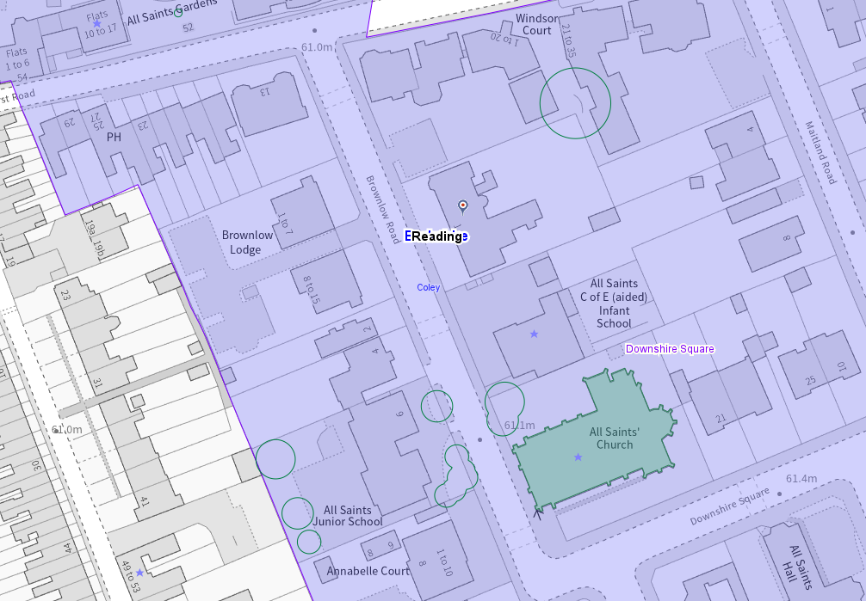
Application Site (red circle), conservation areas shown in purple and listed buildings with stars on them

Significance of heritage assets
The NPPF defines significance as the “value of a heritage asset to this and future generations because of its heritage interest.”

The interest may be architectural or historic, as set out in the Town and Country Planning (Listed Building and Conservation Areas) Act 1990 Section 1.

“Significance derives not only from a heritage asset’s physical presence, but also from its setting.” (NPPF, 2026)

Historic England assesses significance in a similar manner, referring to evidential, historic, aesthetic and communal values of a place.
The application site is located within the Character Area 1 - Central core of Brownlow Road and Downshire Square with All Saints Church and adjoining Infants School. The area’s special character comes from its mix of Victorian and later architectural styles within a planned street layout of large, tree-lined plots. Its historic appeal is strengthened by the survival of boundary walls, railings and mature trees, including prominent avenues along Downshire Square. Together, these features create a strong sense of unity, with All Saints Church and All Saints School forming the focal point of the area.

The historic buildings of the application site have undergone very little alteration, and as such, although the buildings within the application site are not listed, given their scale, historic and architectural features (design and appearance) highly contribute to the conservation area and the streetscape.

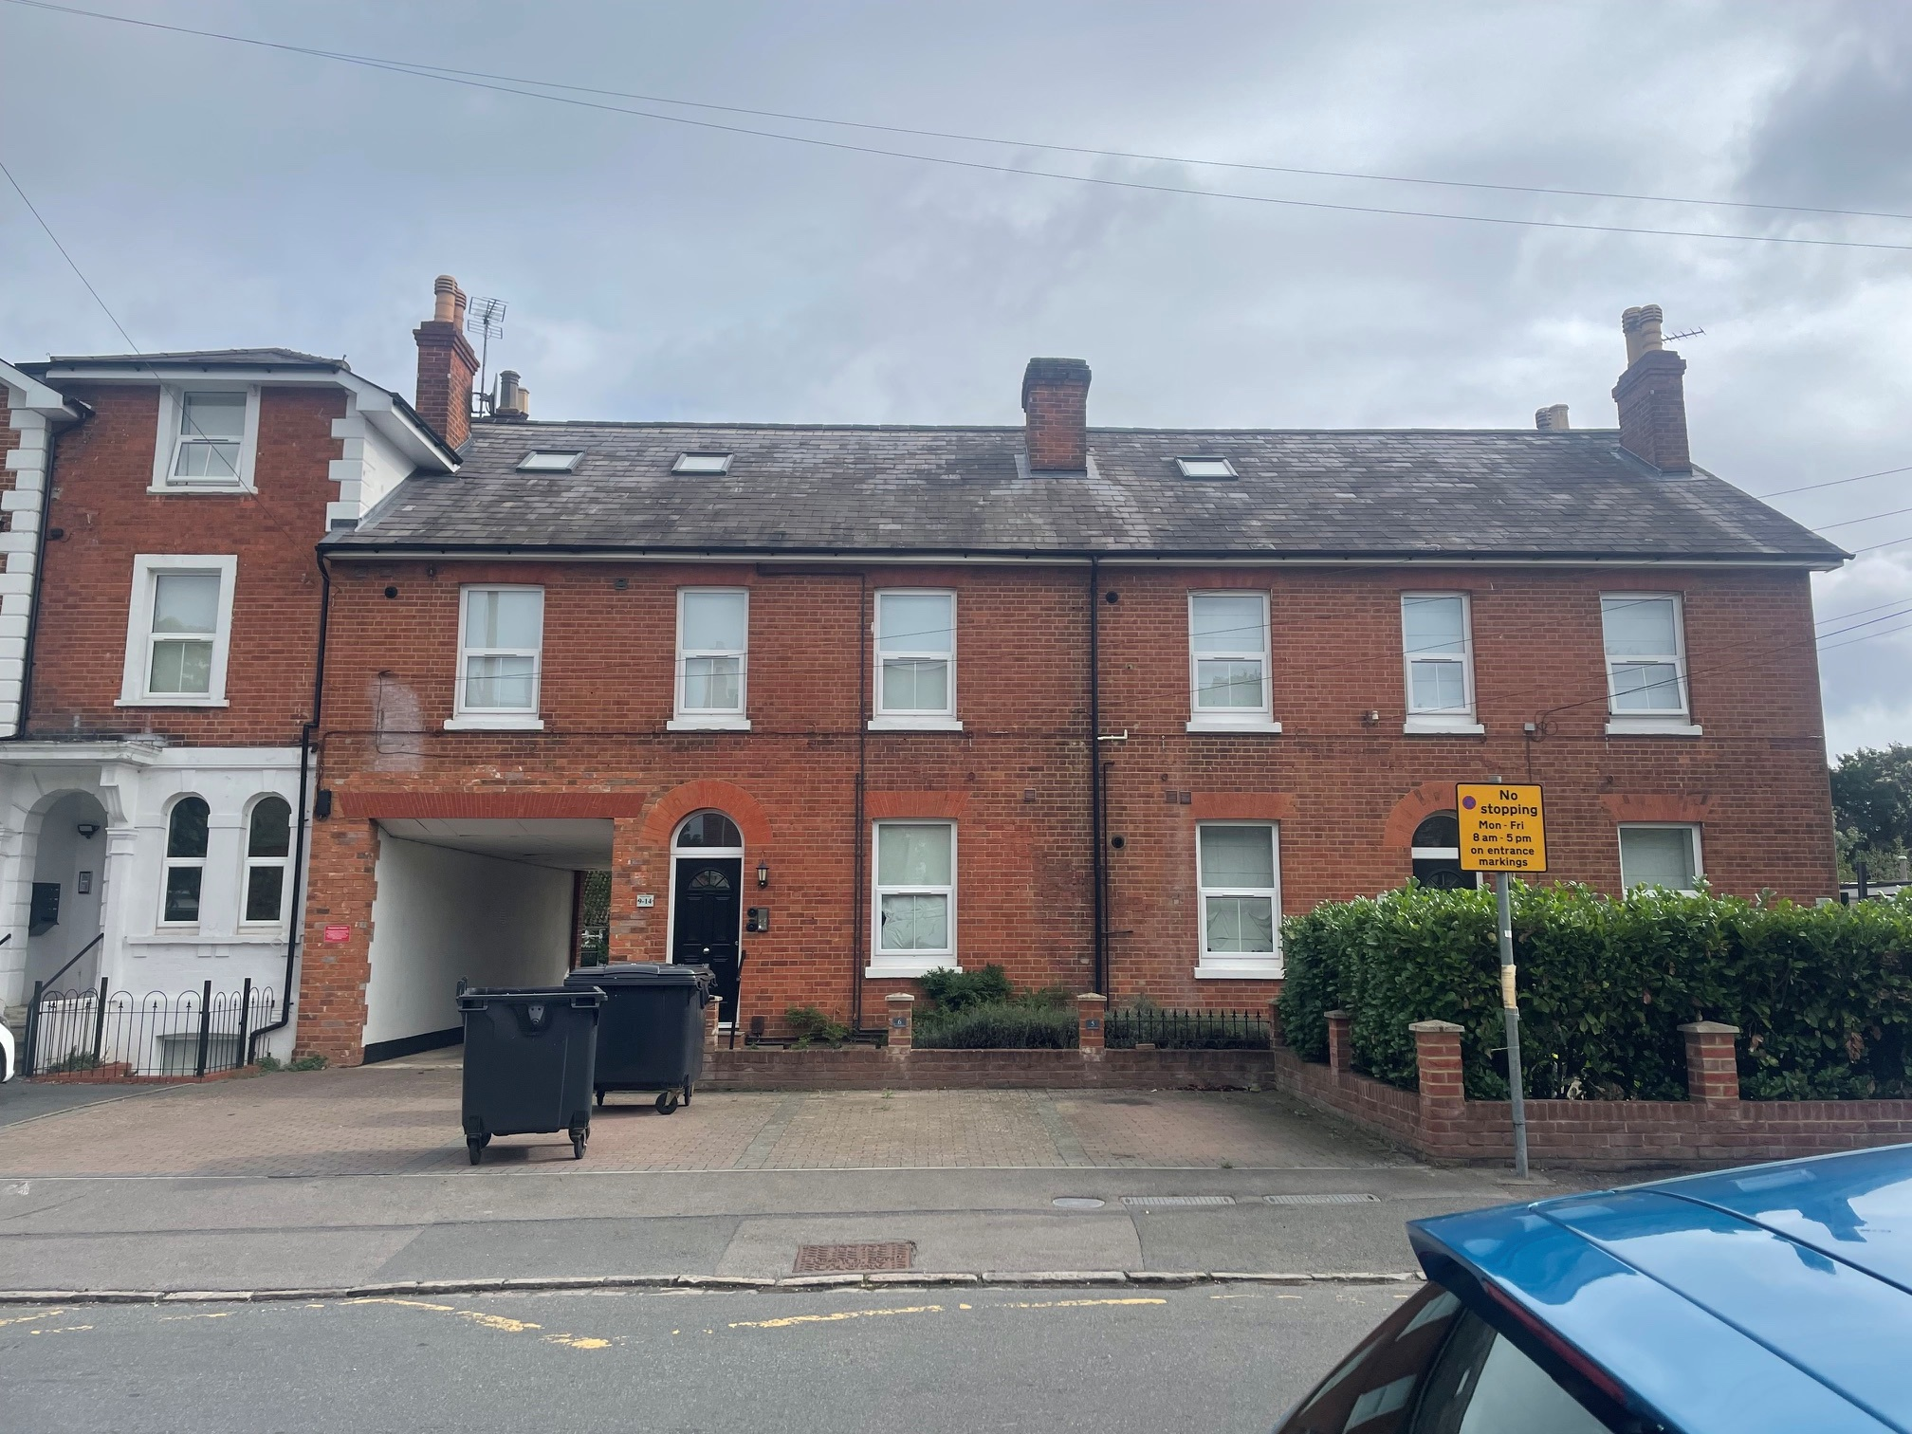
View of the application site from Brownlow Road

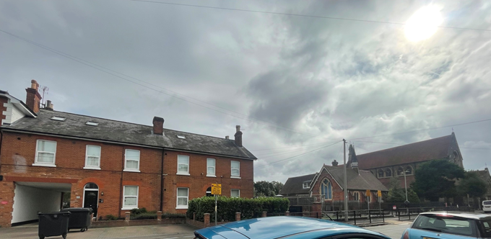
Application site and listed buildings of All Saints School and All Saints Church

The official listing descriptions of the listed buildings are read as below.
Church of All Saints (Church of All Saints, Non Civil Parish - 1155115 | Historic England)
“Details
SU 7072
13/458
DOWNSHIRE SQUARE
Church of All Saints
II
1865-74 Church of England. Architect J.P. St Aubyn. Daughter of St Mary's for expanding suburb. Early English style. Coursed Pennant sandstone rubble with Bath stone ashlar dressings, weathered buttresses and raised verges. Tiled roof. Five bay aisled nave. Short transept. Apsed east end. Narthex to west with high gabled porch with double entry of many orders and blind geometric tracery filled with carved monograms etc. Foiled rose window above. Intended spire not built.
Interior very good: painted arcade, very rich five window apse, mural mosaics to west.
Listing NGR: SU7040572976”

All Saints Infants School and Playground Area Railings to West (All Saints Infants School and Playground Area Railings to West, Non Civil Parish - 1248739 | Historic England)
“Details
The following building shall be added:-

READING BROWNLOW ROAD SU7073 934-0/12/10010 (East side) All Saints Infants School and playground area railings to west GV II Church of England infants school. 1865-6; by J.P. St Aubyn; extended late C20. Red brick in Flemish bond with blue brick bands and voussoirs and Bath stone windows. Clay plain tile roofs with gabled ends with moulded bargeboards supported on purlin ends and crested ridge tiles, the S.W. gable has terracotta patonce cross. PLAN: Two schoolrooms at right angles to each other forming a T-shaped plan with a porch and master's room or office in the S.E. angle. Victorian Gothic style. EXTERIOR: Single storey. Asymmetrical south front of 3 bays with gables to left and right, the right is smaller and projects further and in the space between a porch with a hipped roof, 3 lancets at the front and a pointed arch doorway at the side with plank door with wrought-iron hinges; set back behind the porch a smaller gable with 2 lancets; the main gables to left and right have large 3-light Geometric tracery windows with toothed brick pointed arches with blue brick voussoirs. Similar window in north gable of west range; the west side of this range 3 pairs of lancets between brick buttresses with set-offs and on the ridge of the roof a louvred bellcote set diagonally with a slate spire. At the rear, north, late C20 single-storey flat-roof extensions to the left of the gable. Including playground area railings to west with forked shafts and fleur-de-lis stanchions with scroll brackets. INTERIOR is virtually unaltered. The two schoolrooms are open to arch-braced roof trusses on corbels, the west schoolroom has boxed-in bell mechanism at apex of roof The master's room or office and the vestibule have exposed braced common-rafter roof structures. Pointed arch plank doors and sliding doors between the schoolrooms.

Listing NGR: SU7038973004”

Impact of proposal upon heritage asset(s)
The proposal is for the installation of signage and cameras for the existing car parking at the application site. There are two proposed types of signage, both of which have the same dimensions of 0.6m x 0.8m, to be put on the front elevations of the existing buildings and on the rear garden walls, the wall of the existing outbuilding and railings in the rear garden. The cameras would be mounted on the front and side elevation walls.
I raise no significant concerns about the size and locations of the proposed signage and cameras. However, I would recommend reducing the number of signs on the front elevations of the buildings, as they would result in little harm given the low number of existing signage on the street, the close relationship with the listed buildings and existing hedging to the front affecting visibility. I would also note that I am unable to understand the exact locations of the proposed signage on the elevations of the buildings.
Furthermore, I understand that the original front and rear garden character of the historic buildings in the application site has been altered through the relevant permissions with ref. PL/11/1231, PL/16/1420 and PL/17/0451, which I consider to have a negative impact on the character and appearance of the conservation area, as these applications brought the car park use and associated hard standing.
Downshire Conservation Area Appraisal states “This is not generally an issue with regard to the overall character and appearance of the conservation area, except at the main road entrances to the conservation area as a consequence of their function.” about ‘Street Clutter’ and “Street lighting columns, signage and street furniture are modern, and this is another area with considerable potential for improvement.” in the conservation area.
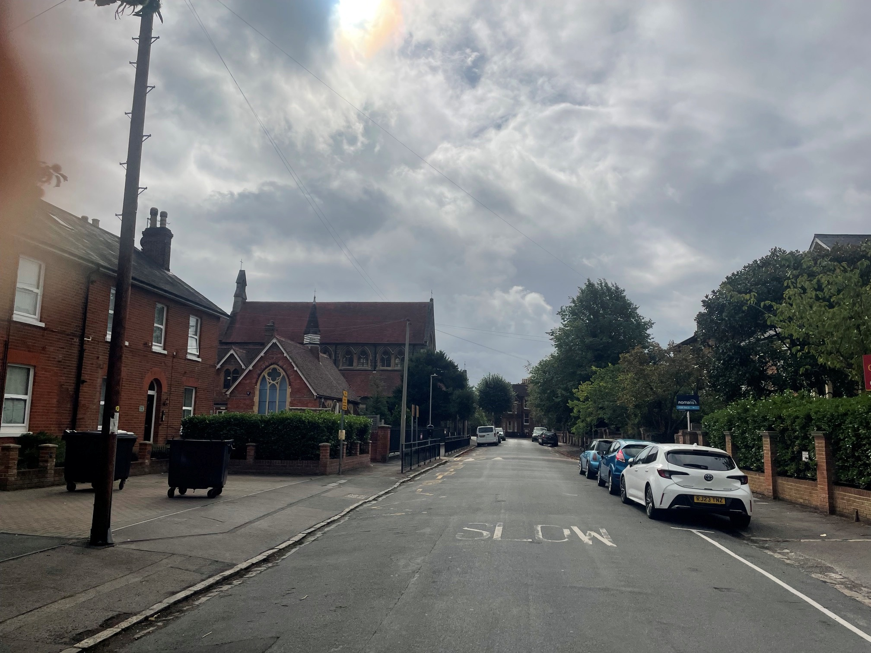
View of Brownlow Road looking south – no noticeable signage

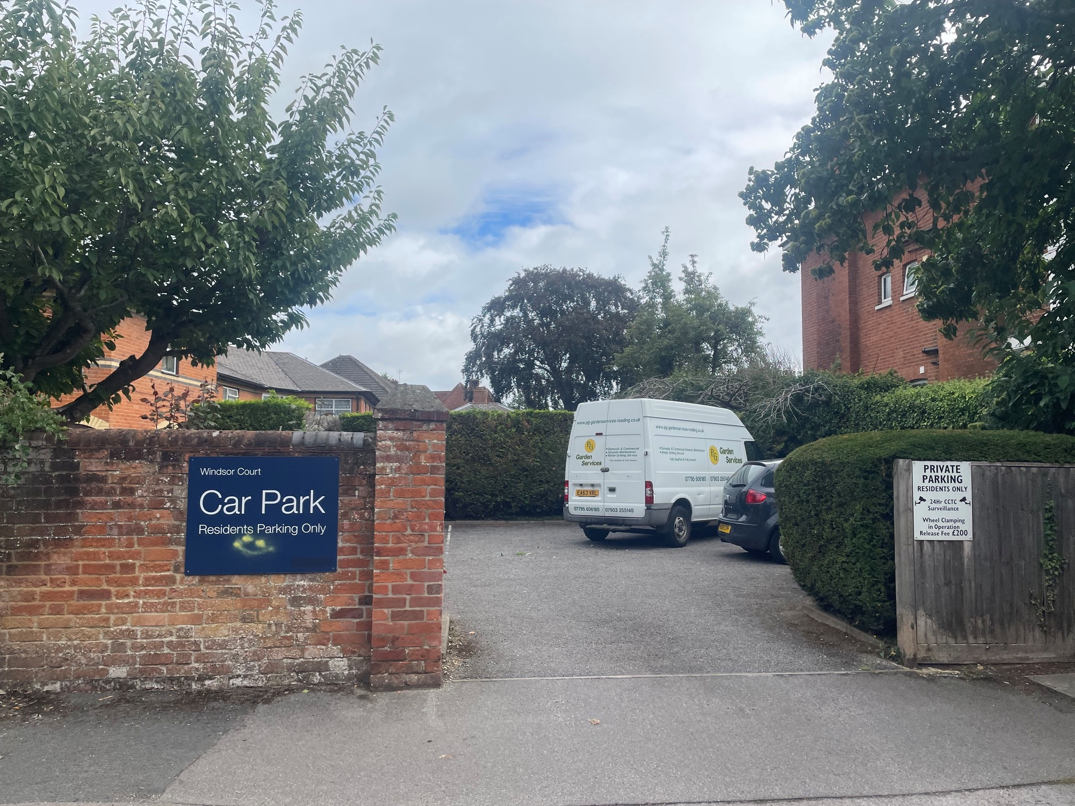
Only these two signages as shown on the photograph above are noted on Brownlow Road.
Therefore, to prevent street clutter and preserve the existing appearance of the street as much as possible (with minimum new elements), I recommend the number of signs proposed for the front be reduced to comply with the aforementioned local and national policies.
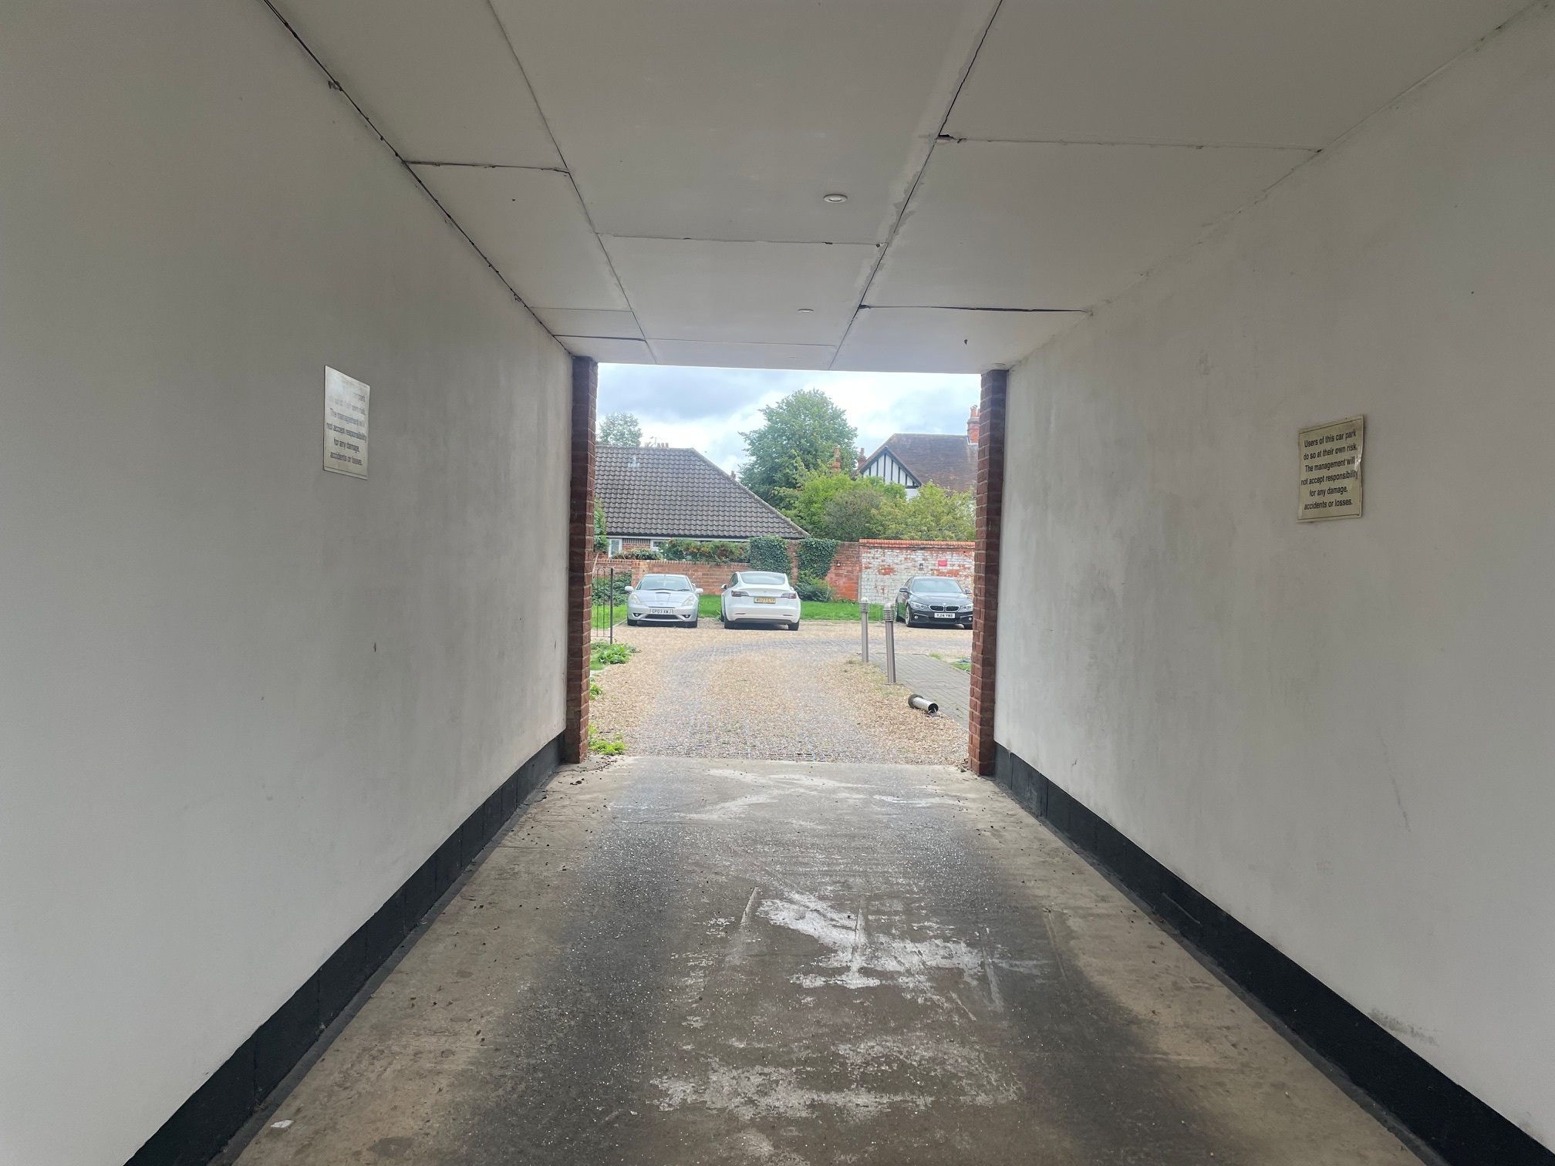
Signage on the walls of the driveway

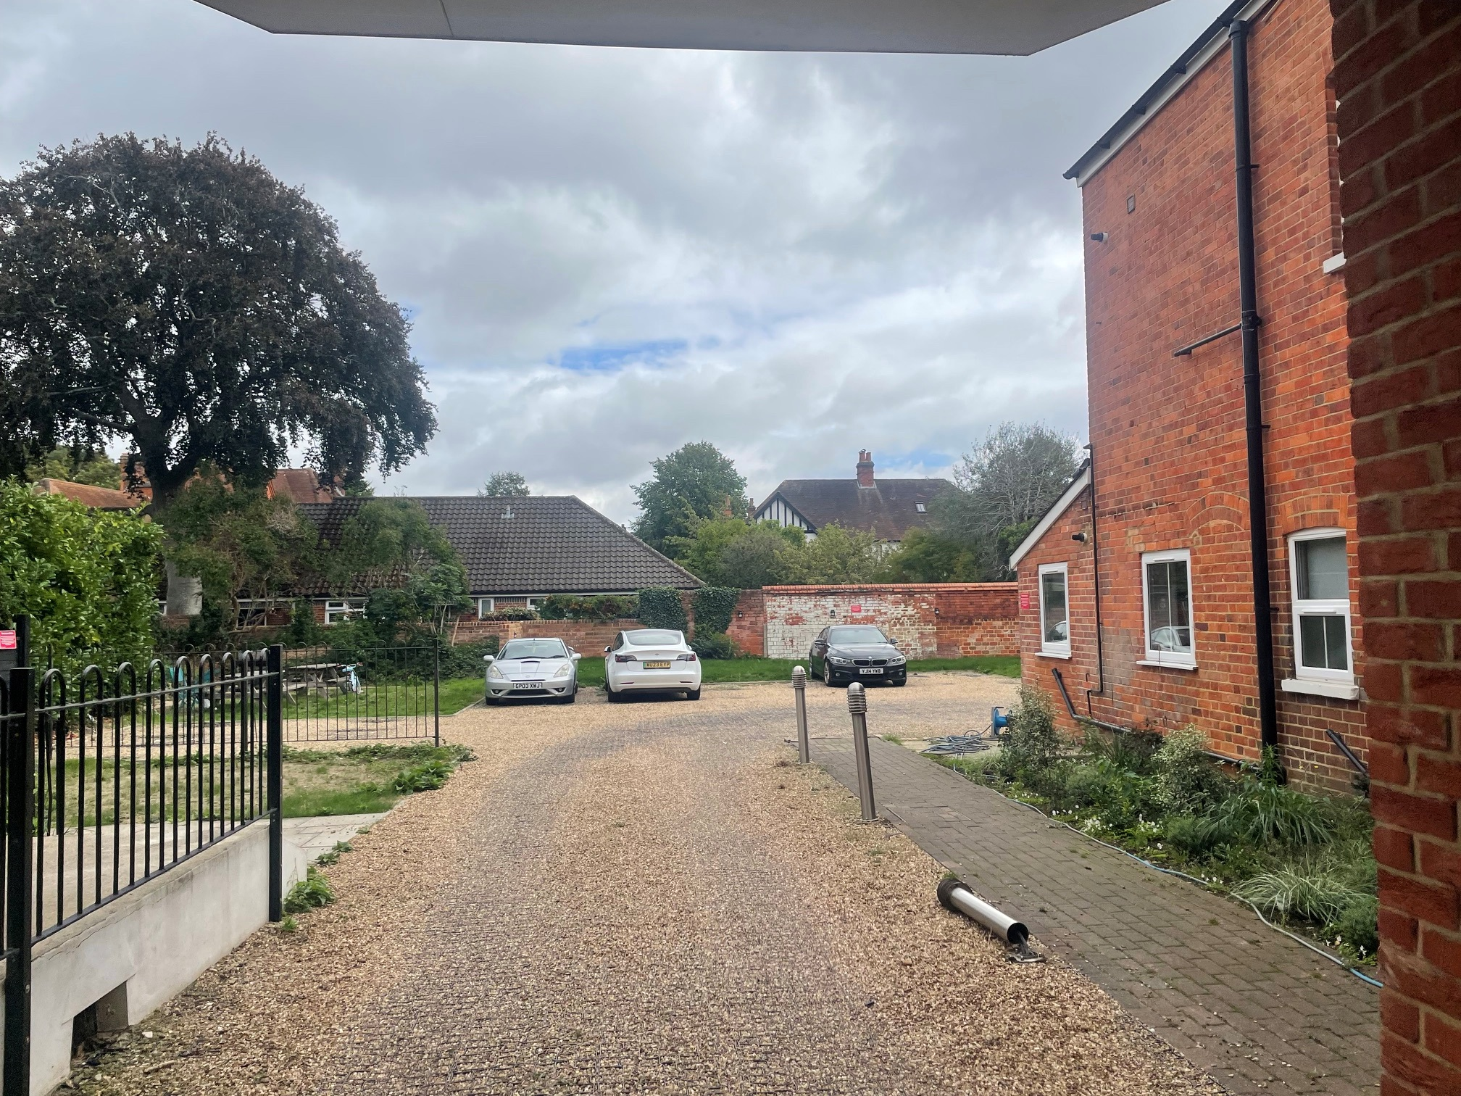
Views of the existing car park (above and below)
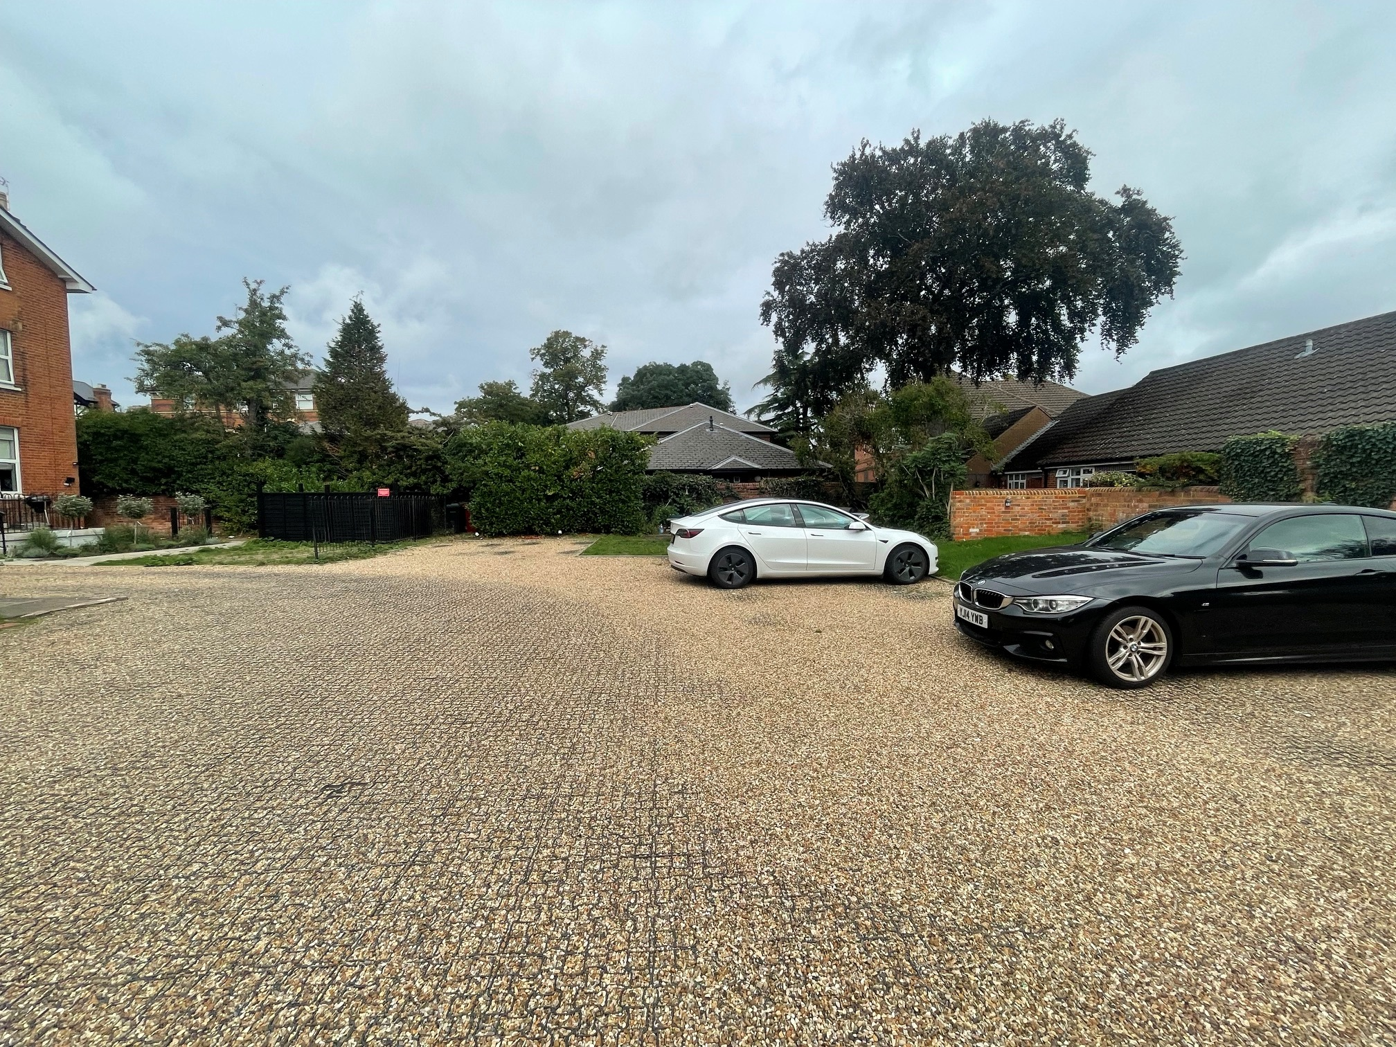
Conservation response
No objections
No objections subject to conditions attached
Clarification required
Object

Contact details
Buju Can Cetin, Conservation Officer
Burcu.CanCetin@reading.gov.uk

