CONSERVATION

Memo
To: Marcelina Rejwerska
From: Buju Can Cetin, Conservation Officer
Date: 15/09/2026
Re: Conservation Officer response
Application Number: PL/26/1132 AND PL/26/1133
Application Type: Householder planning application AND Listed building consent
Address: 86 LONDON STREET, READING, RG1 4SJ
Proposal: Installation of En-suite Shower Rooms/WCs to First and Second Floor Front and Rear Bedrooms, Including Mechanical Ventilation and Drainage Works, and the Erection of a Detached Timber Outbuilding at rear garden (for both applications)

Summary
Objection and Suggested Reasons for Refusal PL/26/1133 (LBC)
REASON FOR REFUSAL - The proposed en-suite shower rooms/WCs to the first and second floor bedrooms, including mechanical ventilation and drainage works by virtue of their detrimental impact on the historic plan form, hierarchy of rooms, loss of historic fabric, harm to retained fabric, and unsympathetic design, would harm the character and special architectural and historic interest of the listed building. The application fails to demonstrate convincing justification and any heritage or public benefit to outweigh this harm. As such, the proposal fails to meet the Policies HE4, HE5 and HE6 of the NPPF (2026) and Policy EN1 of the Reading Borough Local Plan (2019).

Relevant policies and legislation
From the point of view of the historic environment, the main statutory tests are set out within the Planning (Listed Buildings and Conservation Areas) Act 1990. Sections 16(2) and 66 require that special regard be given to the desirability of preserving listed buildings, their settings or any features of special architectural or historic interest which they possess.
Section 72(1) of the Planning (Listed Buildings and Conservation Areas) Act 1990 also requires the Council to pay special attention to the desirability of preserving or enhancing the character and appearance of designated Conservation Areas.

National Planning Policy and Guidance
The NPPF (2026) outlines government policy, including its policy in respect of the historic environment. Chapter 20 of the NPPF 'Conserving and enhancing the historic environment' sets out the Government's high-level policies securing the conservation of heritage assets and making decisions on development proposals.
Policy HE4: Securing the conservation of heritage assets recognises heritage assets as irreplaceable resources and requires their conservation, including any contribution made by their setting in a manner appropriate to their significance. A heritage asset or its setting should be supported with a use consistent with their conservation together with the asset’s contribution to sustainable communities, local economies, and local character and distinctiveness. Proposals should avoid harm to heritage significance wherever possible and, where harm cannot be avoided, minimise it. Any harm to or loss of a designated heritage asset’s significance, including harm arising from development within its setting, must be supported by a clear and convincing justification.

Policy HE5: Assessing effects on heritage assets requires the potential impacts of the development proposals on the significance of the assets to be identified with regard to positive effects, no effect, harm and total loss of significance, and decision-makers’ satisfaction that assessments accurately reflect the effects as stated below:
“a. Have a positive effect, which is where the significance of a heritage asset would be enhanced, or better revealed; or
b. Have no effect on the significance of a heritage asset; or
c. Result in harm to the significance of a heritage asset, either from work affecting the asset itself or from development within its setting. The degree of harm should be identified: substantial harm would occur where the development proposal would seriously affect a key element of the asset’s significance; or
d. Cause the total loss of the significance of a heritage asset.”
This policy also requires development proposals with heritage impacts to be accompanied by an assessment of significance and potential impacts.

For the Proposals affecting designated heritage assets, Policy HE6 states:
“1. When considering the potential effect of a development proposal on the significance of a designated heritage asset, substantial weight should be given to the asset’s conservation (and the more important the asset, the greater the weight should be). This is irrespective of whether any potential effect amounts to a positive effect, harm, substantial harm, or total loss of its significance.”
2. Development proposals which would have a positive effect on a designated heritage asset should be supported.
3. Any harm to a designated heritage asset will be a matter of considerable importance and weight. which should be dealt with in accordance with paragraphs 4 to 6 of this policy.
4. Where a development proposal would harm the significance of a designated heritage asset the effect on the asset and its significance should be weighed against any public benefits resulting from the proposal.
5. Where a development proposal would cause substantial harm to, or the total loss of, the significance of a designated heritage asset, consent should be refused unless it can be demonstrated that the harm is necessary to achieve substantial public benefits that outweigh the harm or loss.”

Similarly, for Conservation areas, Policy HE9 states
“1. Development proposals within or affecting the significance of conservation areas should:
a. Retain and conserve buildings and other features which make a positive contribution to the character or appearance of the conservation area where possible; and
b. Consider the area’s special architectural or historic interest (as identified as part of the designation of the conservation area) in the design of development.
2. Not all elements of a conservation area will necessarily contribute to its significance. Where a development proposal would result in the loss of a building or other element which contributes to the character or appearance of a conservation area that is desirable to conserve, the assessment of impact should take into account the relative significance of the element affected and its contribution to the significance of the conservation area as a whole, and the effects of this considered in accordance with policies HE5 and HE6.”

National Planning Practice Guidance (NPPG) on Historic Environment provides context to the NPPF. NPPG defines ‘public benefits’ from a development that deliver economic, social or environmental objectives as described by Paragraph 17 of the NPPF while “examples of heritage benefits may include:
- sustaining or enhancing the significance of a heritage asset and the contribution of its setting
- reducing or removing risks to a heritage asset
- securing the optimum viable use of a heritage asset in support of its long term conservation”

Local Planning Policy and Guidance
Policy EN1 ‘Protection and enhancement of the historic environment’ of the Reading Borough Local Plan 2019 sets out the Council’s aspirations for the historic environment. The policy requires that all proposals to protect and, where possible, enhance the significance of heritage assets and their settings, historic character and local distinctiveness of the area in which they are located. It echoes the NPPF by stating, “Applications which affect Listed Buildings will not have an adverse impact on those elements which contribute to their special architectural or historic interest including, where appropriate, their settings.”
Policy EN3 ‘Enhancement of conservation areas’ of the Reading Borough Local Plan also requires that development proposals within Conservation Areas contribute positively to local character and distinctiveness.
Policy EN6 ‘New Development in a Historic Context’ also requires new development to contribute to, respect and enhance the architectural and visual qualities of the historic environment characterised by heritage assets.
“When determining planning applications for new development, the following factors will be taken into consideration:
a. The positive contribution of the development to the existing historic townscape (scale, height, mass, proportion, plot size, street form, materials, significant vistas and views, and open space);
b. Sensitivity to historic context;
c. Reflection of borough-wide major heritage themes that contribute to local distinctiveness (e.g. patterned brickwork or former worker terraced housing);
d. Whether development promotes and/or improves access to previously undiscovered or neglected historic significance.”

Market Place/London Street Conservation Area Appraisal is also a material consideration in determining applications for development.

Other Guidance
Historic England Advice Note 2 – Making changes to Heritage Assets illustrates the application of policies set out in the NPPF in determining applications for Planning Permission and Listed Building Consent.
English Heritage’s “Conservation Principles” provides policy and guidance for the “sustainable
management of the historic environment”.

Relevant heritage assets
The application relates to a handsome three-storey (with basement) mid-terrace Grade II listed building at 86 London Street, the historic high street of Reading to London. Dating from the early to mid-18th century, the listed building is a typical Georgian townhouse with some details added in later periods, including Regency and Victorian styles. The site is situated to the west of London Street, where a large number of listed buildings line up, and is located within the Market Place/London Square Conservation Area, as illustrated below.
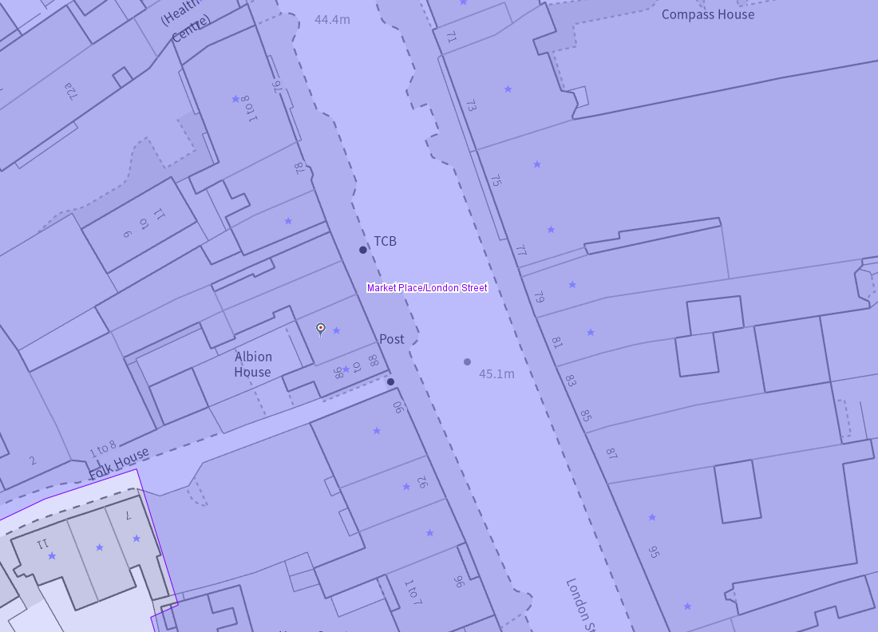
The application site (circled in red), listed buildings (purple starred) and the conservation area (light purple area)

Significance of heritage assets
The NPPF defines significance as the “value of a heritage asset to this and future generations because of its heritage interest.”

The interest may be architectural or historic, as set out in the Town and Country Planning (Listed Building and Conservation Areas) Act 1990 Section 1.

“Significance derives not only from a heritage asset’s physical presence, but also from its setting.” (NPPF, 2023)

Historic England assesses significance in a similar manner, referring to evidential, historic, aesthetic and communal values of a place.

The official listing of 86 London Street (86 London Street, Non Civil Parish - 1113527 | Historic England) read as below:

“Summary
Terraced house, now a shop and flats. Built in the early to mid-C18 with later alterations.
Reasons for Designation
86 London Street is listed at Grade II for the following principal reasons:
Architectural interest:
* as an early to mid-C18 townhouse which contributes to the character of an architecturally varied historic streetscape.
Historic interest:
* as part of the urban development of Reading’s ancient core.
Group value:
* the building is in close proximity to a large number of listed buildings and forms part of a strong historic grouping.
History
The first written record of Reading dates from the ninth century. Asser’s Life of Alfred (part of the Anglo-Saxon Chronicle) records a battle at Reading in January 871 between the Danes and the forces of King Ethelred and his brother Alfred, who would go on to become Alfred the Great. Reading is described in this account as ‘Readingum’, likely derived from ‘Readingas’, an Anglo-Saxon tribe whose name means ‘Reada’s people’ in Old English. By the time of the Norman Conquest of 1066, Reading had become a town of notable size. After Reading Abbey was founded in 1121, the town grew substantially, spurring cloth production, the establishment of the new Market Place, and what would today be known as London Street, an extension to the High Street that facilitated trade to and from London. By 1525, the town’s thriving cloth industry led Reading to become the largest town in Berkshire. In 1542, Henry VIII’s royal charter made Reading a borough. John Speed’s map shows that by 1611, both sides of London Street had been developed with continuous frontages for a considerable distance southward, beyond the modern junction with Crown Street-London Road. Several buildings which predate Speed’s map survive on London Street, some concealed behind later, brick façades. Following significant upheaval during the Civil War, the town flourished during the C18 and C19. Several developments during this period spurred further growth and prosperity, including the arrival of the Great Western Railway in 1840, improvements to the navigability of the River Kennet, and the growth of the local brewing industry. London Street became a fashionable part of town, especially after High Bridge was constructed over the River Kennet in 1788. The survival of many fine Georgian and Victorian buildings along London Street testifies to its prosperity during this period.
86 London Street was constructed in about the early to mid-C18, although it may have been altered in the C19. The building functioned as offices in the late C19. An ancillary building to the rear was demolished in the early 1990s and replaced with a new single-storey office extension, which was subsequently demolished. A connecting doorway between 86 and 88 London Street was inserted in the early C21. The building currently (2023) functions as a letting agency on the ground floor with private apartments above. It is also known as Albion House.
Details
Terraced house, now a shop and flats. Built in the early to mid-C18 with later alterations.
MATERIALS: tuck-pointed red brick laid in Flemish bond with timber and stucco dressings and clay tile roof coverings.
PLAN: a former terraced house of three storeys, now containing a shop (letting agents) on the ground floor and apartments above.
EXTERIOR: the main, east elevation faces the street and is three bays wide and three storeys high. The ground floor comprises, from left to right: two six-over-six sash windows with heavily moulded frames and an entrance doorway which has a moulded doorcase with two console brackets and a cornice. It contains a six-panelled door with brass door furniture beneath an elaborate, rococo-style transom light. A timber cornice separates the ground floor from that above. The first floor has four large Doric pilasters supporting a broad stucco entablature with metopes and a dentilled cornice. Between the pilasters are three six-over-six sash windows with moulded frames and keystones; simple geometric keystones to the outer sashes and a larger console keystone to the central sash. The second floor, or attic storey, has squat six-over-six segmental-headed sash windows with exposed sash boxes and a brick parapet with a stone coping. Behind the parapet is a tile-covered M roof. All of the sash windows to this elevation are flush with the brickwork. The basement has been painted white and contains two hopper windows behind iron railings.
The rear, west elevation is three bays wide with the ground and first floor painted white while the second floor is exposed red brick. On the first floor, there is a large 36-pane uPVC window to the northernmost bay and two eight-over-twelve timber sash windows to the other bays. The second floor is similar with a 36-pane uPVC window and two eight-over-eight sash windows.
Legacy
The contents of this record have been generated from a legacy data system.
Legacy System number:
39050
Legacy System:
LBS”

In addition to the listing description, during the Council’s officers’ site visit, it is noted that not only the external features of the listed building, but also the internal surviving elements reflect the Georgian design with Victorian additions: many plaster and timber mouldings such as deep cornices in high rooms (late 18th to end of 19th century) and wood cornices mirroring the design applied in spacious hall and window treatment, ceiling roses (in the late 19th century), and plain staircase with straight balusters and little carved decoration.

Although it has not been confirmed yet, because the building was listed in 1957, while planning history indicates that it had been in use as offices until it was sold. That is, due to the continuous use and information gathered from the planning history, it appears that the interior of the building still displays high significance without major alteration to the layout, plaster and timber mouldings and the use of period-detailed interior doors. The principal rooms, including the principal original bedroom on the second floor, contribute to the original character of the building, as seen in the following photographs.

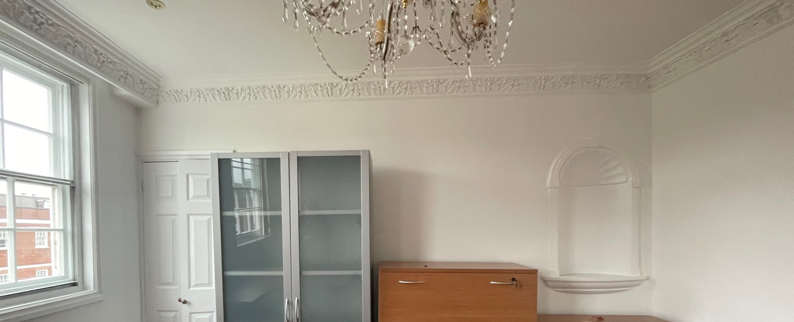

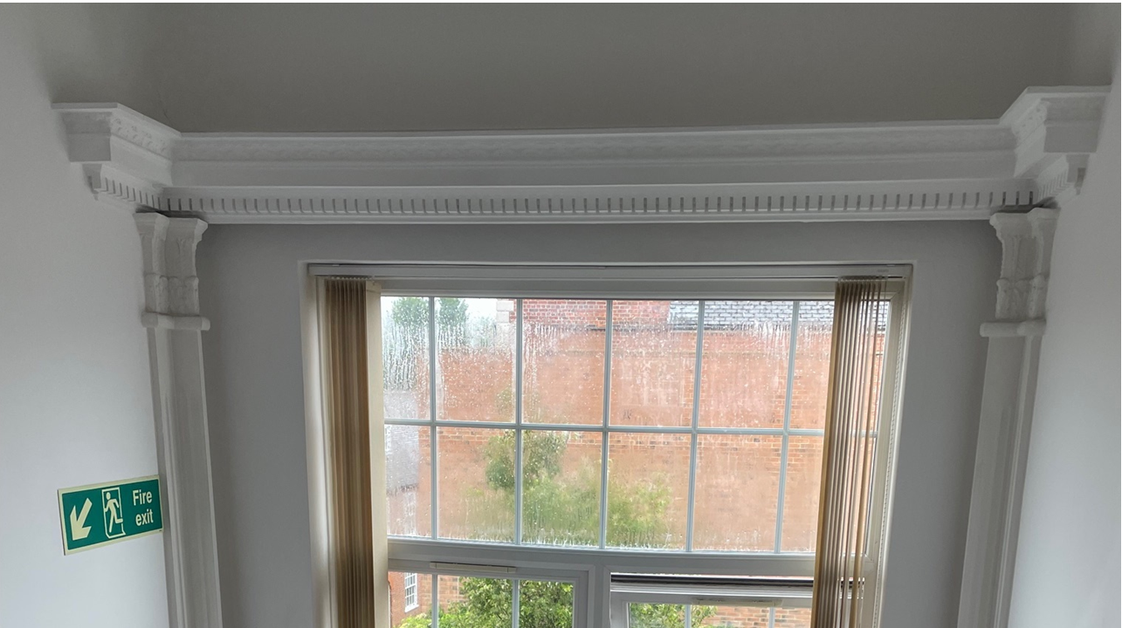

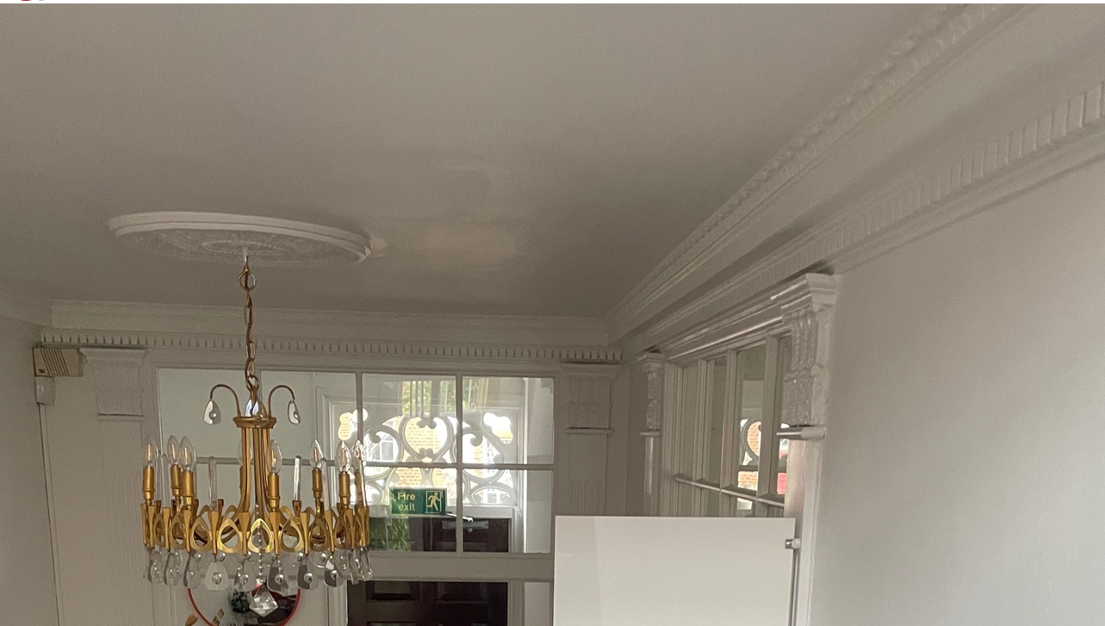

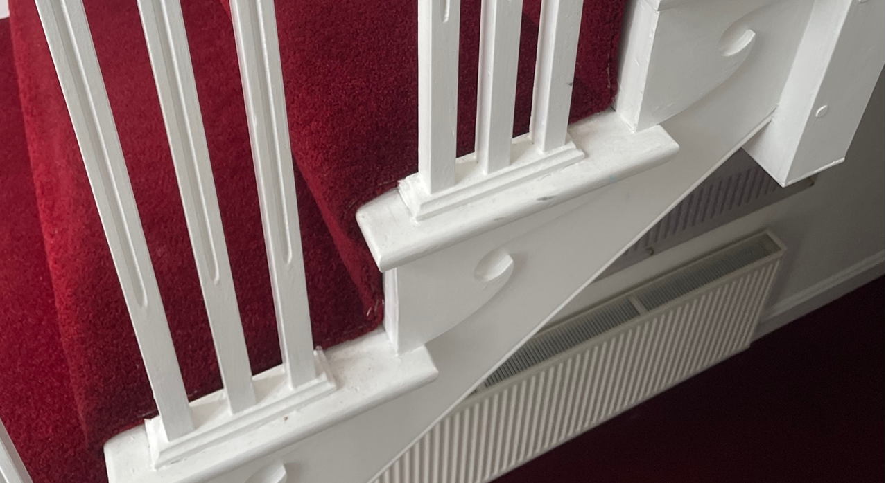

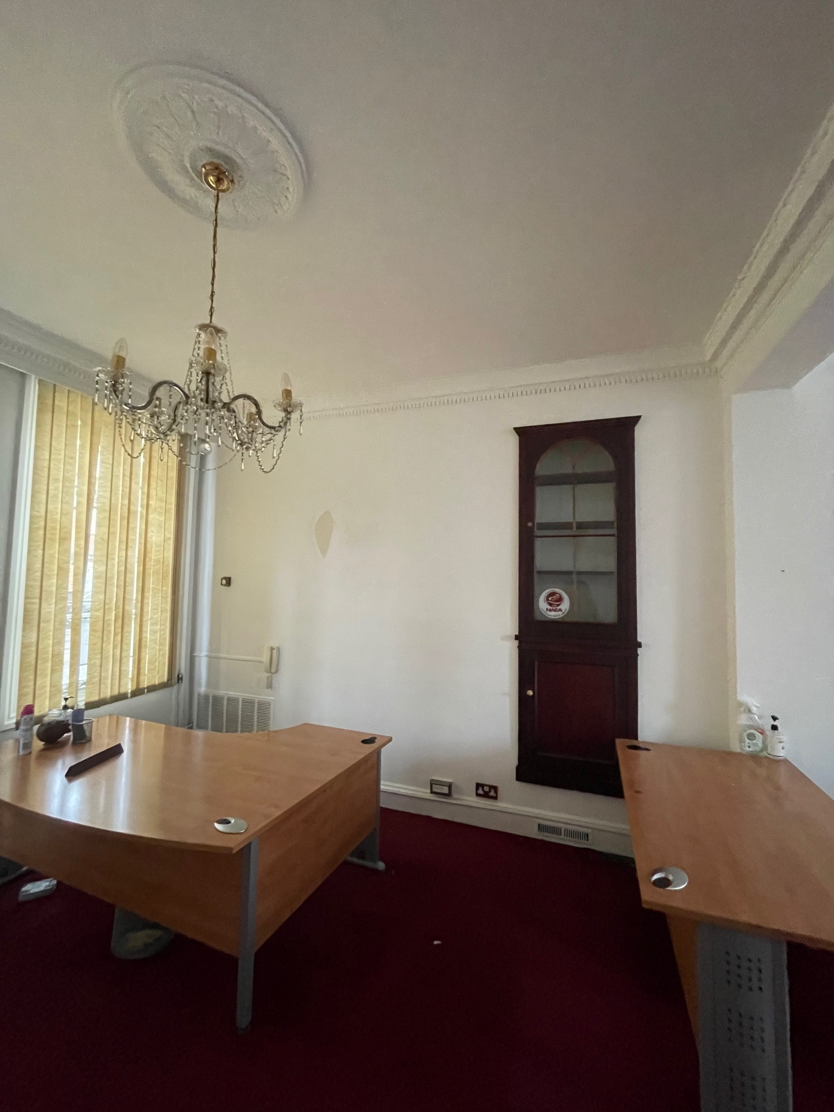

The relevant planning history of the site, among which the refused ones are noted below, includes
- Change of use to offices - 1953
- Lavatory accommodation – 1954
- Use for sale of antiques on ground floor - 1969
- Alterations - 1971
- Single storey office extension – Single storey office extension
- LBC to alter and extend office building – 1980 – REFUSED
- Single storey rear extension – 1989 – REFUSED
- Demolition of existing outbuilding and single storey rear extension for office accommodation – 1992 – REFUSED
- Single storey rear extension to be used as a board room – 1992 – REFUSED
- Retrospective consent for the demolition of a lean to structure and curtilage buildings – 2006
- Formation of a walkaway between 86 & 88 London Street - 2006
- Formation of hardstanding for use as a car park at rear – 2006 – REFUSED
- Installation of CCTV cameras to front of building – 2006
- Landscaping proposal to rear of properties: including hardstanding for parking, new access arrangements, additional foliage and alterations to boundaries - REFUSED
- Blocking up of interconnecting door between premises – 2015
- Change of Use from Office (E) to Residential (C3) (PL/25/0524 – FUL) and Change of Use from Office (E) to Residential (C3) comprising alterations to basement layout, new flooring to basement and ground floor, redecoration and new bike and bin store in rear garden (amended description) (PL/25/0525 – LBC) – GRANTED

The historic maps and photographs of the application site and subject building also provide information on the evolution of the character of the building in parallel with the planning history.

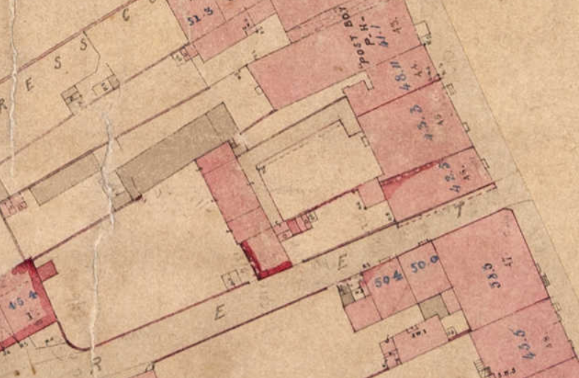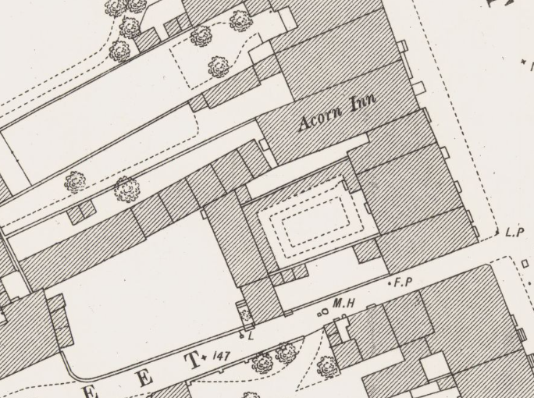
Historic Map of 1853 (Left) and the OS Map dated 1876 (pub. 1879) (Right)

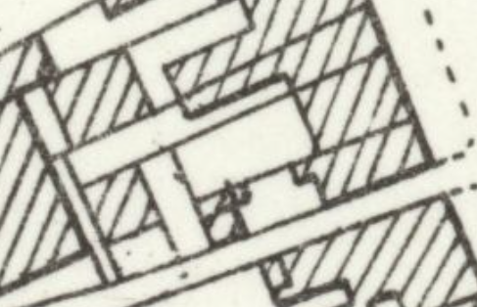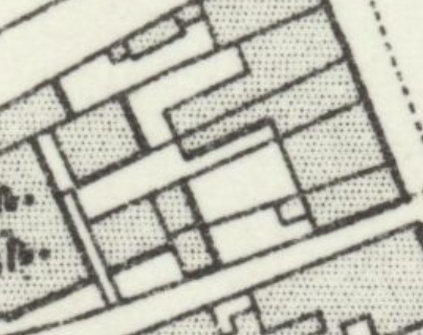
The OS Map of 1898 (pub. 1900) (Left) and 1909 (pub. 1912) (Right)

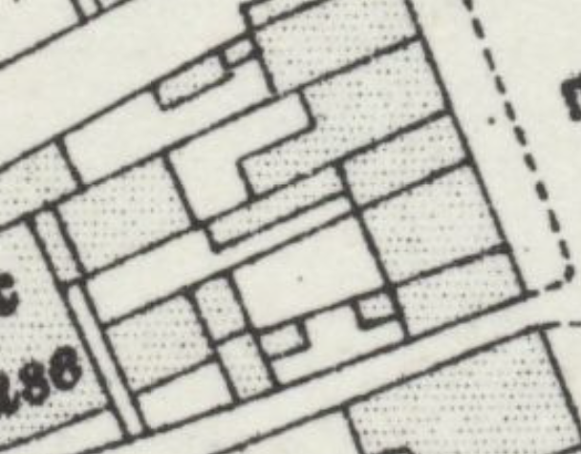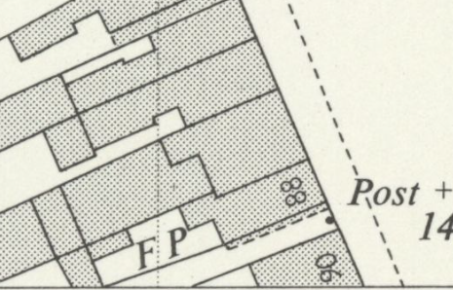
The OS Map of 1931-1932 (pub. 1934) (Left) and 1956 (pub. 1957)

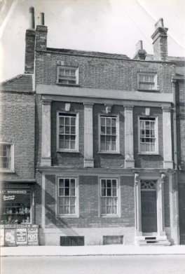
London Street, Reading. West side, c. 1935. Part of No. 88 (Albert George Bond, newsagent, tobacconist and confectioner); No. 86. 1930-1939 : photograph from the National Buildings Record, negative A44/2600 ((Reading Library’s Archive)

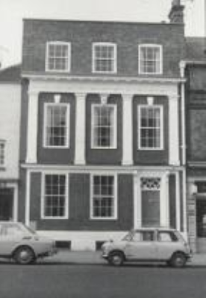
London Street, Reading, c. 1974. West side. No. 86 (offices). 1970-1979 : original filed at Dynix 1250889 (Reading Library’s Archive)

Compared with the 1930s photograph, and based on the granted permissions for the site, it can be considered that after the change of use to offices, the building had alterations to the attic floor and roof that increased height of the second floor, alterations to the windows and removal of chimneys adjacent to No. 88.
The historic maps also suggest that there was a rear extension to the main building, which was removed in the 1980s, affecting the rear elevation of the building. It should also be noted that the Council has not welcomed the additional elements to the rear elevation and hard standing in the rear garden.

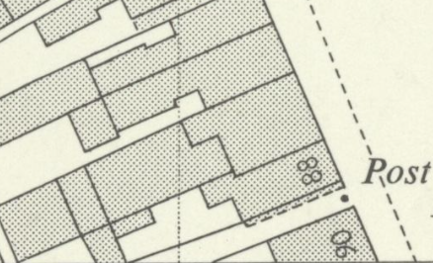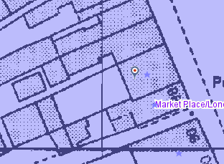
The OS Map of 1967 (Left) and Historic Map of the 1980s (Right – from the Council’s Historic Mapping Tool)

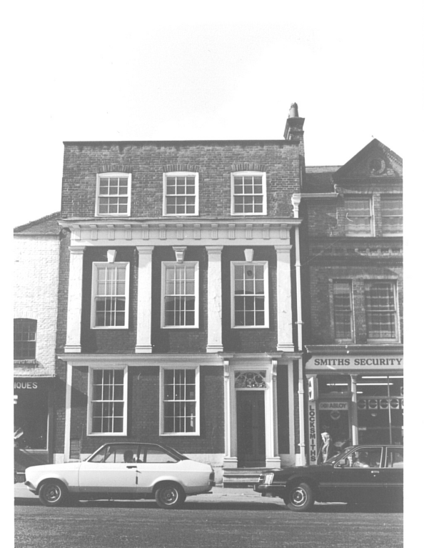
Undated photograph from the Council’s archive, possibly in the 1970s, as the antiques shop use was granted in 1969, same as the existing

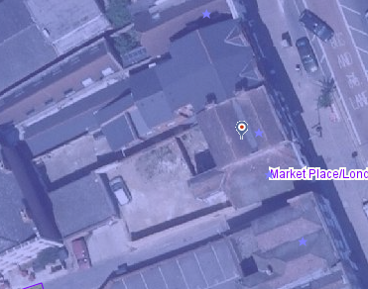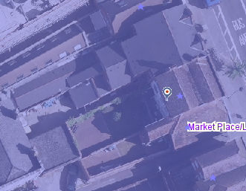
Aerial View of 2006 (Left), 2013 (Right), and 2025 (Below)

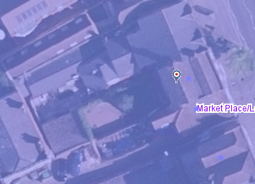

It is clear that the listed building and its curtilage have undergone some alterations, which resulted in changes both externally and internally. Apart from the uPVC windows to the rear elevation, these alterations appear to be sympathetic, while the internal layout of the Georgian house service rooms, kitchen is in the basement, dining and drawing room on the ground and first floors facing the front. As such, both externally and internally, the façade organisation, elements and features, the internal layout, elements and mouldings form the significance of the listed building, while its green rear garden also contributes to the special interest of the building.

The application site lies within the Character Area 1 – London Street, which is described by the conservation area appraisal: “In the late 18th and 19th century, London Street was one of the fashionable parts of town and many of the elegant houses which lined either side of the road still survive. Though altered, no longer in residential use and devoid of their spacious rear gardens, these are the properties which today add grandeur to the streetscene.”

In the appraisal, among the positive and negative aspects in this character area, the ones below deserve attention:

“Character Area 1: Features that make a positive contribution to the historic character and appearance of the conservation area:
• The unusual width of the street, which rises gently from the River Kennet with a slight eastward curve, creates a visually interesting townscape;
• The high concentration of historic buildings on either side, many of which are listed;
• The mix of architectural styles and periods with an overall majority of late 18th/19th century buildings;
• The predominance of brick with occasional use of stone and stucco;
• The strong vertical rhythm created by regular bays of aligned windows and doors;
• Side alleys and streets which afford glimpses and views to east and west;
• Prevalence of white-painted vertical sliding sash windows
• The variety of historic architectural detail including pedimented doorcases, iron balconies and railings, timber shopfronts;

Character Area 1: Features that have a negative impact on the historic character and appearance of the conservation area:
• Vacant commercial and retail space;
• Loss of original windows and front doors to modern replacements;
• Loss of original slate roofs and other architectural features such as gates and railings; • Plethora of signs and other street furniture, some of which may be redundant;
• Garish shopfronts that do not respect the host building e.g. no. 45 London Street;”

Impact of proposal upon heritage asset(s)
External Works
The proposal seeks permission to erect an outbuilding in the rear garden on the existing hard surface, close to the rear boundary wall. I noted that the submitted block plan shows a bike store and bin store whose details were approved under PL/26/0460. The rear elevation of the listed building includes proposed extractor fans/grilles associated with the proposed bathrooms.
The proposed outbuilding would have a flat roof with a height of 2.5m, clad with timber with uPVC fenestration. The proposed natural-looking timber weatherboarding would be appropriate for the listed curtilage. However, plastic/low-quality material windows in the listed curtilage and in the Market Place/London Street Conservation Area would materially detract from the character and appearance of the area. The additional massing at the application site and the use of inappropriate fenestration materials would cause little harm.
The proposed extractor fans and grilles to the front would replace the existing ones and therefore would be acceptable. To the rear, they would occupy limited space; however, given the impacts of the associated internal works, I am unable to support them.
I would like to leave the final judgment to the planning officer regarding the proposed external works.

Internal Works
Following a pre-application process, which advised that four en suites in each and every room on the upper floors of the listed building would not be acceptable, I am surprised to note that the same scheme has been submitted. I noted from the submitted statements that further investigations have been made, and the existing ductwork for ventilation hidden in the historic fabric supports the proposed en-suites.
It should be noted that the private needs (page 36 of the Heritage Statement) of the occupiers of the listed buildings should not be imposed on the historic significance of the building. This is a totally irrelevant justification for the proposed four bathrooms, although the Council suggested a shared bathroom on every floor (2 in total) for family use during the pre-application process. The Council cannot support the proposed ensuites and associated services – pipework, and here are the wider comments on the proposed internal works.
The Council’s officers would not assume that all of the internal decorative plasterwork is original to the 18th century building. There are probably several phases of alteration similar to the ones on the exterior of the listed building.
The most interesting element is the enriched cornices. It is clearly traditional in character, with a repeating foliate/acanthus-type ornament, but the very regular repeated panels and relatively crisp modelling suggest it may be a later historic addition or replacement, quite possibly 19th century. However, that does not make it insignificant, as a Victorian alteration to a Georgian building can itself be important historic fabric. Similarly, 20th-century repairs and replacements can also contribute to the significance of the designated heritage asset.
The existence of a ceiling rose also forms a consistency that the rooms and interior of the building as a whole have the same decorative scheme reflected via its ceiling plasterwork and timberwork seen on the window surrounds.
There is a certinity that the spotlights are modern and their insertion means ceiling has been disturbed before. The flat, uniform ceiling surface and the chandelier with electric installation suggest that there have been later additions and alterations to the ceilings of the room. However, their extent is not known, as no evidence is found in the relevant planning history or historic research. Therefore, the building has internal ceiling decorations with an uncertain date. However, given the features of the plasterwork and timberwork decoration, the history of the building could be interpreted as below:
Early-mid 18th century – main structure and probably some surviving joinery arrangement; the rococo-style entrance transom described in the official listing may belong broadly to the Georgian Period.
Later 18th century/Early 19th century – possible high-quality neoclassical redecoration, potentially including some of the enriched cornices of the interior.
19th century – quite substantial remodelling, probably including at least some of the dentilled entablatures, foliate pilasters and perhaps the naturalistic cornices upstairs.
20th century – Office adaptations, alterations to the second floor, possibly both external and internal; the decorative plasterwork influenced or replicated by the original. Ceilings to be repaired or renewed. Office adaptations resulted in unsympathetic uPVC windows on the rear elevation and the installation of electricity, alarms, modern lights, fire signage, and other servicing.
The submitted information in the Heritage Statement states that the existing decorative cornices are understood to be no more than approximately 50 years old, based upon the opinion of a plasterer. However, no documentary or physical evidence has been provided to justify this. The building, although it has undergone some alterations, contains a range of enriched cornices, mouldings, other decorative plasterwork and timberwork which appear to form part of a successful decorative scheme.
Therefore, there is insufficient evidence to establish that this is late 20th century fabric, and its form, variety and architectural relationship with other internal decorative elements give reasonable grounds to consider that at least some may be historic.
Putting an ensuite into every upper floor room of an early-mid 18th century listed townhouse would change the character of the upper floors substantially. The concern is not just whether the existing decorative features are 50 years old but the cumulative impact of the proposed internal works on the historic plan form, room proportions, decorative pilaster work, floors and ceilings and the amount of new plumbing, drainage, ventilation and servicing required. Creating a bathroom enclosure in every bedroom would result in repeated subdivision of those spaces, and the hierarchy of rooms would be lost.
Regarding the existing ductwork for ventilation, I would like to add that the existence of this does not necessarily provide routes for foul-water drainage from WCs, waste from showers and basins, hot and cold-water supplies or any required alterations to floors/joists to achieve drainage falls. It is acknowledged that using the existing ventilation service could reduce physical harm to the historic fabric; however, the existing proportions, spatial character, and plan form would still be negatively impacted.
Therefore, the argument that the cornices are modern, therefore the works are harmless, or the existing ventilation system can easily be converted into service routes for bathrooms would not establish that the historic room, plan form, floor structure, adjoining plasterwork, and other internal features such as niches (as shown on the photos and plans) have low significance.
The building already has permission to change from offices to a single-family dwelling. Therefore, its viable long-term use has already been established without needing to demonstrate that every upper-floor room requires its own ensuite. Therefore, the former heritage/public benefit weight does not apply, but the current application is only for the convenience of the future occupiers and should not automatically inherit the public benefits associated with the approved change of use.
To conclude, the proposed en-suite shower rooms/WCs to the first and second floor bedrooms, including mechanical ventilation and drainage works by virtue of their detrimental impact on the historic plan form, hierarchy of rooms, loss of historic fabric, harm to retained fabric, and unsympathetic design, would harm the character and special architectural and historic interest of the listed building. The application fails to demonstrate convincing justification and any heritage or public benefit to outweigh this harm. As such, the proposal fails to meet the Policies HE4, HE5 and HE6 of the NPPF (2026) and Policy EN1 of the Reading Borough Local Plan (2019).

Conservation response
No objections
No objections subject to conditions attached
Clarification required
Object

Contact details
Buju Can Cetin, Conservation Officer
Burcu.CanCetin@reading.gov.uk

