DELEGATED APPLICATION REPORT
Ward: Battle Ward
App Ref: PL/26/0824 Full planning permission
Address: BLAZES FIREPLACE CENTRE, 346-348 OXFORD ROAD, READING, RG30 1AQ
Proposal: Proposed new ground floor side windows and doors and rear windows to rear of existing shop
Applicant: Mr Henry Bellamy-Rosser
Received date: 22/06/2026
Target Decision date: 10/09/2026 (EXT)
Case Officer: Chukwudi Onwudinanti

1. SITE DESCRIPTION

The application site comprises a two-storey plus roof-level end-of-terrace mixed-use property fronting Oxford Road. The ground floor is vacant commercial space (formerly occupied by the Blazes Fireplace Centre), with residential accommodation at upper-floor level. The application relates to the ground floor only.

The property occupies a prominent frontage on Oxford Road, within the Oxford Road West District Centre. Oxford Road is characterised by a mixture of commercial, residential and other town centre uses.

The building has an extended ground-floor footprint, incorporating single-storey elements to the rear. A narrow access/service route runs along the side and rear of the property. This is enclosed by the application building, neighbouring buildings, brick boundary walls, garages and other ancillary structures and has a predominantly functional/service character.

The principal Oxford Road elevation comprises the existing commercial shopfront at ground-floor level with residential windows above and dormer windows within the roof.

The property is not a listed building and is not situated within a Conservation Area.

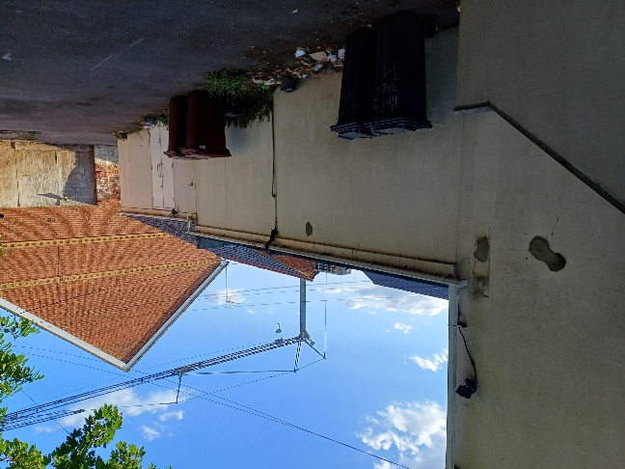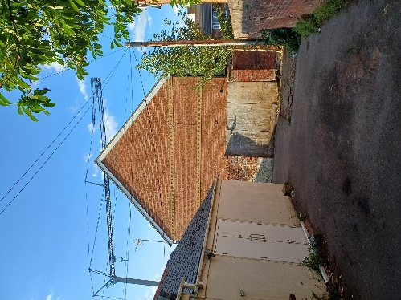
Site Photos

2. PROPOSAL AND SUPPORTING INFORMATION

The application seeks planning permission for alterations to the existing vacant ground-floor commercial premises comprising:

- three new windows to the side elevation;
- two new doors to the side elevation; and
- the reinstatement of three windows within the rear elevation which have previously been blocked up.

The application proposes no change of use. The existing ground-floor unit would remain within Use Class E. The purpose of the proposed alterations is to provide additional natural light and ventilation to the commercial accommodation and provide direct access between the shop and the existing side/rear access area.

The proposed windows would be aluminium framed and double glazed, and the proposed doors would be timber.

The principal Oxford Road elevation would remain unaltered.

Plans and Documents

Received 22/06/2027
Drawing No. P01 – Site Plan Proposed
Drawing No. P02 – Existing Plans, Sections and Elevations
Drawing No. P03 – Existing Elevations
Drawing No. P04 – Proposed Sections, Plans and Elevations
Drawing No. P05 – Proposed Elevations
Planning/Design and Access Statement – DRK Planning, dated 20 June 2026

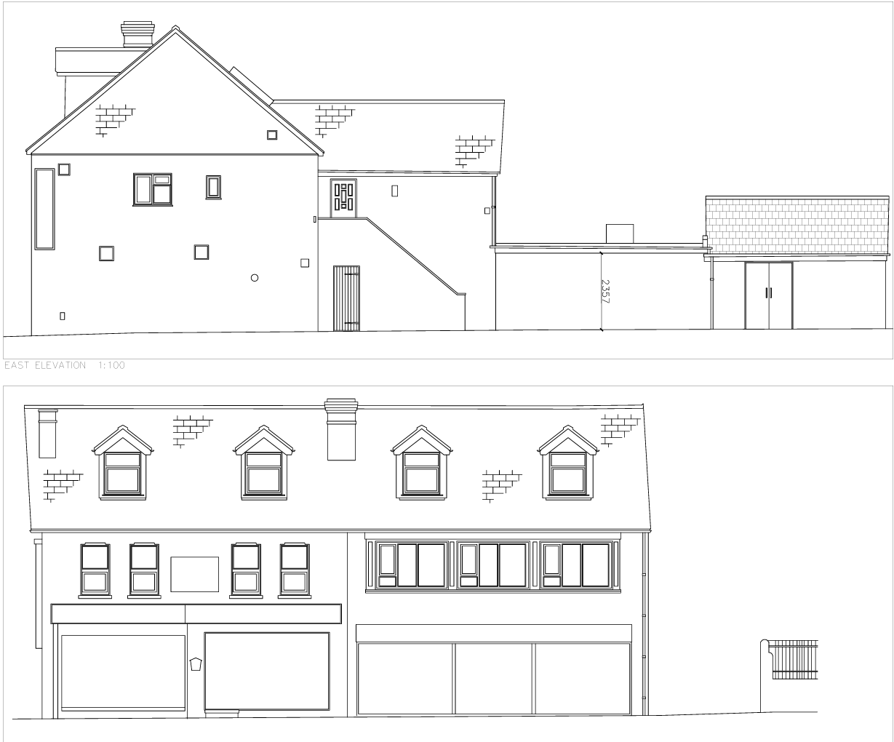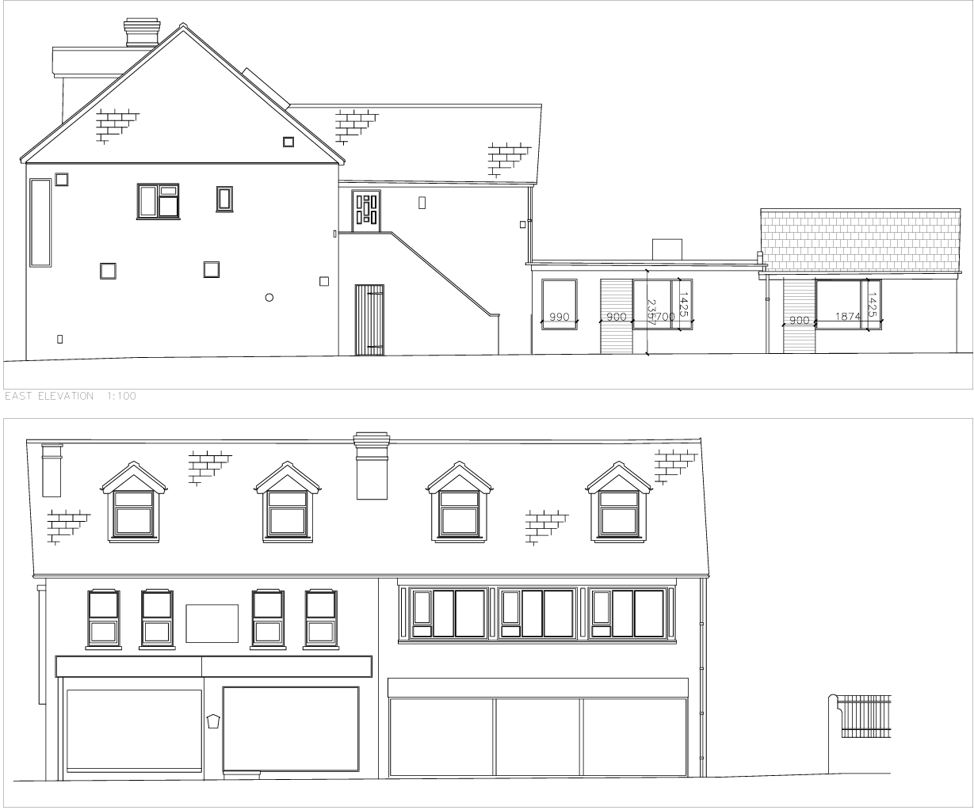
Existing and Proposed Elevations

3. RELEVANT PLANNING HISTORY

PL/17/0187
Conversion of first floor office and vacant rooms to self-contained apartment and internal alterations to existing first floor flat to create relocated bathroom.
Granted 17/05/2017.

PL/03/0553
Change of use of part first floor and second floor from retail showroom/storage to two x one bedroom flats.
Granted 09/06/2003.

PL/89/1145
Erection of external fire escape stairs, three dormer extensions to second floor and alterations to front elevation.
Granted 07/04/1989.

4. CONSULTATIONS
Site Notice was put up on 31/07/2026

Equality Act 2010:
In determining this application, the Council is required to have regard to its obligations under the Equality Act 2010. However, there is no indication or evidence (including from consultation on the application) that the protected groups identified by the Act have or will have different needs, experiences, issues and priorities in relation to this particular planning application. Therefore, in terms of the key equalities protected characteristics it is considered there would be no significant adverse impacts as a result of the development.

5. LEGAL AND PLANNING POLICY CONTEXT

Section 38(6) of the Planning and Compulsory Purchase Act 2004 requires that proposals be determined in accordance with the development plan unless material considerations indicate otherwise.

Material considerations include relevant policies in the National Planning Policy Framework (NPPF), including the presumption in favour of sustainable development. The following local and national planning policy and guidance is relevant to this application:

National Policy
National Planning Policy Framework
National Planning Practice Guidance

Reading Borough Local Plan (2019)
CC1 – Presumption in Favour of Sustainable Development
CC7 – Design and the Public Realm
CC8 – Safeguarding Amenity
RL1 – Network and Hierarchy of Centres
RL3 – Smaller Centres

Local Plan Partial Update
The current version of the Local Plan turned five years old on 5th November 2024. The Local Plan was reviewed in March 2023 and around half of the policies in the plan were considered still up to date. However, the remainder were identified for updating to reflect changing circumstances and national policy. A consultation version of the draft updated Local Plan was published on 6th November 2024 and the submission draft submitted to the Planning Inspectorate on 9th May 2025, with the Examination taking place in 2026.

Although there is a five-year period for carrying out a review of a plan after it is adopted, this does not mean that policies automatically become out of date when they are five years old. It remains a matter of planning judgement whether individual policies have been overtaken by subsequent circumstances or changes in national policy.

The policies pertinent to this application remain relevant to the consideration of the development and can continue to be afforded weight in the appraisal below.

6. APPRAISAL

Principle of Development

The application relates to external alterations to an existing commercial unit within Use Class E. No change of use or additional commercial floorspace is proposed.

The application form confirms that the existing use is a ground-floor shop and premises within Use Class E.

The application site is located within the Oxford Road West District Centre, where commercial and other town centre uses form an established component of the character and function of the area.

The proposal would retain the existing commercial use and would not result in the loss of commercial floorspace or adversely affect the function of the District Centre.

The principle of the proposed development is, therefore, considered acceptable.

Character and Appearance

Policy CC7 seeks high-quality design which responds positively to the local context and character.

The proposed alterations would be confined to the ground-floor side and rear elevations of the property. There would be no alteration to the principal Oxford Road elevation.

The side and rear elevations are considerably less prominent than the principal frontage and are experienced within an existing service/access area characterised by a mixture of rear elevations, boundary walls, garages, bins, service structures and other functional development.

The proposed side elevation would incorporate three new windows and two new doors. The openings would be of a scale and proportion appropriate to the existing ground-floor commercial accommodation.

Three former windows within the rear elevation would also be reinstated. The existing drawings identify these openings as presently blocked up, while the proposed drawings show their reinstatement within the existing openings.

The proposed windows would be aluminium framed and double glazed, with timber doors. Given the secondary location of the alterations and the existing mixed character of openings and materials within the building, these materials are considered appropriate.

The proposed alterations are modest in scale and would not materially alter the overall architectural composition of the building. The principal Oxford Road frontage, including the existing commercial shopfront, upper-floor windows and roof form, would remain unaffected.

The proposal is, therefore, considered to respect the character and appearance of the host building and surrounding area and complies with Policy CC7.

Residential Amenity
Policy CC8 seeks to ensure that development does not cause a significant detrimental impact upon the living environment of existing or new residential properties.

Residential accommodation is present at upper-floor level within the application building and within the surrounding area. However, all of the proposed openings would be situated at ground-floor level.

The three reinstated rear windows would face into the existing enclosed rear service/yard area and towards predominantly blank built form and boundary structures rather than directly towards principal residential windows or private residential amenity areas.

The site photographs demonstrate the enclosed and functional character of this area and the limited opportunity for direct overlooking into residential accommodation.

The proposed side windows and doors would similarly face the existing access/service passage alongside the property. This is a hard-surfaced circulation and service area enclosed by existing built development and boundary structures rather than private residential garden space.

Given their ground-floor position and the physical relationship with surrounding buildings and boundaries, the proposed openings would not result in a significant increase in overlooking or loss of privacy.

The proposed doors would provide direct access from the existing commercial premises to the side/rear area. Whilst this may result in some additional movement through the existing access area, the proposal does not involve a change of use of the existing commercial use. No external plant, extraction equipment, outdoor customer area or other activity likely to generate significant additional noise or disturbance is proposed.

The proposed development is, therefore, not considered to result in an unacceptable impact upon neighbouring residential amenity and complies with Policy CC8.

Highways and Access
The proposal would not alter the existing vehicular access from Oxford Road and does not propose a new pedestrian or vehicular access from the public highway.

The application form confirms that there would be no new or altered vehicular or pedestrian access and no addition or removal of parking spaces.

The proposed doors would provide access between the existing commercial premises and the established side/rear access area only.

The proposal would therefore have no material impact upon highway safety, access or parking.

Biodiversity Net Gain
The development consists entirely of alterations to existing built elevations; the de minimis exemption is considered applicable.

7. CONCLUSION
The proposed development has been assessed as set out above and is considered to be acceptable.
The proposed windows and doors would represent modest alterations to the secondary side and rear elevations of the existing commercial premises and would not materially affect the principal Oxford Road frontage.

The development would respect the character and appearance of the host building and surrounding area and would not result in a significant detrimental impact upon neighbouring residential amenity.

There would be no change of use, loss of commercial floorspace or material implications for highway safety, parking, or biodiversity.

8. RECOMMENDATION
Grant
Recommended Conditions:
Approved Plans
Time Limit Standard
Materials As Specified

