Alternative Sample for the Type 2 Brick
The alternatives below are taken in the same light / space so are a true comparison of the alternative v proposed.
Proposed | Alternative
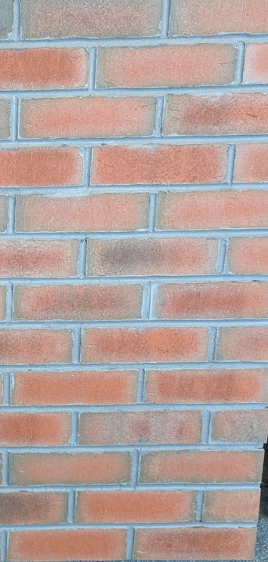  Blended Waterstruck – Wetherby 744 | 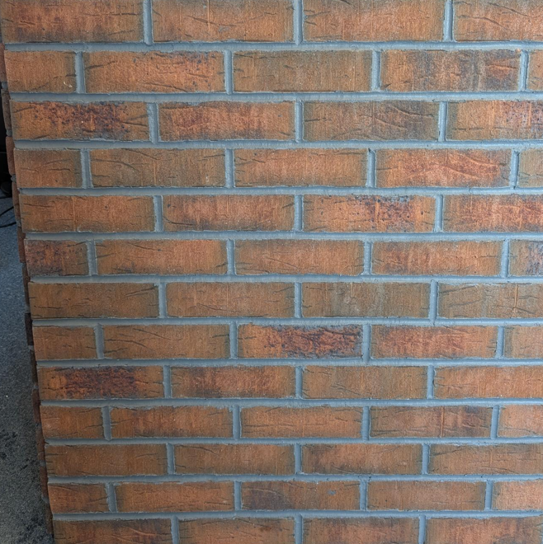  Terracotta Stock – Wetherby 687
Blended Waterstruck – Wetherby 744 | 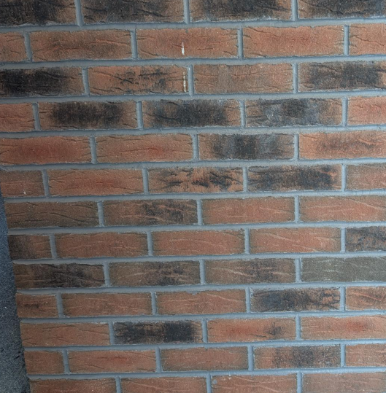  Dark Red Multi Stock – Wetherby 685

