CONSERVATION

Memo
To: Huimin Chen
From: Buju Can Cetin, Conservation Officer
Date: 08/09/2026
Re: Conservation Officer response
Application Number: PL/26/1072
Application Type: Listed building consent
Address: ST AGNES, GROVE HILL, EMMER GREEN, READING, RG4 8PN
Proposal: Replacement of Two First-Floor Windows

Summary
Objection – Suggested Reasons for Refusal – The proposed replacement plastic windows, because of their inappropriate material, design and appearance, would harm the special architectural and historic interest of this Grade II listed building. No public benefit outweighs this harm, and it has not been demonstrated that the desired energy-efficiency improvements are unachievable through sympathetic design and materials. The proposal would not accord with the requirement to preserve the special interest of the listed building in Sections of the Planning (Listed Buildings and Conservation Areas) Act 1990. It would also not meet Policies HE4, HE5 and HE6 of the NPPF 2026, and Policies EN1 and EN6 of the Reading Borough Local Plan 2019.

Relevant policies and legislation
From the point of view of the historic environment, the main statutory tests are set out within the Planning (Listed Buildings and Conservation Areas) Act 1990. Sections 16(2) and 66 require that special regard be given to the desirability of preserving listed buildings, their settings or any features of special architectural or historic interest which they possess.

National Planning Policy and Guidance
The NPPF (2026) outlines government policy, including its policy in respect of the historic environment. Chapter 20 of the NPPF 'Conserving and enhancing the historic environment' sets out the Government's high-level policies securing the conservation of heritage assets and making decisions on development proposals.
Policy HE4: Securing the conservation of heritage assets recognises heritage assets as irreplaceable resources and requires their conservation, including any contribution made by their setting in a manner appropriate to their significance. A heritage asset or its setting should be supported with a use consistent with their conservation together with the asset’s contribution to sustainable communities, local economies, and local character and distinctiveness. Proposals should avoid harm to heritage significance wherever possible and, where harm cannot be avoided, minimise it. Any harm to or loss of a designated heritage asset’s significance, including harm arising from development within its setting, must be supported by a clear and convincing justification.

Policy HE5: Assessing effects on heritage assets requires the potential impacts of the development proposals on the significance of the assets to be identified with regard to positive effects, no effect, harm and total loss of significance, and decision-makers’ satisfaction that assessments accurately reflect the effects as stated below:
“a. Have a positive effect, which is where the significance of a heritage asset would be enhanced, or better revealed; or
b. Have no effect on the significance of a heritage asset; or
c. Result in harm to the significance of a heritage asset, either from work affecting the asset itself or from development within its setting. The degree of harm should be identified: substantial harm would occur where the development proposal would seriously affect a key element of the asset’s significance; or
d. Cause the total loss of the significance of a heritage asset.”
This policy also requires development proposals with heritage impacts to be accompanied by an assessment of significance and potential impacts.

For the Proposals affecting designated heritage assets, Policy HE6 states:
“1. When considering the potential effect of a development proposal on the significance of a designated heritage asset, substantial weight should be given to the asset’s conservation (and the more important the asset, the greater the weight should be). This is irrespective of whether any potential effect amounts to a positive effect, harm, substantial harm, or total loss of its significance.”
2. Development proposals which would have a positive effect on a designated heritage asset should be supported.
3. Any harm to a designated heritage asset will be a matter of considerable importance and weight. which should be dealt with in accordance with paragraphs 4 to 6 of this policy.
4. Where a development proposal would harm the significance of a designated heritage asset the effect on the asset and its significance should be weighed against any public benefits resulting from the proposal.
5. Where a development proposal would cause substantial harm to, or the total loss of, the significance of a designated heritage asset, consent should be refused unless it can be demonstrated that the harm is necessary to achieve substantial public benefits that outweigh the harm or loss.”

Local Planning Policy and Guidance
Policy EN1 ‘Protection and enhancement of the historic environment’ of the Reading Borough Local Plan 2019 sets out the Council’s aspirations for the historic environment. The policy requires that all proposals to protect and, where possible, enhance the significance of heritage assets and their settings, historic character and local distinctiveness of the area in which they are located. It echoes the NPPF by stating, “Applications which affect Listed Buildings will not have an adverse impact on those elements which contribute to their special architectural or historic interest including, where appropriate, their settings.”
Policy EN6 ‘New Development in a Historic Context’ also requires new development to contribute to, respect and enhance the architectural and visual qualities of the historic environment characterised by heritage assets.
“When determining planning applications for new development, the following factors will be taken into consideration:
a. The positive contribution of the development to the existing historic townscape (scale, height, mass, proportion, plot size, street form, materials, significant vistas and views, and open space);
b. Sensitivity to historic context;
c. Reflection of borough-wide major heritage themes that contribute to local distinctiveness (e.g. patterned brickwork or former worker terraced housing);
d. Whether development promotes and/or improves access to previously undiscovered or neglected historic significance.”

Other Guidance
Historic England Advice Note 2 – Making changes to Heritage Assets illustrates the application of policies set out in the NPPF in determining applications for Planning Permission and Listed Building Consent.
English Heritage’s “Conservation Principles” provides policy and guidance for the “sustainable
management of the historic environment”.

Relevant heritage assets
This application relates to a two-storey Grade II listed detached building, St Agnes (St Agnes, Non Civil Parish - 1155897 | Historic England) located to the east of Grove Hill in Emmer Green. The application site is not within a conservation area, as illustrated below.
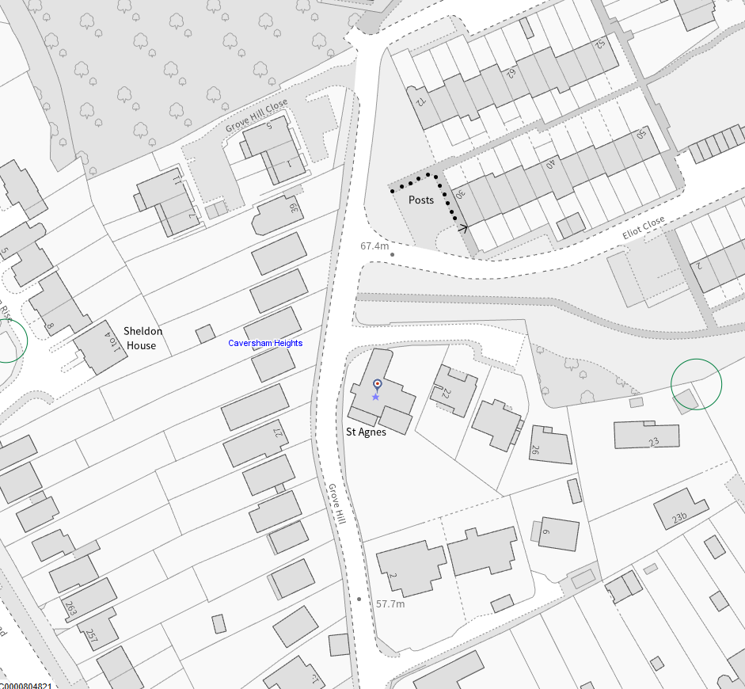
The Application Site is circled in red

Significance of heritage assets
The NPPF defines significance as the “value of a heritage asset to this and future generations because of its heritage interest.”

The interest may be architectural or historic, as set out in the Town and Country Planning (Listed Building and Conservation Areas) Act 1990 Section 1.

“Significance derives not only from a heritage asset’s physical presence, but also from its setting.” (NPPF, 2023)

Historic England assesses significance in a similar manner, referring to evidential, historic, aesthetic and communal values of a place.

The official listing description of St Agnes is read as below:
“Details
SU 7175
10/324
GROVE HILL
St Agnes
II
Circa 1835. Tudor cottage with scalloped bargeboards to gables, and hoodmoulds to windows. Two storeys flint with brick quoins and dressings to north. Stucco fronted to south with central gable which has vent in shape of cross-arrow loop. Two ranges of windows, casements. Modern sun porch. West front has three gables of uneven size, cross-arrow loop vent in left hand one. Three windows on first floor, glazing bar sashes. Central projecting gable porch with hoodmould to round-headed doorway. Two light mullion window to left.
Listing NGR: SU7127575897”

The historic maps of the application site show that the subject property was known as ‘Woodleigh’ from the Victorian Period until the 1930s. Its front elevation has a projecting gable porch sited in the middle of its two gables, and its historic lean-to extension to the rear/east elevation constituted the original footprint of the building, which is still legible through the roof of the building.
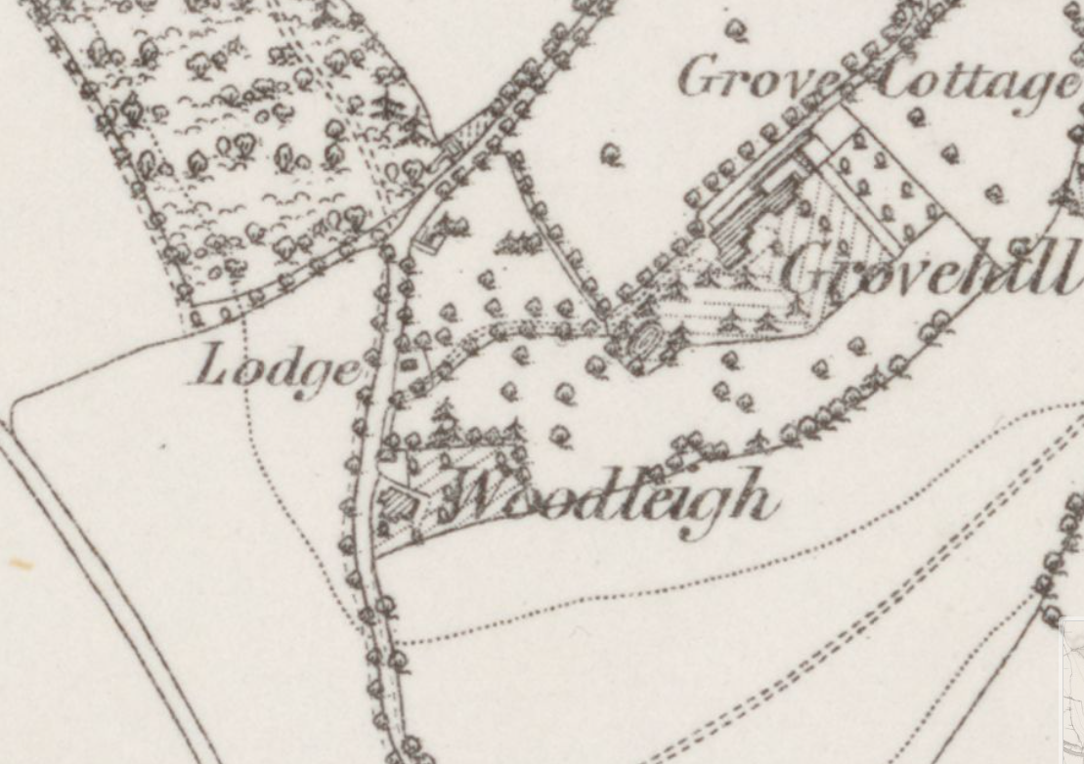
The Ordnance Survey (OS) Map dated 1877 – 78 (published in1882), St Agnes is annotated as ‘Woodleigh’

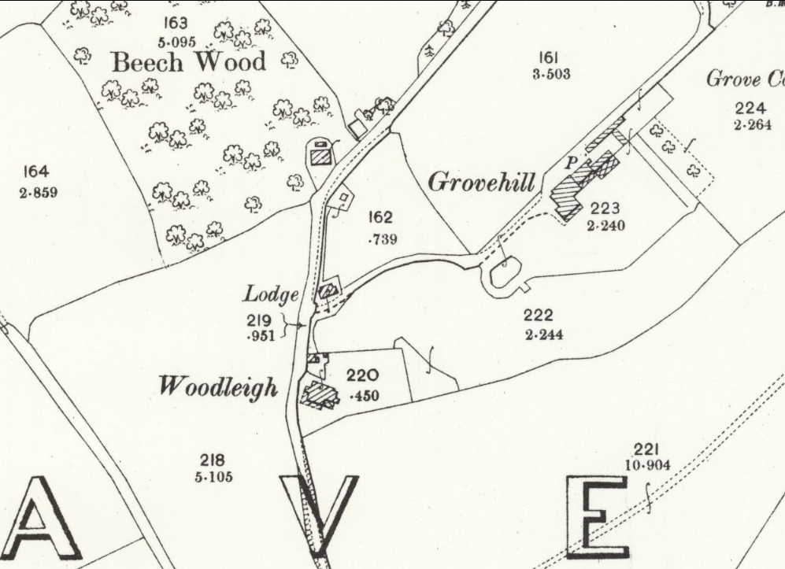
The OS Map dated 1897 (published in 1899)

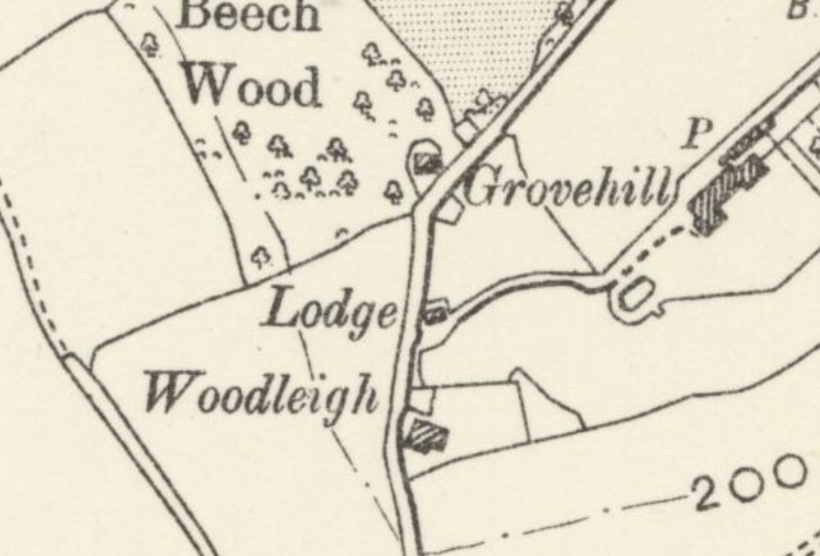
The OS Map dated 1897 (published in 1900)
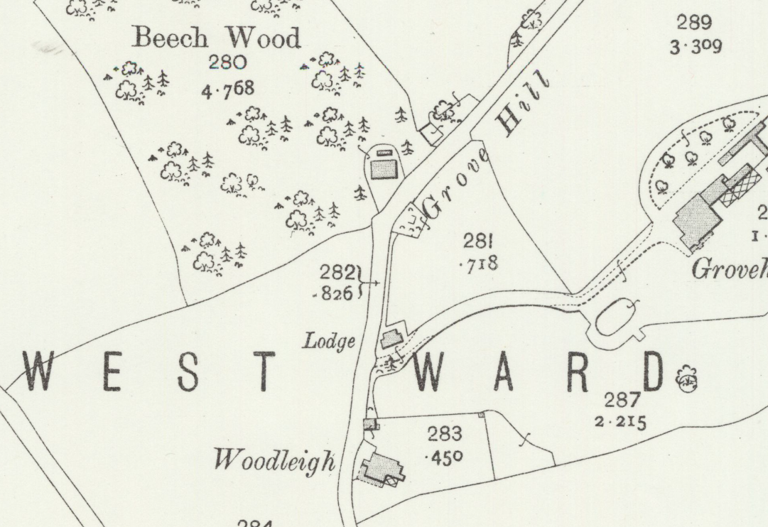
The OS Map dated 1910 (published in 1913)

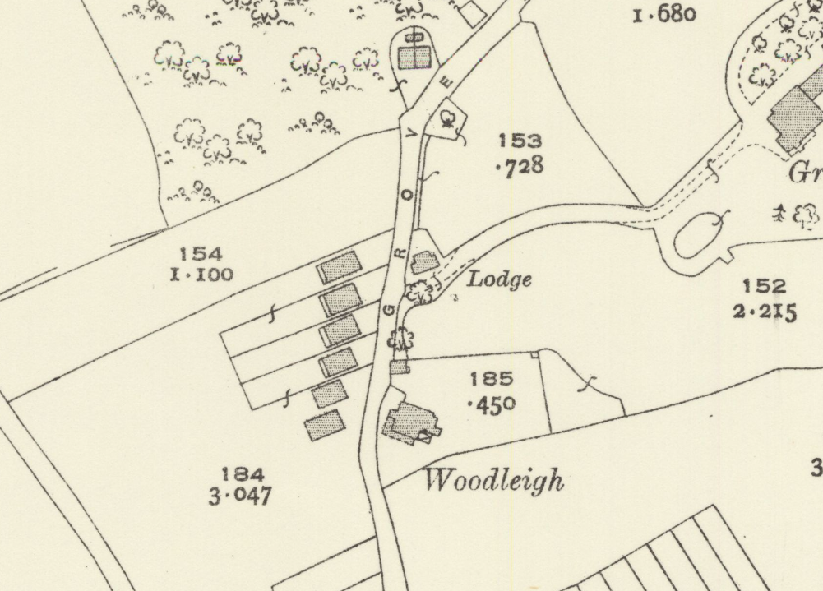
The OS Map dated 1932
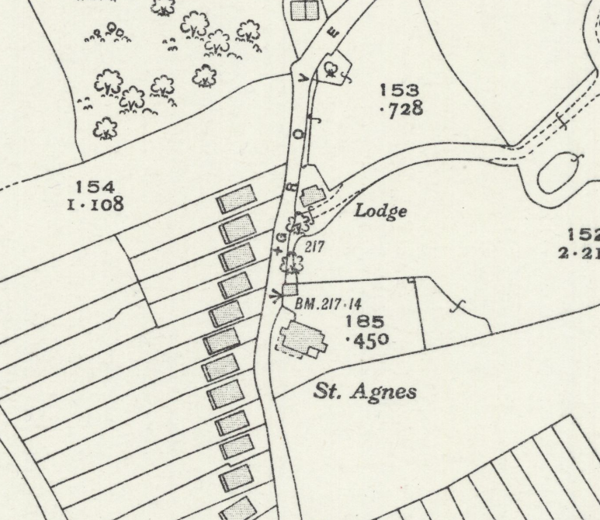
The OS Map dated 1936 (published in 1938)

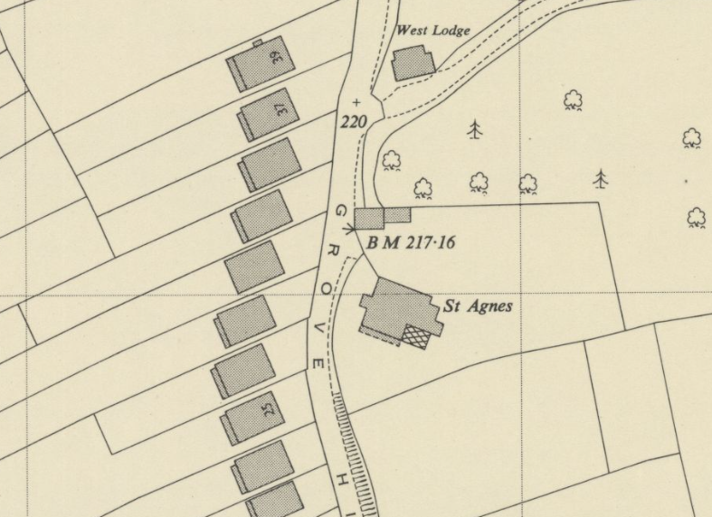
The OS Map dated 1956
It appears that the generous plot of the listed building was reduced in size, and modern houses were constructed, while the building underwent some extensions to the south and east after the 1910s, which were replaced with the modern ones in the 1970s and 1980s. As such, its exterior retains evidence of its evolution from the 1830s to the Victorian Period, modern periods and present times, the last of which are the solar panels and water heaters placed on the roof of the property after the 2000s.
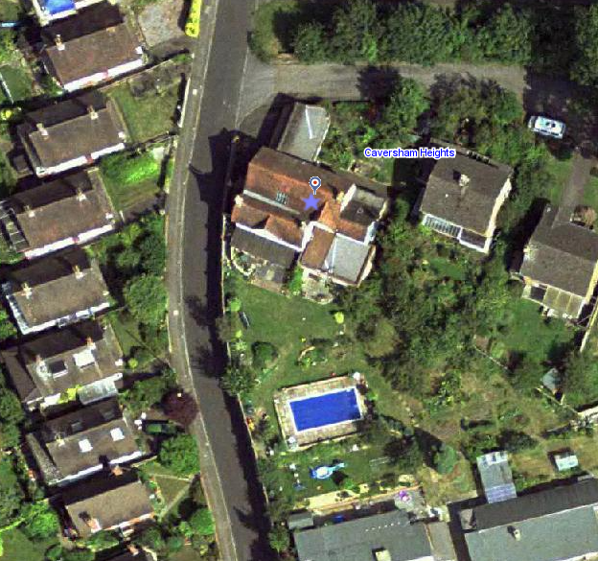
Aerial photography dated 2002 (above) and 2006 (below) (from the Council’s Historic Mapping Tool) – The original footprint is legible through the tiled roof of the listed building. There have been no alterations to the original footprint since the late 19th century
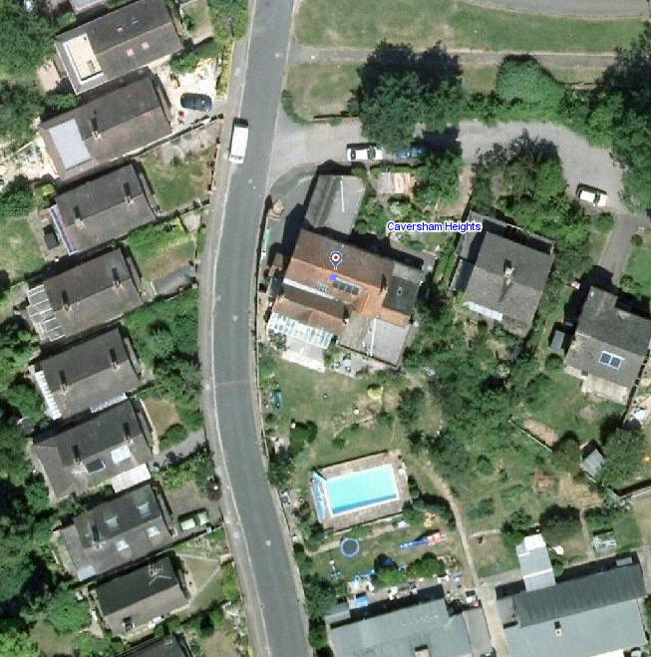
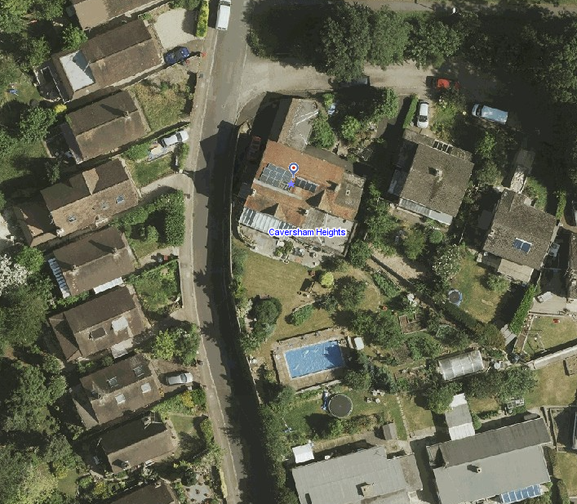
Aerial photography dated 2013 (above) and 2021 (below) (from the Council’s Historic Mapping Tool)
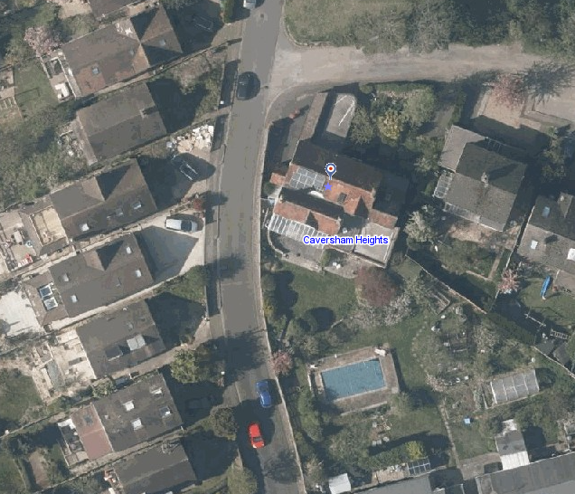
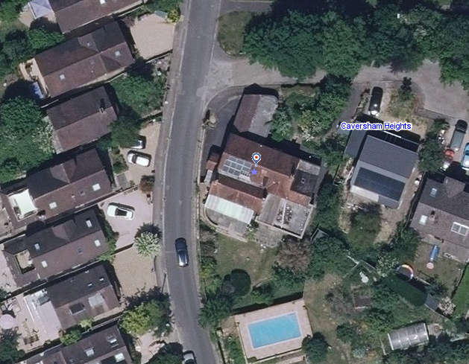
Existing Aerial photograph of the listed building (from the Council’s Historic Mapping Tool) – Original footprint of the building is shown in yellow. The garage extension is located to the north, the lean-to conservatory is to the south-west, the annex is to the south-east, and small extensions to the bathroom are to the north-east under flat roofs
During the officers’ site visit, it is noted that there are many uPVC windows, air conditioning units, and satellite dishes that have been installed which do not appear in the planning history of the property. They are considered to be causing harm to the significance of the building. It is also noted that the existing render is not stucco/original lime render but modern, showing some cracking and flaking.
Although not fully viewed, internally there are surviving features and elements such as the original staircase and electrical components of historic value.
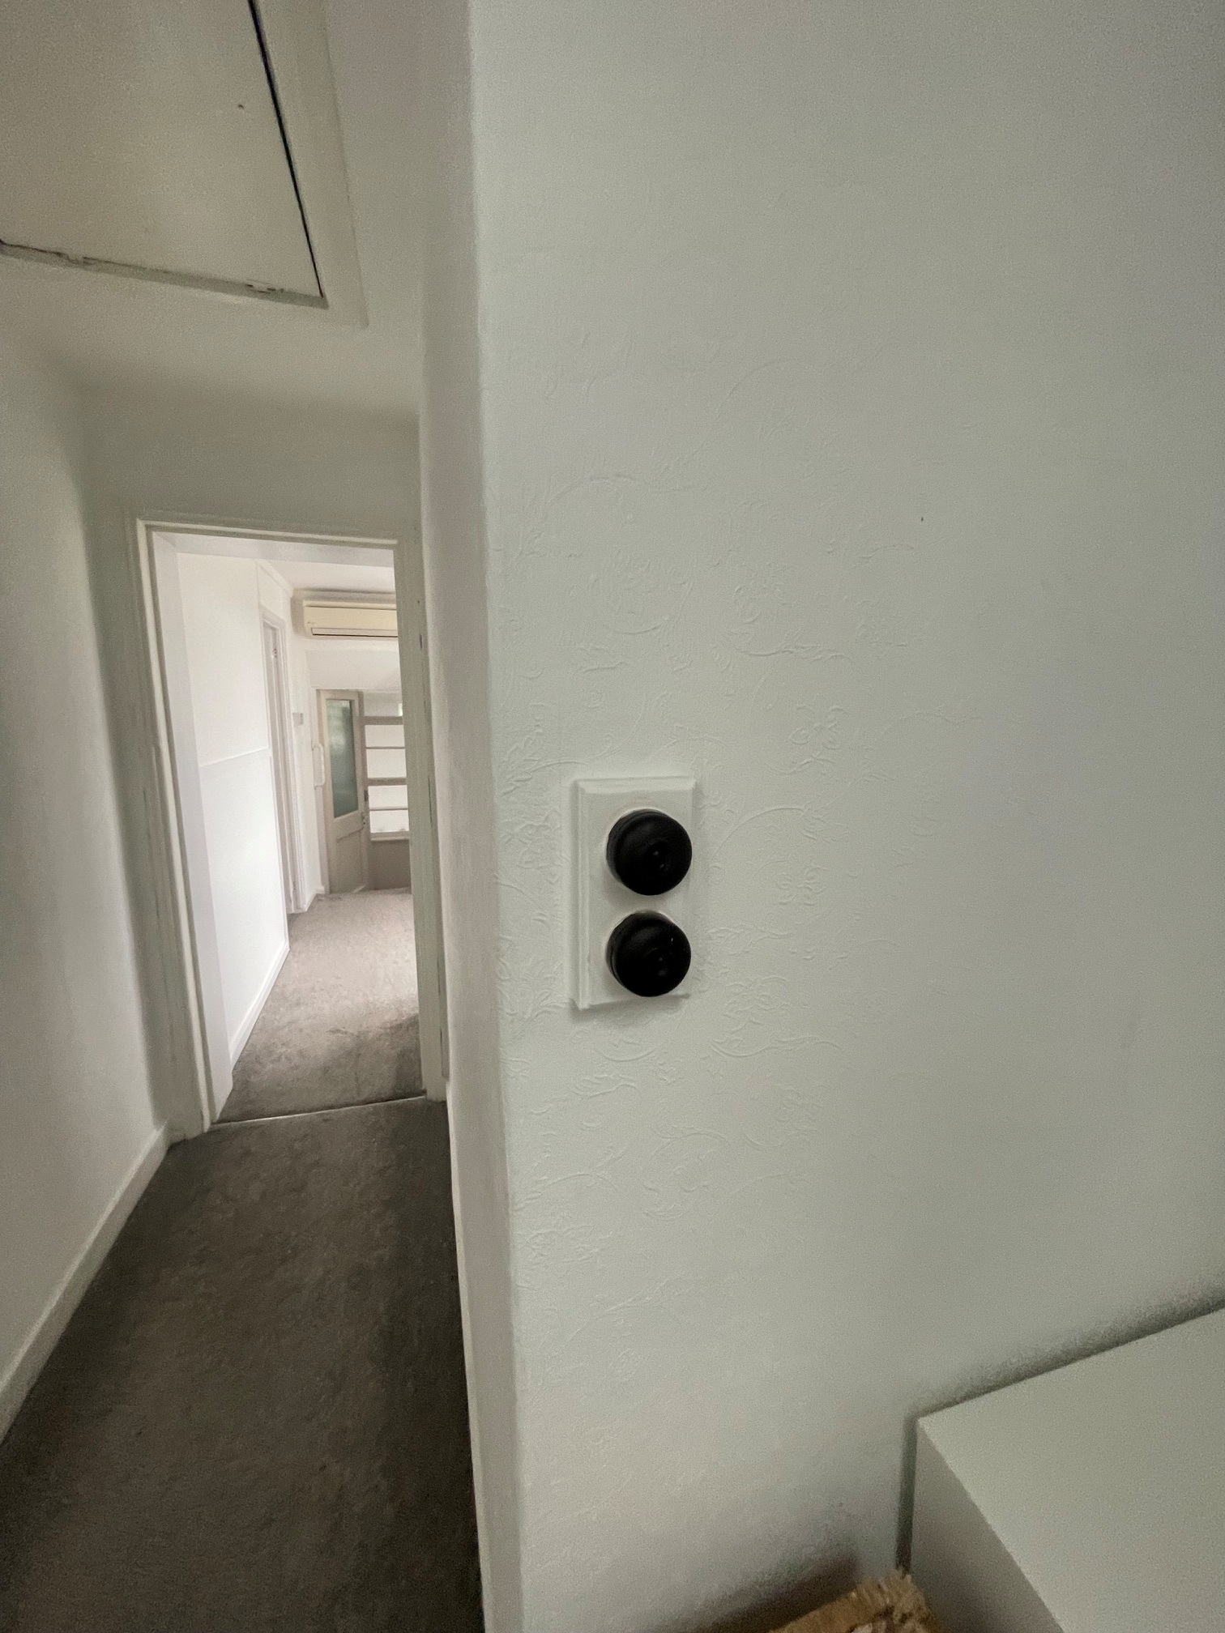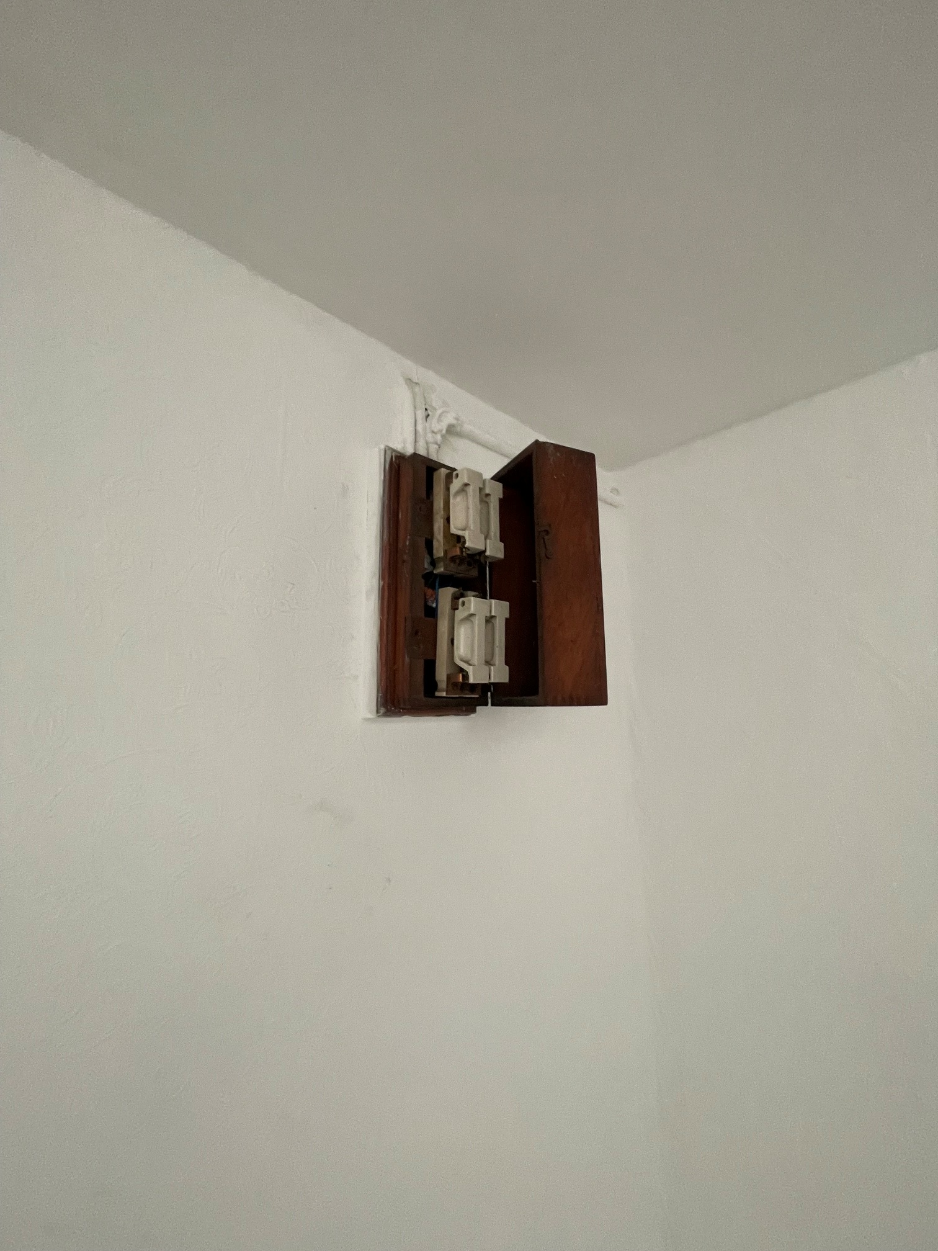
Photographs of historic electrical components

Impact of proposal upon heritage asset(s)
The application is for the replacement of two windows located on the first floor of the listed building on the eastern/rear elevation. The proposed replacement windows would constitute the existing design and be made of uPVC.
From the heritage statement, I noted that there are three major periods shaping the character of the listed building: 17th Century, Victorian and Modern. Given the map regression of the footprint of the building, the official listing description and existing historic architectural features, it is the Georgian/early 19th century and Victorian Periods that form the most significant parts of the listed building. The replacement windows are proposed for these two periods.
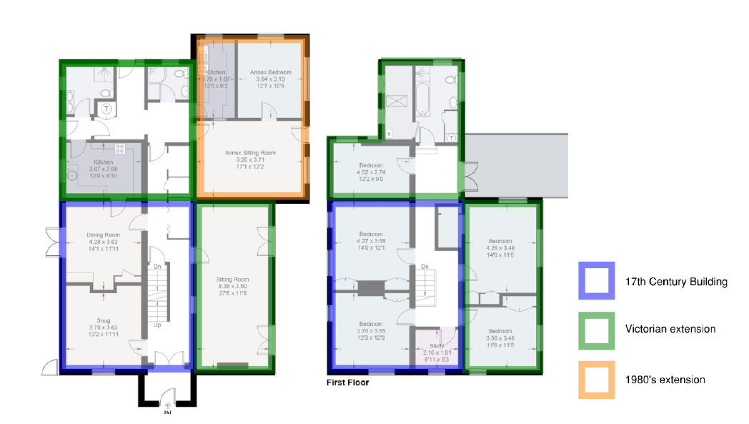
Periods of the listed building, from the submitted Heritage Statement
From the planning history of the building, it is noted that, regarding the replacement fenestration, there is only one application with ref. 130334/LBC for ‘Replacement of Five First Floor Windows’ that was for aluminium windows and withdrawn. As such, none of the existing non-original windows has a listed building consent.
I understand the building was recently purchased by the applicant and there have been and would be external and internal works to the building. As suggested during the site visit, all works should be discussed with the Council to avoid any further harm to the historic fabric of St Agnes. I would highly recommend withdrawal of this/current application as uPVC windows are not suitable for the period and architecture of the building.
For any future application, for replacement fenestration and further works to the historic fabric, I would like to make the following comments as suggestions to the applicant:
- As the subject listed building represents a cottage in rural Caversham, a traditional small house with two floors under a simple tiled roof, its traditional features may/should include: mullioned or casement windows, thatched roofs, timber post-and-beam construction, low ceilings with exposed beams, and earthen floors, which were later often replaced with tiles laid on sand. However, as dated circa 1835, St Agnes represents a gentle cottage made of flint and brick, admiring nature in an old English way with its gable ends – vernacular character combined with Victorian architecture in the country. It has similar architecture to the following illustrations from the book ‘Life in the English Country Cottage’ by Adrian Tinniswood, described as ‘Cottage of Gentility ’, designed between 1790 and 1840. As such, St Agnes must have had a mixture of casement and vertical sliding timber sash windows originally.
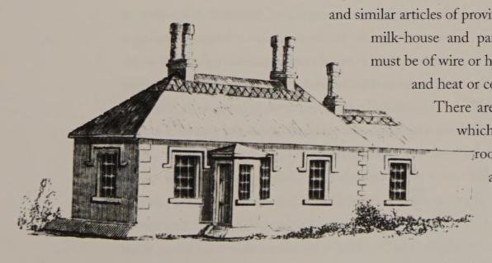
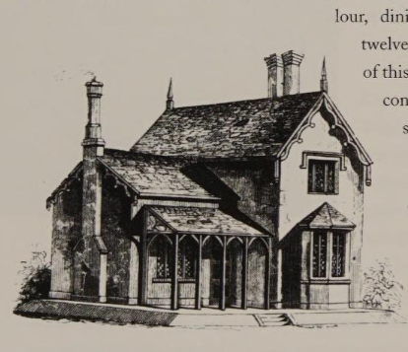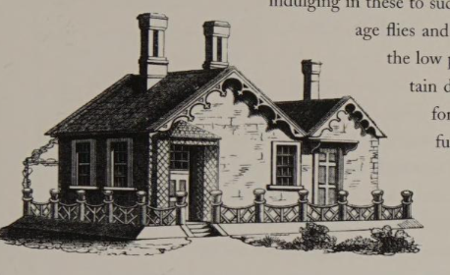
- To determine the most suitable design for the windows, research on the history of the building should be carried out. A heritage consultant/architect should be involved within the application process.
- From a simple search on the Reading Library’s Online Archive, I found the following image. Although not totally clear, the building had vertical sliding timber sash windows with multiple panes on its front elevation.
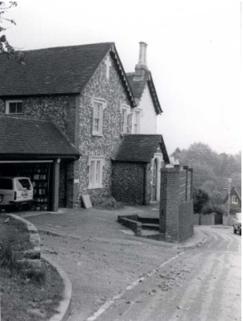
"St. Agnes, " a house in Grove Hill, Caversham, Reading, photographed in 1982. It is a listed building, of brick and flint, with tall chimneys and fancy barge-boards. 1980-1989
- All proposed window replacements should be timber, with a design based on visual evidence or period detail/representative of the period and architecture of the subject listed building’s period.
The existing windows are not original; however, they do not have consent, and they already harm the significance of St Agnes. The proposed windows would cause further harm. Timber slim profile double-glazed windows with suitable design could be acceptable, as they could bring heritage benefit with energy efficiency measures. Therefore, the application cannot be supported on heritage grounds, and refusal is recommended for the reason below.

REASON FOR REFUSAL
The proposed replacement plastic windows, because of their inappropriate material, design and appearance, would harm the special architectural and historic interest of this Grade II listed building. No public benefit outweighs this harm, and it has not been demonstrated that the desired energy-efficiency improvements are unachievable through sympathetic design and materials. The proposal would not accord with the requirement to preserve the special interest of the listed building in Sections of the Planning (Listed Buildings and Conservation Areas) Act 1990. It would also not meet Policies HE4, HE5 and HE6 of the NPPF 2026, and Policies EN1 and EN6 of the Reading Borough Local Plan 2019.

Conservation response
No objections
No objections subject to conditions attached
Clarification required
Object

Contact details
Buju Can Cetin, Conservation Officer
Burcu.CanCetin@reading.gov.uk

