CONSERVATION

Memo
To: Catrin Davies
From: Buju Can Cetin, Conservation Officer
Date: 25/08/2026
Re: Conservation Officer response
Application Number: PL/26/0708
Application Type: Full planning permission
Address: 10 Castle Street, Reading, RG1 7RD
Proposal: Conversion of the existing building to mixed restaurant/takeaway (Sui Generis) use at ground floor and basement with the creation of 4 flats (Use Class C3) across the ground, first, second and third floors with external alterations to the rear elevation.

Summary
Objection & Clarifications Required (Request for revisions and further information) – The proposed works associated with the change of use of the listed building cannot be supported on heritage grounds as they would result in less than substantial harm at a moderate level (at the highest end) on the significance of the building. The revisions to conserve chimney breasts, to correct drawings to include the missing chimney stack and replacement timber dormer windows are not sufficient but necessary for heritage balance, along with suitable materials to be used. I also suggest conditions for internal works as the proposal lacks sufficient information for the significance and heritage impacts of the proposed works.
I am unable to provide a reason for refusal due to the previously approved scheme.

Relevant policies and legislation
From the point of view of the historic environment, the main statutory tests are set out within the Planning (Listed Buildings and Conservation Areas) Act 1990. Sections 16(2) and 66 require that special regard be given to the desirability of preserving listed buildings, their settings or any features of special architectural or historic interest which they possess.
Section 72(1) of the Planning (Listed Buildings and Conservation Areas) Act 1990 also requires the Council to pay special attention to the desirability of preserving or enhancing the character and appearance of designated Conservation Areas.

National Planning Policy and Guidance
The NPPF (2026) outlines government policy, including its policy in respect of the historic environment. Chapter 20 of the NPPF 'Conserving and enhancing the historic environment' sets out the Government's high-level policies securing the conservation of heritage assets and making decisions on development proposals.
Policy HE4: Securing the conservation of heritage assets recognises heritage assets as irreplaceable resources and requires their conservation, including any contribution made by their setting in a manner appropriate to their significance. A heritage asset or its setting should be supported with a use consistent with their conservation together with the asset’s contribution to sustainable communities, local economies, and local character and distinctiveness. Proposals should avoid harm to heritage significance wherever possible and, where harm cannot be avoided, minimise it. Any harm to or loss of a designated heritage asset’s significance, including harm arising from development within its setting, must be supported by a clear and convincing justification.
Policy HE5: Assessing effects on heritage assets requires the potential impacts of the development proposals on the significance of the assets to be identified with regard to positive effects, no effect, harm and total loss of significance, and decision-makers’ satisfaction that assessments accurately reflect the effects.
For the Proposals affecting designated heritage assets Policy HE6 states:
“1. When considering the potential effect of a development proposal on the significance of a designated heritage asset, substantial weight should be given to the asset’s conservation (and the more important the asset, the greater the weight should be). This is irrespective of whether any potential effect amounts to a positive effect, harm, substantial harm, or total loss of its significance.”
(…)
“4. Where a development proposal would harm the significance of a designated heritage asset the effect on the asset and its significance should be weighed against any public benefits resulting from the proposal. Important public benefits can include securing the long-term reuse of a vacant or underused listed building, and enabling energy efficiency and low carbon heating measures to be employed.”
National Planning Practice Guidance (NPPG) on Historic Environment provides context to the NPPF. NPPG defines ‘public benefits’ from a development that deliver economic, social or environmental objectives as described by Paragraph 17 of the NPPF while “examples of heritage benefits may include:
- sustaining or enhancing the significance of a heritage asset and the contribution of its setting
- reducing or removing risks to a heritage asset
- securing the optimum viable use of a heritage asset in support of its long term conservation”

Local Planning Policy and Guidance
Policy EN1 ‘Protection and enhancement of the historic environment’ of the Reading Borough Local Plan sets out the Council’s aspirations for the historic environment. The policy requires that all proposals to protect and, where possible, enhance the significance of heritage assets and their settings, historic character and local distinctiveness of the area in which they are located. It echoes the NPPF by stating, “Proposals should seek to avoid harm in the first instance. Any harm to or loss of a heritage asset should require clear and convincing justification, usually in the form of public benefits”.
Applications which affect Listed Buildings are expected not to have an adverse impact on the elements that contribute to their special architectural or historic interest, including their settings.
Policy EN3 ‘Enhancement of conservation areas’ of the Reading Borough Local Plan also requires that development proposals within Conservation Areas contribute positively to local character and distinctiveness.
Policy EN6 ‘New Development in a Historic Context’ also requires new development to contribute to, respect and enhance the architectural and visual qualities of the historic environment characterised by heritage assets.
“When determining planning applications for new development, the following factors will be taken into consideration:
a. The positive contribution of the development to the existing historic townscape (scale, height, mass, proportion, plot size, street form, materials, significant vistas and views, and open space);
b. Sensitivity to historic context;
c. Reflection of borough-wide major heritage themes that contribute to local distinctiveness (e.g. patterned brickwork or former worker terraced housing);
d. Whether development promotes and/or improves access to previously undiscovered or neglected historic significance.”

Other Guidance
Historic England Advice Note 2 – Making changes to Heritage Assets illustrates the application of policies set out in the NPPF in determining applications for Planning Permission and Listed Building Consent.
English Heritage’s “Conservation Principles” provides policy and guidance for the “sustainable
management of the historic environment”.

Relevant heritage assets
This application relates to a Grade II listed building that forms a pair of early 19th century houses converted to shops in the late 19th century with rear extensions in the 20th century. Located at 10 Castle Street, the building has three and a loft with a mansard roof, which is also adjacent to Grade II* listed St Mary’s Church and Grade II listed 8 Castle Street within the St Mary’s Butts/Castle Street Conservation Area where a number of listed buildings are concentrated, as illustrated below.
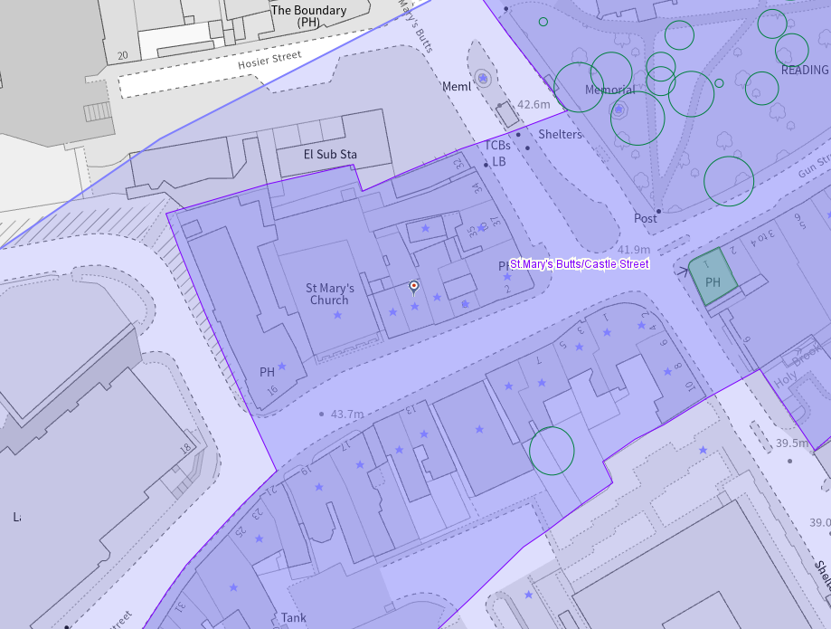
The Application Site is circled in red, the conservation areas are light purple, and listed buildings have a star on them
As is clear from the map above, the listed buildings whose settings are potentially affected by a development are
Grade I listed Reading Minster Church of St Mary, Non Civil Parish - 1113573 | Historic England
Grade II listed Former cottage to the rear of 8 Castle Street Former cottage to the rear of 8 Castle Street, Non Civil Parish - 1321963 | Historic England
Grade II listed The Horn Inn The Horn Inn, Non Civil Parish - 1303691 | Historic England
Grade II listed 35, 36 and 37 St Mary's Butts 35, 36 and 37 St Mary's Butts, Non Civil Parish - 1321885 | Historic England
Grade II listed 11 Castle Street 11 Castle Street, Non Civil Parish - 1113411 | Historic England
Grade II listed 13 Castle Street 13 Castle Street, Non Civil Parish - 1113412 | Historic England
Grade II* listed 15 Castle Street 15 Castle Street, Non Civil Parish - 1303734 | Historic England
Grade II listed 9 Castle Street 9 Castle Street, Non Civil Parish - 1154642 | Historic England
Grade II listed 7 Castle Street 7 Castle Street, Non Civil Parish - 1113410 | Historic England

Significance of heritage assets
The NPPF defines significance as the “value of a heritage asset to this and future generations because of its heritage interest.”

The interest may be architectural or historic, as set out in the Town and Country Planning (Listed Building and Conservation Areas) Act 1990 Section 1.

“Significance derives not only from a heritage asset’s physical presence, but also from its setting.” (NPPF, 2023)

Historic England assesses significance in a similar manner, referring to evidential, historic, aesthetic and communal values of a place.

The official listing description of the subject Grade II listed building is read as below:

10 and 12 Castle Street
“Summary
Pair of early C19 houses, converted to shops in the late C19 and extended to the rear in the C20.
Reasons for Designation
10 and 12 Castle Street, a pair of early-C19 houses, converted to shops in the late C19 and extended to the rear in the C20, are listed at Grade II for the following principal reasons:
Architectural interest:
* as an early-C19 building which contributes to the character of an architecturally varied historic streetscape.
Historic interest:
* as part of the urban development of Reading’s ancient core.
Group value:
* the building is in close proximity to a large number of listed buildings and forms part of a strong historic grouping.
History
The crossroads formed by the north-south route of St Mary’s Butts/Bridge Street and the east-west route of Gun Street/Castle Street is believed to be the centre of the original Saxon settlement at Reading, established sometime before the ninth century, with the lowest crossing point of the River Kennet lying a short distance away to the south.
Reading was well-established by the time of the Norman Conquest, and the Domesday Book (1086) records six mills and a large estate in the town. St Mary’s Church, which lies on the north-east corner of the crossroads and was mostly rebuilt in 1551-1555, was the town’s primary church until the establishment of Reading Abbey in the C12 and became so again following the dissolution in the late 1530s.
Running west from the crossroads, Castle Street forms part of the ancient route through the town between London and the West Country, and the street historically contained many inns and guesthouses. As Reading expanded beyond its medieval limits during the C18 and C19, development spread further along Castle Street. Earlier buildings were gradually replaced with substantial townhouses and public buildings in brick or Bath Stone, although some timber-framed buildings of the C16 and C17 survive.
10 and 12 Castle Street were constructed around 1800, probably on the site of earlier buildings. In the late C19 they were converted to commercial use at ground floor level and historic mapping shows that both houses were extended to the rear by 1879. At number 10, the rear extension appears to have been rebuilt in two phases during the late C20, while the extension at number 12 may have been removed.
The shopfront to number 10 is late C20 and that to number 12, is mid-C20. The roof form has been altered by the addition of a mansard to the south and west elevations and the cornice to number 12 has been replaced. The ground floor of both properties currently (2023) remains in commercial use.

Details
Pair of early C19 houses, converted to shops in the late C19 and extended to the rear in the C20.
MATERIALS: built of brick with timber shopfronts, under a roof of slate and plain tiles.
PLAN: main entrances to the centre, incorporated into the shopfront at number 12. Number 12 also has a side entrance.
EXTERIOR: the houses are three-storey, over a basement with a later mansard attic storey. The brown brick is laid in Flemish bond and the window openings to the first and second floors have gauged brick and flat arches. There is a stone cill band above the ground floor and each house is served by a tall, brick stack.
12 Castle Street has a timber shopfront with transom glazing, flanked by a pair of stucco Doric pilasters rising to a Doric entablature bearing the shop fascia. The recessed entrance door appears to be C20. There is a tripartite multi-pane window to the first and second floor and a multi-pane, flat-roofed dormer to the mansard. The plain cornice appears to be timber and is located beneath a rendered parapet.
10 Castle Street has a six-panel door with a radiating and wreathed fanlight above, set within a stuccoed round-arched architrave, under gauged brickwork. It is approached by a set of rounded steps. The shopfront is plain with two, plate glass windows and a glazed door. The first and second floors have the same window design as number 12, with the addition of a 12-pane sash window to each floor, above the main doorway. There is a dentil brick cornice and parapet. The mansard has two flat-roofed dormers, which have uPVC multi-pane windows.
Across the rear elevation of both houses, there is a variety of timber sash windows, including a large stair window in the central bay of the second floor. There are three dormers in the mansard. Projecting north from the rear elevation of number 10 are a series of later C20 extensions, constructed of brick with flat roofs and casement windows.”
In addition to individual listing descriptions of the buildings within the immediate surrounding of the application site, the summary of special interest of the St Mary’s Butts/Castle Street Conservation Area provides a summary of significance components of the area:
“• The Grade I listed Church of St Mary in St Mary’s Butts, a Reading landmark, originally Norman, and mentioned in the Domesday Book, but now mostly Medieval in origin, which is the focal building of the Conservation Area.
• St Mary’s Churchyard, an important open space in the centre of town.
• Other important landmark buildings including the Grade II* listed St Mary’s Church in Castle Street.
• The architectural and historic interest of the area’s other buildings, with examples dating from the sixteenth century to the present day, but the majority of which show a coherence of scale within their various architectural styles.
• Important Grade II* listed buildings at 15 and 17 Castle Street (both 16th century), 19 Castle Street (early 18th century), 63 Castle Street (circa 1750) and the Church of St Mary, Castle Street (1798).
• A high percentage of listed buildings, listed individually and for their group value, dating from before 1875.”

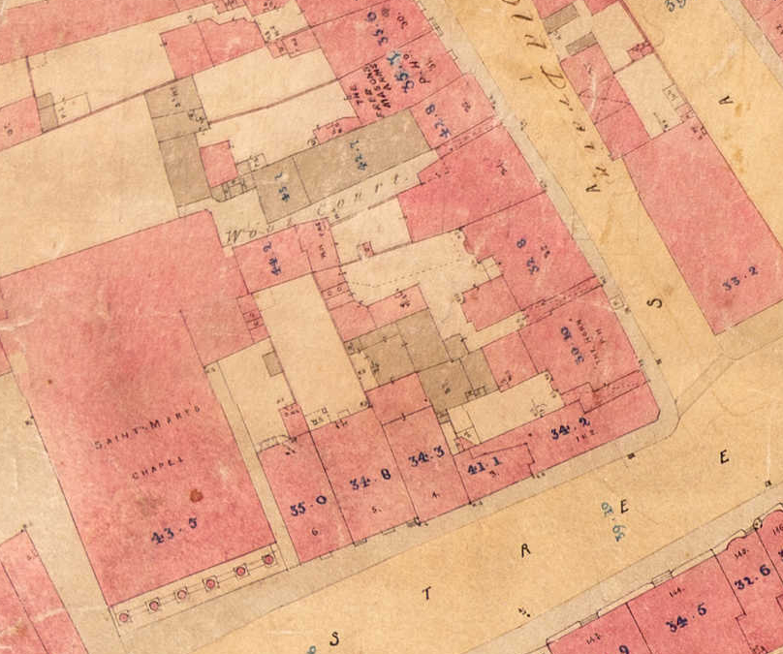
Reading Board of Health Map, 1853, showing the application site with original footprint which appears to be altered by the rear extension(s) the existing of which was constructed after 1980, as confirmed by the following historic maps
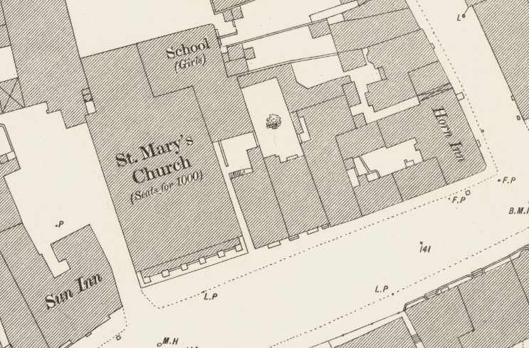
The Ordnance Survey (OS) Map dated 1876 (published in1879)

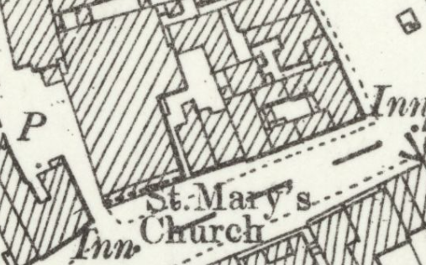
The OS Map dated 1898 (published in 1900)

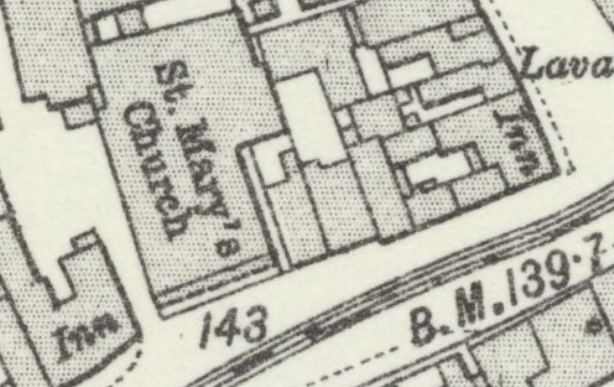
The OS Map dated 1909 to 1910 (published in 1912)
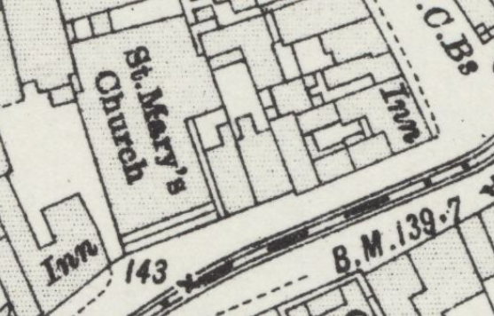
The OS Map dated 1931 to 1932 (published in 1934)

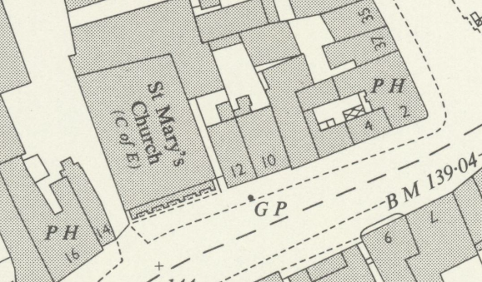
The OS Map dated 1957

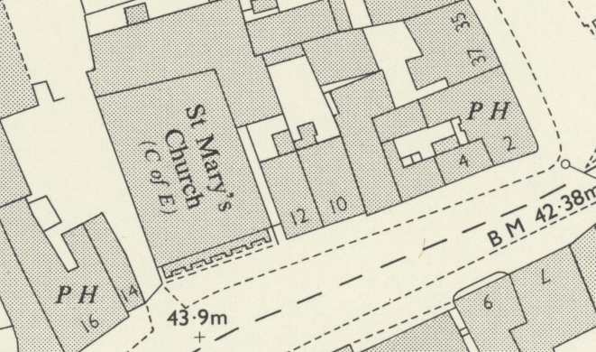
The OS Map dated 1969 (published in 1970)
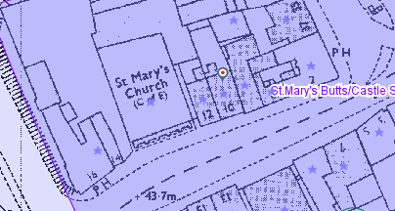
The Application Site in the 1980s (from the Council’s Historic Mapping Tool)

As given by the planning history of the listed building below, and the planning officer’s site visit, the subject building had undergone some external and internal alterations. Among the external ones, although the rear extension is not visible from the public realm, it still has an impact on the curtilage of the listed building and the character of the conservation area. The replacement uPVC windows of the front dormers are also detracting elements, causing harm to the significance of the listed building.

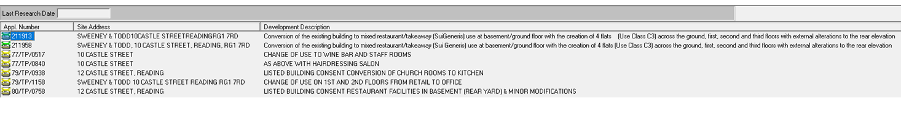
Internally, the original staircase, skirting boards, chimney breast and floorboards are the surviving elements of the historic fabric. As such, any proposed development for the building is expected to preserve the retained elements to avoid further harm to the historic architectural interest of the designated heritage asset.

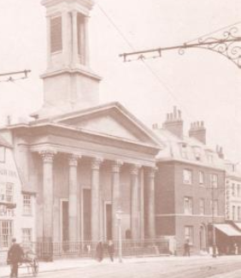
Snip from Castle Street, Reading. North side, showing No. 16 (Sun Inn, Charles Roberts), St. Mary's Church, No. 12, No. 10 (James Goddard, butcher), and Nos. 6-8 (James Freeman, grocer). 1910-1919 : notelet with photograph by Dann and Lewis, Reading; postcard version at Dynix 1142916 (from the Reading Library’s Online Archive), the principal elevation of the building could be considered as the least altered and therefore the most significant part of the listed building.
Impact of proposal upon heritage asset(s)
I noted that the proposed development and associated works to the historic fabric of the listed building are the same as the approved schemes with reference numbers PL/21/1913 (211913) and PL/21/1958 (211958). I also noted from the officer’s report for the approved scheme that there was no conservation input to the proposals except for the one for pre-application, which provided only basic thoughts and acceptance in principle for the proposal.
As I am unable to raise an objection, I have concerns about the following (not limited to), which I recommend the agent/applicant reconsider and submit relevant documents accordingly because the proposed works would result in less than substantial harm at a moderate level to the significance of the designated heritage asset. I request revisions and further information.
- Both the existing and proposed elevation drawings show only one chimney stack while there are two. I recommend correcting this on the drawings.
- A counter and kitchen would be inserted on the ground floor for the proposed sui generis use. Although I noted that this floor has been much altered due to this section of the building being original and would have an impact on the historic fabric, the details of the counter, kitchen layout and extractor system should be submitted to the Council. In addition, because the rear wall of the listed building would be filled in, details of the proposed wall, including a section drawing, would be required. Conditions are suggested for these elements.
- I would generally object to the proposal of bathrooms and kitchens inside the historic fabric on each and every floor where the existing and original layout constitutes rooms, the front ones the principals. The proposed internal layout and associated works appear to result in harm. Therefore, I suggest a condition for the proposed services. The proposed internal layouts include new internal walls whose details are also required. I highly recommend all proposed materials be suitable for the historic fabric and be traditional.
- For the second and third floors, I noted that existing chimney breasts are proposed to be removed, which would cause additional harm to the listed building as the original fabric would be lost. The proposed floor layouts for the second and third floors are not acceptable. The building is treated as a non-listed one rather than a building of historic architectural interest. The second and third floor layout should be revised to retain/conserve the chimney breasts.
- There is no proposed conservation approach or conservation work to the designated heritage asset. As such, there is no heritage benefit. I would like to see the replacement of the UPVC dormer windows with timber ones in the original design at least.
- I find the proposed works for the listed building cannot be supported on heritage grounds. The revisions to conserve chimney breasts, to correct drawings to include the missing chimney stack and replacement timber dormer windows are not sufficient but necessary for heritage balance, along with suitable materials to be used and proposed works subject to the suggested conditions below.
Suggested Conditions:
All external and internal works of making good to the retained fabric shall match the existing adjacent work with regard to the methods used and to material, colour, texture and profile. All such works and finishes shall be maintained as such thereafter.
REASON: In order to safeguard the special architectural or historic interest of the heritage asset in accordance with Policy EN1 of the Reading Borough Local Plan 2019.

Prior to commencement of the relevant part of the works, details of the following shall be submitted to and approved in writing by the Council:
- proposed internal partition walls and filled-up walls of the historic fabric, the counter on the ground floor, including a section drawing with the details of the method of construction
- a method statement detailing how the proposed kitchens, including a commercial kitchen on the ground floor and bathrooms, will be constructed and finished
- type and location of any new services including (but not limited to) pipework, rainwater goods, boiler flues, extractors/extract vent grilles, meter cupboards, and soil vent pipe terminations
- full schedule of internal finishes to floors, ceilings and walls
The works shall not be carried out other than in full accordance with the approved details.
REASON: In order to safeguard the special architectural or historic interest of the heritage asset in accordance with Policy EN1 of the Reading Borough Local Plan 2019.

Conservation response
No objections
No objections subject to conditions attached
Clarification required
Object

Contact details
Buju Can Cetin, Conservation Officer
Burcu.CanCetin@reading.gov.uk

