DN for PL/24/1125 Refers to Rev 14 BUT also confirms that:
You confirmed that the Planting Schedule, Tree Pit Details, and Fencing Details were re-submitted for completeness, there are no amendments to these plans, although I note the revision numbers are different to when shown on my last letter about this condition.

On the assumption, therefore, that the attached represents the final and implemented landscaping, it includes new trees on the south side of the car park.
As such, it is reasonable to request further comment on how these will not be impacted by the proposed 2.4m fence – both installation (no comment on protection of landscaping during erection is provided) and whether any facilitative pruning is required to allow for the fence. The Proposed Site plan Rev P02 has the fence within the canopy of these young trees (assumed to have been implemented and alive):

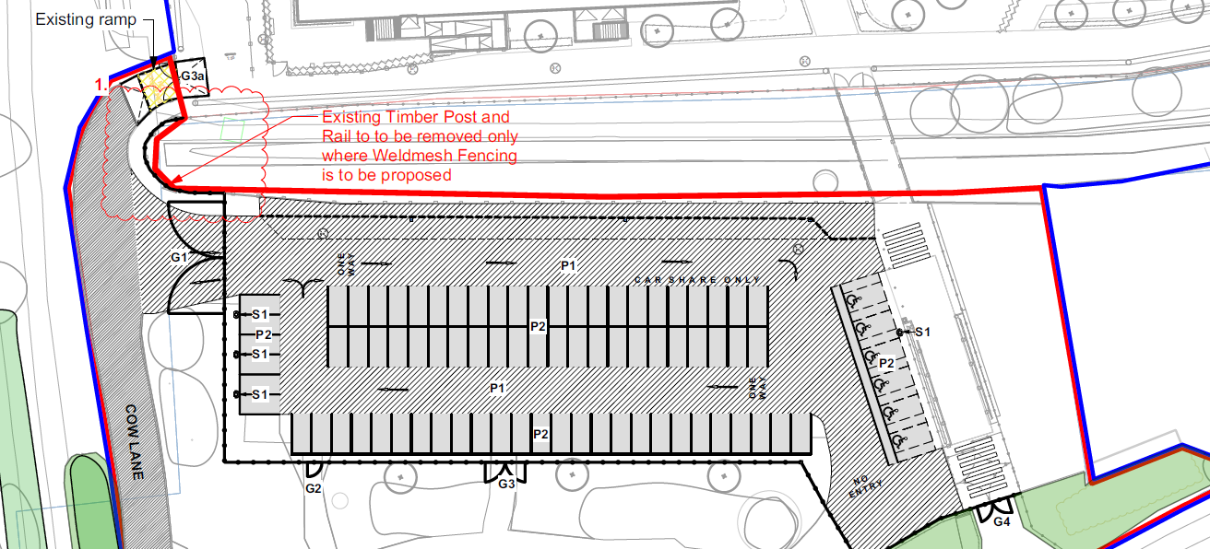

A further tree / landscape impact and protection statement is required to address the above concerns. The brief statement provided thus far falls short of providing comfort.

