27/08/2026

Planning Application Ref: PL/26/1026
Officer: Gary Miles
Application Type: Full planning permission
Address: 9 MANCHESTER ROAD, READING, RG1 3QD
Proposal: Retrospective application for the construction of a single
storey structure for display of fresh produce and associated products.

This application seeks retrospective planning permission for the retention of a single-storey extension that expanded the floor space of the existing retail unit. The extension is located within the curtilage of the site is illustrated below.
Proposed layout: iShare/Extent of Public Highway
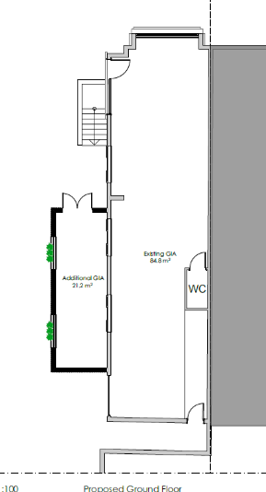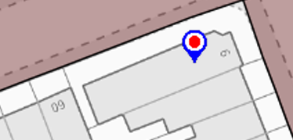

Plans show that the side extension will have windows as shown below:

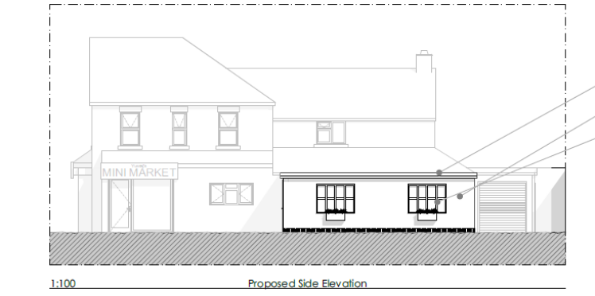

Windows should not project over or obstruct the public highway when open. The extent and direction of the opening of the windows have not been illustrated. Plans clearly identifying the extension and opening of the windows in relation to the public footway are required.

Confirmation is required that the new extension will remain ancillary to the retail unit and not be commercially let. If this application were to be approved an appropriate condition should be applied.

Please ask the applicant to address the above points so that this application can fully be determined.

N. Hussain
Transport Development Control advisor

