DESIGN AND ACCESS STATEMENT
Caversham AFC Pavilion, Clayfield Copse Recreation Ground

1.0 Introduction
This Design and Access Statement has been prepared by DRA Works on behalf of Caversham AFC in support of a full planning application for a defined package of external works at the Caversham AFC Pavilion, Clayfield Copse Recreation Ground, Caversham.
The statement should be read alongside the previously submitted Design and Access Statement accompanying application PL/26/0756 FUL, which set out in full the background to the project, the club's needs, the internal reconfiguration of the pavilion and the associated alterations to windows and doors. That material is not repeated here except where it is necessary to explain the works now proposed. This statement is therefore deliberately focused, and addresses only the four elements listed below.
The application is submitted following Level 1 pre-application advice from Reading Borough Council under reference PL/25/1713, issued on 25 March 2026. The design has been developed in direct response to that advice, and section 6.0 of this statement sets out, point by point, how each of the officer's design comments has been addressed.

1.1 Scope of this application
Planning permission is sought for the following four elements only:
- An insulated render system and red silicone render finish to the external walls of the existing pavilion building, together with a dark panel beneath the servery window matching the colour of the window frames.
- A new 40ft metal storage container, painted to match the red render finish of the pavilion, supported on screw piles, and screened by climbing plants in powder-coated aluminium planters on a wire trellis fixed to the container.
- A 2.0m high palisade fence forming a secure external goal storage enclosure to the south (rear) of the pavilion.
A new native laurel hedgerow is also proposed as part of the landscape treatment associated with the terrace, as shown on drawing 102/P/03.
All other works to the pavilion — including the internal reconfiguration and the alterations to windows and doors — are covered by the earlier permission and do not form part of this application.

2.0 The site and its context
Clayfield Copse is a designated area of Local Green Space under Policy EN7Nj of the Reading Borough Local Plan 2019. The wider designation comprises two areas of Ancient Woodland — Clayfield Copse Woodland and Blackhouse Wood — both of which are Priority Habitats and designated Local Wildlife Sites protected under Policy EN12. The southern part of the Local Green Space, to which this application relates, contains two playing fields with the pavilion and its ancillary storage building, together with a skate park, two tennis courts and clubhouse, a playground and a public car park accessed from Caversham Park Drive.
The pavilion is a single-storey building of modest scale with painted brick and clad walls beneath a shallow-pitched corrugated metal roof. It sits well within the recreation ground and is screened from views outside Clayfield Copse by the mature trees lining the site perimeter. It is visible in views from within the recreation ground, principally from the playing fields to the north and north-west, and from the footpath connecting the pavilion to the car park.
A band of mature trees runs along the southern boundary immediately to the rear of the pavilion, and a large individual tree — identified as T1 in the pre-application submission — stands close to the eastern side of the building. The woodland to the west is covered by Area Tree Preservation Order 82/05. The nearest residential properties are over 80 metres away on Caversham Park Road.
The pre-application response describes the existing pavilion as "rather utilitarian" and of very little architectural merit, and the existing dark green storage container as more utilitarian still. Officers positively encouraged the club to consider how the exterior of the building might be refurbished alongside the internal works. This application is the club's response to that encouragement.

3.0 Planning history and policy context
Level 1 pre-application advice was sought in November 2025 and issued on 25 March 2026 under reference PL/25/1713. Officers confirmed that the general principle of refurbishing and improving the existing pavilion facilities is supported, that the proposals would enhance the sporting and community function of the site without material loss of Local Green Space, and that Sport England, as statutory consultee, considered the proposals to fall within their exception criteria and were unlikely to object.
Officers identified two matters requiring careful attention: the relationship of any new structure or hard surfacing with nearby trees, and the design quality of the proposals — in particular the acceptability of a storage container and of palisade fencing. Both are addressed directly in this statement and in the supporting arboricultural information.
The following Local Plan policies are of particular relevance to the works now proposed:
- EN7Nj — Local Green Space and Public Open Space
- OU1 — New and Existing Community Facilities
- CC7 — Design and the Public Realm
- CC2 and CC3 — Sustainable Design and Construction, and Adaptation to Climate Change
- EN12 — Biodiversity and the Green Network
- EN14 — Trees, Hedges and Woodland
- EN18 — Flooding and Drainage
- CC8 — Safeguarding Amenity
Paragraph 104 of the National Planning Policy Framework (December 2024) is also engaged. As established at pre-application stage, the proposals are ancillary facilities supporting the principal use of the site as a playing field and accord with paragraph 104(b).

4.0 Design

4.1 Use and amount
There is no change of use. The pavilion remains in use as a sports pavilion and community facility serving Caversham AFC's 760 registered players, together with the local fitness and yoga groups who have endorsed the club's proposals. The works now proposed add no new internal floorspace to the pavilion. The only increase in built footprint arises from the replacement storage container, the terrace and the goal storage enclosure — all of which sit immediately adjacent to the existing building and none of which encroach on pitch provision or on any part of the open space used and enjoyed by the wider public.
The outdoor social space to the north-west of the pavilion comprises two related elements. Immediately adjoining the building is a permeable block-paved terrace, which provides level, all-weather access from the servery and social area and accommodates fixed and moveable seating (described further at sections 4.2 and 4.7). Beyond it, bounded by the new native laurel hedgerow, lies an informal gravel area.
The gravel area is proposed to be used, on limited and occasional occasions only, as overspill space for events and functions held within the pavilion’s social area — for example club presentation days, end-of-season events and occasional community functions. It is, in this sense, an extension of the established community use of the pavilion, taken outdoors on an occasional basis. It is not a new or separate use, it does not involve any change of use class, and it does not represent an intensification of the pavilion’s activity beyond the community and sporting use already established on the site. When it is not in occasional use in connection with the pavilion, the gravel area remains open and available for the general informal enjoyment of users of the recreation ground.
No buildings, enclosures, lighting or fixed installations are proposed within the gravel area. It is an open, unbuilt, permeable surface, laid at grade, which retains the openness and the green, landscaped character of this part of Clayfield Copse.
Loss of open space
Clayfield Copse is designated as Local Green Space and Public Open Space under Policy EN7Nj of the Reading Borough Local Plan 2019, and both the terrace and the gravel area lie within that designation. The proposals do not build on that open space. Neither the paved terrace nor the gravel overspill area introduces any building, structure or enclosure; both are surface treatments laid at grade, and both are permeable. The openness of the Local Green Space — the essential attribute that Policy EN7Nj and the National Planning Policy Framework’s protection of Local Green Space exist to safeguard — is preserved in full. The land remains open, unbuilt and publicly accessible and, save on the limited occasions described above, available for general use. No playing pitch or playing field is affected, and no part of the open space used and enjoyed by the wider public is enclosed or removed from public use.
Paragraph 104 of the National Planning Policy Framework provides that existing open space and recreational land should not be built on other than in defined circumstances. As no building on the open space is proposed, the primary protection in paragraph 104 is not engaged in the way that it would be for a building. In any event, the works to which the terrace and gravel area belong are, taken as a whole, for improved sport, recreational and community provision — a warm, accessible and better-equipped pavilion serving 760 registered players and a growing range of community users — the benefits of which clearly outweigh any loss of amenity grassland (paragraph 104(c)). Sport England, as statutory consultee, confirmed at pre-application stage that it considered the proposals to fall within its exception criteria and was unlikely to object.
Policy OU1 supports proposals for extended and improved community facilities, and recognises that works of this kind may result in some loss of open areas, which may be acceptable where the impact on those areas is minimised. Here the impact is minimised in every respect available: the surfaces are permeable and laid at grade, the gravel area is unenclosed and unlit, no playing pitch is lost, and the extent of amenity grassland affected is modest in the context of the wider Local Green Space. That loss is further offset by the new native laurel hedgerow and the climbing plants to the container, which together represent a net addition of planting and habitat to the site in accordance with Policy EN12.
For these reasons it is submitted that the proposals involve no material loss of open space, that the openness and public enjoyment of the Local Green Space are preserved, and that the terrace and gravel area accord with Policies EN7Nj and OU1 and with paragraph 104 of the NPPF.

4.2 Layout
The layout is shown on drawing 102/P/03. The terrace is located to the north-west of the pavilion, addressing the playing fields and directly serving the social area and servery. This is the natural place for it: it is where spectators and players already gather, it benefits from afternoon and evening sun, and it allows the servery to open directly onto an outdoor seating area. The permeable paved terrace sits immediately against the building, with the informal gravel overspill area beyond it to the north-west, the whole bounded by the new native laurel hedgerow, which encloses and screens the outdoor space from the wider recreation ground.
The storage container is positioned adjacent to the north-east elevation of the pavilion, tight against the building so that it reads as a subordinate element of the pavilion group rather than as a free-standing object in the open space. Its siting has been determined by the arboricultural constraints set out in section 5.0.
The goal storage enclosure is located directly to the south (rear) of the pavilion, in the least visible position available on the site, screened from the playing fields by the building itself and backed by the existing tree band along the southern boundary.

4.3 Scale
All elements are single-storey and low. The render and dark panel are surface treatments and do not alter the height, massing or roof form of the pavilion in any way. The storage container is a standard 40ft unit, lower than the eaves of the pavilion. The goal storage fence is 2.0m high, discussed further at section 4.6.

4.4 Appearance — the pavilion
The single most significant improvement offered by this application is the treatment of the pavilion's external walls. An insulated render system will be applied to the existing walls and finished in a red silicone render. This achieves three things at once.
First, it addresses the officer's criticism of the building's utilitarian appearance directly. The pre-application response suggested cladding the building to present a more typical red brick appearance in order to relate it to the tennis clubhouse elsewhere in Clayfield Copse. The club and its architect have considered this carefully. A red silicone render achieves the same objective of a warm red-toned, coherent and characterful building, but does so with a cleaner, more contemporary finish appropriate to a modern sports pavilion, and without the visual pastiche of a thin brick slip applied to a metal-and-block structure. The colour selected sits comfortably within the palette of the existing building and of the wider recreation ground, and reflects the club's own colours.
Second — and this is the point of substance — the insulated render system delivers a significant thermal upgrade to the building fabric. This responds directly to the questions raised by both the planning officer and Sport England about what is being done to make the building more thermally efficient and environmentally sustainable. Retaining and upgrading the existing structure, rather than demolishing and rebuilding, is also the lowest-embodied-carbon route to a fit-for-purpose facility.
Third, it materially extends the life of the building fabric and reduces long-term maintenance liability for what is a Council-owned asset.
Beneath the servery window, a dark panel is proposed in a colour matching the window frames. This provides a robust, wipe-clean surface at the point of heaviest use and wear, and visually anchors the servery opening as a distinct element within the elevation. The corrugated roof is retained. Rainwater goods and the covered veranda structure are retained and redecorated.
The visualisations at Appendix A illustrate the intended appearance of the completed building, viewed from the playing fields and from the approach path.

4.5 Appearance — the storage container
Officers advised at pre-application stage that a bare steel container or shed was unlikely to demonstrate sufficient design quality to satisfy Policy CC7, and suggested that a permanent building, potentially as an extension to the pavilion, might be preferable. The club has given this serious consideration and has concluded that a designed and integrated container remains the right solution here, for the following reasons.
- A masonry extension would require conventional foundations. In this location that means excavation within the root protection area of nearby trees — precisely the harm that officers were most concerned to avoid. The container is supported on screw piles, which are installed without excavation and are the standard arboriculturally-sensitive foundation solution. It is, in tree terms, the least harmful option available.
- The container is fully reversible. It can be removed at the end of its useful life leaving the ground beneath it entirely undisturbed — an important consideration on designated Local Green Space and immediately adjacent to protected trees.
- The project is grant-funded through an agreement between Caversham AFC, the Berks & Bucks FA, the Football Foundation and RBC Leisure. A masonry extension of equivalent capacity would consume a disproportionate share of that funding, at the direct expense of the facility improvements that constitute the public benefit of the scheme.
The design mitigates the visual concerns that officers raised. The container is painted to match the red render finish of the pavilion, so that the two elements read as a single coordinated composition rather than the "cluttered and uncoordinated appearance" identified in the pre-application response. It is positioned tight against the pavilion rather than standing alone in the open space. And it is planted: native climbing plants in 600 x 600mm red powder-coated aluminium planters grow up a wire trellis fixed to the container itself, so that within a short establishment period the exposed faces read as a green wall rather than as a metal box. The planters echo the container's colour and are themselves a designed element.
The result is a considered, coordinated and softened structure, not an off-the-shelf container dropped on site. It is respectfully submitted that this satisfies the design quality requirement of Policy CC7 while avoiding the arboricultural harm that the alternative would cause.

4.6 Appearance — goal storage enclosure
Full-size goalposts cannot be stored inside the pavilion or the container, and the site has no natural surveillance outside match times. A secure external enclosure is therefore necessary if the club's equipment — much of it grant-funded — is to be protected.
The enclosure is formed of 2.0m high palisade fencing. Officers advised that fence height should be kept as low as possible consistent with security requirements. 2.0m is the minimum height at which the enclosure provides meaningful protection against opportunistic entry; below this height the fence can simply be climbed and the enclosure serves no purpose.
Its impact is minimised by position rather than by height. The enclosure sits directly behind the pavilion on the southern side, where it is screened from the playing fields and from the principal public approach by the pavilion building itself, and backed by the existing tree band along the southern boundary. It is not visible in any view from outside Clayfield Copse.
Importantly, and in direct response to the pre-application advice, no palisade fencing is proposed to the front of the pavilion. The two sections of palisade shown adjacent to the front elevation in the pre-application material have been deleted from the scheme entirely. The open character of the playing fields in front of the building is preserved.

4.7 Landscaping
The terrace is laid in Keyblok Priora permeable concrete block paving by Marshalls, on a clean grit laying course over an open-graded, no-fines sub-base. The blocks incorporate nibs which form voids at the joints, allowing surface water to pass through the surface at source and into the sub-base, where it is attenuated and released. No fines are used in any layer of the construction, so the void structure remains open and the pavement continues to function over its design life. Surface water is therefore managed within the terrace footprint rather than discharging as concentrated run-off to the surrounding ground, in accordance with Policy EN18. Thresholds are ramped at all doorways to give level access into the building.
Sport England advised that deciduous planting should not be located adjacent to playing surfaces owing to maintenance implications. The laurel hedgerow is evergreen and is set back from the pitches, and the proposals accord with that advice.

5.0 Trees and arboriculture
Officers identified the relationship with trees as the key constraint on development at this site, and this application is accompanied by a tree survey and Arboricultural Impact Assessment prepared by a suitably qualified arborist in accordance with BS 5837:2012, as requested at pre-application stage. [Confirm document titles and authors and insert here.]
The design has been developed around the following principles:
- No excavated foundations within any root protection area. The storage container is supported on screw piles, installed without excavation, which is the recognised no-dig solution in these circumstances.
- Permeable, no-dig construction for the terrace, avoiding the impermeable sealing of rooting environments.
- No pruning of retained trees is proposed or required to accommodate any element of the scheme. Access to the container has been arranged so that no future pressure to prune arises.
- Tree protection measures during construction will be implemented in accordance with the Arboricultural Method Statement, including protective fencing and ground protection to the extents shown on the tree protection plan.
The rear extension option considered at pre-application stage (Option C) has been discounted, precisely because of its proximity to the canopy spread and root protection areas of the southern tree band. The scheme now proposed is the option with the lightest arboricultural touch.

6.0 Response to pre-application advice (PL/25/1713)
The table below summarises how each relevant point of officer and Sport England advice has been addressed in the works forming this application. Comments relating to internal layout and to windows and doors were addressed through the earlier application and are not repeated.

Pre-application advice | Response in this application
Consider refurbishing the exterior of the pavilion given its poor quality appearance. | Insulated render system with red silicone render to all external walls, plus a dark panel beneath the servery window. See section 4.4.
Cladding to present a red brick appearance was suggested. | A red-toned render finish is proposed instead, achieving the same warm, coherent and characterful result with a cleaner contemporary finish and a substantial thermal benefit. See section 4.4.
A bare steel container or shed is unlikely to be acceptable under Policy CC7. | The container is painted to match the pavilion render, positioned tight against the building, and screened by climbing plants in matching powder-coated planters on a wire trellis. See section 4.5.
Siting of a container or terrace should avoid canopy spreads and root protection areas; screw piles / no-dig solutions preferred. | Container supported on screw piles with no excavation; terrace of permeable no-dig construction. Supported by tree survey and AIA. See section 5.0.
A tree survey and Arboricultural Impact Assessment prepared by a qualified arborist will be required. | Both are submitted with this application.
Goal storage fencing should be kept as low as possible; full elevation details required. | 2.0m palisade, the minimum effective height, positioned behind the pavilion where it is screened from public views. Elevation details on drawing [insert]. See section 4.6.
Palisade fencing to the front of the pavilion would not be acceptable. | All fencing to the front of the building has been deleted from the scheme.
Terrace areas should use permeable materials (Policy EN18). | Keybok Priora permeable paving. See section 4.7.
Additional landscaping should be provided, including planting around the terrace. | New native laurel hedgerow enclosing the outdoor space (paved terrace and gravel overspill area), plus native climbing plants in planters to the container. See section 4.7.
No deciduous planting adjacent to playing surfaces (Sport England). | Proposed hedgerow is evergreen and set back from the pitches.
Biodiversity net gain must be addressed. | Additional native hedgerow planting to be provided where indicated.
What upgrades are being made to the building fabric for thermal efficiency? | The insulated render system is a substantial fabric upgrade to the external walls. See section 8.0.
The building does not provide level access at the main entrance. | Ramped thresholds are formed within the new terrace construction at all doorways. See section 9.0.

7.0 Biodiversity
The woodland areas to the west, north and east are separated from the works by sufficient distance that no impact on those designated areas arises, and no impacts on protected species were identified at pre-application stage. The new laurel hedgerow and the climbing plants to the container both add habitat on site, and any residual net gain requirement is proposed to be delivered on site.

8.0 Sustainability
Policies CC2 and CC3 require development, including refurbishment, to use energy and resources efficiently and to take account of the effects of climate change.
The defining sustainability measure in this application is the insulated render system. It substantially improves the thermal performance of the pavilion's external walls, reducing heating demand and running costs for a building operated by a volunteer-run community club. Retaining and upgrading the existing structure rather than replacing it retains the embodied carbon already invested in the building. The permeable terrace construction manages surface water at source. The container's screw pile foundations avoid concrete and are demountable and reusable.

9.0 Access

9.1 Inclusive access
Officers noted that the existing building does not provide level access, there being a step up at the main entrance doors. The new terrace resolves this. Its construction incorporates ramped thresholds at all doorways, giving level, step-free access into the pavilion from the terrace and from the approach path. The terrace surface is a block pavior laid to falls, providing a firm, even and slip-resistant surface suitable for wheelchair users, pushchairs and those with limited mobility.
The terrace itself is a level, generously proportioned outdoor space accessible to all users of the pavilion, with space for both fixed and moveable seating and clear circulation routes maintained between tables. The design has had regard to Sport England's Accessible and Inclusive Sports Facilities design guidance note.
The proposals have been considered in the context of the Equality Act 2010 and are designed to be used and enjoyed by all users of the facility regardless of age, disability or other protected characteristic. The removal of the step at the entrance is a material improvement on the existing situation for disabled users.

9.2 Vehicular and cycle access
No change to vehicular access or parking is proposed. The existing community car park to the south of the pavilion continues to serve the facility. The proposals do not intensify use of the building and generate no additional trips.

9.3 Access during construction
Construction access will be taken from the existing car park and footpath. Tree protection fencing will be erected before any works commence and maintained throughout, in accordance with the Arboricultural Method Statement. The playing fields will remain in use during the works.

10.0 Amenity and security
The nearest residential properties are more than 80 metres away on Caversham Park Road. Officers concluded at pre-application stage that the proposals would have no noticeable effect on residential amenity, and nothing in the works now proposed alters that conclusion. The terrace is intended for daytime and early evening use in connection with the club's existing activities and does not represent an intensification of use.
The scheme improves security at a site with limited natural surveillance. The goal storage enclosure protects equipment that is presently stored in the open, and the container provides secure, lockable storage in place of the existing dilapidated unit. Neither creates concealed spaces or dark recesses adjacent to public routes.

11.0 Conclusion
This application seeks permission for a tightly defined package of external works which complete the improvement of the Caversham AFC Pavilion begun under the earlier permission.
The works respond directly to the advice given at pre-application stage. The render finish answers the officer's invitation to improve the poor external appearance of the building, and does so while delivering a substantial thermal upgrade. The terrace resolves the building's long-standing failure to provide level access, uses permeable materials, and is accompanied by new planting. The storage container is coordinated in colour with the pavilion, softened by climbing planting, and founded on screw piles so that it can be built and later removed without disturbing tree roots. The goal storage enclosure is placed where it is least visible, at the minimum height that makes it effective, and all fencing to the front of the building has been removed from the scheme.
Taken together, the proposals enhance the character and appearance of the building and its setting in accordance with Policy CC7, protect the trees that officers identified as the key constraint in accordance with Policy EN14, improve the sustainability of a Council-owned asset in accordance with Policies CC2 and CC3, manage surface water in accordance with Policy EN18, and add planting and habitat in accordance with Policy EN12. They involve no material loss of open space — the paved terrace and the occasional gravel overspill area to the north-west are open, permeable and unenclosed, preserving the openness and public enjoyment of the Local Green Space — and no prejudice to the use or enjoyment of the playing fields, consistent with Policies EN7Nj and OU1 and with paragraph 104 of the NPPF.
The public benefit is real and immediate: a well-designed, warm, accessible and secure facility serving 760 registered players and a growing range of community users, delivered through partnership funding between the club, the Berks & Bucks FA, the Football Foundation and Reading Borough Council. Approval is respectfully requested.

12.0 Schedule of submitted drawings and documents

Reference | Title
102 / P / 01 | Existing Floor Plan & Elevations
102 / P / 03 | Proposed Elevations & Site Plan
Appendix A | Proposed visualisations (reproduced at Appendix A)
[insert] | Tree Survey
[insert] | Arboricultural Impact Assessment and Method Statement

Appendix A — Proposed visualisations
The following visualisations have been prepared to illustrate the intended external appearance of the pavilion following completion of the works described in section 4.0. They are indicative of finish, colour and character; construction detail is shown on drawing 102/P/03.

View 1 — From the playing fields to the north
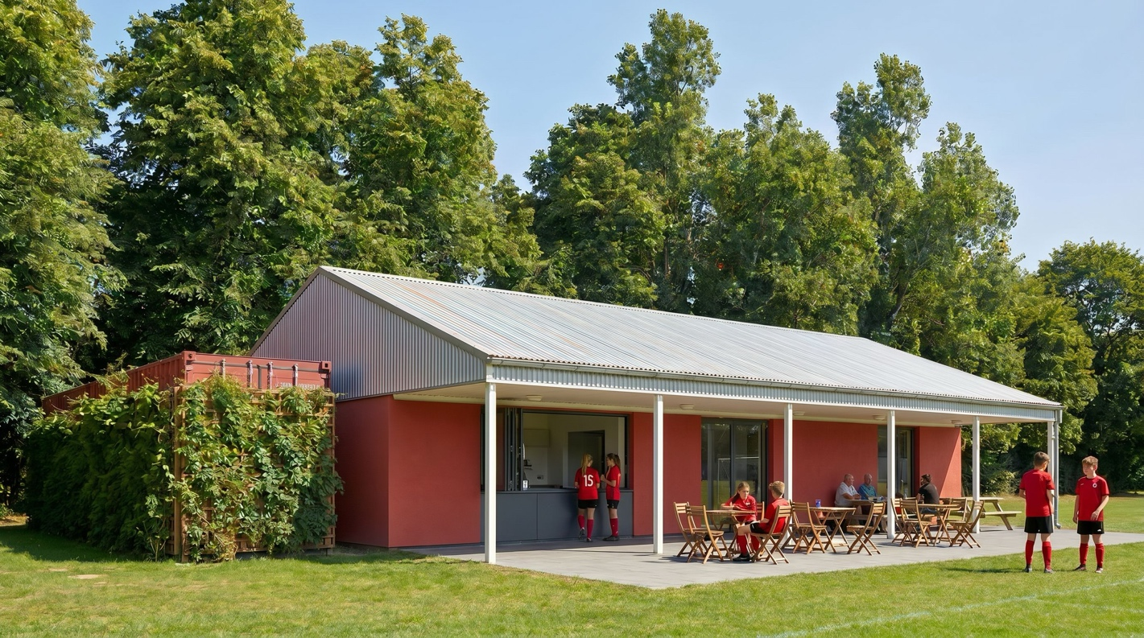
Figure 1: The pavilion viewed from the playing fields. The red silicone render finish is shown to the external walls, with the dark panel beneath the servery window matching the colour of the window frames. The existing corrugated metal roof and covered veranda are retained. The storage container is visible to the left, painted to match the render finish of the pavilion and screened by native climbing plants growing on the wire trellis fixed to its face. The permeable paved terrace runs the length of the elevation beneath the veranda.

View 2 — From the approach path to the north-west
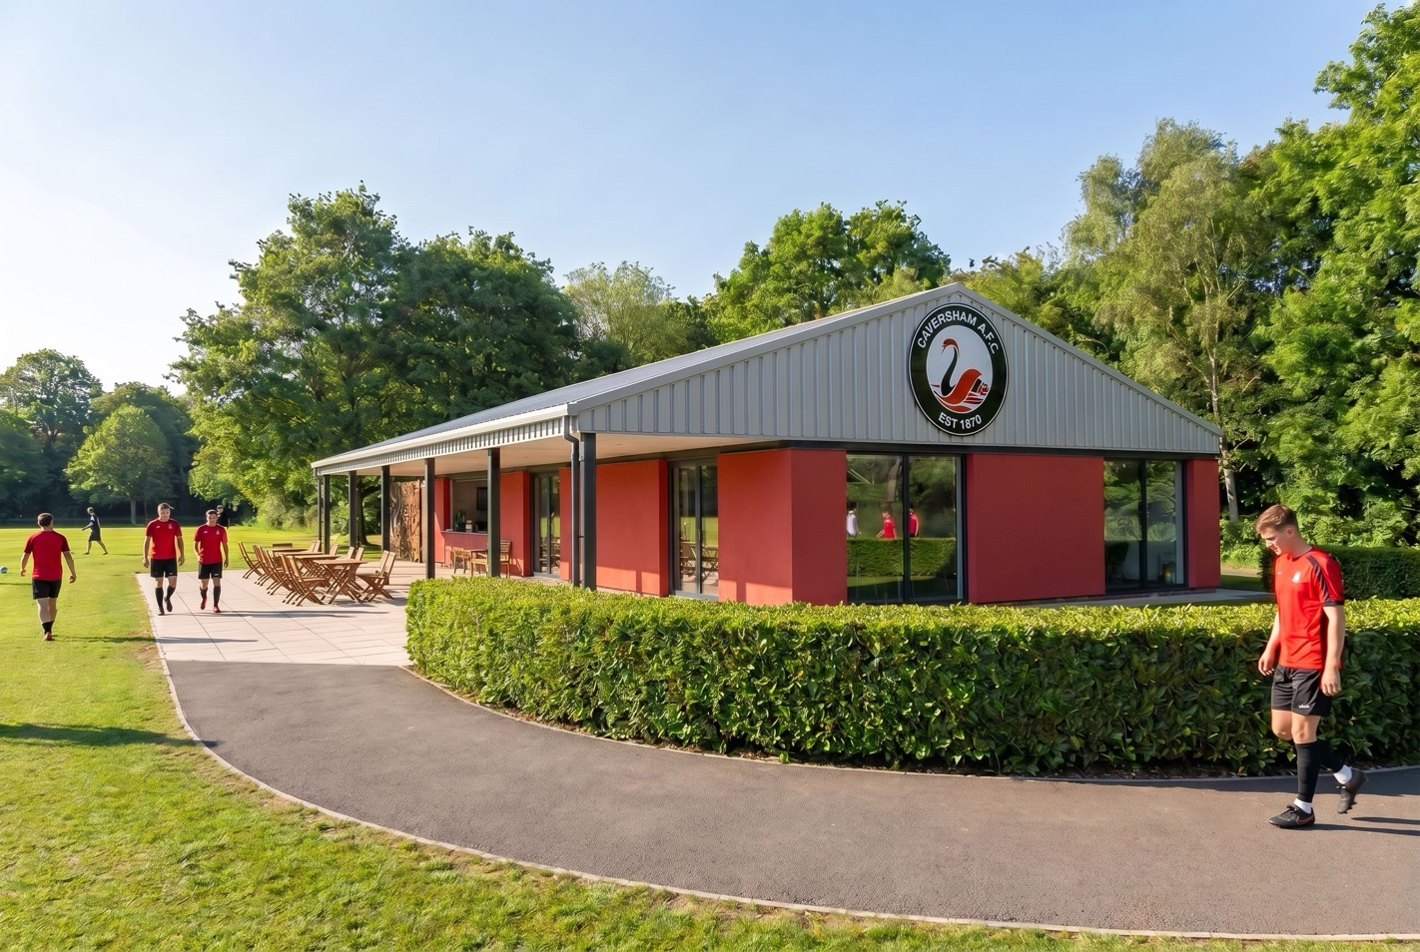
Figure 2: The pavilion viewed from the footpath connecting the car park to the building — the principal public approach. The red render is shown against the retained profiled cladding to the gable, which carries the club crest. The new native laurel hedgerow is shown to the terrace boundary in the foreground, providing enclosure to the seating area and screening it from the wider open space. Level, step-free access into the building is achieved by ramped thresholds formed within the terrace construction.
Note: images to be inserted into the frames above prior to submission. Colours shown are indicative; final render colour to be agreed and may be secured by condition.

