DELEGATED APPLICATION REPORT
Ward: Kentwood Ward
App Ref: PL/26/0335 Removal/variation of conditions
Address: Unit 1, Scours Lane, Tilehurst, Reading, RG30 6AX
Proposal: Section 73 application to vary Condition 2 (Drawings) of planning application PL/24/0852 “Proposed development a Drive-Through restaurant (Use Class E (a,b) and Sui Generis Hot Food Take Away, Car Parking, enhanced landscaping and Access Arrangements. Variation of Conditions 9 and 10 (BREEAM) of application 220637” (to amend the layout, hard and soft landscaping and elevational details and include EV Charging units)”.
Applicant: Mrs Nick Harrison
Received date: 12/03/2026
Target Decision date: 4/9/26 (EOT agreed)
Case Officer: Catrin Davies

- SITE DESCRIPTION

The application site relates to an area of grassland located on the south east side of Scours Lane, opposite the junction with Oxford Road, near Norcot Roundabout. There is a change in site levels and the site slopes up from the north to the south of the site.

The surrounding area to the north and west is predominantly comprised of the industrial and commercial units of Stadium Way. The area to the south is predominantly residential, with shops nearby on the opposite (south) side of the Norcot Roundabout. The River Thames is to the north of the site, beyond the railway line.

The site is located within the Portman Road Core Employment Area (EM2h) as well as within an Air Quality Management Area.

There are 3 trees on the site which are protected by a Tree Preservation Order (reference 30/10). Scours Lane is a designated Green Link and Oxford Road a treed corridor, which these trees, and others on the site, form part of.

The rearmost part of the site, to the north, is within Flood Zones 2 and 3 as designated by the Environment Agency.

- PROPOSAL AND SUPPORTING INFORMATION

The application seeks to vary condition 2 (drawings) of application PL/24/0852 “Proposed development a Drive-Through restaurant (Use Class E (a,b) and Sui Generis Hot Food Take Away, Car Parking, enhanced landscaping and Access Arrangements. Variation of Conditions 9 and 10 (BREEAM) of application 220637”

Condition 2 reads:

The development hereby permitted shall ONLY be carried out in accordance with the following approved plans:
Site Location Plan (Drawing No 2483-URB-ZZ-00-DR-A-208100 Rev P00a),
Site Block Plan as Proposed (Drawing No 2483-URB-ZZ-00-DR-A-208150 Rev P00a),
Ground Floor Plan as Proposed (Drawing No 2483-URB-ZZ-00-DR-A-208151 Rev P00a),
Roof plan as proposed (Drawing No 2483-URB-ZZ-RF-DR-A-208150 Rev P00a),
Elevations as Proposed (Drawing No 2483-URB-ZZ-XX-DR-A-208250 Rev P00a),
Sections as Proposed (Drawing No 2483-URB-ZZ-XX-DR-A-208350 Rev P00a),
Landscape Cross Sections (Drawing No QD784-301),
Cellular Tree Protection System (Drawing No QD784-303),
Cross Section Location Plan (Drawing no QD784-302),
Details of Unit 1 Well-being Space (Drawing No QD788-201 Rev A),
Unit 1 Well-being Space (Drawing QD788-200 Rev A),
Planting details (Drawing No QD788-203),
Hard Landscape Details (Drawing No QD788-204),
Landscape Masterplan (Drawing No GD784-300 Rev A),
Wildlife Enhancement Plan (Drawing QD784-304),
Transport Statement dated September 2021
Energy Strategy Statement Rev 01
Noise Impact Assessment dated January 2022
Flood Risk Assessment dated September 2021
Air Quality Assessment dated February 2022
Odour Risk Assessment dated February 2022
Arboricultural Impact Assessment and Arboricultural Method Statement dated 5th August 2022
Tree Survey Report revised January 2022

REASON: For the avoidance of doubt and to ensure that the development is carried out and adhered to in accordance with the application form and associated details hereby approved.

The proposal intends to amend the layout of the scheme with amended to parking and the inclusion on EV charging units.

Block Plan:

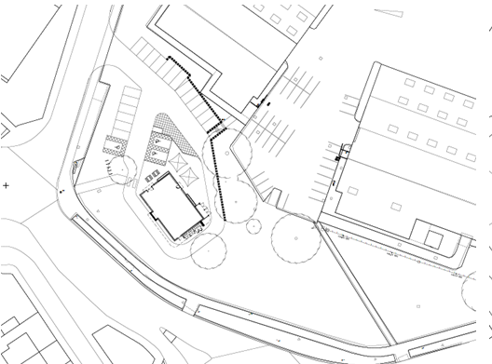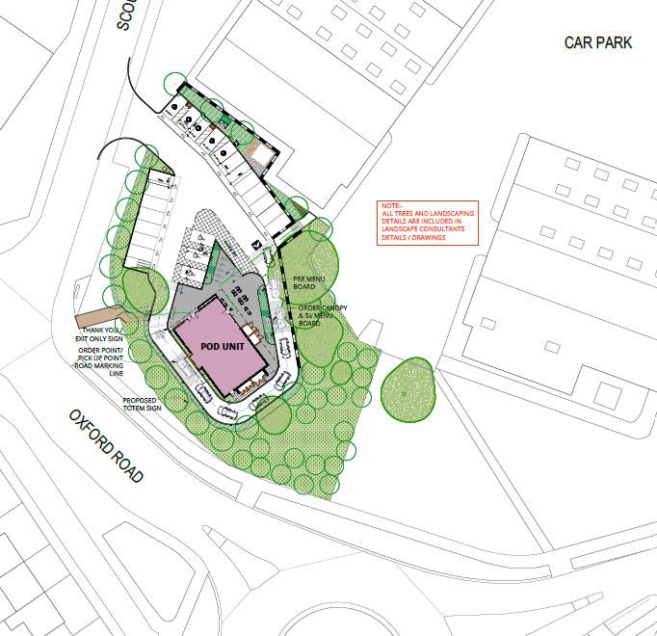

Approved Proposed
Floor Plans

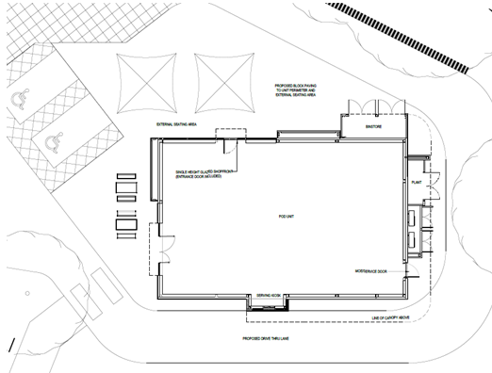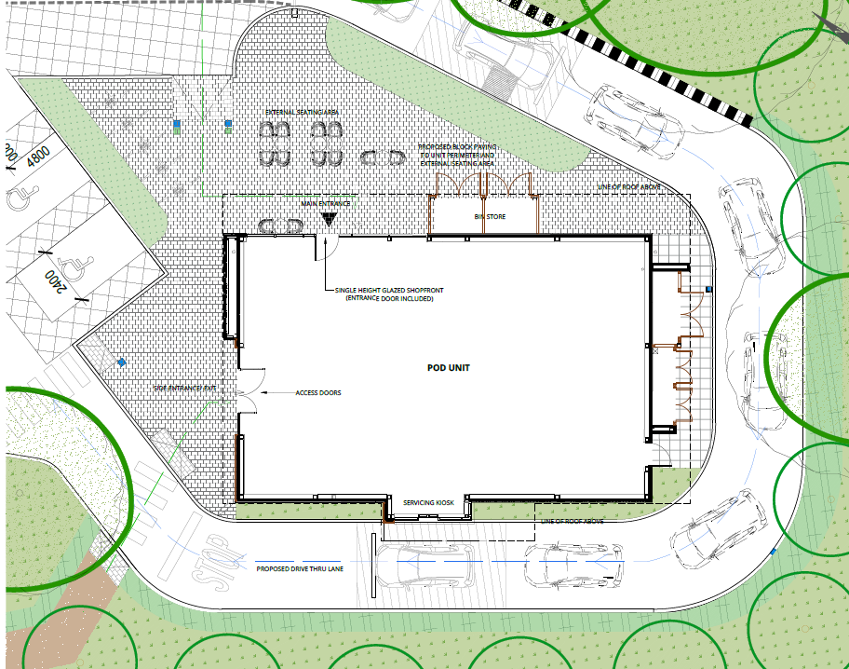

Approved Proposed

Elevations

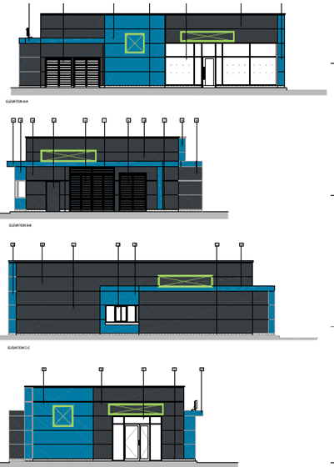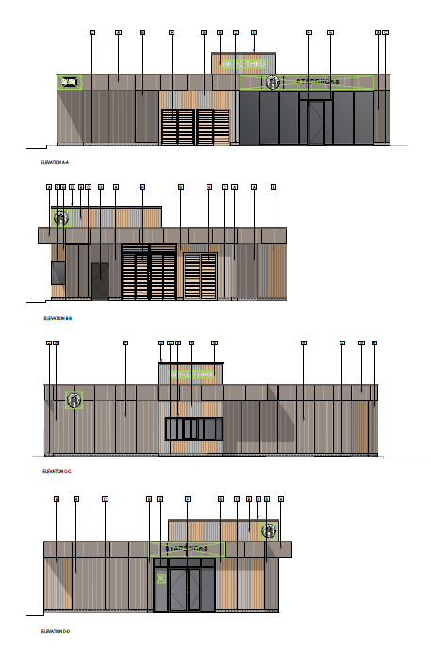

Approved Proposed

Plans and documents submitted:

Site Block Plan 2889-URB-ZZ-00-DR-A-208150 Rev P12
PROPOSED SITE EXTERNAL WORKS SECTION THROUGH STEPS SECTION A _ A drawing P 24-0805 EW20 Rev P2 received 12th of August 2026
Wildlife Enhancement Plan QD784-301 Revised 1 received 12th of August 2026
QD784-304-Rev G-Cellular Tree Protection System-2026-07-04 received 9th of July 2026
QD787-Soft Landscape Specification-2026-07-07 received 9th July 2026
2889-URB-ZZ-00-DR-A-208151-P06 Ground floor plan proposed received 9th of July 2026
QD784-402-Rev H-Topsoil Details-2026-07-05 received 9th of July 2026
QD784-404-Rev F-Landscape Cross Sections-2026-07-04 received 9th July 2026
QD784-400-Rev L-Detailed Planting Plan-2026-07-05 received 9th July 2026
QD784-300-Rev L-Landscape General Arrangement-2026-07-04 received 9th July 2026
QD784-403-Rev G-Landscape Cross Sections Location Plan-2026-07-04 received 9th July 2026
QD784-Topsoil Specification-2026-07-22 received 9th July 2026
QD784-201-Rev C-Tree Protection Plan-2026-07-07 received 9th July 2026
2889-URB-ZZ-00-DR-A-208150 Site Block Plan P12 received 9th July 2026
QD784-401-Rev K-Hard Landscape Details-2026-07-07 received 9th July 2026
2889-URB-ZZ-XX-DR-A-208250-P03 Proposed elevations received 26th March 2026
2889-URB-ZZ-00-DR-A-208150-P06 Proposed Block Plan received 26th March 2026
2889-URB-ZZ-RF-DR-A-208150-P05 Proposed roof Plan received 26th March 2026
2889-URB-ZZ-00-DR-A-208101-P00 Scours Lane Location Plan received 26th March 2026

Planning History:

The application site has an extensive history the most relevant to this application is:

PL/26/0291- Application for a Non-Material Amendment Following a Grant of Planning Permission PL/24/0852 to amend details with regards to the EV Charging points. Refused
PL/25/1509- Section 73 application to vary Condition 2 (Drawings) of planning application PL/24/0852 “Proposed development a Drive-Through restaurant (Use Class E (a,b) and Sui Generis Hot Food Take Away, Car Parking, enhanced landscaping and Access Arrangements. Variation of Conditions 9 and 10 (BREEAM) of application 220637” (to amend the design). Withdrawn.
PL/24/0852- Proposed development a Drive-Through restaurant (Use Class E (a,b) and Sui Generis Hot Food Take Away, Car Parking, enhanced landscaping and Access Arrangements. Variation of Conditions 9 and 10 (BREEAM) of application 220637. Approved with Conditions.

- CONSULTATIONS

The following were consulted:

Planning Natural Environment

The Tree Officer raises no objection to the proposal. While noting that the 1.6m ground level increase within the RPA is not ideal and expressing disappointment that amended landscape cross-sections and Cellular Tree Protection System drawings were not provided, they acknowledge that the approved porous design is acceptable and do not request any further amendments.

Transport Development Control

No objection to the section 73

Ecology Consultations

No objection

Environment Protection

No comments on the proposed amendments.

Public Consultation

A site notice was displayed at the application site and no letters of representations were received.

- LEGAL AND PLANNING POLICY CONTEXT

Section 38(6) of the Planning and Compulsory Purchase Act 2004 requires that proposals be determined in accordance with the development plan unless material considerations indicate otherwise. Material considerations include relevant policies in the National Planning Policy framework (NPPF) - among them the 'presumption in favour of sustainable development'. The following local and national planning policy and guidance is relevant to this application:

National Policy and Guidance
National Planning Policy Framework 2026

Reading Borough Local Plan (2019)
CC1: Presumption in Favour of Sustainable Development
CC2: Sustainable Design and Construction
CC3: Adaptation to Climate Change
CC4: Waste Minimisation and Storage
CC7: Design and the Public Realm
CC8: Safeguarding Amenity
CC9: Securing Infrastructure
EN1: Protection and Enhancement of the Historic Environment
EN4: Locally Important Heritage Assets
EN6: New Development in a Historic Context
EN12: Biodiversity and the Green Network
EN17: Noise Generating Equipment
TR1: Achieving the Transport Strategy
TR3: Access, Traffic and Highway-Related Matters
TR4: Cycle Routes and Facilities
TR5: Car and Cycle Parking and Electric Vehicle Charging
OU1: New and Existing Community Facilities
ER1: Sites for Development in East Reading

SPG/SPD
Revised Parking Standards and Design (2011)
Sustainable Design and Construction (2019)

Other documents
Reading Borough Council (Brighter Futures for Children) – Accessibility Strategy (Education)

Local Plan Partial Update (May 2025)

The current version of the Local Plan (adopted in November 2019) turned five years old on Tuesday 5th November 2024. The Local Plan was reviewed in March 2023 and around half of the policies in the plan are considered still up to date. However, the rest need to be considered for updating to reflect changing circumstances and national policy. A consultation version of the draft update of the Local Plan was published on 6th November 2024.

Although there is a five-year period for carrying out a review of a plan after it is adopted, nothing in the NPPF or elsewhere says that policies automatically become “out of date” when they are five years old. It is a matter of planning judgement rather than legal fact whether a plan or policies within it are out-of-date. This will depend on whether they have been overtaken by things that have happened since the plan was adopted, either on the ground or through changes in national policy, for example. Officer advice in respect of the Local Plan policies pertinent to these applications listed above is that they remain in accordance with national policy and that the objectives of those policies remains very similar in the draft updated Local Plan. Therefore, they can continue to be afforded weight in the determination of this planning application and are not considered to be ‘out of date’.

The Local Plan Partial Update was submitted to the Secretary of State on 9th May 2025. Submission marks the beginning of a process of public examination led by an independent Inspector. Due to the stage of examination, the draft Local Plan can be afforded limited weight.

Equality Act 2010:

In determining this application, the Council is required to have regard to its obligations under the Equality Act 2010. However, there is no indication or evidence (including from consultation on the application) that the protected groups identified by the Act have or will have different needs, experiences, issues and priorities in relation to this particular planning application. Therefore, in terms of the key equalities protected characteristics it is considered there would be no significant adverse impacts as a result of the development.

- APPRAISAL

Principle of the development

In the determination of this application regard must be had to the Development Plan and National policy within the NPPF. The application site is located within the urban area where the principle of such development is considered to be acceptable subject to detailed consideration.
This must be considered in light of the presumption in favour of sustainable development advocated by the NPPF.

The application has been made under Section 73 of the Town and Country Planning Act 1990 (S73) which enables the applicant to apply to develop land without compliance with conditions attached to a previous consent. Under this section the Local Planning Authority may amend, add, or remove conditions but may not amend any other part of the permission which includes the original description of the development proposal. S73 also specifically excludes the reconsideration of issues other than those covered by the conditions that are subject of the application.

The application seeks to vary condition 2 (drawings) of application PL/24/0852 “Proposed development a Drive-Through restaurant (Use Class E (a,b) and Sui Generis Hot Food Take Away, Car Parking, enhanced landscaping and Access Arrangements. Variation of Conditions 9 and 10 (BREEAM) of application 220637”. The proposal wish to alter the site layout as well as the design of the building.

The principle of development and the general planning merits were considered under the previous application. The key considerations therefore are whether the development would, taking into account the proposed changes, continue to have an acceptable impact on the key planning matters considered under the previous application; these are considered in turn below.

Design Considerations

Policy CC7 aims to preserve or enhance the character of the area in which a development is in terms of layout, landscape, density, scale, height, massing, architectural detail and materials.

Whilst the amended proposal would not appear identical to the appeal approved scheme, it remains comparable in terms of its overall scale, form and commercial character.

The site occupies a prominent position at the junction of Oxford Road, Wigmore Lane and Scours Lane and is visible from a number of public viewpoints. Accordingly, the quality of the building design and its relationship with the surrounding streetscene are important considerations. The proposed building would remain of a scale and massing appropriate to its setting and would continue to read as a standalone commercial building within an area characterised by a mix of highway infrastructure, commercial development and associated urban form.

The revised external materials are considered appropriate for the proposed use and would provide a contemporary appearance. The amendments to the architectural detailing and elevational treatment would add visual interest and would result in a building of acceptable design quality. The amended parking arrangement and ancillary structures would appear as functional and expected components of this type of development and would not detract from the overall appearance of the site.

In addition, the retention of perimeter landscaping and the provision of additional tree planting would assist in softening the appearance of the built development and maintaining a landscaped setting for the scheme. This would help to reduce the visual prominence of hard surfaced areas and ensure that the development integrates satisfactorily into the surrounding streetscene.

Taking all matters into account, the amended proposal is considered to represent a high quality design that would respond appropriately to the character of the area. The changes proposed under this Section 73 application would not result in harm to the character or appearance of the site or its surroundings and the development is therefore considered to comply with Policies CC7 and CC9 of the Reading Borough Local Plan (2019), which seek to secure high quality design that responds positively to local character and contributes positively to the public realm.

Trees

Policy EN14 of the Reading Borough Local Plan (2019) seeks to protect trees and requires development proposals to retain and enhance trees where possible, recognising their contribution to visual amenity, local character and environmental quality.

The appeal decision attached significant weight to the contribution made by the existing trees to the character and appearance of the area. The Inspector observed that the trees on the site varied in age, quality and canopy spread and noted that the mature trees proposed for removal were located within a prominent cluster towards the northern part of the site. Importantly, the Inspector found that these trees were highly visible from the surrounding area and possessed a high amenity value, making a positive contribution to the character and appearance of the locality. Notwithstanding this acknowledged value, the Inspector concluded that the impacts arising from the loss of these trees would be adequately mitigated through substantial replacement planting. In reaching this conclusion, the Inspector placed considerable weight on the proposed planting of 38 replacement trees and found that, once established, the scheme would improve the overall level of tree cover on the site. The Inspector further concluded that there would be an overall net gain in tree cover and that the scale and visibility of the replacement planting would adequately compensate for the loss of the existing trees.

The current Section 73 application continues to incorporate significant tree planting throughout the site and retains a strong landscaping framework around the development. The proposed planting would continue to provide an attractive landscaped setting for the development and would assist in softening the appearance of the built form, parking areas and associated infrastructure when viewed from the surrounding road network. Whilst the layout and design of the development have been amended, the proposal would continue to deliver substantial tree cover across the site and maintain the visual contribution that planting makes to the character of this prominent gateway location. It is therefore considered that the amended scheme remains consistent with the conclusions reached by the Inspector that replacement planting can successfully mitigate the effects of development on the site and ensure an acceptable appearance within the wider streetscene.

Ecology

Policy EN12 of the Reading Borough Local Plan seeks to maintain, protect and enhance the Green Network, recognising its importance in providing ecological connectivity between habitats. In allowing the appeal, the Inspector concluded that whilst the development would result in a reduction in the width of the Green Link, the Green Link would remain connected to the wider Green Network and would therefore not be fragmented. The Inspector placed weight on the proposed biodiversity enhancements, including native planting, wildflower areas, bird boxes, bat boxes, log piles and hedgehog habitats, finding that these measures would provide benefits to on-site biodiversity and wildlife and enhance the natural environment. Furthermore, the Inspector concluded that the significant planting and wildlife enhancements would enhance the biodiversity value of the site and mitigate any effects arising from the reduction in the width of the Green Link. Consequently, the appeal proposal was found to accord with the objectives of Policy EN12 relating to ecological connectivity and enhancement of biodiversity.

Policy EN12 of the Reading Borough Local Plan seeks to maintain, protect and enhance the Green Network, recognising its importance in providing ecological connectivity between habitats. In allowing the appeal, the Inspector concluded that whilst the development would result in a reduction in the width of the Green Link, the Green Link would remain connected to the wider Green Network and would therefore not be fragmented. The Inspector placed weight on the proposed biodiversity enhancements, including native planting, wildflower areas, bird boxes, bat boxes, log piles and hedgehog habitats, finding that these measures would provide benefits to on-site biodiversity and wildlife and enhance the natural environment. Furthermore, the Inspector concluded that the significant planting and wildlife enhancements would enhance the biodiversity value of the site and mitigate any effects arising from the reduction in the width of the Green Link. Consequently, the appeal proposal was found to accord with the objectives of Policy EN12 relating to ecological connectivity and enhancement of biodiversity.

Given the importance placed by the Inspector on the delivery of the approved biodiversity enhancements in concluding that the development would enhance the biodiversity value of the site and mitigate the effects arising from the reduction in the width of the Green Link, it is considered necessary to ensure that these measures are fully implemented. Accordingly, a condition is recommended requiring the submission of photographic evidence to the Local Planning Authority demonstrating the installation of the approved ecological enhancement measures, including any bird boxes, bat boxes and other habitat features. This will ensure that the biodiversity enhancements assessed as part of the application are delivered and maintained in the interests of biodiversity and in accordance with Policy EN12 of the Reading Borough Local Plan (2019).

Highways

Policy TR1 of the Reading Borough Local Plan (2019) requires development to provide safe and suitable access arrangements and ensure that impacts on the transport network are acceptable. Policy TR3 seeks to promote sustainable travel choices, including walking, cycling and electric vehicle infrastructure.

In determining Appeal APP/E0345/W/22/3313424, the Inspector considered concerns regarding additional traffic associated with the proposed drive-through restaurant and takeaway. The Inspector acknowledged that the development would result in an increase in activity on and around the site but concluded that the increase in vehicle movements would be limited in extent. No unacceptable highway impacts were identified and the appeal was subsequently allowed subject to conditions securing the approved access arrangements, parking provision, cycle parking and electric vehicle charging infrastructure.

The current Section 73 application proposes amendments to the site layout, including revisions to the parking arrangements and circulation within the site. However, the development would continue to utilise the approved access arrangements and would operate within the same use parameters as the appeal-approved scheme. The revised layout continues to provide an appropriate level of parking, servicing and vehicle circulation within the site whilst also accommodating cycle parking and electric vehicle charging facilities.

The Council's Highway Authority has reviewed the amended proposals and raises no objection subject to the recommended conditions. Officers are satisfied that the amended parking layout and internal vehicle movements would continue to operate safely and efficiently and would not result in a severe impact on the local highway network. The proposal therefore remains consistent with the findings of the Inspector and is considered to accord with Policies TR1 and TR3 of the Reading Borough Local Plan (2019).

Conditions

Condition 4 of planning permission 220637 (Parent consent) was discharged under application PL/24/0842 and is therefore proposed to be varied and retained as a compliance condition. Condition 5 was only required where the approved contamination assessment identified contamination posing unacceptable risks necessitating further remediation. As no such unacceptable risks were identified, the condition is no longer necessary and is proposed to be removed. The revised Condition 4 secures the approved mitigation and remediation measures and includes provisions to address any previously unidentified contamination encountered during the course of development.

Condition 7 of planning permission 220637 (Parent Consent) was partially discharged under 24/1070 with the Archaeology Officer not recommending full discharge until the works are completed and a satisfactory report submitted post construction. Condition 7 (condition 6 within the decision notice) have therefore been amended to reflect this and ensure the proposal complies with Policy EN1 and EN2 of the Reading Borough Local Plan 2019.

Condition 8 of application PL/24/0852 requires details of the external materials to be submitted to and approved in writing by the Local Planning Authority prior to development above foundation level. As part of the current Section 73 application, details of the proposed external materials have been submitted and are shown on the approved plans. The proposed materials are considered to be of a high quality and would contribute positively to the appearance of the development, ensuring that it responds appropriately to the character of the area and accords with Policy CC7 of the Reading Borough Local Plan (2019). Given that the details of the external materials have now been provided and assessed as part of this application, there is no longer a requirement for a pre-commencement details condition. It is therefore considered appropriate to replace the existing condition with a compliance condition requiring the development to be carried out in accordance with the approved plans and materials schedule.

- CONCLUSION

The proposed variation has been assessed against the Reading Borough Local Plan, the NPPF and other material considerations. It is considered that the amendments would not result in any unacceptable impacts on visual amenity, trees, ecology or highway safety, and the development remains acceptable. Accordingly, the application is recommended for approval, subject to conditions.

