The proposed development consists of the remediation of existing carpark and the replacement of the car parking surfacing thereby removing the existing permeable paving and replacement with porous tarmac surfacing. The principle of this change has been deemed acceptable.

The scheme also includes the installation of fencing and gates at various locations around the application site, those provided around the car parking area have been deemed acceptable in principle however a car park management plan was previously requested given that the vehicle route for coaches serving the school and servicing the adjacent garden centre runs through the school car park. The previously approved layout provided no restriction whilst the proposed fencing and gates would obstruct access for deliveries.

The applicant as part of the submitted management plan has claimed that the proposal would not alter the way in which deliveries to the garden centre currently operate however, I have attached the Technical Note associated with the school development that includes the approved swept path analysis for coaches and the garden centre (extracts also provided below) and the proposed fencing and gates will alter this operation. Given that this proposed route would no longer be possible the applicant would be required to provide updated swept path analysis to demonstrate that the same vehicles would be able to enter and exit the garden centre unimpeded.

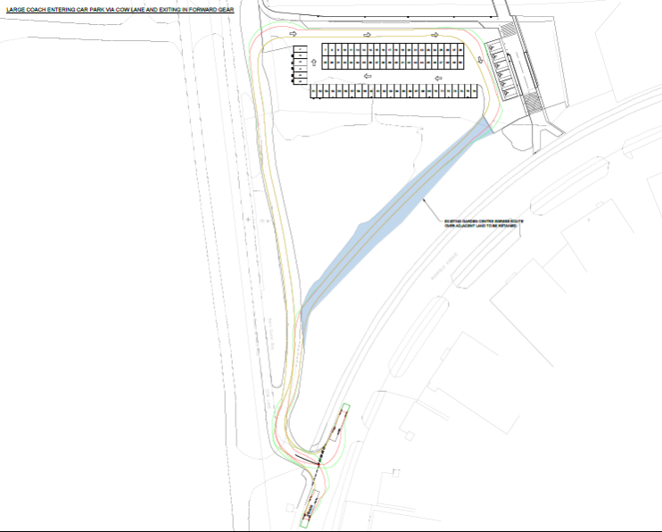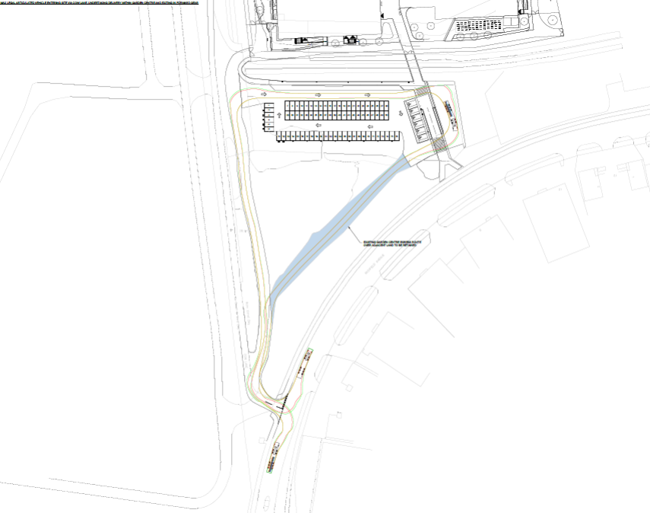

Given that this has not been undertaken the Highway Authority are concerned that sufficient deliveries and coach pick up and drop offs will not be accommodated on the site and will occur on Richfield Avenue to the detriment of Highway safety and flow of traffic.

The management plan has also stated that an intercom system will be in operation so that drivers can request entry. Further information is required on this:

• Where is the intercom system to be located given that this would need to be in the centre of the access road to allow a driver to request access. Swept path analysis would need to be presented for all movements to ensure that movement is not detrimentally impacted.
• In relation to the garden centre how will this intercom be operational during the school holidays and out of school hours when school staff will not be on site.

Without this information the Highway Authority are unable to determine whether the car parking area is to be provided with sufficient capacity to facilitate an acceptable access to the parking area not only for cars but for servicing vehicles.

Given the above the Highway Authority would be unable to recommend the approval and therefore object to the development on the following grounds.

Insufficient information has been submitted with the planning application to enable the access arrangements to the parking area; coach drop off and pickups and servicing arrangements for the adjacent garden centre to be fully assessed. From the information submitted, it is considered that the servicing is likely to take place on Richfield Avenue that would adversely affect the safety and flow of users of the existing road network within Reading. This is contrary to Policy TR3 of the Adopted Reading Borough Local Plan November 2019 and Policy TR4 1d of the National Planning Policy Framework adopted August 2026.

