26/08/2026
Planning Application Ref: PL/26/1023
Officer: Marcelina Rejwerska
Application Type: Householder planning permission
Address: 10 CINTRA AVENUE, READING, RG2 7AU
Proposal: Demolition of detached garage, single storey rear extension
and 2no. chimney stacks. Erection of new pitched roof garage/garden room and single storey rear extension. Including fenestration alterations, external landscaping and 1no. tree removal, to the side and rear elevations.
As part of the proposed development, a new single garage is to be constructed to compensate for the loss of the existing integral garage. It is generally recommended that a single garage provides internal dimensions of 7.0m in length by 3m in width to allow convenient access to and from each vehicle, together with sufficient storage space to the rear for bicycles. The existing garage is larger than the proposed replacement as illustrated below.

Proposed Garage Existing Garage
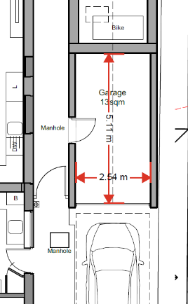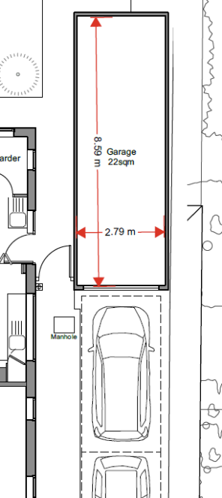

Notwithstanding this, there remains adequate scope within the site to accommodate additional off-street parking outside of the garage as illustrated below:

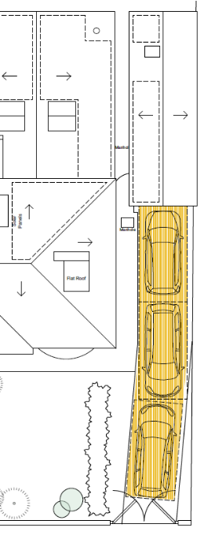
However, it is noted that the position of the third vehicle conflicts with the gate that opens into the site. In accordance with current adopted standards the site would only require 2 parking spaces. Therefore, plans should illustrate 2 parking spaces or a sliding gate/removal of the gate. No changes to the existing vehicle crossing are proposed.

The Natural Environment Officer should be consulted as there is reference to the loss of a tree.

There are no Transport objections to this application.

Suggested conditions and informatives:

DC2 VEHICLE PARKING (TO BE APPROVED)
DC3 VEHICULAR ACCESS (AS SPECIFIED)
IF3 Highways

N. Hussain
Transport Development Control Advisor

