DELEGATED APPLICATION REPORT
Ward: Abbey Ward
App Ref: PL/26/0763 Full planning permission
Address: 12 FRIARS WALK, READING
Proposal: Erection of an external secondary escape staircase to existing residential building (Block F), and the associated works.
Applicant: -
Received date: 10/06/2026
Target Decision date: 05/08/2026
Case Officer: Catrin Davies

- SITE DESCRIPTION

The application site relates to Plot F (Ebb & Flow) within the Station Hill development in central Reading. The site comprises an existing residential apartment building containing 183 dwellings, located between Friar Street and Garrard Street and fronting Friars Walk. The building is fully constructed and occupied and forms part of the wider mixed-use regeneration of the Station Hill area.

The surrounding area is predominantly urban in character, comprising a mix of residential, commercial and mixed-use development. The site is bounded by Friars Walk to the west and Garrard Street to the north, with Merchants Place and land to the east including the consented redevelopment site at 35-39 Friar Street. The building is approximately 12 storeys in height when viewed from Friars Walk and 13 storeys when viewed from Garrard Street.

Access to the building is principally provided from Friars Walk, with a secondary access from Garrard Street. An open pedestrian route is located to the rear (eastern side) of the building, providing connectivity between Merchants Place and Friars Walk. The proposed external staircase would be positioned within this area.

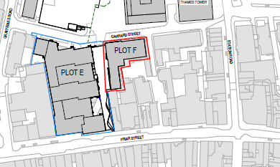

Site constraints:
- Allocated site
- Area of archaeological potential policy
- Central Core policy CR1
- Primary Shopping Area policy CR1
- Air Quality Management Area see policy EN15

- PROPOSAL AND SUPPORTING INFORMATION

The application seeks planning permission for the erection of an external secondary escape staircase and associated works to Block F (“Flow”), an existing residential building within the Station Hill development.

The proposed staircase would be located on the eastern elevation of the building adjacent to its south-eastern corner, within the existing pedestrian walkway linking Merchants Place and Friars Walk. The staircase would provide an additional means of escape from the southern residential corridor at each floor above first floor level, together with access from the roof terrace.

The staircase would extend from ground level to the upper floors of the building and would comprise a steel-framed structure with associated landings, fire-rated enclosures, cladding and access doors from the existing corridors. The lower section of the staircase, up to a height of approximately 9 metres, would be enclosed within fire-resistant construction to provide protection from a potential fire within the podium-level car park. Above this level, the staircase would incorporate fire-rated end walls and perforated cladding to the eastern side to facilitate ventilation.

The proposal has been designed to ensure compatibility with the building's existing fire safety strategy, including the location of exits from the southern corridor and the relationship of the staircase to existing smoke ventilation arrangements serving the development. The staircase would be sited wholly within the application site boundary and would maintain a separation in excess of 4 metres from the consented development at 35-39 Friar Street to the east.

The Proposed Development would require minor modifications to the existing storm water drainage
network.

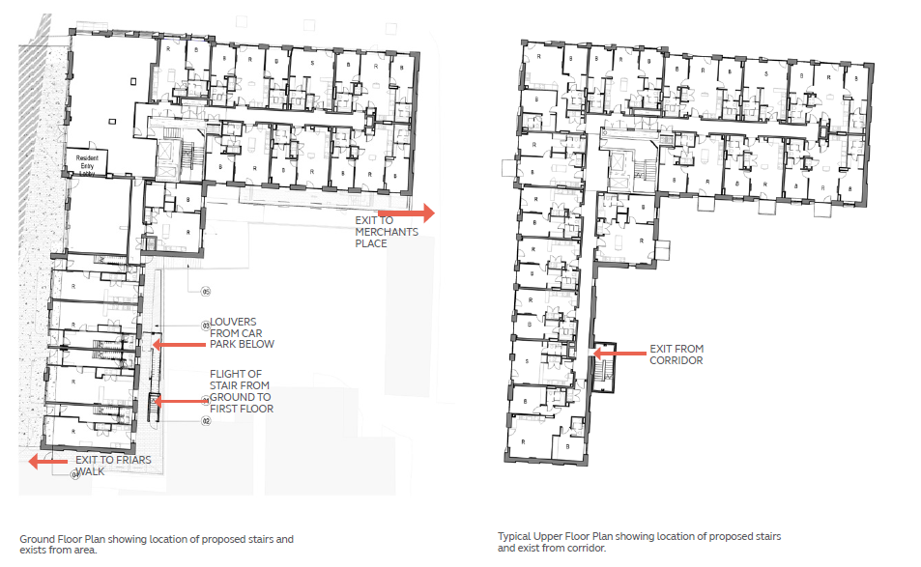

Need for the Development

The proposal has been brought forward in response to the evolving building safety framework including measures established through the Building Safety Act 2022 and subsequent amendments to Approved Document B of the Building Regulations. The application building is a Higher-Risk Building and exceeds 18 metres in height. Whilst the building was lawfully constructed and occupied in accordance with the regulatory requirements in force at the time of its development, the proposed secondary staircase is intended to enhance the building's means of escape and improve resilience in the event of a fire or other emergency. The additional staircase would provide an alternative escape route for residents and support compliance with contemporary fire safety guidance and best practice applicable to higher-risk residential buildings.

Plans and documents:

791-0427732-HLE-RP-FE-SHR Block F Staircase Fire Statement-Rev02
2026-0519 Station Hill Plot F Stair - Design and Access Statement
260609 - Station Hill Ph 1 Block F - Staircase - Cover Letter
Daylight Sunlight - Technical Note
Drainage Strategy Supplementary Memo 050526
SHR-ARC-SB-ZZ-PL-A-100-300 - Site - Location Plan
SHR-ARC-SB-ZZ-PL-A-100-301 - Existing Site Plan
SHR-ARC-SB-ZZ-PL-A-100-302 - Proposed Site Plan
SHR-ARC-SB-ZZ-PL-A-130-300 - Existing Floor Plans - Ground Floor and Level 01
SHR-ARC-SB-ZZ-PL-A-130-301 - Existing Floor Plans - Typical Floor Plan and Level 12
SHR-ARC-SB-ZZ-PL-A-130-302 - Proposed Floor Plans - Ground Floor and Level 01
SHR-ARC-SB-ZZ-PL-A-130-303 - Proposed Floor Plans - Typical Floor Plan and Level 12
SHR-ARC-SB-ZZ-PL-A-130-304 - Enlarged Ground Floor and Level 01
SHR-ARC-SB-ZZ-PL-A-130-305 - Enlarged Typical Floor Plan and Level 12
SHR-ARC-SB-ZZ-PL-A-200-300 - Existing Elevations 1-2
SHR-ARC-SB-ZZ-PL-A-200-301 - Existing Elevations 2-2
SHR-ARC-SB-ZZ-PL-A-200-302 - Proposed Elevations 1-2
SHR-ARC-SB-ZZ-PL-A-200-303 - Proposed Elevations 2-2
SHR-ARC-SB-ZZ-PL-A-300-300 - Section AA and Section BB – Existing
SHR-ARC-SB-ZZ-PL-A-300-301 - Section AA and Section BB – Proposed
SHR-ARC-SB-ZZ-PL-A-400-400 - Proposed Bay Study

Planning History
Application Ref. 190441: Outline application (pursuant to section 73 of the Town & Country Act 1990) for mixed use redevelopment of the site through the demolition and alteration of existing buildings and erection of new buildings & structures to provide Offices (Use Class B1), a range of town centre uses including retail and related uses (Use Class A1-A5)leisure (Use Class D2) and residential units, associated infrastructure, public realm works and ancillary development (all matters reserved) as permitted by planning permission 151427 granted on 26 July 2016 (which itself was an application under S73 to vary planning permission granted on 9 January 2015) [Approved, 6th December 2019]

Application Ref. PL/20/1533: Application for the approval of reserved matters (access, scale, appearance, layout and landscaping) and submission of details (Conditions 12, 13, 15, 16,17,18, 19, 20, 21, 22, and 52) for Plot F within the development site known as Station Hill, submitted pursuant to the Outline Planning Application ref. 201536/VAR. The proposals comprise the construction of a ground plus 12 storey building comprising 184 Build to Rent residential units, 762 sqm (GEA) of flexible retail, leisure and business floorspace (Use Class E, Sui Generis, F.1 and F.2), cycle storage, car parking, servicing, plant areas, landscaping, new public realm and other associated works. [Approved, 23rd July 2021]

Pre-application advice was sought in respect of the current proposal.

- CONSULTATIONS

Building Safety Regulator (BSR)

Following a review of the information provided in the planning application, the BSR is content with the fire safety design as set out in the project description, to the extent it affects land use planning considerations.

Public Consultation

A site notice was displayed at the application site and on the council website and no representations were received.

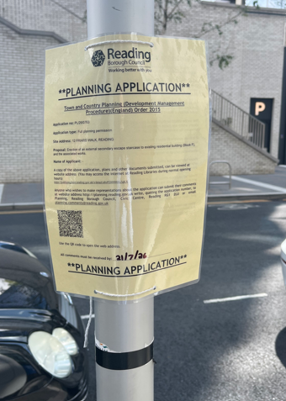

- LEGAL AND PLANNING POLICY CONTEXT

Local Plan Partial Update
The current version of the Local Plan (adopted in November 2019) turned five years old on Tuesday 5th November 2024. The Local Plan was reviewed in March 2023 and around half of the policies in the plan are considered still up to date. However, the rest need to be considered for updating to reflect changing circumstances and national policy. A consultation version of the draft update of the Local Plan was published on 6th November 2024.

Although there is a five-year period for carrying out a review of a plan after it is adopted, nothing in the NPPF or elsewhere says that policies automatically become “out of date” when they are five years old. It is a matter of planning judgement rather than legal fact whether a plan or policies within it are out-of-date. This will depend on whether they have been overtaken by things that have happened since the plan was adopted, either on the ground or through changes in national policy, for example. Officer advice in respect of the Local Plan policies pertinent to these applications listed above is that they remain in accordance with national policy and that the objectives of those policies remains very similar in the draft updated Local Plan. Therefore, they can continue to be afforded weight in the determination of this planning application and are not considered to be ‘out of date’

The Local Plan Partial Update was submitted to the Secretary of State on 9th May 2025. Officer advice in respect of the Local Plan policies pertinent to this application is that they remain in accordance with national policy (aside from Policy H1, which is acknowledged to be out-of-date) and that the objectives of those policies remains very similar in the submission draft updated Local Plan. Therefore, they can continue to be afforded weight in the determination of this planning application and are not considered to be ‘out of date’ (aside from Policy H1).

Relevant Policies:

National Policy
National Planning Policy Framework 2024
National Planning Practice Guidance

Reading Borough Local Plan (Nov 2019)
CC1 (Presumption in Favour of Sustainable Development)
CC2 (Sustainable Design and Construction)
CC7 (Design and the Public Realm)
CC8 (Safeguarding Amenity)
CR11 (Station/river Major Opportunity Area)
CR10 (Tall Buildings)
EN18 (Flooding and Sustainable Drainage System)

Equality Act 2010:
In determining this application the Council is required to have regard to its obligations under the Equality Act 2010. However, there is no indication or evidence (including from consultation on the application) that the protected groups identified by the Act have or will have different needs, experiences, issues and priorities in relation to this particular planning application. Therefore in terms of the key equalities protected characteristics it is considered there would be no significant adverse impacts as a result of the development.

- APPRAISAL

Principle of Development

The site forms part of the Station Hill development within the Station/River Major Opportunity Area, where Policy CR11 seeks to ensure development contributes positively to the area and does not compromise the delivery of neighbouring sites.

The proposal relates solely to the provision of an external secondary escape staircase to an existing residential building. No changes are proposed to the use of the building or the number of residential units. The works would enhance the building's fire safety arrangements and are not considered to prejudice the future development of surrounding sites. Accordingly, the principle of the development is considered acceptable and in accordance with Policy CR11 of the Reading Borough Local Plan.

Design Consideration

Policy CC7 aims to preserve or enhance the character of the area in which a development is in terms of layout, landscape, density, scale, height, massing, architectural detail and materials. Policy CR10 (Tall Buildings) highlights that, in Reading, tall buildings are defined as 12 storeys (36
metres) of residential development or above. The policy states that in the Station Area Cluster, tall
buildings should:
- follow a pattern of the tallest buildings at the centre of the cluster;
- contribute to the creation of a coherent, attractive, and sustainable cluster of buildings; and
- ensure that adequate space is provided between the buildings to avoid the creation of an overly dense townscape and to allow buildings to be viewed as individual forms.

The proposed staircase would be located on the eastern elevation of Block F within an existing pedestrian access area between the building and Merchants Place. The siting of the staircase on a secondary elevation limits its prominence in views from the principal frontages of the building and from the surrounding public realm. The proposal has been designed as an ancillary addition to the existing building, with its scale and form reflecting its functional purpose as an emergency means of escape.

The development would not increase the number of storeys, nor would it result in a material increase in the overall bulk of the building. Whilst the staircase would be visible from neighbouring land and some surrounding viewpoints, it would remain subordinate to the host building and would not alter the established role of Block F within the Station Area tall buildings cluster. The proposal would therefore maintain the separation and visual relationship between surrounding buildings and is not considered to result in an overly dense townscape.

The proposal is considered to respond appropriately to the existing building and its surroundings and is not considered to give rise to unacceptable harm to the character or appearance of the area. The development is therefore considered to accord with Policies CC7 and CR10 of the Reading Borough Local Plan.

Residential Amenity

Policy CC8 of the Reading Borough Local Plan seeks to ensure that development does not result in unacceptable impacts on the amenity of existing or future occupiers, including in relation to privacy, outlook, daylight and sunlight, noise and disturbance, and visual dominance.

The proposed staircase would be attached to the eastern elevation of the building and positioned within an existing circulation area to the rear of the site. The application is supported by a Daylight and Sunlight Assessment which concludes that the proposal would not result in any material reduction in daylight or sunlight to neighbouring properties, including the consented development at 35-39 Friar Street. Having regard to the submitted assessment, the scale of the structure and its relationship with surrounding buildings, no significant impacts on daylight or sunlight are considered likely.

In terms of privacy, the staircase would serve as a secondary means of escape and would not function as an external amenity space. No new habitable room windows are proposed as part of the development and opportunities for overlooking would therefore be limited. Given the nature of the proposed use, the development is not considered likely to give rise to unacceptable impacts on privacy. However, in the interests of safeguarding neighbouring amenity, it is considered reasonable and necessary to impose a condition restricting the use of the staircase to emergency evacuation, emergency access, inspection, testing and maintenance purposes only.

The proposal would not introduce any noise-generating uses and, subject to the above condition, use of the staircase would be limited to emergency situations and periodic maintenance activities. As such, significant impacts in terms of noise and disturbance are not anticipated. Whilst the proposal would introduce an additional built element, its scale, siting and relationship with neighbouring properties are not considered to result in an unacceptable sense of enclosure, visual dominance or harm to outlook.

Accordingly, the proposal is considered to accord with Policy CC8 of the Reading Borough Local Plan.

Drainage

Policy EN18 of the Reading Borough Local Plan seeks to ensure that development manages surface water appropriately, does not increase flood risk on or off site, and incorporates sustainable drainage measures where appropriate.

The proposed development would require minor modifications to the existing surface water drainage network. The application is supported by a Sustainable Drainage Supplementary Memo prepared by Ramboll, which advises that the development would result in an increase in drained roof area of approximately 1.5% compared with the approved scheme. This increase is considered negligible in the context of the wider drainage strategy serving the development.

The submitted information indicates that the existing drainage network has sufficient capacity to accommodate the additional runoff associated with the proposed staircase and associated structures. Given the limited scale of the development and the relatively minor increase in impermeable area, no material impact on surface water drainage or flood risk is anticipated.

The proposal is therefore considered to accord with Policy EN18 of the Reading Borough Local Plan

Other Matters

The proposal is intended to enhance the fire safety arrangements of the existing building through the provision of an additional means of escape. The applicant has confirmed that the building was designed and constructed in accordance with the relevant fire safety requirements applicable at the time of construction and that the proposed staircase would supplement the existing fire safety strategy.

The Planning Authority notes the intended safety benefits of the proposal which are a material benefit in favour of the proposals. The detailed assessment of fire safety compliance, including compliance with Building Regulations and other building safety legislation, falls outside the scope of the planning process and is a matter for Building Control and the relevant regulatory bodies. The assessment of this application has therefore focused on the planning merits of the proposal, including its design, visual impact and effects on neighbouring amenity.

While the Building Safety Regulator has advised that it is content with the fire safety design as described within the planning application insofar as it relates to land use planning considerations, this should not be taken as confirmation or approval that the proposal satisfies all fire safety, Building Regulations, or wider building safety legislative requirements. These matters fall outside the scope of the planning assessment and remain subject to separate consideration by the relevant regulatory bodies.

- CONCLUSION

The development is considered acceptable in terms of appearance and with no harmful impacts on residential amenities. The general fire safety improvements are a benefit (the specific requirements remain subject to detailed review by other relevant authorities in due course).The development has been assessed against the policies within the Reading Loval Plan the policies of the NPPF, guidance in the PPG, and other material considerations including third party representations. It has been concluded that the development would not result in any harm that would justify refusal in the public interest. The decision has been taken in compliance with the requirement of the NPPF to foster the delivery of sustainable development in a positive and proactive manner

- RECOMMENDATION

Grant subject to conditions

