DELEGATED APPLICATION REPORT
Ward: Kentwood Ward
App Ref: PL/26/0378 Full planning permission
Address: 130 WESTWOOD ROAD, TILEHURST, READING, RG31 6LL
Proposal: Change of Use of Existing Ancillary Accommodation to an independent one-bedroom dwelling with associated parking, refuse and landscaping (retrospective)
Applicant: Mr Brendan Ryce
Received date: 19/03/2026
Target Decision date: Originally 27/05/26 EOT agreed until 26/06/2026
Case Officer: Catrin Davies

- SITE DESCRIPTION

The application site relates to a single storey building located on the northern side of Armour Road. The building is single storey gable pitched roof, the building is stepped in from the road with parking at the front for two parking spaces with a degree of soft landscaping, the wider site contains 130 Westwood Drive which is a two storey dwelling as well at its curtilage. The building subject to this change of use application was previous an ancillary garage with its lawful use being ancillary accommodation.

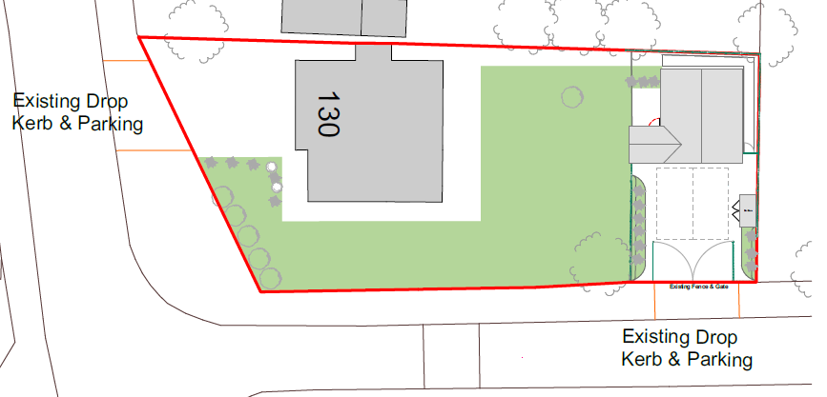

- PROPOSAL AND SUPPORTING INFORMATION

The application seeks planning permission for the change of use of existing ancillary accommodation to an independent one-bedroom dwelling with associated parking, refuse and landscaping. Planning permission was granted for the ‘conversion of the garage to ancillary living accommodation’ under application 220544.

The assessment determined that ‘The proposed conversion of the garage to habitable use ancillary to the main house as shown on the amended plans would not be harmful to the character or appearance of the site or its surroundings and would not have a detrimental impact on the amenities of the original building or those of neighbouring properties. As such the proposal is found to be in accordance with Policies CC7 (Design and the Public Realm), CC8 (Safeguarding amenity) and H9 (House Extensions and Ancillary Accommodation) of the Reading Borough Local Plan (2019) and the Council’s Supplementary Planning Guidance “A Design Guide to House Extensions” (2021).’

- CONSULTATIONS

The following were consulted:

Transport Development Control

Planning permission was granted under application 220544 on 24 June 2022 for the conversion of the existing garage to ancillary living accommodation. That permission was subject to a condition restricting occupation of the building to a use ancillary to the main dwelling at 130 Westwood Road.

The current application seeks permission for the existing annexe to be occupied as a separate, commercially let residential unit (Use Class C3), whilst remaining within the same ownership as the main dwelling.

Parking Provision
The proposed one-bedroom residential unit would require one independently accessible parking space, with the main dwelling retaining its existing provision of two parking spaces.

The submitted site plan shows the site benefits from two existing vehicle access points. Two parking spaces are proposed to be allocated to the new one-bed unit, accessed from Armour Road. The main dwelling would retain on site parkin accessed from Westwood Rd.

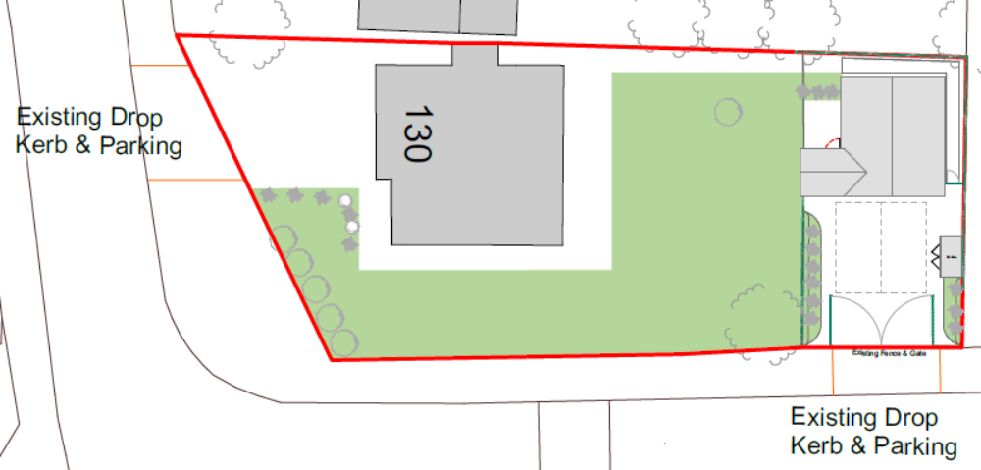

While the proposed level of parking exceeds the Council’s adopted parking standards for a one-bedroom dwelling, it is recommended that only one space is provided for the new unit. This would allow sufficient space to be made available for bin storage and collection arrangements.

Refuse and Recycling
At present, it is unclear where bins will be stored and presented for collection. The access area is gated, and bins are not permitted to be stored on the public footway. The removal of one parking space would create additional space for bin presentation, enabling kerbside collection when the gates are left open on collection days.

Cycle Storage
In accordance with the Council’s adopted standards, the new residential unit is required to provide secure, covered cycle storage for a minimum of one cycle. This could be provided in the form of a secure garden shed. No cycle storage has been indicated on the submitted plans, and this matter will need to be addressed.

Conclusion
In principle, Transport Services raise no objection to the proposal, subject to:
- Provision of one parking space only for the new residential unit;
- Clarification and provision of an appropriate bin storage and collection area; and
- Provision of secure, covered cycle storage in accordance with adopted standards.

Please ask the applicant to submit revised plans addressing the points above.

Public Consultation

A site notice was displayed at the application site as well as the council website and no letters of representation were received.

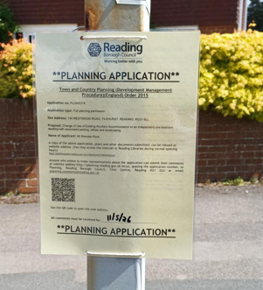

Plans:
9119-110 Proposed Site Plan REV 02 Amended plan received 27th May 2026
9119-106 Existing and Proposed Elevations received 19th March 2026
9119-104 Existing and Proposed Ground Floor Pla received 19th March 2026

Planning History:

PL/22/0544: Conversion of garage to ancillary living accommodation. Approved 24/6/2022
PL/21/1391: Conversion of existing garage into Annexe. Withdrawn
Pre-app – can give summary of advice

- LEGAL AND PLANNING POLICY CONTEXT

Section 38(6) of the Planning and Compulsory Purchase Act 2004 requires that proposals be determined in accordance with the development plan unless material considerations indicate otherwise. Material considerations include relevant policies in the National Planning Policy framework (NPPF) - among them the 'presumption in favour of sustainable development'. However, the NPPF does not change the statutory status of the development plan as the starting point for decision making (NPPF paragraph 12).

In this regard, the NPPF states that due weight should be given to the adopted policies of the Local Plan 2019 according to their degree of consistency with the NPPF (the closer the policies in the plan to the policies in the NPPF, the greater the weight that may be given).

Local Plan Partial Update
The current version of the Local Plan (adopted in November 2019) turned five years old on Tuesday 5th November 2024. The Local Plan was reviewed in March 2023 and around half of the policies in the plan are considered still up to date. However, the rest need to be considered for updating to reflect changing circumstances and national policy. A consultation version of the draft update of the Local Plan was published on 6th November 2024.

Although there is a five-year period for carrying out a review of a plan after it is adopted, nothing in the NPPF or elsewhere says that policies automatically become “out of date” when they are five years old. It is a matter of planning judgement rather than legal fact whether a plan or policies within it are out-of-date. This will depend on whether they have been overtaken by things that have happened since the plan was adopted, either on the ground or through changes in national policy, for example. Officer advice in respect of the Local Plan policies pertinent to these applications listed above is that they remain in accordance with national policy and that the objectives of those policies remains very similar in the draft updated Local Plan. Therefore, they can continue to be afforded weight in the determination of this planning application and are not considered to be ‘out of date’

The Local Plan Partial Update was submitted to the Secretary of State on 9th May 2025. Officer advice in respect of the Local Plan policies pertinent to this application is that they remain in accordance with national policy (aside from Policy H1, which is acknowledged to be out-of-date) and that the objectives of those policies remains very similar in the submission draft updated Local Plan. Therefore, they can continue to be afforded weight in the determination of this planning application and are not considered to be ‘out of date’ (aside from Policy H1).

Relevant Policies:

National Policy
National Planning Policy Framework 2024
National Planning Practice Guidance

Reading Borough Local Plan (Nov 2019)
CC1 (Presumption in Favour of Sustainable Development)
CC2 (Sustainable Design and Construction)
CC3 (Adaptation to Climate Change)
CC5 (Waste Minimisation and Storage)
CC6 (Accessibility and the Intensity of Development)
CC7 (Design and the Public Realm)
CC8 (Safeguarding Amenity)
CC9 (Securing Infrastructure)
EN12 (Biodiversity and the Green Network)
EN14 (Trees, Hedges and Woodland)
EN16 (Pollution and Water Resources)
H1 (Provision of Housing)
H2 (Location, Accessibility, Density and Housing Mix)
H3 (Affordable Housing)
H5 (Standards for New Housing)
H10 (Private and Communal Outdoor Space)
H11 (Development of Private Residential Gardens)
TR3 (Access, Traffic and Highway-Related Matters)
TR5 (Car and Cycle Parking and Electric Vehicle Charging)

Supplementary planning documents/guidance
Revised Parking Standards and Design (2011)
Sustainable Design and Construction (2019)
Affordable Housing Supplementary Planning Document (2021)
Planning Obligations Under Section 106 (2015)

Equality Act 2010:
In determining this application the Council is required to have regard to its obligations under the Equality Act 2010. However, there is no indication or evidence (including from consultation on the application) that the protected groups identified by the Act have or will have different needs, experiences, issues and priorities in relation to this particular planning application. Therefore in terms of the key equalities protected characteristics it is considered there would be no significant adverse impacts as a result of the development.

- APPRAISAL

Land Use Considerations

The NPPF states that: “Planning policies and decisions should promote an effective use of land in meeting the need for homes and other uses, while safeguarding and improving the environment and ensuring safe and healthy living conditions. Strategic policies should set out a clear strategy for accommodating objectively assessed needs, in a way that makes as much use as possible of previously-developed or ‘brownfield’ land”.

Notwithstanding, Policy H11 (which is read in conjunction with Policy CC7) of the Reading Borough Local Plan (Development of Private Residential Gardens) includes policies relating to appropriate development of residential gardens (detailed below).

Policy H2 of the Reading Borough Local Plans states that the appropriate density of residential development will be informed by:
- The character and mix of uses of the area in which it is located;
- Its current and future level of accessibility by walking, cycling and public transport;
- The need to achieve high quality design;
- The need to maximise the efficiency of land use; and
- The need to minimise environmental impacts, including detrimental impacts on the amenities of adjoining occupiers.

There is no in-principle objection to residential use in itself within this residential area, however, a proposal would need to comply with the policies set out within the Reading Borough Local Plan, which will be discussed further within this report.

Standards for new housing
In respect of standards for new housing, Policy H5 of the Reading Local Plan requires all new build dwellings outside the Central Area to comply with the nationally described space standards, alongside meeting requirements for water efficiency, energy performance and accessibility. While the building has already been constructed this was for ancillary accommodation and not a new residential dwelling as such Policy H5 would have been applied should an application been submitted for residential. It is not considered that an applicant should be able to circumvent policies by not applying for the intended purpose originally. Nevertheless, Policy H5 gives an indication as to what will be acceptable.

The proposed one-bedroom dwelling would fall below the minimum space standards, providing approximately 33.5sqm of internal floorspace, which is significantly below the required minimum of 37sqm (or 39sqm depending on configuration). This represents a clear shortfall and would result in a substandard, cramped and unsatisfactory form of accommodation for future occupiers. Furthermore, the application has not provided any details to demonstrate compliance with the required higher water efficiency standards or the relevant energy performance requirements, including the expectation for zero carbon or improved emission rates. When considered alongside the constrained nature of the site and the limited amenity provision, it is not considered that the proposal would achieve the high standard of residential accommodation required by Policy H5, and the scheme therefore fails to comply with the Council’s adopted standards for new housing.

Design and Character
Policy CC7 aims to preserve or enhance the character of the area in which a development is in terms of layout, landscape, density, scale, height, massing, architectural detail and materials.

Policy H2 of the Reading Borough Local Plans states that the appropriate density of residential development will be informed by:

- The character and mix of uses of the area in which it is located;
- Its current and future level of accessibility by walking, cycling and public transport;
- The need to achieve high quality design;
- The need to maximise the efficiency of land use; and
- The need to minimise environmental impacts, including detrimental impacts on the amenities of adjoining occupiers.

The Council’s adopted Policy H11 requires that new residential development that involves land within the curtilage or the former curtilage of private residential gardens will be acceptable where:

- “The proposal makes a positive contribution to the character of the area in terms of:
  - The relationship of the existing built form and spaces around buildings within the surrounding area;
  - A layout which integrates with the surrounding area with regard to the built up coverage of each plot, building line(s), rhythm of plot frontages, parking areas, and existing pattern of openings and boundary treatments on the site frontage;
  - Providing appropriate hard and soft landscaping, particularly at site boundaries. This includes features such as the variety of trees, hardstanding/lawns and hedges, etc;
  - Compatibility with the general building height within the surrounding area;
  - The materials and elevational detail. These should be high quality, and where appropriate distinctive and/ or complementary;
  - The arrangement of doors, windows and other principal architectural features and their rhythm between buildings.
- The application site provides a site of adequate size and dimensions to accommodate the development proposed in terms of the setting and spacing around buildings, amenity space, landscaping and space for access roads and parking;
- The proposal includes access, which meets appropriate highway standards;
- The proposal does not lead to tandem development;
- The design and layout minimises exposure of existing private boundaries to public areas, and avoids the need for additional physical security measures;
- The proposal does not cause a significant detrimental impact to the amenity of adjacent and nearby occupants;
- The emphasis is on the provision of family-sized housing;
- The development provides biodiversity net gain wherever possible, and would not have an adverse impact on biodiversity in terms of the fragmentation of blocks of gardens, which as a unit or in association with adjacent green space are deemed to make an important contribution to biodiversity and contribute to the green network; and
- The proposal does not prejudice the satisfactory development of a wider area.”

The proposed one-bedroom dwelling, by reason of its siting, scale and site layout, would result in a cramped and overdeveloped form of development that would relate poorly to its plot and fail to preserve or enhance the character of the area, contrary to Policy CC7. The subdivision of the plot would result in a materially smaller plot size and garden area compared to surrounding properties, disrupting the established pattern of spacious residential plots and undermining the prevailing character of the area. Furthermore, the limited separation distances to the north, west and eastern boundaries would give rise to a cramped and contrived form of development, with insufficient space around the building. This arrangement fails to reflect the established rhythm, spacing and openness that characterise the surrounding built form, resulting in an overdeveloped appearance.

The submitted site plan indicates the provision of a new 4m wide frontage gate; however, no corresponding elevation drawings or detailed specifications have been submitted to demonstrate its height, design, appearance or materials. Consequently, it is not possible to fully assess the visual impact of the proposed enclosure. Notwithstanding this, during the site visit a substantial gate was observed enclosing the site frontage. This creates a visually dominant and unneighbourly form of development that is at odds with the open and permeable character of the surrounding area. Such an arrangement fails to make a positive contribution to the character and appearance of the street scene, contrary to Policies CC7 and Policy H11, and instead introduces an incongruous and dominant appearance that erodes the established pattern of development within the locality.

Finally, the proposal seeks to introduce a one-bedroom dwelling within a garden setting. This does not align with the aim of Policy H11(7), which places emphasis on the provision of family-sized housing in such locations. As such, the proposal would not contribute appropriately to the borough’s housing mix.

Residential Amenity

Policy CC8 of the Reading Borough Local Plan requires that “Development will not cause a detrimental impact on the living environment of existing residential properties or unacceptable living conditions for new residential properties, in terms of:
• Privacy and overlooking;
• Access to sunlight and daylight;
• Visual dominance and overbearing effects of a development;
• Harm to outlook …”

Additionally, Policy EN16 states that “development will only be permitted where it would not be damaging to the environment and sensitive receptors through land, noise or light pollution.”

Policy H10 states that “Dwellings will be provided with functional private or communal open space, including green space wherever possible”.

Amenity of future occupiers

The relationship of the dwelling to its boundaries, including the presence of close-boarded boundary fencing, and trees would result in poor outlook from primary habitable room windows, with a constrained and enclosed sense of enclosure. In particular, windows on the southern elevation would predominantly face parked vehicles within a gated and enclosed setting, further limiting outlook and contributing to a poor quality residential environment. In addition, insufficient information has been provided to demonstrate that adequate levels of daylight and sunlight would be achieved, and the proximity of boundary treatments and parked cars is likely to further restrict light. Furthermore, the external amenity provision for the dwelling is limited in size and functionality, failing to provide meaningful or high-quality private open space in accordance with Policy H10. When taken together with the substandard internal floorspace, which falls below the nationally described space standards, the proposal would result in a cramped and poor overall level of amenity for future occupiers.

Amenity of neighbouring properties

With regard to the impact on the main dwelling at No.130, it is acknowledged that the subdivision of the garden associated with the proposal represents a departure from the existing arrangement and is therefore a negative aspect of the scheme. However, it is considered that sufficient and meaningful amenity space would remain available to serve No.130 itself following the subdivision, this element alone would not warrant refusal. The application has provided limited details in respect of boundary treatments; however, based on observations made during the site visit, it is evident that boundary fencing has been erected to subdivide the land. Given that the proposed dwelling is single storey in form and having regard to the presence of these boundary treatments, it is not considered that the development would give rise to direct overlooking or overbearing effects. In particular, the window on the western elevation serves a bathroom and is fitted with obscure glazing, which could reasonably have been secured by condition. On this basis, it is considered that the proposal would not result in material harm to the living conditions of the occupiers of No.130.

In relation to the impact on surrounding neighbouring properties, it is considered that the proposal would not give rise to material harm to residential amenity. The dwelling would maintain a reasonable degree of separation from adjacent properties, ensuring that there is meaningful distance between the proposed development and neighbouring properties. Furthermore, given the single-storey nature of the proposal, it would not result in undue overshadowing, overbearing impact, or loss of light to neighbouring occupiers. As such, it is not considered that the development would adversely affect the amenities of adjoining or nearby residents.

Affordable Housing

Policy H3 (Affordable Housing) of the Reading Borough Local Plan requires developments of this scale to make a financial contribution towards the provision of affordable housing. In accordance with the Council's Affordable Housing SPD (2021), this equates to a contribution equivalent to 5% of the Gross Development Value of the development.

During the course of the application, the applicant agreed in principle to provide the required affordable housing contribution and submitted valuation information which was assessed and considered acceptable by the Council. However, as the proposal is recommended for refusal on other planning grounds, no Section 106 Agreement has been completed to secure the contribution.

Consequently, there is no mechanism in place to secure the affordable housing contribution required by Policy H3 and the development would therefore fail to mitigate its impact on the Borough's acute affordable housing needs.

The failure to secure affordable housing attracts significant weight. Reading experiences exceptionally high levels of housing need and affordability pressures. The Council's Housing Needs Assessment (2024) identifies a requirement for approximately 406 affordable homes per annum, representing the majority of the Borough's objectively assessed housing need. The assessment highlights that the consequences of failing to provide affordable housing include increased homelessness, overcrowding, households occupying unsuitable accommodation, longer periods of dependence on family accommodation, and difficulties in retaining a workforce to support economic growth.

The need for affordable housing is further evidenced by the Council's most recent Annual Monitoring Report, which records that only 11 affordable homes were completed during 2024/25, compared to 890 total housing completions in the same monitoring period. This demonstrates a substantial shortfall in affordable housing delivery despite overall housing delivery exceeding annual targets. The disparity between identified need and actual delivery reinforces the critical importance of securing affordable housing contributions from all qualifying residential developments.

The Council's adopted position, as established through the examination of the Reading Borough Local Plan, is that the need for affordable housing within the Borough is so severe that contributions should be sought from residential developments of all sizes, including schemes comprising fewer than ten dwellings. Policy H3 remains an adopted development plan policy and continues to attract substantial weight. The proposal has therefore failed to demonstrate compliance with a key mechanism through which the Council seeks to address identified housing needs and support the creation of mixed and balanced communities.

Whilst it is acknowledged that the applicant has agreed in principle to provide the required contribution, and that this matter could potentially be overcome through the completion of a satisfactory Section 106 Agreement, in the absence of a completed legal mechanism the proposal conflicts with Policy H3 of the Reading Borough Local Plan and the Affordable Housing SPD. This weighs significantly against the proposal in the overall planning balance.

Highways Consideration
Policy TR3 states, In determining proposals involving a new or altered access onto the transport network, improvement works to the transport network, the creation of new transport infrastructure or the generation of additional trips on the transport network, consideration will be given to the effect on safety, congestion and the environment.

Policy TR5 requires that the development should provide car parking and cycle parking that is appropriate to the accessibility of locations within the Borough to sustainable transport facilities, particularly public transport.

The application site was historically used as a garage with access from Armour Road, and the proposed use would not result in a material change to the established access arrangements. Revised plans have been submitted following the initial highways comments, reducing the level of parking provision to one space for the proposed unit. Whilst further detailed clarification would typically be required in respect of cycle storage and refuse arrangements, notwithstanding concerns raised above in respect of layout and domestic paraphanelia it is considered that these could be adequately accommodated within the site. As such, the proposal is not considered to give rise to unacceptable impacts in respect of highway safety, parking or servicing, in accordance with Policies TR3 and TR5 of the Reading Borough Local Plan, and these matters would not form a reason for refusal. Had there been no overriding reasons for refusal, further information would have been sought to address these details.

Sustainability Considerations

In accordance with Policies CC2, and H5 of the Reading Local Plan (2019) all development would be required to demonstrate how it is proposing to be constructed to address climate change. In this instance the application has not been supported by any information regarding sustainability as such it has not been demonstrated to comply with these policies. As such this will form a refusal reason.

Waste Considerations

The proposal includes bin storage allocated within the application site as shown on the floor plans, it is considered this is adequate.

CIL

The proposal would be a Community Infrastructure Levy (CIL) liable development if approved. If the scheme had been acceptable an informative would have been attached to the decision notice to advise the applicant of their responsibilities in this respect.

Fall-back position

It is acknowledged that planning permission was granted under application 220544 for the conversion of the garage to ancillary living accommodation. In assessing that proposal, the Council concluded that the development would not be harmful to the character and appearance of the area or to neighbouring residential amenity. However, that assessment was undertaken on the basis that the accommodation would remain incidental and ancillary to the occupation of the host dwelling and would not function as a separate self-contained residential unit. Furthermore, a condition was attached in this respect.

The current proposal differs materially from the approved scheme in that it seeks to create an independent dwellinghouse with its own curtilage, parking provision, refuse storage and means of enclosure. As a consequence, the planning impacts of the development must be assessed as a separate residential unit rather than as ancillary accommodation.

In design terms, the approved ancillary accommodation continued to read as a subordinate outbuilding within the residential curtilage of the main dwelling and did not necessitate the subdivision of the plot or the creation of a separate domestic planning unit. By contrast, the proposed dwelling requires the formal subdivision of the garden, dedicated parking, cycle and refuse storage areas, and additional boundary treatments to create a separate residential curtilage. These interventions result in a noticeably more intensive form of development that erodes the spacious character of the plot and creates a cramped and contrived appearance. The proposal would therefore fail to preserve or enhance the established character of the area in a manner that was not associated with the previously approved ancillary accommodation.
Similarly, whilst the physical building remains largely unchanged, the amenity assessment differs significantly because the proposal would create a new self-contained dwelling required to provide an acceptable standard of accommodation in its own right. As ancillary accommodation, future occupants would have access to the facilities, living spaces, private amenity areas and overall residential environment of the main dwellinghouse. Consequently, matters such as the size of the accommodation and the quality of outlook were considered in the context of accommodation that was subordinate to and functionally linked with the main house.

As a separate dwelling, however, the accommodation must provide satisfactory living conditions independently. In this regard, the constrained relationship with surrounding boundaries, limited outlook, enclosed setting, restricted private amenity space and substandard internal floorspace become significant planning concerns. Whilst these physical relationships existed when the annex was approved, the impacts are materially different when assessed against the requirements of an independent dwelling, which must provide an appropriate standard of accommodation for future occupiers without reliance on the host dwelling. The proposal therefore fails to comply with Policies CC8 and H10 of the Reading Borough Local Plan, notwithstanding the previous approval for ancillary accommodation.

Planning Balance

The NPPF is a material consideration in planning decisions. Planning policies and decisions must also reflect relevant international obligations and statutory requirements.

Paragraph 11 of the NPPF deals with the presumption in favour of sustainable development, setting out that, for decision taking this means:

d) Where there are no relevant development plan policies, or the policies which are most important for determining the application are out-of-date, granting permission unless:

- The application of policies in this Framework that protect areas or assets of particular importance provides a strong reason for refusing the development proposed; or
- Any adverse impact of doing so would significantly and demonstrably outweigh the benefits, when assessed against the policies in the Framework taken as a whole, having particular regard to key policies for directing development to sustainable locations, making effective use of land, securing well designed places and providing affordable homes, individually or in combination.

Footnote 8 of the NPPF provides further clarification on decision-taking for applications involving the provision of housing and assessing when policies which are most important for determining the application are out-of-date. Footnote 8 states that this includes situations where the local planning authority cannot demonstrate a five-year supply of deliverable housing sites (with the appropriate buffer), or where the Housing Delivery Test indicates that the delivery of housing was substantially below (less than 75% of) the housing requirement over the previous three years.

In relation to five-year supply of deliverable housing sites the Council accepts that we are currently not in a position to demonstrate a five year housing land supply (plus the appropriate buffer) as such the ‘tilted balance’ is engaged.

When the tilted balance is engaged, it is necessary to conduct a planning balance in determining applications and the balance is whether the harms ‘significantly and demonstrably’ outweigh the benefits of granting permission when assessed against the policies in the NPPF.

In assessing the proposal, some weight is afforded to the provision of an additional residential unit within the existing urban area, contributing to the Borough's housing stock and making efficient use of previously developed residential land.

However, the benefits arising from the delivery of a single additional dwelling are limited. Whilst the Council acknowledges the importance of increasing housing supply, the proposal would provide only one additional unit of accommodation and therefore makes only a modest contribution towards meeting identified housing needs.

Furthermore, significant weight must be given to the identified harm arising from the proposal. The scheme would fail to provide a satisfactory standard of accommodation for future occupiers by reason of its substandard floorspace, constrained layout, poor outlook, limited amenity space and failure to demonstrate adequate levels of daylight and sunlight. As such, the proposal would not secure the high standard of amenity required by Policies CC8 and H10 of the Reading Borough Local Plan and the objectives of the National Planning Policy Framework. This considerably lessens the weight to be given to the provision of one, poor quality, dwelling.

In addition, the subdivision of the plot and associated introduction of separate domestic paraphernalia, including parking, refuse storage, cycle storage and boundary enclosures, would result in a cramped and contrived form of development that would be harmful to the character and appearance of the site and surrounding area. This harm attracts significant weight.

Whilst there are benefits associated with the provision of an additional dwelling, it is not considered that a poorly designed dwelling providing a substandard living environment would represent a meaningful or high-quality contribution to housing delivery. The harm arising from the failure to meet minimum space standards is substantial and the resulting poor living conditions would conflict with the objectives of het development plan and the framework, which seek to ensure high-quality sustainable housing. The adverse impacts identified are therefore considered to significantly and demonstrably outweigh the modest benefits of the proposal when assessed against the policies of the Development Plan and the Framework taken as a whole.

The supporting statement sates that “the building already exists, has already been converted and already contains the facilities associated with day-to-day residential occupation” It continues “the built form, scale, massing, design and visual presence of the development have already been assessed by the Local Planning Authority and found to be acceptable in the context of the site and surrounding area when permission 220544 was granted.”

The current permission is for ancillary accommodation only. The 2022 is clear that the use is to be ancillary – this is referred to in the description of development and secured by condition. Whilst the outbuilding does contain facilities shown on the floor plan, case law has established that the provision of facilities for independent living would not necessarily result in the creation of a separate planning unit from the main dwelling, rather it would be a matter of fact and degree. Nevertheless, the permission is clear that this is ancillary accommodation and not a separate dwelling. The block plan shows a door leading from the annexe to the main garden allowing a direct route across the lawn to the main house. There is no fence and no subdivision of the plot. Currently, there is no way into the building from the outside – the front door is in the garden of the main house. The approved scheme was considered acceptable as ancillary accommodation, but not a new dwelling.

- CONCLUSION

On the basis of the above and in light of any other material planning applications, the proposal is considered not to be in accordance with the development plan. Accordingly, the recommendation is made to refuse planning permission.

