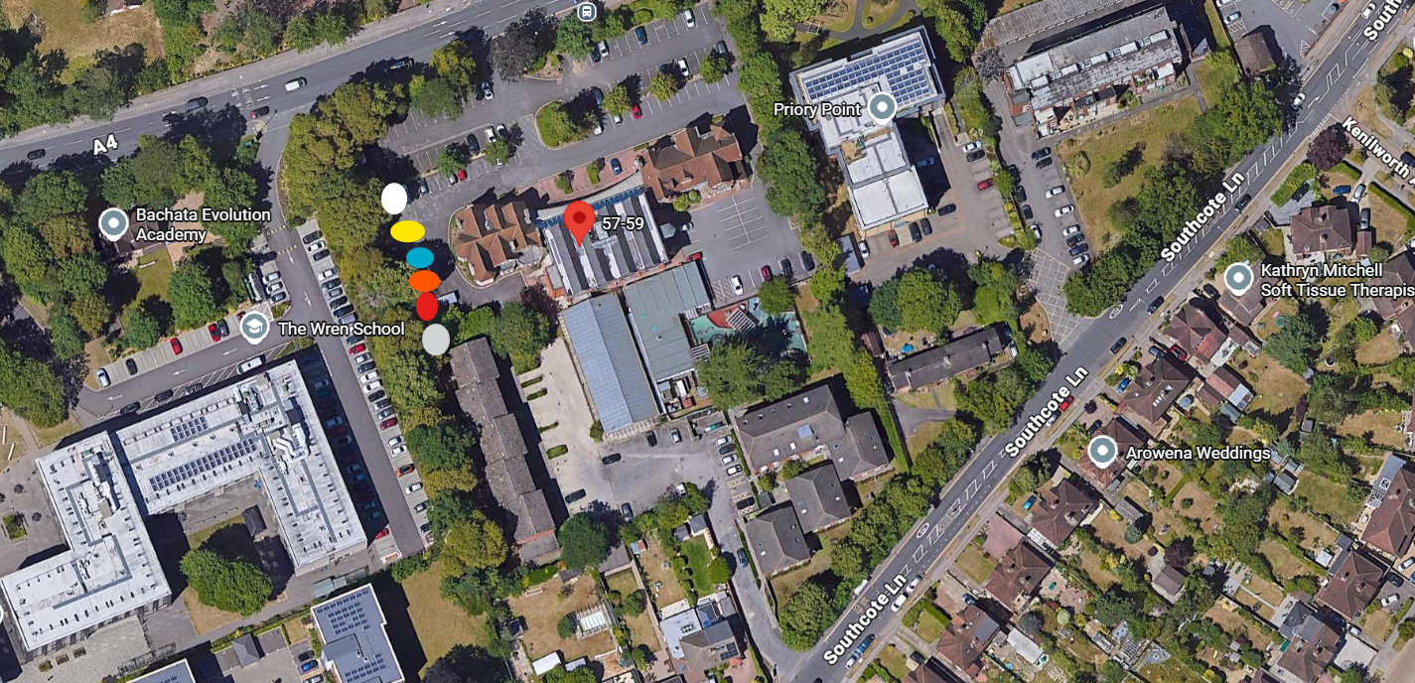

Work location
Bath Road
57-59
Berkshire
RG30 2BA

Works to be done

T1 Grey dot Sycamore – Raise crowns on branches to 5.4m by reducing lower hanging branches only to provide clearance for ambulance parked underneath and security cameras
T2 Red dot Common Lime - Raise crowns on branches to 5.4m by reducing lower hanging branches only to provide clearance for ambulance parked underneath and security cameras
T3 Orange dot Horse Chesnut - Raise crowns on branches to 5.4m by reducing lower hanging branches only to provide clearance for ambulance parked underneath and security cameras
T4 Blue dot Common Lime - Raise crowns on branches to 5.4m by reducing lower hanging branches only to provide clearance for ambulance parked underneath and security cameras
T5 Yellow dot Horse Chestnut - Raise crowns on branches to 5.4m by reducing lower hanging branches only to provide clearance for ambulance parked underneath and security cameras
T6 White dot Sycamore - Raise crowns on branches to 5.4m by reducing lower hanging branches only to provide clearance for ambulance parked underneath and security cameras

