04/08/26
Planning Application Ref: PL/26/0923
Officer: Marcelina Rejwerska
Application Type: Householder planning permission
Address: 146 SOUTHAMPTON STREET, READING, RG1 2RD
Proposal: The extension and refurbishment of an existing derelict house. New off street parking and external landscaping.

Previous Application for this site - PL/25/1263 – REFUSED
Southampton Street (A327) is a one way (South to North) main transport corridor and is located within the Zone 2, the primary core area but on the periphery of Zone 1, the central core area, which lies at the heart of Reading Borough, consisting primarily of retail and commercial office developments with good transport hubs. The site is well connected with a high level of public transport accessibility and access to public car parks. There are extensive parking restrictions in place preventing unauthorised on street parking including the operation of the Councils Residential Parking Permit Scheme.

This application is for the extension and refurbishment of an existing dwelling.
The application proposes 1 off street parking spaces accessed via the creation of a new 3m wide vehicle crossing from Southampton Street. Submitted plan illustrates an on-site turning are.
Proposed site plan:
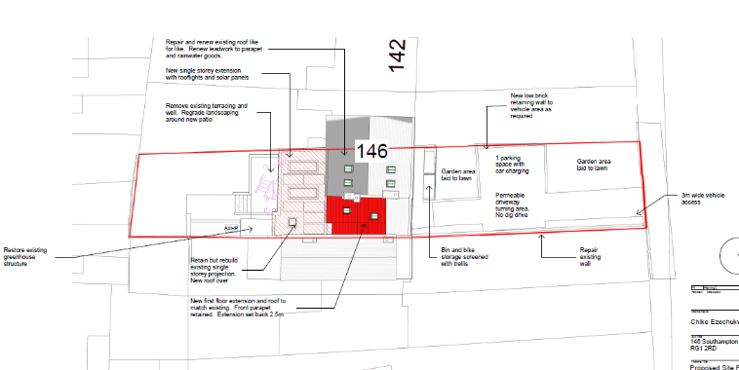
visibility splays of 2.4 metres by 43 metres are required to be illustrated. Revised plans are required.
There is a gradient down to the footway and therefore any proposal would be required to ensure that surface water is contained on the site either by way of a permeable parking surface i.e. permeable paving or a drainage channel would be required just within the property boundary. This can be covered by way of condition.

A license will be required to undertake all works on the public Highway; this includes the creation of the new vehicle crossing.

There are trees are on site; the Natural Environment Officer will need to be consulted.
It is noted that an electric vehicle charging point is being proposed, this is in line with the Councils Local Strategy Plan TR5.
In accordance with the Council’s Parking Standards and Design SPD, a 3+ bedroom dwelling should be provided with 2 secure cycle storage spaces. In a development of this nature this can be provided within a garage or a secure garden shed. Plans indicate storage provided at the front o the site. The applicant should consider relocating this to the rear for added security.

Bin storage should comply with Manual for Streets and British Standard 5906: 2005 for Waste Management in Buildings to avoid the stationing of service vehicles on the carriageway for excessive periods. As this is a replacement dwelling an assumption has been made that the bin collection and storage will be as current existing arrangements.

Given the sites location a scaled down version of a CMS will be required covering location of storage, deliveries etc.

Suggested conditions and informatives:

C2 CONSTRUCTION METHOD STATEMENT (TO BE SUBMITTED)
DC1 VEHICLE PARKING (AS SPECIFIED)
DC3 VEHICULAR ACCESS (AS SPECIFIED)
DC5 CYCLE PARKING (AS SPECIFIED)
DC8 REFUSE AND RECYCLING (AS SPECIFIED)
DC14 VISIBILITY SPLAYS (TO BE APPROVED)
DC24 EV CHARGING POINTS

SU7 SUSTAINABLE DRAINAGE (TO BE APPROVED)
No development shall commence on site until an appropriate method of drainage preventing water run-off from a private property onto the public highway has been submitted to and approved in writing by the Local Planning Authority.

REASON: These details are required due to insufficient information being contained within this submission and in order to reduce the risk of water run off on to the public highway in accordance with Policy EN18 of the Reading Borough Local Plan 2019.

IF3 Highways
I29 Access construction

N. Hussain
Transport Development Control Advisor

