The proposed development consists of the erection of ancillary outbuilding to accommodate additional nursery spaces. Firstly it should be clarified about what this increase would in fact be as the submitted documentation is conflicting referencing either 24 or 25 children. A similar planning application was withdrawn in 2025, application reference PL/25/0883.

The existing Nursery is registered for 88 children daily under the age of five years providing childcare Monday to Friday 8am-6pm. The site employs 30 staff on roll and there is off-street parking at the front of the building for three cars accessed from a dropped kerb off the Grove Road service road. The frontage of the site also provides secure storage for buggies and up to 17 bikes.

There is high demand for on-street parking in the area due to the various different uses in close proximity to the application site including a small parade of retail units, Emmer Green Primary School and Emmer Green Surgery.

A new Nursery building will be provided in a new building constructed on land immediately behind the existing nursery building. The new building will be used as a Day Nursery, complementing the existing provision allowing for an additional 24-25 children (under threes) who fall into the Government’s new Early Years Funding entitlements. It is stated that staffing will not increase and will be met by existing levels however, it should be clarified whether all 30 FTE staff will be on site all day everyday, or if there would in fact be in an increase in staffing levels during the day to cater for the additional children.

Access to the new building will be by way of the existing nursery on Grove Road. The private access to the site from Knights Way will be gated and retained for emergency use only. Refuse storage/collection and other servicing will all be undertaken by way of the existing nursery on Grove Road. These activities all take place in any event so there will be no overall increase in vehicle movements as a result of these activities.

In terms of parking, parking standards are set out in the RBC, Revised Parking Standards and Design Supplementary Planning Document (SPD) which takes into account the accessibility of the site. The site is located in Zone 3, Secondary Core Area. Typically these areas are within 400m of a Reading Buses high frequency ‘Premier Route’, which provides high quality bus routes. In accordance with the adopted Parking Standards and Design SPD, a D1 day nursery would be required to provide a parking provision of 1 space per 2 FTE staff and 1 drop-off space per 10 pupils based on flexible pick-up/drop-off times.

The frontage of the site can accommodate 3 on-site parking spaces which are used by staff. Based on the proposed number of staff and pupils (for the existing nursery and proposed building), the proposed development would require 27 parking spaces which cannot be accommodated within the site.

The applicant has undertaken a staff and pupil travel survey and this has identified a combined modal split of 26% utilising the private car. However, this data should be separated so that staff and pupils can be reviewed individually. In addition to this as part of the previous planning application for the site a survey was undertaken of staff and pupil travel modes and the Highway Authority requested further information in relation to the method of data collection and survey return rate from staff and children. This is essential data to ascertain whether the survey is in fact a reliable tool to predict the future travel habits of the additional pupils and therefore further information is required.

The Transport Statement asserts that impacts of the nursery are reduced even further by the fact that the nursery is in close to the nearby primary school many nursery pupils have siblings attending the nearby primary school and therefore trips associated with the nursery are likely to be linked trips. However, no evidence has been provided to confirm this and as such the Highway Authority are unable to accept this assumption.

Notwithstanding the above the application currently assumes that the proposed 25 additional childcare spaces are expected to generate only 7 additional car trips to the site.

There is unrestricted on street parking on Grove Road (service road) and there is high demand for on-street parking in the area especially during peak times. Given that there are only 3 on-site staff parking spaces, all demand for pick up and drop off’s to the nursery is currently met by the on-street unrestricted parking areas illustrated in the image below taken from the Transport Statement for the previous planning application. The applicant has now undertaken a car parking survey surrounding the application site that extends 200m form the site. However, given the nature of the proposal parents will aim to park as close to the nursery building as possible and therefore they will park on the service road or wait around until such time as a space becomes available potentially blocking access and egress of others. Further details of the survey will therefore be required identifying the location of the parking that occurred that includes a particular breakdown of the Grove Road service road.
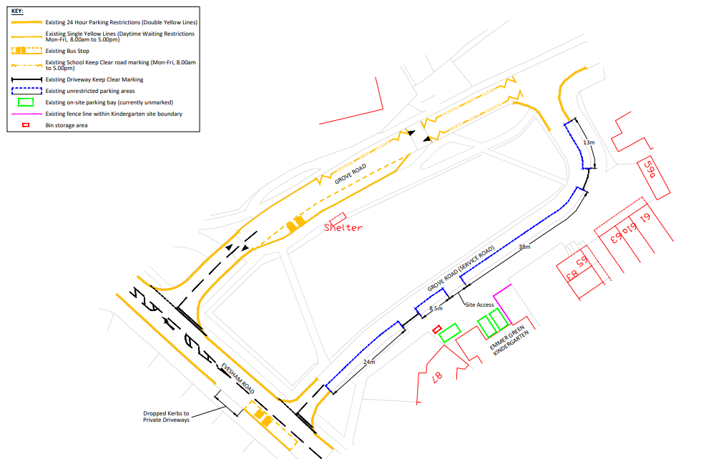

Policy TR5 states that development should provide car parking and cycle parking that is appropriate to the accessibility of locations within the Borough to sustainable transport facilities, particularly public transport. It goes on to say that ensuring the appropriate level of car parking in new developments involves striking a careful balance to ensure that there is not a knock-on effect on the safety and function of the highway through on-street parking. There is already high demand for on-street parking in the area and it is considered that the proposed development will intensify this further. High levels of on-street parking can affect highway safety, the free-flow of traffic, amenity, access by emergency services, refuse collection and delivery of goods compromising the safety of users of the transport network including pedestrians and cyclists.

Based on the information available, it appears the proposal will generate an intensification of vehicular traffic and on-street parking on Grove Road and the surrounding road network. In view of this, the Highway Authority cannot support the application.

Refusal reason

- The applicant has failed to demonstrate that the proposed development would not have a detrimental impact on the functioning of the transport network. The proposed on-site parking provision is inadequate, intensifying existing parking pressures and compromising the safety of users of the transport network including pedestrians and cyclists. Therefore, it is considered that the development fails to demonstrate that it complies with the Local Planning Authority’s standards in respect of vehicle parking, and is in conflict with Local Plan Policy TR5.

