30/07/2026

Planning Application Ref: PL/26/0557
Officer: Huimin Chen
Application Type: Householder planning permission
Address: 20 WINSER DRIVE, READING, RG30 3EQ
Proposal: Garage conversion including bay window to front elevation,
first floor side extension over garage and single storey rear extension including 1no. roof lantern
The proposed development would result in the loss of the existing garage, which is intended to be converted to ancillary accommodation. This would lead to the loss of one off-street parking space.
Submitted proposed block plan illustrates 2 parking spaces demonstrating how two in-curtilage parking spaces can be provided in accordance with the Council's adopted Parking Standards and Design SPD. On this basis, it is considered that adequate off-street parking can be retained, and therefore there are no highway or transportation objections to the proposal.
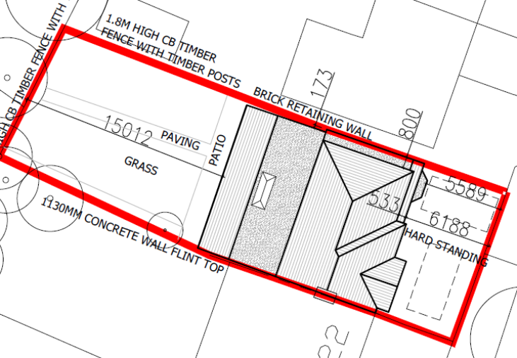

DC1 VEHICLE PARKING (AS SPECIFIED)
IF3 Highways

N. Hussain
Transport Development Control Advisor

