Personal Flood Plan for 1A Patrick Road Reading, RG4 8DD

Resident’s Name:…………………………………………………………………………………………………………...

Date completed:……………………………………………………………………
This document should be reviewed and updated on a regular basis (at least every three years), following flood events and changes in personal circumstances.
Nature of Flooding
The access/escape route to this site (shown overleaf) is at risk of flooding from the River Thames during extreme flood events. This area is predicted to flood with at least several days of advance warning. The Environment Agency model data predicts the escape/access route to be wet for approximately 10 days during a 1 in 100 year event in 2125 (allowing for predicted climate change), with depths exceeding 0.25m on the footway for 5 of those days. Reading Borough Council Emergency Planning Team has advised that access “would be not possible for some weeks”.
The Environment Agency data does not predict flooding of your house during an extreme 1 in 1,000 year flood. However, if flooding affects critical utilities (e.g. water supply, sewerage, electricity, gas) then your property will no longer be a suitable place of refuge and the Emergency Services are likely to order evacuation.
The default response to predicted flooding shall be to ensure that you are prepared to stay in your home for a significant period of time. You must also be prepared to evacuate your home for a significant period of time.
The following pages provide a checklist of actions to be taken before, during and after a flooding and which must be completed, as far as possible, upon receipt of this document. Both a ‘refuge pack’ and an ‘evacuation pack’ should be prepared and reviewed on a regular basis (refer to the checklists on pages 5 & 6).
The most critical action is that you must sign up to the flood warning service (0345 988 118).
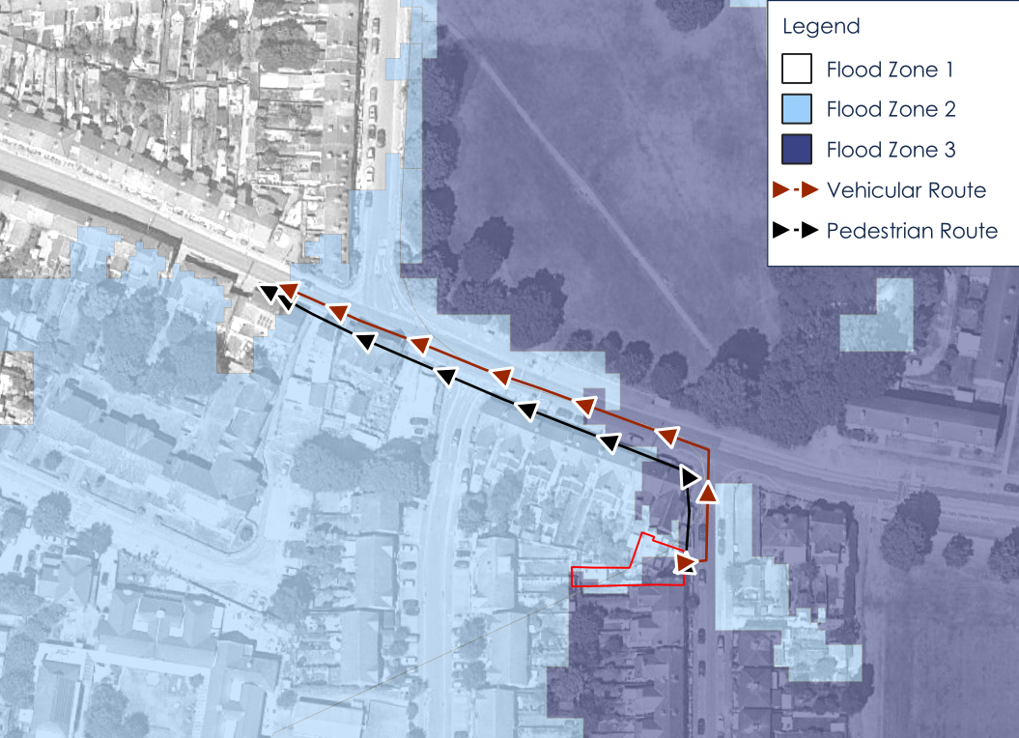
Flood Warnings
You must sign up to the Environment Agency Floodline Service (0345 988 118). The actions to be taken in response to the various levels of flood warnings are summarized in the table below. The risk descriptors relate to flooding within the flood warning area generally, rather specifically to the property itself.

Warning Level | Risk | Notes
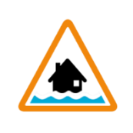  Flood Alert | Flooding is possible, be prepared | Prepare for flooding by confirming all necessary items to facilitate safe refuge or evacuation are present in sufficient quantities.
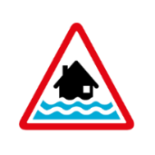  Flood Warning | Flooding is expected, immediate action required. | As per flood Alert and additionally consider evacuation, particularly if there is, or is likely to be, an issue with supply of vital utilities (water, electricity, gas). Evacuate if instructed to do so by the emergency services to inform this decision.
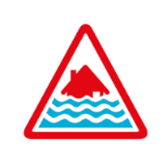  Severe Flood Warning | Flooding could cause danger to life and significant disruption to communities. | Take refuge unless it is desirable to evacuate and safe escape is still possible, or you have been advised to do so by the emergency services.

Checklists to help you prepare for flooding

Before a flood

Actions | Done | Notes
Sign up for flood warnings
Check you understand what the warnings mean:
- Flood alert
- Flood warning
- Severe flood warning
Note your local radio station for travel and weather updates
Note the phone number for Floodline (0345 988 118)
Note your local websites and social media
for updates
Check if your insurance covers you for flooding
Check you know how to turn off your electricity, water and gas
Prepare a Refuge Pack (see below)
Prepare an Evacuation Pack (see below)

Refuge Pack

Items | Done | Notes
Sufficient non-perishable food and drinking water to sustain the occupants and any pets
Sufficient medication

Suggested Evacuation Pack Contents

Items | Done | Notes
A copy of the personal flood plan
A list of emergency contact numbers (utilities, insurance company, EA) and useful contacts sheets.
Copies of important documents including passports, driving licences and insurance certificates (in the event of an evacuation).

Mobile phone and charger, and portable powerpacks.
Torches and/or camping lights
Radio
Spare batteries
A first aid kit, antibacterial hand gel,.

Whistle.

Essential medicines including hearing devices and glasses/contact lenses (if required) and repeat prescription forms
Dry, waterproof clothing and a change of clothing, including warm clothing.

Items needed for babies & small children – food, nappies, toiletries etc. (if required).

Items needed for pets (leads, food etc.)

Move important documents and possessions above ground level so that they’re safe from flood water even during an extreme flood. Protect them in a waterproof container. Keep them in a place that is easy to get to in an emergency.

Documents | Done | Notes
Passport
Driving licence
Medical cards
Insurance documents
Computers or laptops
Mobile phones and charges
Important photos and papers
Items of sentimental value

Getting help
Keep a note of who can help you and anyone you can help.
This might be relatives, friends or neighbours. Make a note of what help you might need from them, or what you can do to help them.

Contact details you might need

Insurance | Done | Notes
Home
Contents
Vehicle

Utilities | Done | Notes
Electricity
Gas
Water
Telephone
Broadband
Mobile phone
Media providers

Finance | Done | Notes
Bank accounts

Pets | Done | Notes
Kennels
Carers
Vets

Council | Done | Notes
District or unitary
Town or parish

Medical | Done | Notes
Doctors
Hospitals

Pets and animals
Think about what to do with pets if a flood happens.

Actions | Done | Notes
Where they might go
Food
Carriers
Leads
Medicines
If you are asked to evacuate, many centres will allow you to bring your pet. Put cats or small animals in a carrier or small box.

Immediately before a flood
Actions you can take if you know you are about to be flooded

Actions | Done | Notes
Turn off electricity, water and gas supplies
Get your evacuation pack together and prepare to move from your home
Make sure your mobile phone or devices are charged

When a flood happens
Actions you should take

Actions | Done | Notes

Follow warnings, information and advice issued by authorities
Do not walk or drive through flood water, as it may conceal hidden dangers
Do not put yourself or others at risk
Take your evacuation pack with you if you are directed to an evacuation centre
Let your family or friends know you are safe
Check they are safe too

After a flood
Actions you can take if flooding has occurred

Actions | Done | Notes
Do not return to your home until you are told it is safe to do so
When returning home, remember that flood water may contain sewage and conceal hidden dangers

Contact your insurance company to start the claims process
If you rent your property, contact your landlord and contents insurance company
Throw away items damaged by flood water after your property and items have been checked by a loss adjuster
Throw away items in an appropriate manner
You may need gas or electricity engineers to check your supply before turning it back on.

Further information
Further information on the nature of flooding can be found in the following documents submitted to support the planning application, which include details on simulated flooding in the area (progression and duration, depths etc.):
- 26-225-60-031 The Granary 1a Partrick Road Flood Emergency Management Plan
- 26-225-60-030The Granary 1a Partrick Road Flood Risk Assessment
You can find more general information from:
- Your Reading Borough Council
- The British Red Cross
- The National Flood Forum

Use this space to make any further notes you think might help you.

