DELEGATED APPLICATION REPORT
Ward: Caversham Heights Ward
App Ref: PL/26/0583 Householder planning permission
Address: 16 WESTDENE CRESCENT, CAVERSHAM, READING, RG4 7HD
Proposal: Garage conversion to gym
Applicant: Rohan D’Silva
Received date: 01/05/2026
Target Decision date: 28/07/2026 (EXT)
Case Officer: Chukwudi Onwudinanti

- SITE DESCRIPTION
The application site comprises a detached dwelling located at 16 Westdene Crescent, Caversham. The property is situated within an established residential area characterised by detached and semi-detached dwellings of varying scale and design.

The site benefits from a detached garage/outbuilding positioned within the rear/side garden area, separate from the main dwelling and set well back within the plot.

The application site is not located within a Conservation Area and the building is not statutorily listed.

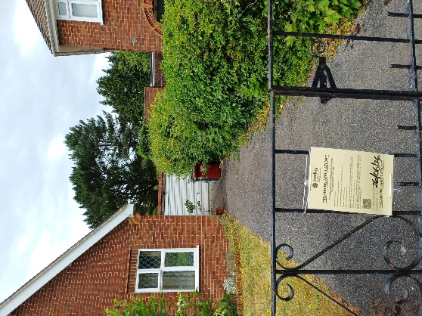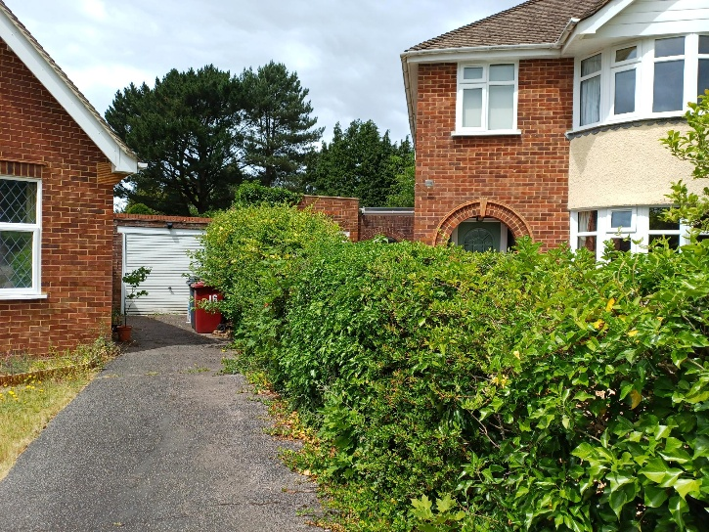
Site Photos

- PROPOSAL AND SUPPORTING INFORMATION
Planning permission is sought for the conversion of the existing detached garage into a gym.

The proposed works include:

• Conversion of the existing detached garage to a domestic gym, increasing the maximum height to 2.87m ground to eaves (Existing- max 2.4m height reducing to 1.95m);
• Upgrading of the garage walls and floor;
• Removal and replacement of the existing garage roof;
• Installation of French doors to the front;
• Installation of a new window to the rear;
• External brickwork and roof materials to match the existing building.

Plans and Documents dated 07/03/2026 received 01/05/2026

Drawing No WC-R00-EX-101 Rev R00 – Site Plan Location Map
Drawing No WC-R00-EX-102 Rev R00 – Existing Floor Plans
Drawing No WC-R00-EX-104 Rev R00 – Existing Elevations
Drawing No WC-R00-PR-101 Rev R00 – Site Plan Location Map
Drawing No WC-R00-PR-102 Rev R00 – Proposed Floor Plans
Drawing No WC-R00-PR-104 Rev R00 – Proposed Elevations
Drawing No: WC-R00-PR-106 Rev R00 – Proposed Sections

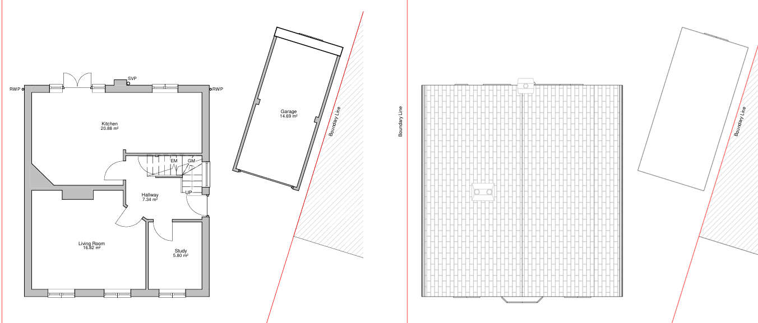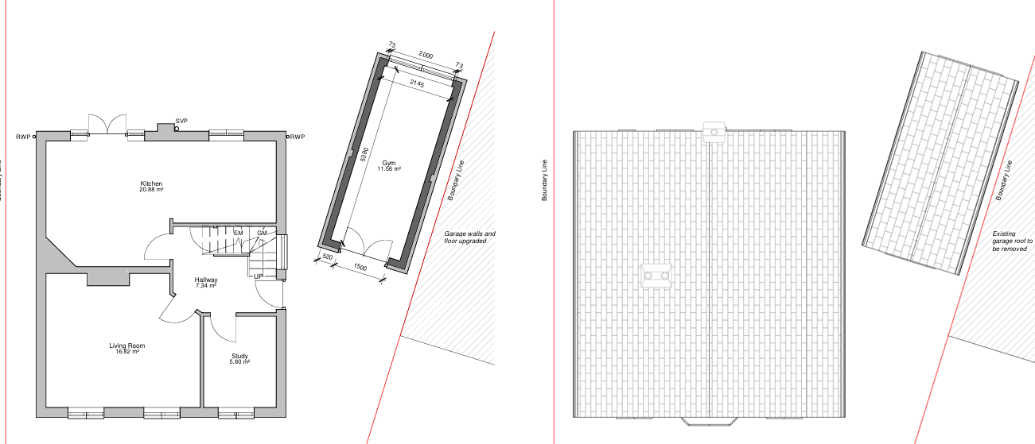
Existing and Proposed Plans

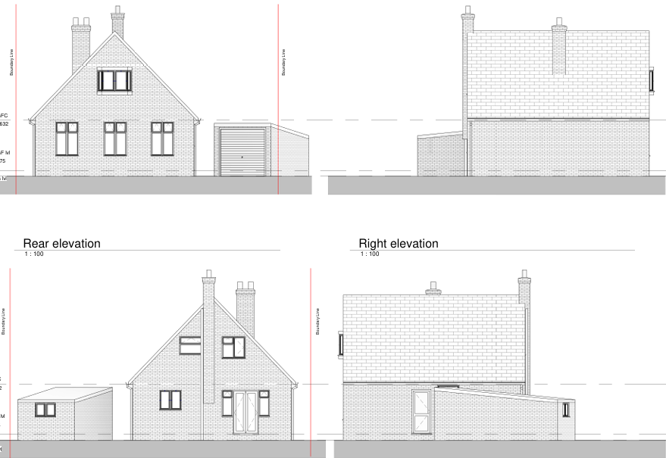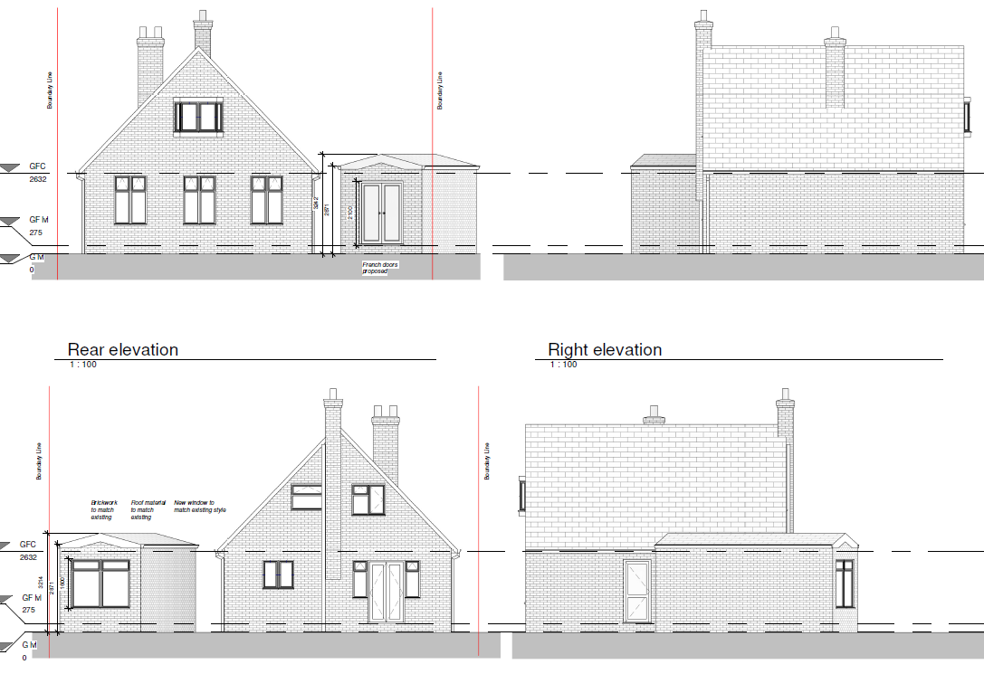
Existing and Proposed Elevations

- RELEVANT PLANNING HISTORY
App Ref: PL/04/1136 (HOU)
Description: Two storey side and rear extension
Decision: Approved
Decision Date: 21/01/2005

App Ref: PL/26/0584 (CLP)
Description: Single storey rear extension
Decision: Pending

- CONSULTATIONS
A Site Notice was displayed on 05/06/2026.
No letters of representation have been received.

Equality Act 2010:
In determining this application, the Council is required to have regard to its obligations under the Equality Act 2010. However, there is no indication or evidence (including from consultation on the application) that the protected groups identified by the Act have or will have different needs, experiences, issues or priorities in relation to this particular planning application. Therefore, in terms of the key protected characteristics, it is considered that there would be no significant adverse impacts arising from the proposed development.

- LEGAL AND PLANNING POLICY CONTEXT
Section 38(6) of the Planning and Compulsory Purchase Act 2004 requires that proposals be determined in accordance with the development plan unless material considerations indicate otherwise. Material considerations include relevant policies in the National Planning Policy Framework (NPPF) – among them the presumption in favour of sustainable development.

National Policy
National Planning Policy Framework
National Planning Practice Guidance

Reading Borough Local Plan (2019)

CC7 (Design and the Public Realm)
CC8 (Safeguarding Amenity)
H9 (House Extensions and Ancillary Accommodation)
H10 (Private and Communal Outdoor Space)
TR5 (Car and Cycle Parking)

SPD
Design Guide to House Extensions SPD (2021)

Local Plan Partial Update
The current version of the Local Plan turned five years old on 5 November 2024. The Local Plan was reviewed in March 2023 and around half of the policies in the plan are considered still up to date. However, the remainder require updating to reflect changing circumstances and national policy. A consultation version of the draft updated Local Plan was published on 6 November 2024 and the Submission Draft was submitted to the Planning Inspectorate on 9 May 2025. Examination hearings took place in February 2026.

Although there is a five-year period for carrying out a review of a plan after it is adopted, neither the National Planning Policy Framework nor legislation provides that policies automatically become out of date once they are five years old. Whether a policy is out of date is a matter of planning judgement, taking account of subsequent changes in national policy and local circumstances.

Officer advice is that the Local Plan policies relevant to this proposal remain consistent with national planning policy. Furthermore, the objectives of the policies referred to below remain substantially unchanged within the emerging Local Plan. Accordingly, whilst the emerging Local Plan attracts limited weight at this stage, the adopted Local Plan policies continue to carry significant weight in the determination of this application and are not considered to be out of date.

- APPRAISAL
Character and Appearance
Policy H9 states that extensions should respect the character of the dwelling and surrounding area in terms of scale, siting, materials and design. Policy CC7 similarly requires development to respond positively to local context through high-quality architecture, appropriate proportions and suitable materials. Paragraph 135 of the National Planning Policy Framework requires development to be visually attractive, sympathetic to local character and to create a high standard of design.

The proposal would retain the building in its current position and would not increase the overall floor area, but the height would increase slightly. The garage door would be replaced with double French doors with an enlarged window to the rear. The proposed French doors and window would be domestic in appearance and acceptable within the residential curtilage.

The submitted elevations show the proposed brickwork and roof materials would match the existing building.

Given the siting of the building and the modest nature of the alterations, the proposal would not appear visually intrusive or harmful to the character of the dwelling or surrounding area.

The proposal therefore complies with Policies CC7 and H9.

Residential Amenity
Policy H9 states that development should not result in an overbearing impact on neighbouring properties and should avoid unacceptable loss of outlook, daylight, sunlight or privacy. Policy CC8 seeks to ensure that development safeguards the living environment of existing and future occupiers. Paragraph 135(f) of the National Planning Policy Framework similarly requires development to secure a high standard of amenity for existing and future users.

The proposed gym use would be incidental to the use of the dwelling and would not, in itself, give rise to unacceptable noise or disturbance in a residential context. The proposed new openings would not result in harmful overlooking given the single-storey nature of the building and its domestic use.

Subject to a condition ensuring that the converted garage remains ancillary to the main dwelling and is not used as a separate dwelling, independent unit of accommodation or commercial premises, the proposal would not result in unacceptable harm to neighbouring residential amenity.

The proposal therefore complies with Policies CC8 and H9.

Private Amenity Space
Policy H10 seeks to ensure that adequate private outdoor amenity space is retained for residential occupiers.

There would be no change to the footprint of the building and, therefore, no change to the available amenity space and would, therefore, comply with Policy H10.

Highways and Parking
The application form indicates that the proposal would not affect existing car parking arrangements. It appears as if the garage is not used for parking purposes and there is an existing driveway with space for a couple of cars. The site would retains external space capable of accommodating parking within the curtilage, and the proposal would not alter the existing vehicular access or highway arrangement. Given the domestic nature of the proposal and the absence of any new dwelling or separate use, no material highway safety harm is identified.

The proposal is therefore acceptable in relation to Policy TR5.

- CONCLUSION
The proposed development would convert an existing detached garage into a domestic gym incidental to the enjoyment of the main dwelling.

The proposal would preserve the character and appearance of the host dwelling and surrounding area, would not result in unacceptable impacts upon neighbouring residential amenity, and would not give rise to highway safety concerns.

The development therefore accords with the National Planning Policy Framework and Policies CC1, CC7, CC8, H9, H10 and TR5 of the Reading Borough Local Plan (2019), together with the Design Guide to House Extensions SPD (2021).

- RECOMMENDATION: Grant
Subject to the following conditions:
- Time Limit
- Approved Plans
- Materials to Match Existing
- Ancillary Use Only

