DELEGATED APPLICATION REPORT
Ward:
App Ref: PL/26/0221 Householder planning permission
Address: 11 APPLEBY END, READING, RG30 2NR
Proposal: Front Porch, Single storey rear and side extension, Internal Alterations (Amended)
Applicant: Mr Servesh Singh
Received date: 18/02/2026
Target Decision date: 28/07/2026 (EXT)
Case Officer: Chukwudi Onwudinanti

1. SITE DESCRIPTION

The application site comprises a residential dwelling located within an established suburban area. The surrounding area is characterised by similar residential properties with a mixture of original dwellings and domestic extensions of varying forms.

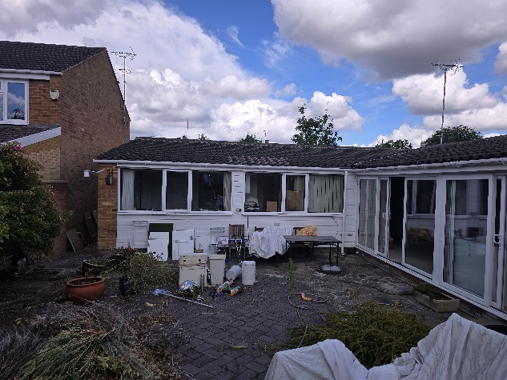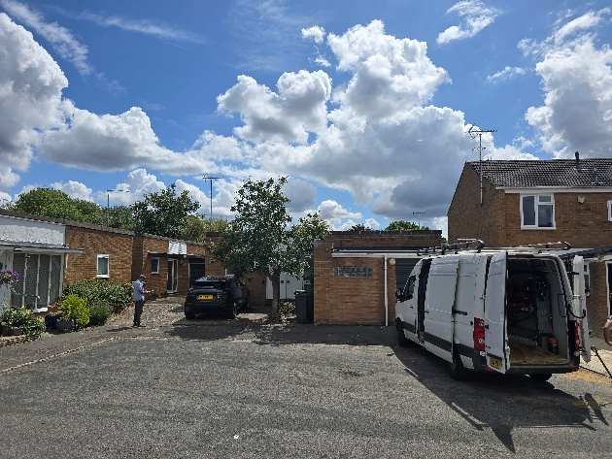

2. PROPOSAL AND SUPPORTING INFORMATION
Planning permission is sought for:

- A single-storey rear/side extension incorporating a flat roof, with mostly glazed roof and ‘glass wall’ incorporating a shower room at one end creating an open glazed area adjacent to the proposed internally reconfigured open plan layout kitchen/dining/ living area and existing bedroom.
- A front porch addition

- Minor associated alterations to windows and roof

The proposed development represents a modest increase in the footprint of the dwelling and does not involve extensions at first floor level.

Plans and Documents received 18/02/2026, unless otherwise stated:

- PRASAD-TD-25-331-P1, Rev 3 – Site and Location Plan, received 24th February 2026
- PRASAD-TD-25-331-E1, Rev 2 – Existing Elevations
- PRASAD-TD-25-331-E2, Rev 2 – Existing Ground Floor
- PRASAD-TD-25-331-P3, Rev 3– Proposed Ground Floor
- PRASAD-TD-25-331-P2, Rev 3 – Proposed Elevations
- PRASAD-TD-25-331-P6, Rev 3 – Proposed Roof Plan
- PRASAD-TD-25-331-P7, Rev 3 – Sections 1, 2, 3

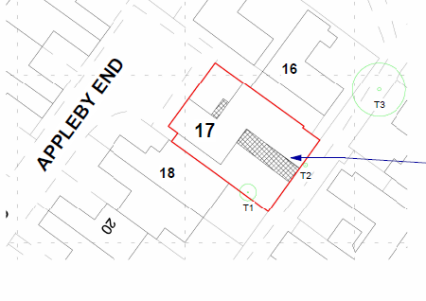

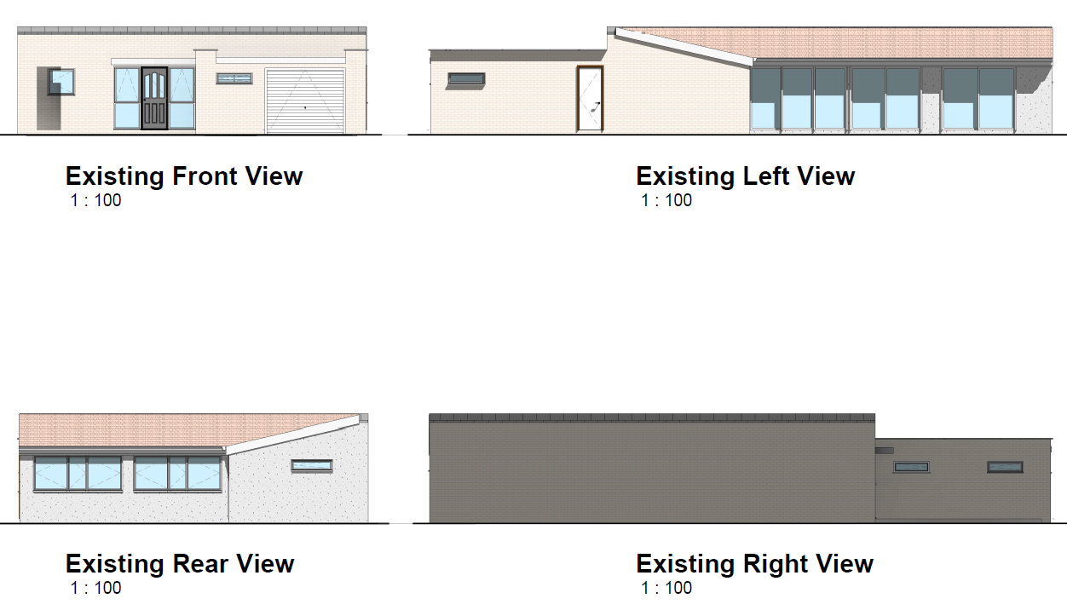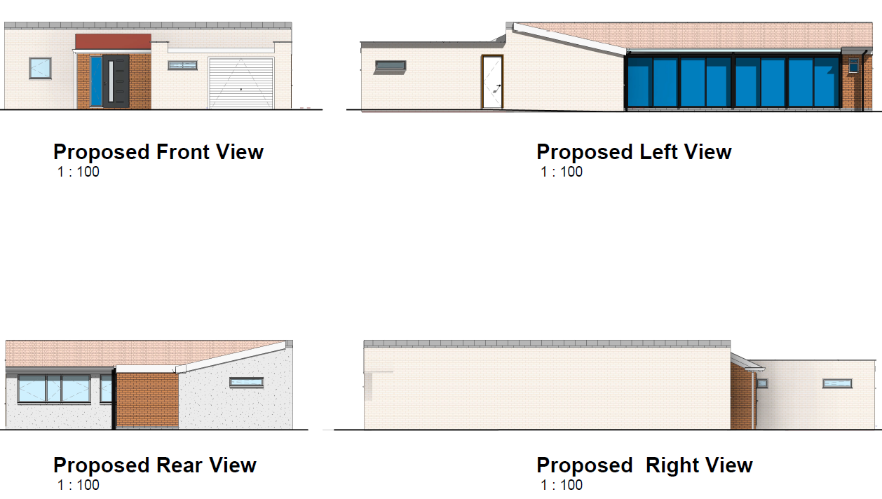

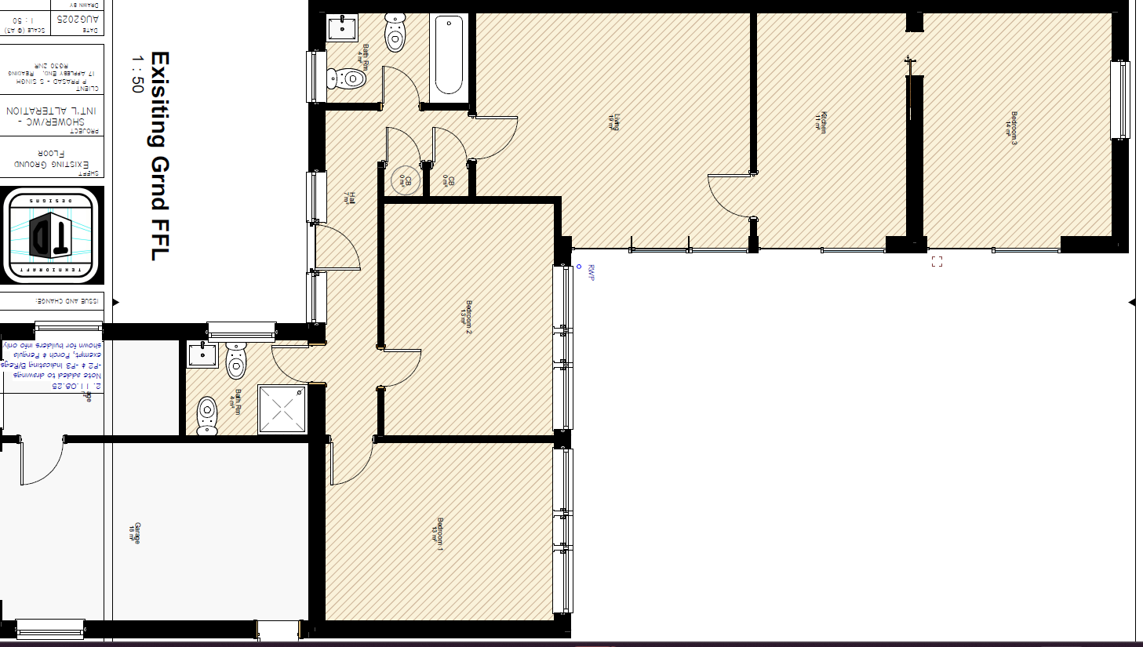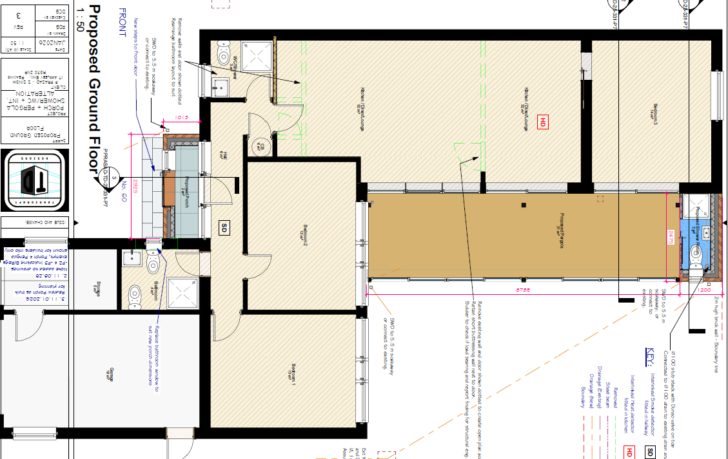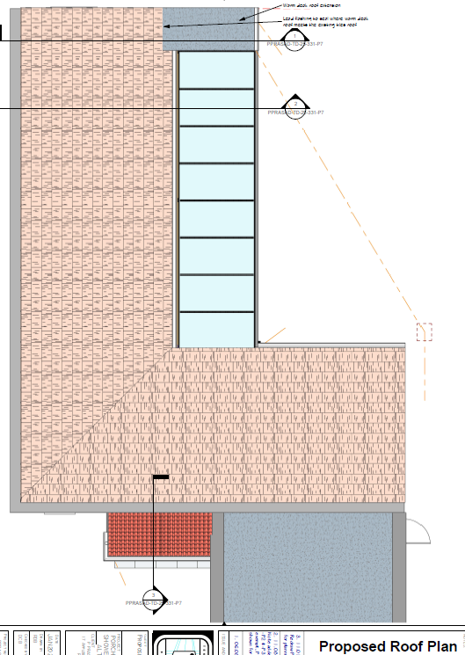
Existing Floor Plan Proposed Floor Plan and Roof Plan

3. RELEVANT PLANNING HISTORY
PL/25/1156 - Addition of front porch, a small single story rear extension and a stand alone pergola to the rear of the dwelling - Withdrawn – As Not Permitted Development (16/10/2025)

5. CONSULTATIONS
A Site Notice was put up 06/03/2026

No letters of representation have been received.

Equality Act 2010:
In determining this application, the Council is required to have regard to its obligations under the Equality Act 2010. However, there is no indication or evidence (including from consultation on the application) that the protected groups identified by the Act have or will have different needs, experiences, issues and priorities in relation to this particular planning application. Therefore, in terms of the key equalities protected characteristics it is considered there would be no significant adverse impacts as a result of the development.

6. LEGAL AND PLANNING POLICY CONTEXT
Section 38(6) of the Planning and Compulsory Purchase Act 2004 requires that proposals be determined in accordance with the development plan unless material considerations indicate otherwise. Material considerations include relevant policies in the National Planning Policy Framework (NPPF), including the presumption in favour of sustainable development. The following local and national planning policy and guidance is relevant to this application:

National Policy
National Planning Policy Framework
National Planning Practice Guidance

Reading Borough Local Plan (2019)
CC1 (Presumption in Favour of Sustainable Development)
CC7 (Design and the Public Realm)
CC8 (Safeguarding Amenity)
H9 (House Extensions and Ancillary Accommodation)
H10 (Private and Communal Outdoor Space)

SPD
Design Guide to House Extensions SPD 2021

Local Plan Partial Update
The current version of the Local Plan turned five years old on 5th November 2024. The Local Plan was reviewed in March 2023 and around half of the policies in the plan are considered still up to date. However, the rest need to be considered for updating to reflect changing circumstances and national policy. A consultation version of the draft updated version of the Local Plan was published on 6th November 2024 and the submission draft submitted to the Planning Inspectorate on 9th May 2025, and the Examination was in February 2026.

Although there is a five-year period for carrying out a review of a plan after it is adopted, nothing in the NPPF or elsewhere says that policies automatically become out of date when they are five years old. It is a matter of planning judgement rather than legal fact whether a plan or policies within it are out-of-date. This will depend on whether they have been overtaken by things that have happened since the plan was adopted, either on the ground or through changes in national policy, for example.

Officer advice in respect of the Local Plan policies pertinent to this application is that they remain in accordance with national policy. The objectives of the policies listed above remain very similar in the draft updated Local Plan, and although at present they have some weight in the decision -making process the current policies can continue to be afforded weight in the appraisal below and are not considered to be ‘out of date’.

6. APPRAISAL

Character and Appearance
Policy H9 states that an extension to a house will be acceptable where it respects the character of the house in terms of scale, location, materials and design and respects the character and pattern of neighbouring properties and the street as a whole. Policy CC7 also sets out relevant considerations for design.

The proposed development comprises a single-storey rear/side extension, front porch and pergola. The rear extension is modest in scale and incorporates a flat roof which remains well below the ridge and eaves of the existing dwelling. The development is confined to the rear and would not be prominent within the street scene.

The front porch is modest in scale and proportionate to the host dwelling, and the pergola structure is lightweight in form and does not add significant bulk. The proposal reads as a subordinate addition and maintains the hierarchy of the host dwelling.

The proposal therefore complies with Policies CC7 and H9.

Residential Amenity
Policy H9 states that an extension will be acceptable where it does not result in an overbearing impact on neighbours. Policy H10 seeks to ensure that the amenity of gardens and other outdoor areas are not compromised. Policy CC8 states an extension to a house will be acceptable where it will not cause a significant detrimental impact to the living environment of existing or new residential properties.

The extension is single storey in scale and is therefore limited in its impact in terms of overshadowing and loss of light. No upper floor windows are proposed that would result in overlooking.

The depth, height (2.6m) and siting of the extension would not give rise to an overbearing impact. The pergola is open in form and would not materially impact neighbouring amenity.

The proposal therefore complies with Policies CC8 and H9.

The nearest tree to the structure proposed is 5m away and is not considered to be endangered by the proposal as the foundation would be minimal.

CONCLUSION
The proposed development has been assessed as set out above and is considered to be acceptable on that basis, subject to the following conditions.

RECOMMENDATION: Grant

Recommended Conditions:
Approved Plans
Time Limit Standards
Materials As Specified
Restricted Use of Roof

