Project No | 26-225
Revision No | 00
Issue date | 02/07/26

THe GranaRY, 1A Patrick Road
Reading RG4 8DD
FLOOD EMERGENCY
PLAN

Control Sheet
This report has been prepared by Calibro Consultants Ltd for the sole benefit and use of the Client.
Calibro Consultants Ltd offer no liability for the information contained within the report to any third party.

Prepared by | Signature | Date
Alex Bearne  BSc MSc  Associate Flood Risk Consultant & Hydrologist |  | 01/07/2026

Reviewed by | Signature | Date
Patrick Goodey  BSc MSc  Head of Flood Risk & Hydrology |  | 02/07/2026

Approved for issue by | Signature | Date
Patrick Goodey  BSc MSc  Head of Flood Risk & Hydrology |  | 02/07/2026

CONTENTS
1 SUMMARY 1
2 INTRODUCTION 5
3 SITE AND FLOOD RISK 6
4 FLOOD EMERGENCY PLAN 12

Tables
Table 1-1 EA Flood Warnings and Actions 2
Table 1-2 FEP Summary 4

Figures
Figure 1-1 Evacuation Routes 3
Figure 3-1 Site Context 6
Figure 3-2 Flood Zones 7
Figure 3-3 Access/Escape Routes 8
Figure 3-4 1 in 100 year +35% Flood Depths at 41 hours 9
Figure 3-5 1 in 100 year +35% Flood Depths at 48 hours 10
Figure 3-6 1 in 100 year Flood Depths at 118 hours 10
Figure 4-1 Evacuation Routes 16

SUMMARY

Introduction
    - This Flood Emergency Plan (FEP) sets out the risk of flooding to proposed flats at The Granary, 1a Patrick Road and the necessary actions for the (FEP). The key information from the document is summarised in this Chapter. This document considers flooding over the lifetime of the development.

Nature of the Risk
    - Site-specific analysis concludes document in the Flood Risk Assessment (Calibro doc ref: 26-225-60-030-002) that the proposed flats are not at risk of flooding, but the access route will be in severe flood events. The progression of flooding is slow giving sufficient warning times in advance of flooding affecting the site access.

General Responsibilities.
    - The owner or manager of the property is responsible for:
Ensuring occupants have a copy of the FEP.
Ensuring occupants are aware of the requirement to register with the Flood Line Direct Service.
Reviewing and where necessary updating the FEP, as a minimum every three years or after a flood event.

    - The tenant or owner will be responsible for nominating a responsible person for each flat.
    - The responsible persons will be responsible for:
Ensuring the FEP reflects any special requirements such as those relating to limited mobility or medical conditions are reflected in the FEP.
Ensuring all occupants are registered with the Floodline (https://get-flood-warnings.service.gov.uk/sign-up/service-selection) or by calling 03459 81188.)
Ensuring all occupants are familiar with the FEP.
Ensuring the necessary provisions are in place for safe refuge.
Maintaining the refuge pack and evacuation pack.
Assisting with the update of the FEP following a flood event.
Implementing the appropriate actions in response to Flood Warnings or direction from Reading Borough Council (RBC) or the emergency services.

Flood Actions
    - The Environment Agency (EA) issue three levels of flood warning the recommended actions for each of these is summarised in Table 1-1.
Table 1-1 EA Flood Warnings and Actions
Warning Level | Risk | Occupant Actions
Flood Alert | Flooding is possible | Prepare for flooding by ensuring all necessary items to facilitate safe refuge or evacuation are present in sufficient quantities.
Flood Warning | Flooding is expected | Consider evacuation particularly if there is, or is likely to be, an issue with supply of vital utilities (water, electricity, gas). Occupants should take advice from RBC, the EA and/or emergency services to inform this decision.
Severe Flood Warning | Flooding could cause danger to life and significant disruption to communities. | Take refuge unless it is desirable to evacuate and safe escape is still possible, or they have been advised to do so by RBC, the EA and/or emergency services.

    - The site is on edge of the floodplain and flooding of the surroundings will commence days before flooding of the site access, see Section 3.4.
    - The evacuation routes are north on Patrick Road and then west on Gosbrook Road as shown in Figure 1-1. The pedestrian route is the safest route. At its lowest point approximately 50mm lower than the footway outside the property.

Figure 1-1 Evacuation Routes
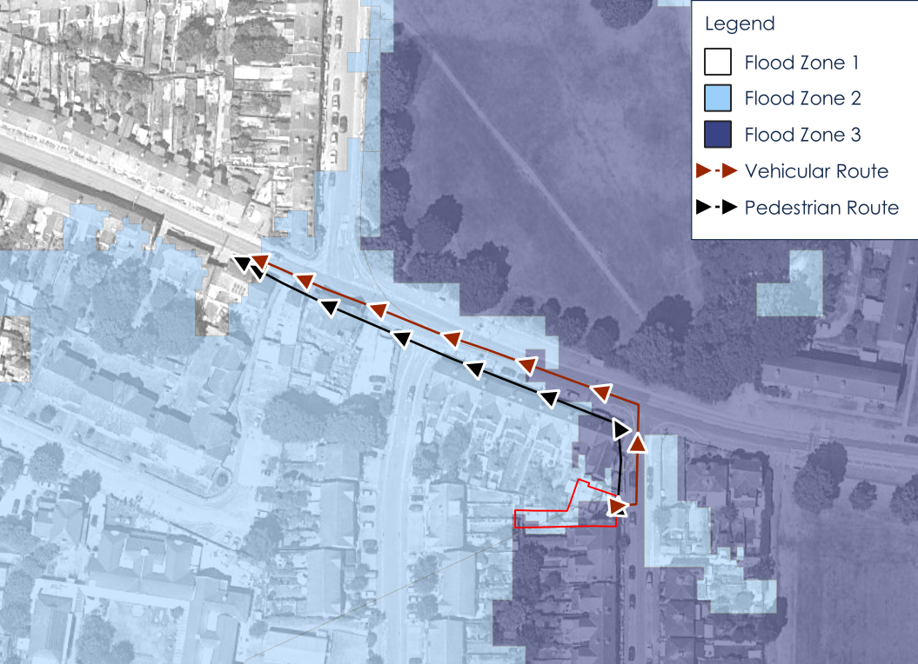

Key Contacts
    - Key contacts are listed Table 1-2. They should be updated as required.
Table 1-2 FEP Summary
Key Contact | Name | Phone Number
Responsible Person 1
Responsible Person 2
Environment Agency | Floodline (24hrs a day) | 0345 988 1188
Reading Borough Council | Council offices are open:  Monday 9am - 5pm  Tuesday 9am - 5pm  Wednesday 9am - 5pm  Thursday 9am - 5pm  Friday 9am - 4.30pm | 0118 937 3737
Reading Borough Council | Out of Hours | 0118 937 3737
Others (as needed)

INTRODUCTION

Background
    - The Local Plan Authority (LPA) have requested that a Flood Emergency Plan (FEP) is submitted to support the Class MA PD application for conversion of existing offices into two flats (PL/26/0333) at the Granary, 1a Patrick Road, Reading, hereafter referred to as the site.
    - The policy requirement stated in the Planning Practice Guidance is:
“Access routes should allow occupants to safely access and exit their dwellings in design flood conditions. Vehicular access to allow the emergency services to safely reach the development during design flood conditions will also normally be required”.
    - The objective of this plan is to set out the nature of flooding risk to the site, to detail the Flood Warnings and estimated lead time available, and to detail how the Plan is triggered by who and when, and what actions are required.
    - To suit planning stipulations, this document considers this risk over the assumed 100 year lifetime of the proposed development. The site falls with the ‘Thames and South Chilterns’ catchment. The appropriate allowance for climate change (commensurate with residential ‘more vulnerable’ development in Flood Zone 2 or 3) to the 2080s (2070-2125) is +31%.
    - The FEP would be a living document, updated every three years.

SITE AND FLOOD RISK

Site Description
    - The site is an existing building and yard at The Granary, 1a Patrick Road, Caversham, Reading. The centre of the site is at grid reference 471710, 174630 and the postcode is RG4 8DD. It is located just to the south of the junction of Patrick Road and Gosbrook Road in the residential area of Caversham, Reading.
    - The River Thames is located approximately 300m to the south of the site. The River Kennet is approximately 1.2km to the south. The site location and watercourses are shown in Figure 1-1.
Figure 3-1 Site Context
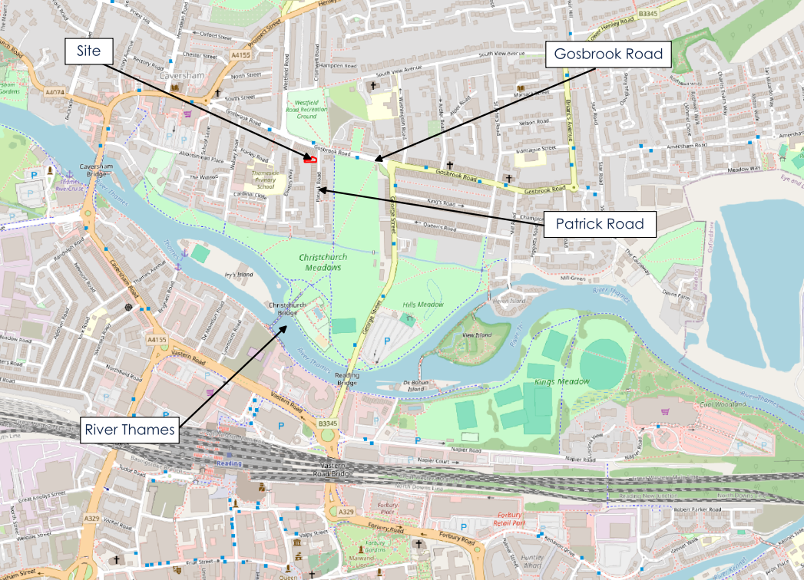

Site Proposals
    - The proposals are for 2 privately rented or owner occupied one-bedroom flats

Flood Risk
    - The site is classified as being within Flood Zone 2 and Flood Zone 3 as shown in Figure 3-2.

Figure 3-2 Flood Zones
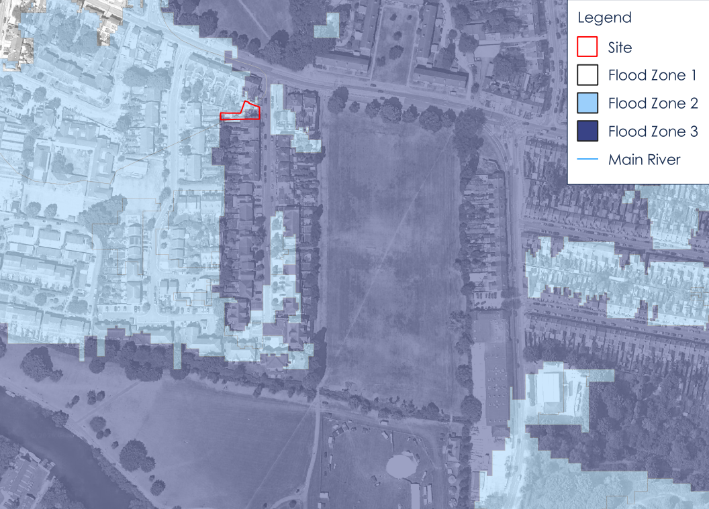
    - A detailed site-specific assessment was carried out as part of the Flood Risk Assessment (FRA) submitted to support the planning application. The assessment used data from the Thames Pangbourne to Sonning Modelling Study (2019) provided by the Environment Agency (EA) and surveyed ground levels. It concluded that the only material flood risk is the risk of fluvial flooding to the access and consequently this is the focus of the document.
    - The source of risk is the River Thames which has catchment of 4,600km². Consequently, the river has a slow rate of rise and flood events will have a long duration.

Key Levels
    - The following levels were extracted from the undefended scenario peak flood level grids at the location of the proposed dwellings:
- 1 in 100 year – 37.88mAOD
- 1 in 100 year +25% - 38.172mAOD
- 1 in 100 year +35% - 38.250mAOD
- 1 in 1,000 year – 38.30mAOD
    - The design (1 in 100 year +31%) event level is estimated to be 38.22mAOD assuming a linear relationship between flow and level between the +25% and +35% events.
    - The existing floor levels are 0.18m above this (38.4mAOD), and above the 1 in 1,000 year flood level.
    - The lowest recorded survey level on the pedestrian access/escape route 37.84m. This equates to a peak depth of 0.38m during the design event and a peak depth of 0.46m in a 1 in 1,000 year event.
    - In the present day, the peak depth in the 1 in 100 year event would be very shallow, at only 0.04m.
    - The lowest recorded survey levels on the vehicular access/escape route are 37.74mAOD on Patrick Road adjacent to the site access. This equates to peak depth of 0.48m during the design event and a peak depth of 0.56m in a 1 in 1,000 year event.
    - The surveyed ground levels and access/escape routes are shown in Figure 3-3.
Figure 3-3 Access/Escape Routes
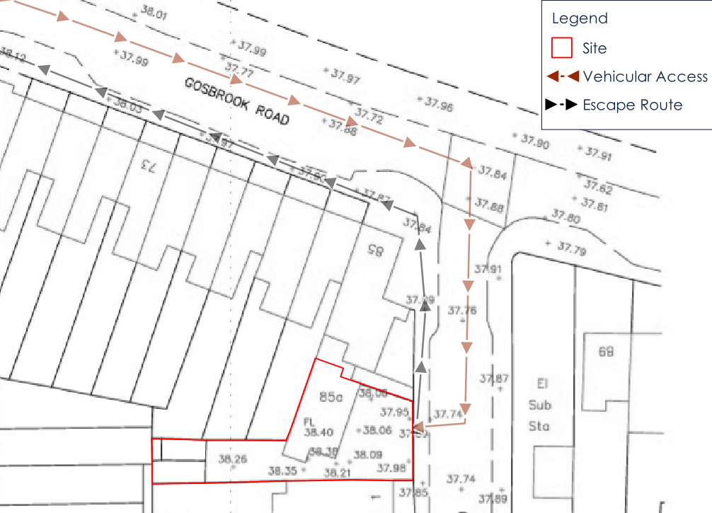
    - Even during a 1 in 1,000 year event, the peak depth would not preclude access by emergency services.

Flood Onset, Progression and Duration
    - The EA model predicts widespread flooding significantly in advance of flooding of the access route to the site. During the 1 in 100 year +35% event, flooding commences at Christchurch Meadows 41 hours into the simulation and at the park to the east of the site at 48 hours into the simulation. No flooding is predicted to Patrick Road or Gosbrook Road to the east 118 hours into the simulation. Consequently, there would be days of warning that flooding may occur, with the park to the east providing a clear visual warning.
    - The predicted depths of flooding during the 1 in 100 year +35% event at key points in the simulation are presented in Figure 3-4, Figure 3-5 and Figure 3-6.
Figure 3-4 1 in 100 year +35% Flood Depths at 41 hours
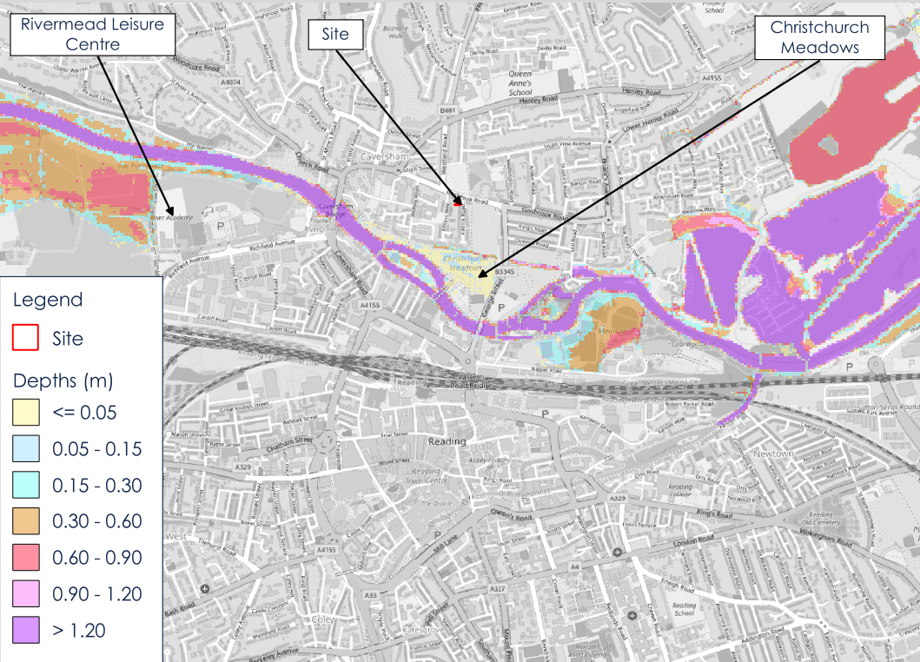

Figure 3-5 1 in 100 year +35% Flood Depths at 48 hours
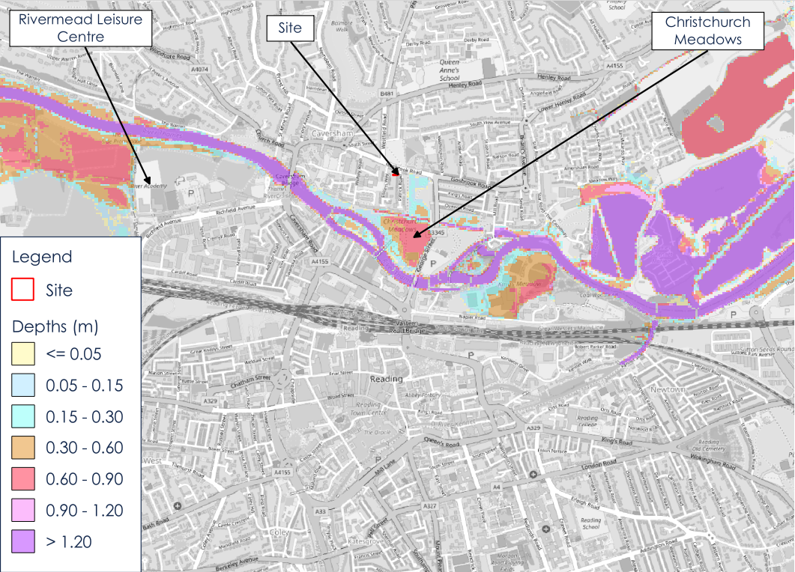
Figure 3-6 1 in 100 year Flood Depths at 118 hours
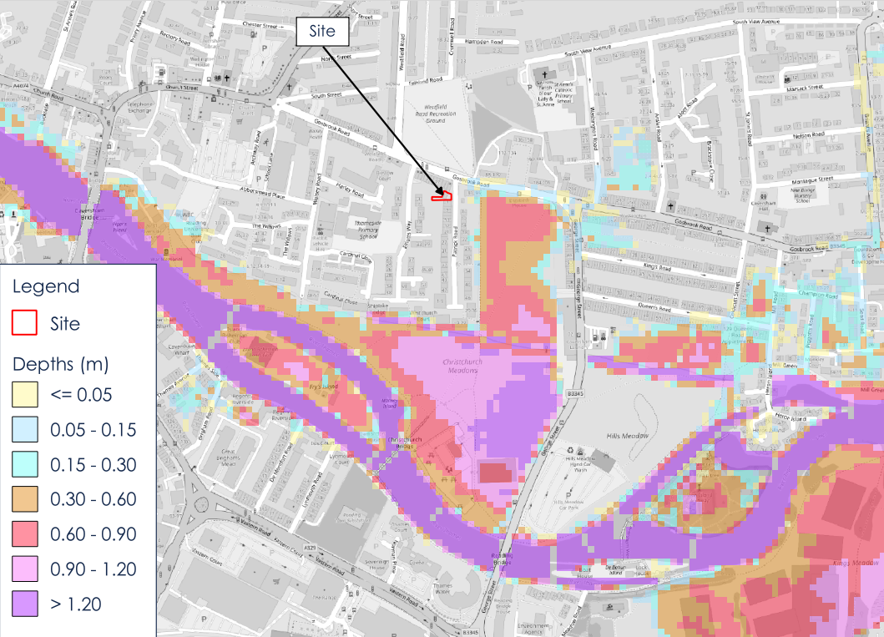
    - Flooding of the proposed pedestrian access/escape route commences at 145 hours into the simulation, four days after significant flooding of the park to the east. At this point depths on the vehicular access/escape route would be 0.1m and not preclude regular vehicle movement.
    - The duration of flooding to the pedestrian access/escape route, during the 1 in 100 year +35% is approximately 10 days. The duration where depths are above 0.25m and the hazard rating in the lowest part of the access increases to ‘Moderate - Danger for some (i.e. children) ’ is only 5 days. This is the peak hazard value during the simulation.
    - The peak flood velocities are very low, consistently significantly below 0.2m/s, and the site is on the edge of the predicted flood extent a long way from any fast flowing water so debris loading is likely to be limited.
    - The duration of flooding over 0.3m is approximately 2.5 days. 0.3m is a commonly used depth threshold for the limit of safe access. It is expected that safe access would be possible for people without mobility impairments during these conditions.
    - The rate of rise of flood waters as the flood progresses is approximately 3.5mm/hr (which equates to or 0.06mm/min or 84mm/day). This rate of rise is essentially negligible when considering the limited time that would be spent passing through floodwaters (approximately 150m at the peak of the event).
    - Flood depths in the present day 1 in 100 year event are very shallow, meaning safe access should be available during such conditions.

FLOOD EMERGENCY PLAN

Introduction
    - The FEP presented in this document has been produced in accordance with the PPG and the ADEPT/EA Flood Risk Emergency Plans for New Developers document. Its core ethos will be to maximise the safety of the occupiers without placing undue burden on the emergency services.
    - The FEP would be made available to each new occupier. It is recognised that the FEP may need to change over time to reflect the flood predictions at that time and ensure it stays relevant for the lifetime of the development.

Flood Warnings
    - The EA operate a flood forecasting and warning service in areas at risk of flooding which operates 24 hours a day, 365 days a year. It uses a combination of direct measurements of river levels and rainfall and forecasting data from the Met Office, in order to determine the likelihood of flooding.
    - Floodline is a free service provided by the Environment Agency that provides flood warnings direct by phone, email or text message. It is possible to register on the website (https://get-flood-warnings.service.gov.uk/sign-up/service-selection) or by calling 03459 81188.
    - The site is within the ‘River Thames at Reading and Caversham including the Portman Road and Richfield Avenue industrial estates, Caversham Road area of Reading and the Lower Caversham area’ flood warning area.
    - If flooding is forecast, alerts are provided direct to the user. The three levels of warning are summarised below:
Flood Alert: Flooding is possible.
Flood Warning: Flooding is expected.
Severe Flood Warning: Flooding could cause danger to life and significant disruption to communities.
    - EA flood warnings are typically issued at least six hours ahead of a likely event. However, given the weather required to generate a severe flood event, there would be additional warning of impending flooding problems through the Met Office, local news and social media channels, expected to be days in advance of an extreme flood event.
    - Flooding of the access would be preceded by hundreds of homes being flooded and therefore a Severe Flood Warning should be issued well in advance of this. Given the scale of flooding in this scenario, Reading Borough Council’s (RBC) responsibility as a Category 1 responder include maintaining detailed plans for such an emergency and warning and informing the public. Consequently, it’s expected that there will be warnings and advice on actions disseminated by RBC in addition to those issued by the EA and Met Office.
    - As a huge number of properties will need to be evacuated before flooding affects the site access, it is presumed that a stay-put policy will be preferred so as to not place undue burden on the emergency services.
    - The site owner/manager will be responsible for ensuring that all occupants are aware of the requirement to be signed up to the Floodline service.

Safe Refuge
    - The proposed flats would serve as a place of safe refuge remaining dry during design and extreme flood conditions, having heating, water, electricity and sanitation facilities.
    - In order to facilitate refuge, a refuge pack should be prepared. This should include sufficient non-perishable food and drinking water to sustain the occupants for a period of up to 10 days. The refuge pack should also include any necessary medications.
    - The refuge pack should be reviewed frequently and updated as necessary, particularly in regard to medicines.
    - Other useful items would also serve as an evacuation pack discussed below.
    - Safe access should be available during a present day 1 in 100 year flood. However, the severity of the flood will not be clear until levels are clearly receding and consequently a stay-put policy would still be preferred given that hundreds of homes would be flooded days prior to the access being at risk.

Evacuation Pack
    - An evacuation pack should be prepared for the occupants in the case of evacuation. Below is a list of recommended items:
A copy of the FEP.
A list of emergency contact numbers (utilities, insurance company, EA) and useful contacts sheets.
Copies of important documents including passports, driving licences and insurance certificates (in the event of an evacuation).
Spare house and car keys.
Torches and rechargeable camping lights in the event of power outage.
Spare batteries for torches and the radio.
A portable radio to monitor local news and weather broadcasts.
A first aid kit, antibacterial hand gel, essential medicines including hearing devices and glasses/contact lenses (if required) and repeat prescription forms.
Whistle.
Dry, waterproof clothing and a change of clothing, including warm clothing.
Blankets.
Mobile phone and charger, and portable powerpacks.
Wash kit and essential toiletries, and a towel.
Cash.
Items needed for babies & small children – food, nappies, toiletries etc. (if required).
Pet lead(s) (if required).

    - The evacuation pack should be checked at least every 12 months.

Command and Control
    - Each flat will allocate an occupier responsible for ensuring the requirements of this FEP are completed. The responsible person should review the FEP and ensure it is fit for the specific needs of the occupants of the flat. This is particularly important should occupants have impaired mobility or medical condition that would impact on their ability to evacuate and/or stay put. In some circumstances it may be necessary to create a personal evacuation plan.
    - The occupiers will receive and disseminate flood warnings and information. Such information would be received from various sources, including social media feeds, the EA Floodline register or Met Office alerts. They would be responsible for making decisions based on the circumstances and the site users, ensuring instructions are received by all.
    - The following actions are likely to be followed:
On receipt of a Flood Alert, the occupants should prepare for flooding by ensuring all necessary items to facilitate safe refuge or evacuation are present in sufficient quantities. The occupants should also make necessary administrative arrangements should evacuation be required.
On receipt of a Flood Warning, the occupants should consider evacuation particularly if there is, or is likely to be an issue with supply of vital utilities (water, electricity, gas). Occupants should liaise with RBC, the EA and/or emergency services to inform this decision.
On receipt of a Severe Flood Warning the occupants should take refuge unless it is desirable to evacuate and safe escape is still possible, or they have been advised to do so by RBC, the EA and/or emergency services.
Once flooding of the access has commenced occupants should seek refuge in their properties unless otherwise advised by RBC, the EA or emergency services.

    - In addition to EA Flood Warnings, the above actions could also be triggered by appropriate messages or instructions from the emergency services or RBC.

Safe Evacuation Procedures and Routes
    - Safe refuge is available, and therefore it is unlikely that evacuation would be required. Given the severe weather conditions likely during times of flooding and the extensive areas that are likely to require evacuation, the default action will be to ‘stay put’ to avoid undue strain on public places of refuge.
    - If evacuation were required, free and voluntary movement of occupiers would be possible for days before the peak of the flood event (see Section 2.3).
    - The peak depth on the pedestrian escape route will be approximately 50mm higher than the depth on the footway outside the house. The peak depth on the vehicular escape route will be on the highway adjacent to the property. It recommended that evacuation by vehicle is not attempted by road if it is flooded, unless directed to do so by RBC or the emergency services.
    - The occupiers should take the advice of RBC and emergency services regarding whether or not to evacuate.
    - Should evacuation be necessary, occupants should head north on Patrick Road and then east on Gosbrook Road as shown in Figure 4-1.
    - Safe access is available in the present day 1 in 100 year event.

Figure 4-1 Evacuation Routes

Emergency Access
    - Peak depths on the vehicular access/escape route would not preclude access by emergency services should they be required whilst occupants are taking safe refuge.

Post Flooding
    - Flooding is unlikely to result in any damage to the property. It may be necessary to clean the yard if an extreme event occurs.

Document Control
    - It is possible that the actions and recommendations of the FEP change over time.
    - This FEP should be revised at least every three years or following a flood event to reflect learning from the event. This is the responsibility of the property owner or manager.
    - When revised, the FEP should review the latest available information from RBC such as the SFRA. The EA should also be contacted to determine whether there have been updates to the Thames to Sonning Eye model and whether they have any bearing on the FEP. Given the slow progression of the flood event, it is unlikely that updates are necessary unless the flood levels change significantly or climate change allowances are increased significantly.

 81 Whiteladies Road | Bristol | BS8 2NT
 0117 2441 970
 hello@calibro-consultants.com
 www.calibro-consultants.com
Registered office as above
Registered in England & Wales: 9988524

