DELEGATED APPLICATION REPORT
Ward: Redlands
App Ref: PL/25/0980 Householder planning permission
Address: 4 HATHERLEY ROAD, READING, RG1 5QA
Proposal: Side return extension and internal reconfiguration
Applicant: Sofia Chantziara
Received date: 09/07/2025
Target Decision date: 24/07/2026 (EXT)
Case Officer: Chukwudi Onwudinanti

1. SITE DESCRIPTION

The application site comprises a mid-terrace residential property located within an established residential street in Reading. The surrounding area is characterised by similar terraced dwellings with narrow plots and rear garden areas.

The site includes a rear shared pitched roof outrigger, which is common to properties of this type and location.

The site is within an Article 4 Area which restricts conversion from C3 dwellings to C4 small HMOs.

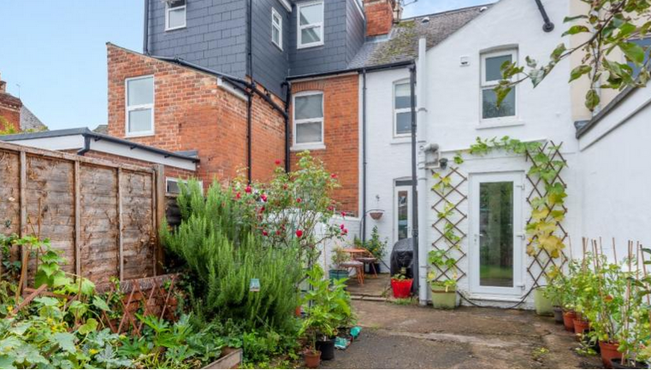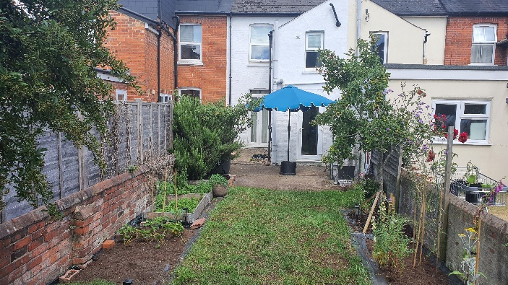

2. PROPOSAL AND SUPPORTING INFORMATION

The application seeks planning permission for:

- A mono-pitched single storey rear extension between the boundary and the outrigger measuring 3.64m deep and 2.5m high, ground to eaves, at the boundary.
- Internal reconfiguration of the ground floor
- Amended size of first floor rear window; to be smaller, and proposed double doors to the rear of the existing outrigger

The proposal involves infilling the existing side outrigger to create an enlarged kitchen and living/dining space at ground floor level.

External materials are proposed to match the existing dwelling, including walls, roof, windows and doors.

Plans and Documents

Received 09/07/2025
Drawing No A001-2D - Existing Plans and Elevations

Received 07/05/2026
Drawing no: A01 - Block Plan & Location Plan Proposed

Received 21/07/2026
Drawing No A001-2D - Proposed Drawings [Floor Plans and Elevations]

Existing Proposed

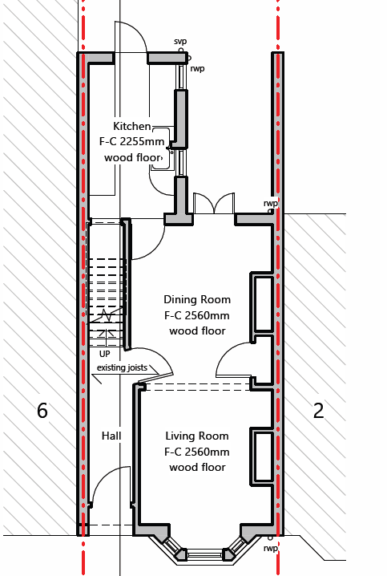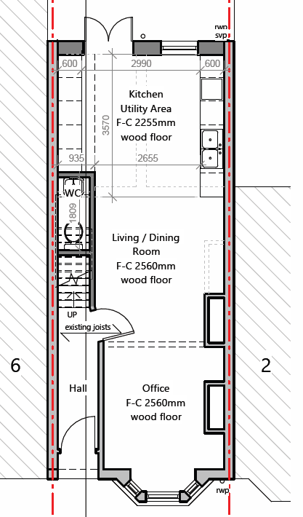

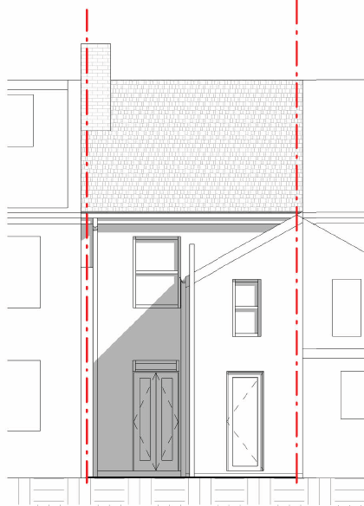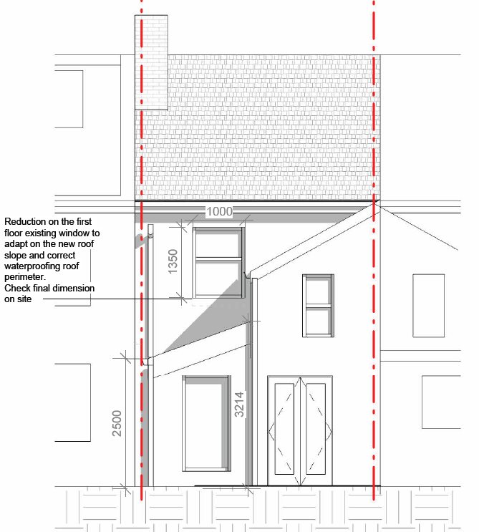

3. RELEVANT PLANNING HISTORY

None.

4. CONSULTATIONS

A Site Notice was put up 25/07/2025

No letters of representation have been received.

Discussions with agent
The agent was advised to reduce the scale of the original submission, such that the rear extension would not be deeper than the existing outrigger. There was also a request a revision to the slope of the proposed extension, such that the lower part would be to the boundary. The eave on the boundary line has further been reduced to 2.5m, with the roof gutters wholly within the confines of the proposal site. Amended drawings were received with these changes.

Equality Act 2010:
In determining this application, the Council is required to have regard to its obligations under the Equality Act 2010. However, there is no indication or evidence (including from consultation on the application) that the protected groups identified by the Act have or will have different needs, experiences, issues and priorities in relation to this particular planning application. Therefore, in terms of the key equalities protected characteristics it is considered there would be no significant adverse impacts as a result of the development.

5. LEGAL AND PLANNING POLICY CONTEXT

Section 38(6) of the Planning and Compulsory Purchase Act 2004 requires that proposals be determined in accordance with the development plan unless material considerations indicate otherwise. Material considerations include relevant policies in the National Planning Policy framework (NPPF) - among them the 'presumption in favour of sustainable development'. The following local and national planning policy and guidance is relevant to this application:

National Policy
National Planning Policy Framework
National Planning Practice Guidance

Reading Borough Local Plan (2019)
CC7 (Design and the Public Realm)
CC8 (Safeguarding Amenity)
H9 (House Extensions and Ancillary Accommodation)
H10 (Private and Communal Outdoor Space)

SPD
Design Guide to House Extensions SPD 2021

Local Plan Partial Update
The current version of the Local Plan turned five years old on 5th November 2024. The Local Plan was reviewed in March 2023 and around half of the policies in the plan are considered still up to date. However, the rest need to be considered for updating to reflect changing circumstances and national policy. A consultation version of the draft updated version of the Local Plan was published on 6th November 2024 and the submission draft submitted to the Planning Inspectorate on 9th May 2025, and the Examination was in February 2026.

Although there is a five-year period for carrying out a review of a plan after it is adopted, nothing in the NPPF or elsewhere says that policies automatically become out of date when they are five years old. It is a matter of planning judgement rather than legal fact whether a plan or policies within it are out-of-date. This will depend on whether they have been overtaken by things that have happened since the plan was adopted, either on the ground or through changes in national policy, for example.

Officer advice in respect of the Local Plan policies pertinent to this application is that they remain in accordance with national policy. The objectives of the policies listed above remain very similar in the draft updated Local Plan, and although at present they have some weight in the decision -making process the current policies can continue to be afforded weight in the appraisal below and are not considered to be ‘out of date’.

6. APPRAISAL

Character and Appearance

Policy H9 states that an extension to a house will be acceptable where it respects the character of the house in terms of scale, location, materials and design and respects the character and pattern of neighbouring properties and the street as a whole in terms of scale, location, materials and design, and any important existing building line. Policy CC7 also sets out relevant considerations for design.

The amended proposed development comprises a single-storey side/rear extension, reduced size first floor window and new double doors to the rear of the existing outrigger. The extension would infill the existing side passage and would be located to the rear of the property, with no alteration to the principal elevation.

The scale and height of the extension are modest and subordinate to the host dwelling. The use of materials matching the existing building ensures that the proposal integrates with the existing property. Material to the consideration of this proposal is the scale of scheme which would be possible under permitted development rights, which would be similar to the proposed scheme.

The proposal is, therefore, considered to respect the character of the host dwelling and the surrounding area.

Residential Amenity

Policy H9 states that an extension will be acceptable where it does not result in an overbearing impact on neighbours. Policy H10 seeks to ensure that the amenity of gardens and other outdoor areas are not compromised. Policy CC8 states an extension to a house will be acceptable where it will not cause a significant detrimental impact to the living environment of existing or new residential properties.

The proposed extension is single storey in height (2.5m ground to eave) and would not introduce additional overlooking or loss of privacy as there are no windows proposed to the side facing the adjoining property on that side. Whilst the infill of the side return may result in a minor sense of enclosure to the adjoining property, this is typical of such developments and is not considered to result in a significant adverse impact.

Whilst the site is in an Article 4 Area where there is a restriction is as it relates to converting a C3 dwelling to C4 small HMO. There is nothing in the development proposed that suggests a change of use from C3 to C4. An informative is included in this regard to confirm that such a change would require planning permission.

Adequate private outdoor space would remain following the development.

The proposal is, therefore, compliant with Policies CC8, H9 and H10.

7. CONCLUSION

The proposed development has been assessed as set out above and is considered to be acceptable on that basis, subject to the following conditions.

8. RECOMMENDATION

Grant

Recommended Conditions:
Approved Plans
Time Limit Standards
Materials As Specified

