DELEGATED APPLICATION REPORT
Ward: Kentwood Ward
App Ref: PL/26/0567 Householder planning permission
Address: 8 RYDAL AVENUE, TILEHURST, READING, RG30 6XT
Proposal: Proposed single-storey rear extension following demolition of an existing conservatory.
Applicant: Mr. Farhan Shahzada
Received date: 28/04/2026
Target Decision date: 23/07/2026 (EXT)
Case Officer: Chukwudi Onwudinanti

1. SITE DESCRIPTION
The application site comprises a two-storey semi-detached dwelling situated within an established residential area on Rydal Avenue, Tilehurst. The property is constructed of facing brick beneath a pitched concrete tiled roof and benefits from an existing rear mono-pitched roof single storey extension with a flat roof conservatory beyond that.

The surrounding area is characterised by similar two-storey residential properties with a mixture of original dwellings and later domestic extensions.

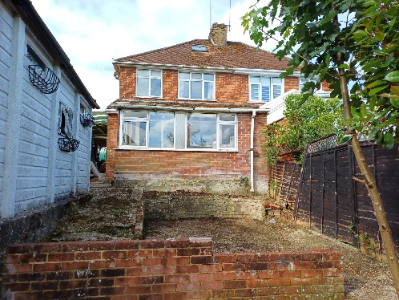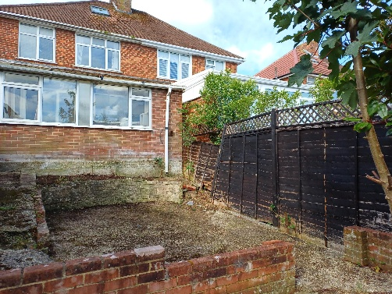

2. PROPOSAL AND SUPPORTING INFORMATION
Planning permission is sought for the demolition of the existing rear conservatory and the replacement with an enlarged flat roof single storey extension for a bedroom and ensuite.

The proposed extension would project beyond the existing rear elevation by 3.35m, and incorporate:
Flat roof construction;
Rooflights within the mono-pitched roof over the existing retained kitchen;
Facing brickwork to match the existing dwelling;
White uPVC windows and doors to match the existing property.

Plans and Documents received 28/04/2026
- Location Plan
- Drawing No: RG306XT-PP-100, dated 27/4/2026 -Site Location and Block Plans, Existing and Proposed Plans and Elevations.

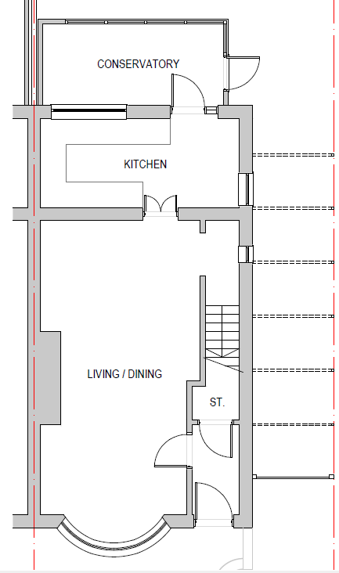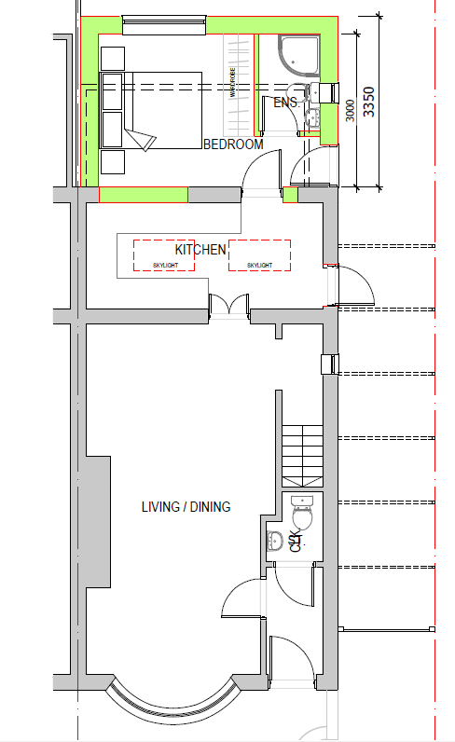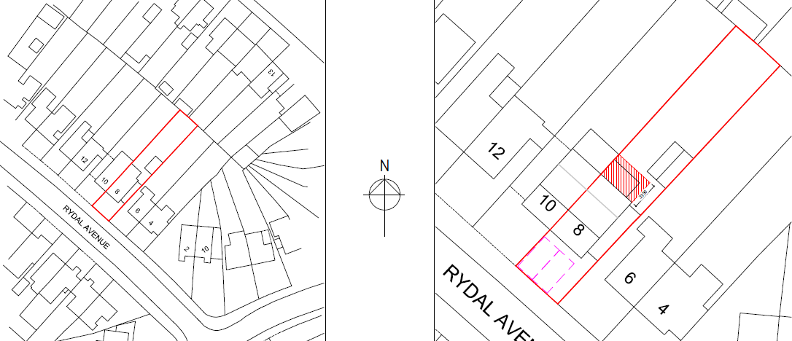

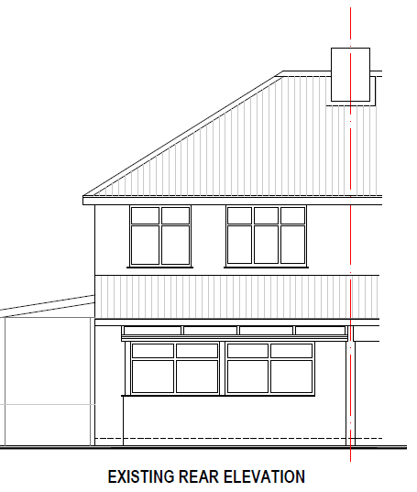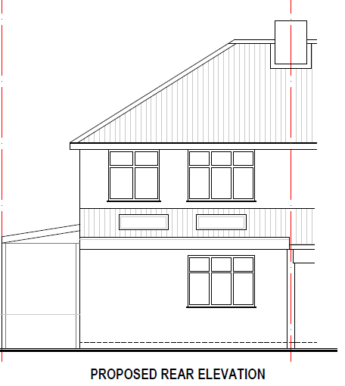

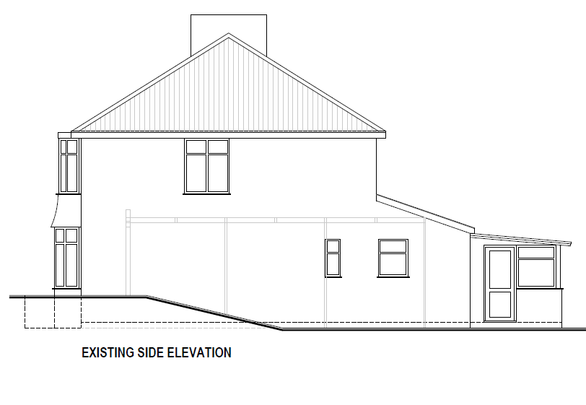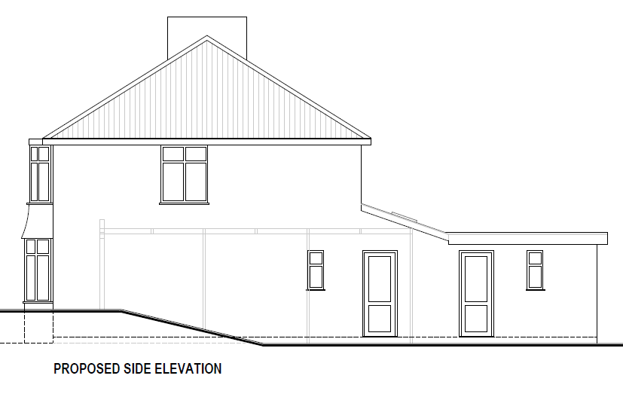

Existing and Proposed Plans and Elevations

3. RELEVANT PLANNING HISTORY
None.

4. CONSULTATIONS
A Site Notice was displayed 05/06/2026
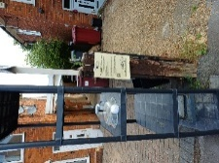

No representations have been received.

Equality Act 2010:
In determining this application, the Council is required to have regard to its obligations under the Equality Act 2010. However, there is no indication or evidence (including from consultation on the application) that the protected groups identified by the Act have or will have different needs, experiences, issues and priorities in relation to this particular planning application. Therefore, in terms of the key equalities protected characteristics it is considered there would be no significant adverse impacts as a result of the development.

5. LEGAL AND PLANNING POLICY CONTEXT
Section 38(6) of the Planning and Compulsory Purchase Act 2004 requires that proposals be determined in accordance with the development plan unless material considerations indicate otherwise. Material considerations include relevant policies in the National Planning Policy Framework (NPPF) - among them the 'presumption in favour of sustainable development'. The following local and national planning policy and guidance is relevant to this application:

National Policy
National Planning Policy Framework
National Planning Practice Guidance

Reading Borough Local Plan (2019)
CC7 (Design and the Public Realm)
CC8 (Safeguarding Amenity)
H9 (House Extensions and Ancillary Accommodation)
H10 (Private and Communal Outdoor Space)

SPD
Design Guide to House Extensions SPD 2021

Local Plan Partial Update
The current version of the Local Plan turned five years old on 5th November 2024. The Local Plan was reviewed in March 2023 and around half of the policies in the plan are considered still up to date. However, the rest need to be considered for updating to reflect changing circumstances and national policy. A consultation version of the draft updated version of the Local Plan was published on 6th November 2024 and the submission draft submitted to the Planning Inspectorate on 9th May 2025, and the Examination was in February 2026.

Although there is a five-year period for carrying out a review of a plan after it is adopted, nothing in the NPPF or elsewhere says that policies automatically become out of date when they are five years old. It is a matter of planning judgement rather than legal fact whether a plan or policies within it are out-of-date. This will depend on whether they have been overtaken by things that have happened since the plan was adopted, either on the ground or through changes in national policy, for example.

Officer advice in respect of the Local Plan policies pertinent to this application is that they remain in accordance with national policy. The objectives of the policies listed above remain very similar in the draft updated Local Plan, and although at present they have some weight in the decision -making process the current policies can continue to be afforded weight in the appraisal below and are not considered to be ‘out of date’.

6. APPRAISAL

Character and Appearance
Policy H9 states that development should respect the character of the dwelling and surrounding area in terms of scale, siting, materials and design. Policy CC7 also sets out relevant design considerations.

The proposal replaces an existing conservatory with a permanent single-storey rear extension. It would be slightly larger than the existing conservatory but would remain clearly subordinate to the host dwelling and would not alter the established character of the property or surrounding area.

The proposed brickwork would match the existing dwelling.

The proposal, therefore, complies with Policies CC7 and H9 of the Reading Borough Local Plan and the design objectives of the NPPF.

Residential Amenity
Policy H9 states that development should not result in an overbearing impact, and Policy CC8 seeks to ensure no significant detrimental impact on neighbouring amenity. Policy H10 seeks to ensure that adequate private outdoor space is retained.

The proposed extension remains single storey in height and is positioned to the rear of the dwelling. Whilst projecting beyond the existing conservatory, the proposal is of modest scale and is not considered likely to result in unacceptable overshadowing or loss of outlook to neighbouring occupiers, especially as the site is of a lower ground level than the two adjoining properties on both sides.

The proposal introduces no first-floor windows or other opportunities for overlooking. The rooflight within the existing mono-pitched roof would not create any additional overlooking.

Having regard to the scale of the extension, the relationship with adjoining properties and the guidance contained within the Design Guide to House Extensions SPD, the proposal is considered to preserve neighbouring residential amenity. The proposal would, therefore, comply with Policies CC8 and H9.

Private Outdoor Amenity Space
Policy H10 seeks to ensure that dwellings retain sufficient usable private outdoor amenity space.

Although the proposal would increase the built footprint of the dwelling, a substantial rear garden would remain available for the occupants. The retained garden area is considered sufficient to meet the objectives of Policy H10.

7. CONCLUSION
The proposed development represents an appropriate form of domestic extension that would remain subordinate to the host dwelling and would preserve the character and appearance of the surrounding area.

The proposal would not result in unacceptable harm to neighbouring residential amenity and would retain adequate private outdoor amenity space.

Accordingly, the proposal accords with the National Planning Policy Framework and Policies CC1, CC7, CC8, H9 and H10 of the Reading Borough Local Plan (2019).

8. RECOMMENDATION

Grant Planning Permission

Subject to the following conditions:
- Time Limit.
- Approved Plans.
- Materials to Match Existing.
- Use of Roof Restriction

