21 July 2026

Planning Application Ref: PL/26/0863
Officer: Marcelina Rejwerska
Application Type: Full planning permission
Address: 2 CONISBORO WAY, CAVERSHAM, RG4 7HT
Proposal: Demolition of existing dwelling house and
construction of replacement dwelling house.

The site is accessed via a private road from Geoffreyson Road and is located within Zone 3, Secondary Core Area, of the Council’s adopted Parking Standards and Design SPD. Typically, these areas are within 400m of a Reading Buses high frequency ‘Premier Route’, which provides high quality bus routes to and from Reading town centre and other local centre facilities.

The application seeks to demolish the existing detached bungalow and replace it with a 4+ bedroom C3 dwelling with a separate annexe located at the rear of the property. The dwelling is located on a currently unadopted part of the public highway and has no dedicated pedestrian footway.

In accordance with the adopted SPD, a 3+ dwelling will require 2 x off road parking spaces. Proposed Site Plan (Ground Floor) 2202(21)020 G illustrates 3 parking spaces located within the curtilage of the site.

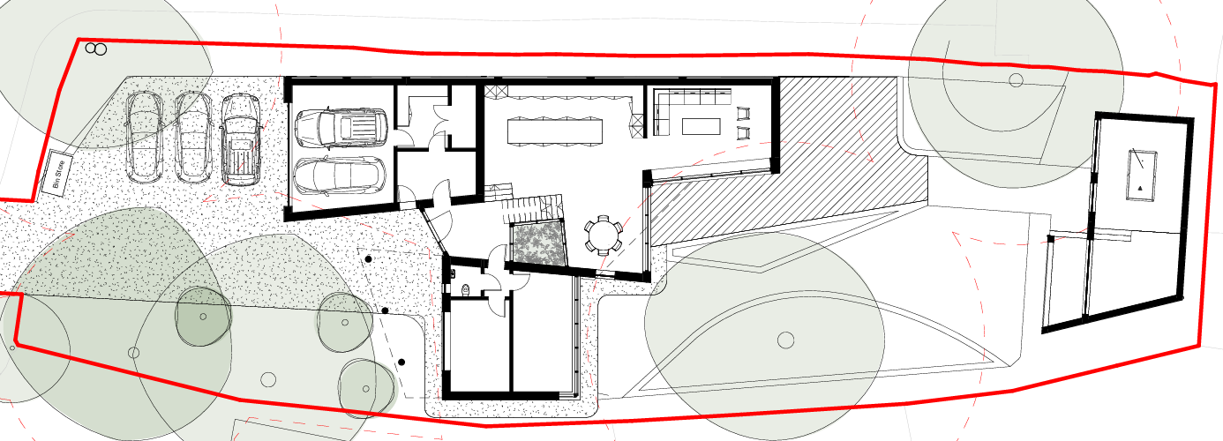

In addition to parking within the grounds a garage a double garage is also proposed. The Councils current Parking Standards and Design SPD recommend that the internal dimensions for a double garage are 7000mm long x 5500mm wide, this is to allow easy access to/from each vehicle and sufficient storage to the rear to accommodate a bicycle. The dimension do not conform to the standards, however as parking is provided in excess of standards, provision is deemed acceptable, spaces are provided with sufficient forecourt depths to allow for on-site turning.

A new pedestrian and vehicle access is proposed to serve the site located along the southern boundary. As previously advised in previous Transport comments for this site, the width of the access should be a maximum of 5m wide, this has now been provided and illustrated on Proposed site Plan Drawing 2202(21) 020 G. As the development is located at the end of a no through road, visibility splays are not required in this instance.

Water run-off from private property onto the public highway is not permitted, an appropriate method of drainage needs to be provided within the property curtilage including the use of suitable permeable surfacing materials.

The Council’s Local Transport Plan 3 Strategy 2011 – 2026 includes policies for investing in new infrastructure to improve connections throughout and beyond Reading which include a network of publicly available Electric Vehicle (EV) charging points to encourage and enable low carbon or low energy travel choices for private and public transport. The Councils Local Plan was adopted in November 2019 and this includes a requirement at Policy TR5 for each new house to be provided with an electric charging point. The Design and Access Statement confirm provision but has not been illustrated on plans.

Plans indicate that a detached annexe is proposed in the rear garden, the applicant has stated that this unt will remain ancillary to the main dwelling, if the proposed annex were to be commercially let, the newly created annex would require parking for 1 car which should be independently accessible from those from the main dwelling, however the potential of a scenario for a commercial let dwelling can be controlled via the application of the appropriate condition if required.

Given the number of trees located on or adjacent the site, the Natural Environment Officer will need to be contacted to ascertain the potential loss/damage to trees.

A minimum of 2 cycle storage spaces which should be in a conveniently located, lockable, covered store are required, in a development of this nature these can be located within a garage however given the size of the garage an alternative will need to be provided, a secure garden shed can be provided. Details and illustrations on revised plans will be required.

Bin storage should not be located further than 15m from the access point of the site to avoid the stationing of service vehicles on the carriageway for excessive periods and should comply with Manual for Streets and British Standard 5906: 2005 for Waste Management in Buildings to avoid the stationing of service vehicles on the carriageway. Given that it is unlikely that a refuse vehicle will enter the site, refuse storage/ collection area has been illustrated near the access that will allow for kerb side collection.

The applicant should be made aware that this development will be subject to a Construction Management Statement.

Suggested conditions and informatives

C1 HOURS OF CONSTRUCTION/DEMOLITION
C2 CONSTRUCTION METHOD STATEMENT (TO BE SUBMITTED)
DC1 VEHICLE PARKING (AS SPECIFIED)
DC3 VEHICULAR ACCESS (AS SPECIFIED)
DC6 CYCLE PARKING (TO BE APPROVED)
DC8 REFUSE AND RECYCLING (AS SPECIFIED)
DC24 EV CHARGING POINTS
IF3 Highways
I29 Access construction

N. Hussain
Transport Development Control Advisor

