17/07/2026
Planning Application Ref: PL/26/0801
Officer: Marcelina Rejwerska
Application Type: Full planning permission
Address: 98 CONISBORO AVENUE, CAVERSHAM, READING, RG4 7JF
Proposal: Erection of a new dwelling.
Application seeks to subdivide the existing site into two plots, retaining the existing dwelling and constructing a new dwelling in the current rear garden. The site is located within Zone 3, Secondary Core Area, of the Council’s adopted Parking Standards and Design SPD. Typically, these areas are within 400m of a Reading Buses high frequency ‘Premier Route’, which provides high quality bus routes to and from Reading town centre and other local centre facilities.

PARKING AND ACCESS
In accordance with the Councils current parking standards and design SPD, a 3+ dwelling will require 2 x off road parking spaces whilst retaining provision for the existing dwelling.
The site is currently served via 3 existing accesses. The most southerly dropped crossing which is currently shared with No 1 Morecambe Ave is to be widened and extended into the site to provide a new 3.2m wide access road leading to the new dwelling as illustrated in the submitted Site Plan Drawing 3902 221 extract below:

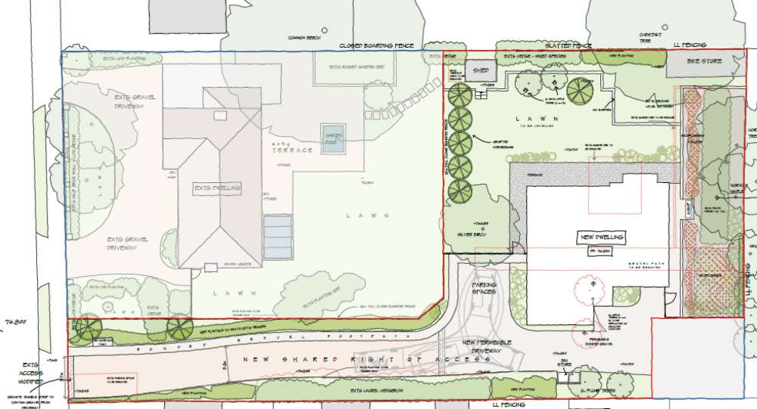

Parking for the existing dwelling is to be retained.

Parking layout has not been illustrated for the new dwelling; however, it is noted that there is available space on site for a minimum 2 vehicles and the provision of onsite turning. This provision is deemed acceptable, however plans illustrating the proposed parking layout will be required, I am happy to deal with this by way of condition.

The widening of the access will result in the partial loss of the grass verge. A license from Highways will be required to undertake all works on the public highway, this includes widening of the access and removal of the grass verge. The widened access will need to be illustrated on plans as will the location of the lamp column. I am happy this can be dealt with by way of condition.

Water run-off from private property onto the public highway is not permitted, an appropriate method of drainage needs to be provided within the property curtilage including the use of suitable permeable surfacing materials. This has been identified on the site plan.

EV CHARGING
The Council’s Local Transport Plan 3 Strategy 2011 – 2026 includes policies for investing in new infrastructure to improve connections throughout and beyond Reading which include a network of publicly available Electric Vehicle (EV) charging points to encourage and enable low carbon or low energy travel choices for private and public transport. The Councils Local Plan was adopted in November 2019 and this includes a requirement at Policy TR5 for each new house to be provided with an electric charging point. This will need to be illustrated on plans; this can be dealt with by way of condition.

TREES
Given the number of trees located on or adjacent the site, the Natural Environment Officer will need to be contacted to ascertain the potential loss/damage to trees.

CYCLE STORAGE
A minimum of 2 cycle storage spaces which should be in a conveniently located, lockable, covered store are required, in a development of this nature these can be located within a garage or a ecure garden shed can be provided. A bike store has been illustrated on the submitted site plan Drawing 3902 221 and is therefore deemed acceptable.

REFUSE STORAGE AND COLLECTION
Bin storage should not be located further than 15m from the access point of the site to avoid the stationing of service vehicles on the carriageway for excessive periods and should comply with Manual for Streets and British Standard 5906: 2005 for Waste Management in Buildings to avoid the stationing of service vehicles on the carriageway. A bin collection point has been illustrated located near the access of the site which would allow for kerb side collection. This is deemed acceptable; It is recommended that the Councils Waste and Recycling team be consulted to ensure the correct type and capacity of bins are provided.
The applicant should be made aware that this development will be subject to a Construction Management Statement.

N. Hussain
Transport Development Control Advisor

