06 November 2024 | 

Title | PLANNING APPLICATION REPORT
Ward | Tilehurst
Planning Application Reference: | PL/24/1212
Site Address: | 5 Conwy Close, Tilehurst, Reading, RG30 4JB
Proposed Development | Proposed conversion of the integral garage to provide a wheelchair accessible wet room and structural works to create an open plan ground floor family space
Applicant | Reading Borough Council
Report author | Gary Miles
Deadline: | 8th November 2024
Recommendations | Grant planning permission, subject to conditions as follows
Conditions | - TL1 – Time Limit – Three Years  - AP1 – Approved Plans  - M3 – Materials as Specified  - PD3 – Obscure Glazing
Informatives | - IF1 – Positive and Proactive Working - approval  - IF5 – Terms  - IF7 – Complaints about Construction

- Executive summary
  - The proposal is to support provision of accessible family accommodation as part of the Council’s housing stock. The proposal is considered acceptable in terms of its effect on the character of the area and the effect on neighbouring amenity.
  - The proposal is recommended for approval subject to the conditions as outlined above.
- Introduction and site description
  - The application seeks full planning permission for the conversion of the integral garage to provide a wheelchair accessible wet room and structural works to create an open plan ground floor family space to support accessible family accommodation.
  - The application is required to be determined by Planning Applications Committee as Reading Borough Council is the applicant.
  - The proposal site consists of a 3-storey semi-detached dwellinghouse. The property is part of a small development of council stock properties constructed in 2018, located adjacent to the Thames Valley School, the Meadway Sports Centre and the Avenue Special School. The property has 4 bedrooms along with living accommodation and an integral garage, over 3 floors. The adjoining and neighbouring properties are also council owned housing stock.

Location Plan
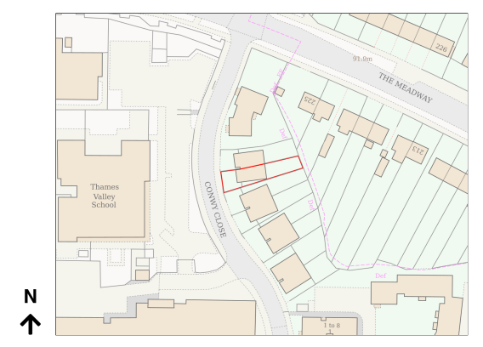

Site Photograph
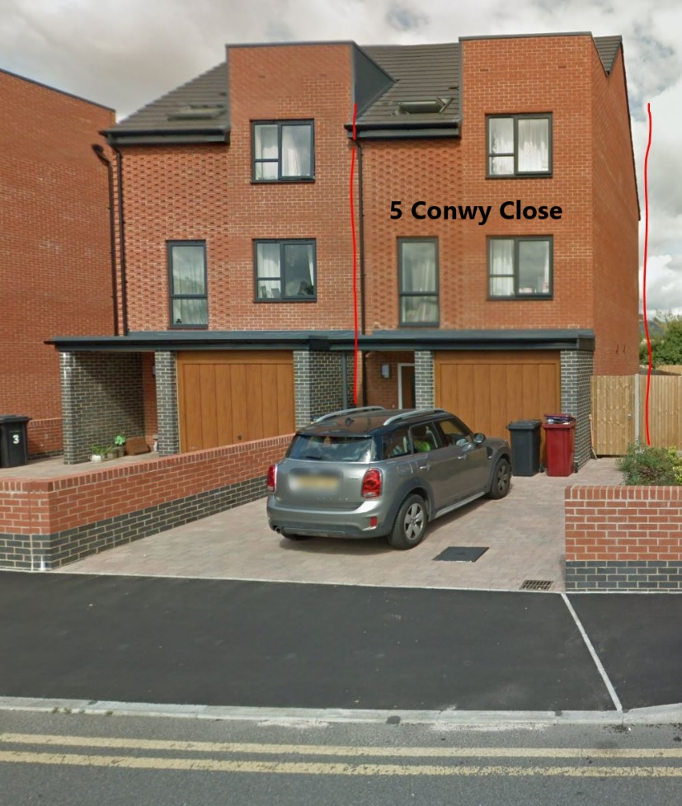

- The Proposal
  - The proposal does not include any extended aspect of the original build. The property has an integral garage with an internal door connection. Proposed conversion of the integral garage is to provide a wheelchair accessible wet room and structural works to create an open plan ground floor family space with reconfigured kitchen with worktop and washing machine void. The existing up and over garage door will remain in situ albeit permanently fixed in place with insulated wall behind, this will keep the façade unchanged. Daylight and ventilation provisions will be created by the installation of a side obscure glazed window on the north-westerly elevation. A flat obscure glazed rooflight will be installed in the existing flat roof section above the garage allowing light to flood into the new wet room.
  - The following plans have been received:
- Site Location Plan, dated Jan 23
- Site Plan, dated Jan 23
- Drawing No. 4577-PL-104-Existing Layout Plan, dated June 16
- Drawing No. 1102 rev P1-General Arrangement Elevations and Sections AA-BB, dated Oct 17
- Drawing No. 5CC-DRP-JG-Drainage Plan, not dated
- Drawing No. MAP-C4966-218-Plans-Ground Level-Proposed Structure, dated Apr 24
- Drawing No. 5CC-PLP-JG-Proposed Layout, dated Sept 2024
Received 13th September 2024
- Planning history
- None.
- Consultations
  - The following consultation responses were received:
5.2 RBC, Transport Development Control
The Transport officer confirms the existing hardstanding frontage offers enough off-street parking for 2 vehicles, even with the loss of the internal garage, this is in line with the council’s current parking standards.
In principle there are no Transport objections to this application.
5.5 Neighbour Consultations
3 Conwy Close, Tilehurst, Reading, RG30 4JB
7 Conwy Close, Tilehurst, Reading, RG30 4JB
No letters of representation have been received.
6. Legal context
6.1 Section 38(6) of the Planning and Compulsory Purchase Act 2004 requires that proposals be determined in accordance with the development plan unless material considerations indicate otherwise. Material considerations include relevant policies in the National Planning Policy framework (NPPF) - among them the 'presumption in favour of sustainable development'. However, the NPPF does not change the statutory status of the development plan as the starting point for decision making (NPPF paragraph 12).
6.2 In this regard, the NPPF states that due weight should be given to the adopted policies of the Local Plan 2019 according to their degree of consistency with the NPPF (the closer the policies in the plan to the policies in the NPPF, the greater the weight that may be given).
6.3 Accordingly, the latest NPPF and the following development plan policies and supplementary planning guidance are relevant:
National Planning Policy
National Planning Policy Framework (2023)
National Planning Practice Guidance
SPD – Design Guide to House Extensions 2021
Reading Borough Local Plan (2019)
CC7 (Design and the Public Realm)
CC8 (Safeguarding Amenity)
H9 (House Extensions and Ancillary Accommodation)
TR5 Car and Cycle Parking and Electric Vehicle Charging
CC2 (Sustainable Design and Construction)
7. Appraisal
Character and Appearance
7.1 Policy H9 states that an extension to a house will be acceptable where it respects the character of the house in terms of scale, location, materials, and design and respects the character and pattern of neighbouring properties and the street as a whole in terms of scale, location, materials and design, and any important existing building line. Policy CC7 also sets out relevant considerations for design.
7.2 Officers consider the conversion of the integral garage to provide a wheelchair accessible wet room with works to create an open plan ground floor family space to support accessible family accommodation is acceptable. The existing garage door will be retained, meaning the property will have the same look and feel as the adjoining neighbour at 3 Conwy Close and the neighbouring semi-detached properties of the same age and character. Officers consider the proposed window to the north-westerly elevation and roof light in the existing flat roof section above the garage would fit with the existing character and would not disrupt the existing architecture and are therefore acceptable in terms of character and appearance.
7.3 The proposal is considered compliant with policies H9 & CC7 of the Reading Borough Local Plan 2019.
Residential Amenity
7.4 Policy H9 states that an extension will be acceptable where it does not result in an overbearing impact on neighbours. Policy H10 seeks to ensure that the amenity of gardens and other outdoor areas are not compromised. Policy CC8 states an extension to a house will be acceptable where it will not cause a significant detrimental impact to the living environment of existing or new residential properties.
7.4 The proposed window to the north-westerly elevation and proposed roof light in the existing flat roof section above the garage are not considered harmful to residential amenity as they will be obscure glazed and would not result in loss of privacy to neighbours.
7.5 The proposal is considered compliant with policies H9 & CC8 of the Reading Borough Local Plan 2019.
Transport
7.6 The Highway Authority was consulted as the proposal includes the converting the integral garage and confirm that the property benefits from a large block paved driveway offering parking for 2 vehicles. The Highway Authority has no objections.
7.7 Officers consider the proposal will be compliant with policies TR5 of the Reading Borough Local Pan 2019.
Sustainable Design and Construction
7.8 Policy CC2 states that proposals for new development, including the construction of new buildings and the redevelopment and refurbishment of existing building stock, will be acceptable where the design of buildings and site layouts use energy, water, minerals, materials and other natural resources appropriately, efficiently and with care and take account of the effects of climate change.
7.9 Whilst the above policy is not directly applicable to this type of application, officers note that the proposal includes constructing a section of insulated wall behind the garage door façade along with thermostatic radiator valves (TRV’s) to make the building thermally efficient and help reduce the home's energy consumption.
7.10 Officers consider the proposal will be compliant with policy CC2 of the Reading Borough Local Pan 2019.
8. Equality implications
8.1 Under the Equality Act 2010, Section 149, a public authority must, in the exercise of its functions, have due regard to the need to:
- eliminate discrimination, harassment, victimisation and any other conduct that is prohibited by or under this Act;
- advance equality of opportunity between persons who share a relevant protected characteristic and persons who do not share it;
- foster good relations between persons who share a relevant protected characteristic and persons who do not share it.

8.2 The key equalities protected characteristics include age, disability, sex, gender reassignment, marriage and civil partnership, pregnancy and maternity, race, religion or belief, sexual orientation. It is considered that there is no indication or evidence that the protected groups have or will have different needs, experiences, issues and priorities in relation to this particular application.
9. Conclusion & Planning Balance
9.1 As with all applications for planning permission considered by the Local Planning Authority, the application is required to be determined in accordance with the development plan unless material considerations indicate otherwise, as per Section 38(6) of the Planning and Compulsory Purchase Act 2004.
9.2 It is considered that, subject to the recommended conditions, the proposed conversion of the integral garage to provide a wheelchair accessible wet room and structural works to create an open plan ground floor family space to support accessible family accommodation, would be acceptable in terms of character and appearance, residential amenity and sustainability. Therefore, this application is recommended for Approval subject to conditions.

Plans

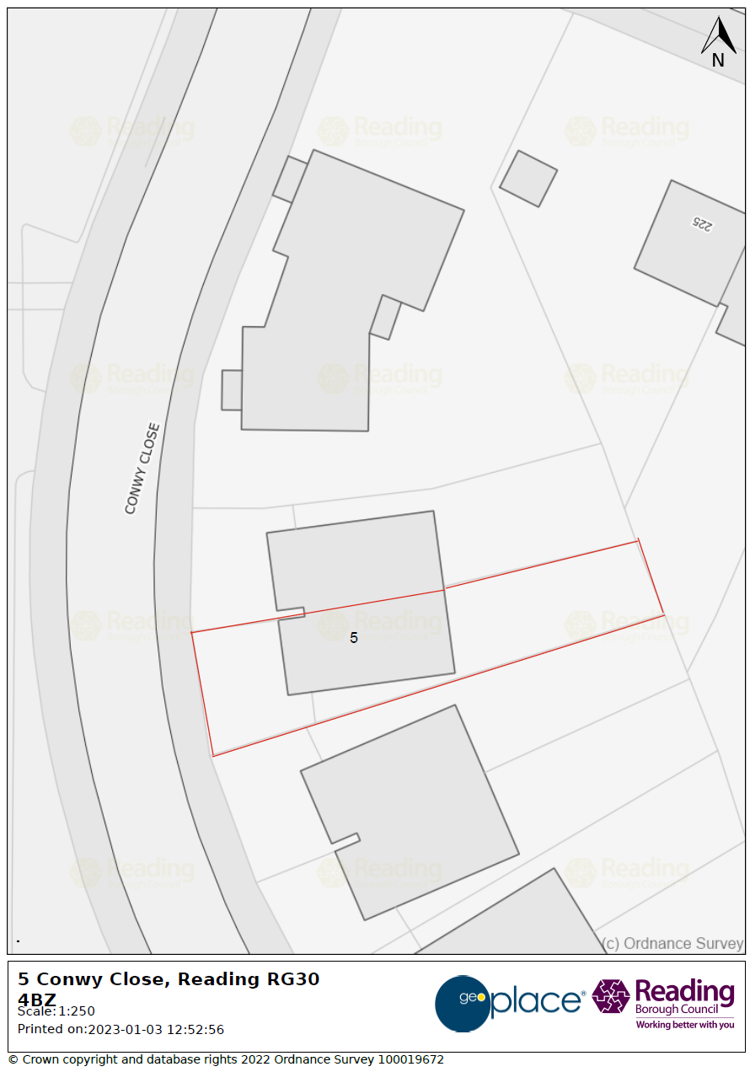

Site Layout Plan

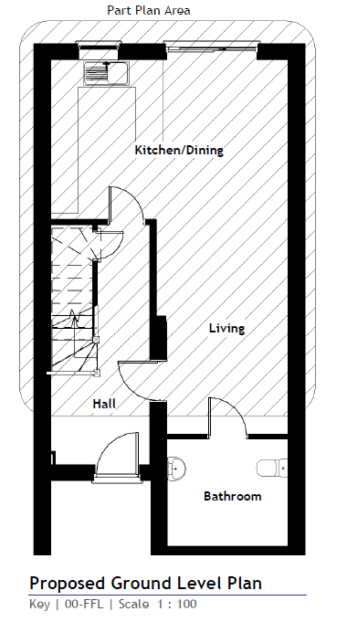

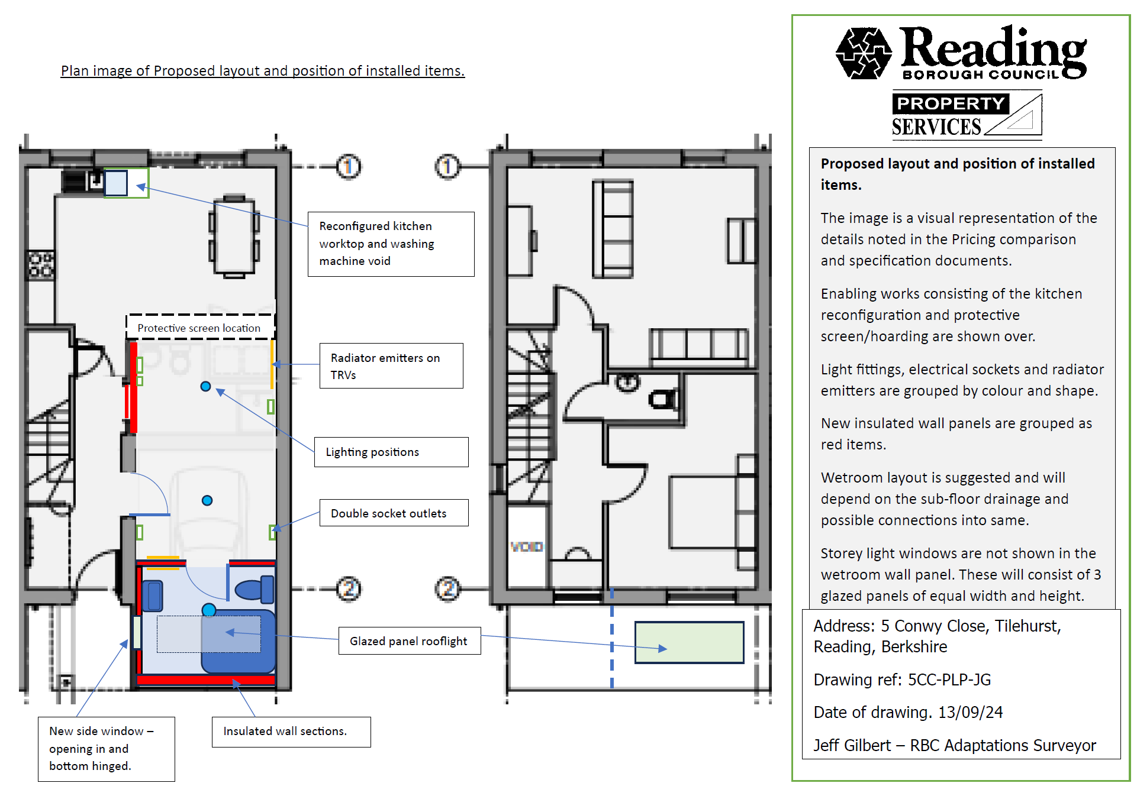
Proposed Internal Site Layout Plan
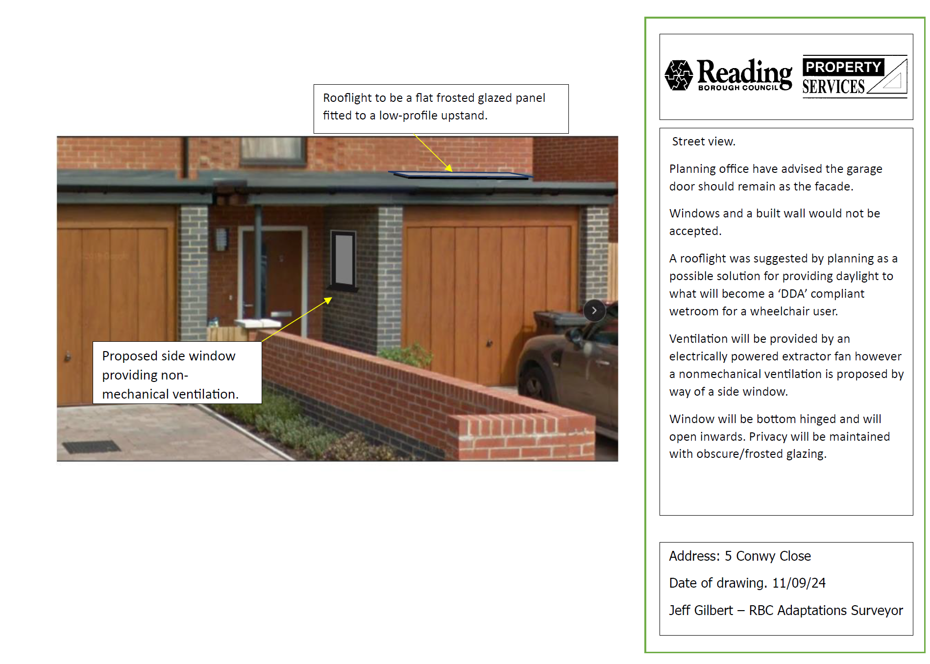
Proposed External Changes

