09/06/26
Planning Application Ref: PL/26/0666
Officer: Anthony Scholes
Application Type: Full planning permission
Address: 70 WHITLEY STREET, RG2 0EQ
Proposal: Erection of 2no. single-storey one-bedroom dwellings

This application is for the erection of 2 x one-bedroom bungalows on land to the rear of 70–72 Whitley Street (A327). Whitley Street is a principal bus route where parking and loading is prohibited except in signed bays which are time restricted to 30 minutes parking.
The site is located in Zone 2, Primary Core Area, of the Revised Parking Standards and Design SPD. This zone directly surrounds the Central Core and extends to walking distances of 2 kilometres from the centre of Reading. This zone is well served by public transport, with buses continuing either into or out of the Central Core Area via this zone.
In accordance with the adopted Parking SPD, the development would be required to provide 1 on-site parking space per 1 bedroom dwelling. Off street parking provision is referred to in Paragraph 112 of the NPPF, which says that:

“If setting local parking standards for residential and non-residential development, policies should take into account:

a) the accessibility of the development;
b) the type, mix and use of development;
c) the availability of and opportunities for public transport;
d) local car ownership levels; and
e) the need to ensure an adequate provision of spaces for charging plug-in and other ultra-low emission vehicles.”

The applicant is proposing a car free development. However, section 4.11 of the planning statement states:

- “the adjacent private car park to the site, is under the same landownership and therefore residents can utilise this parking area. The parking area consists of 7 spaces and is utilised by the Turkish Halal store which has a floor area of 152 m² (Planning Consent 181351/FUL, Change of use of the ground floor (152 sq.m) from use class A4 (public house) to A1 (retail)). In accordance with the Reading Borough Council Parking SPD, food retail stores within Parking Zone 2 require 1 space per 40m², thus the retail unit requires 4 parking spaces. This results in a surplus of three spaces which the residential units will have the use of, if required”.

Although the site is located within a sustainable location, there are areas within the immediate vicinity where parking restrictions do not apply. This may lead to overspill on-street parking.

Furthermore, there is an inconsistency within the applicant’s Planning Statement. While the development is described as a “car-free” scheme, it is also stated that parking could be accommodated within the adjacent private car park for residents of the proposed dwellings. This contradiction requires clarification.

Accordingly, it is considered necessary to secure a dedicated provision of two car parking spaces within the adjacent car park for use by residents of the proposed development.

Given that the car park would serve both the residential units and the retail unit, a Car Park Management Plan should be submitted and approved. This plan should set out how parking spaces will be allocated, managed, and controlled to prevent conflicts between users.

In addition, Electric Vehicle (EV) charging infrastructure should be provided, with at least one charging point per dwelling, in accordance with sustainable transport objectives.

The Councils Residential Permit Scheme operates in the surrounding streets therefore the applicant should note that if this application is approved the relevant conditions and informatives would be applied preventing future occupants from applying for any resident or visitor permits.

Bin storage should comply with Reading Borough Council’s Waste management guidelines for property developers.
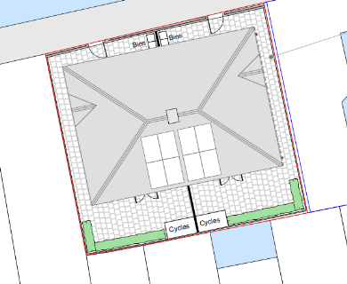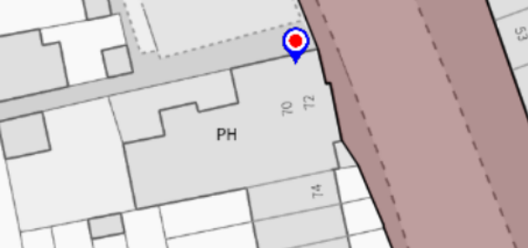

It is unclear how a refuse vehicle would access the site and comply with the recommended pulling and carrying distances. The waste collection team will need to be consulted to determine how and if they would collect from the proposed properties, alternatively a dedicated waste collection point will need to be illustrated on revised plans.

In accordance with the adopted Parking SPD, the development is required to provide a minimum of 1.0 secure cycle parking space for each dwelling which in a lockable, covered store in a development of this nature, this can be provided in each private rear garden.
A construction method statement would be required and secured by condition if a full application is approved.

Please ask the applicant to address the comments above including confirmation of collection of refuse arrangements from the Councils refuse and collection team so that this application can be fully determined.

N. Hussain
Transport Development Control Advisor

