30/06/2026

Planning Application Ref: PL/26/0742
Officer: Catrin Davies
Application Type: Full planning permission
Address: 67 AMBLECOTE ROAD, TILEHURST, READING, RG30 4BS
Proposal: Single storey extension and associated alterations to create
a separate one-bedroom residential dwelling and associated work

Previously approved application for this site:
- PL/20/1769
- Demolition of garage and single storey extension.

The site is located within Zone 3 – Secondary Core Area – as defined in the Council’s adopted Parking Standards and Design SPD. It occupies a corner plot currently developed with a single three-bedroom bungalow.

This application proposes to subdivide the existing dwelling to create two semi-detached bungalows comprising one one-bedroom unit and one two-bedroom unit. A new access and parking area is proposed to the south of the site to serve the existing dwelling.

In accordance with the adopted SPD, a Class C3 use in this location would require a total of 2.0 parking spaces (rounded up from 1.5) for the existing dwelling, and 1 parking space for the proposed one-bedroom dwelling.

The applicant has indicated that parking for the new one-bedroom unit will utilise the existing vehicular access. The currently installed gates are to be removed and replaced with sliding gates. This arrangement is considered acceptable

Proposed Layout.
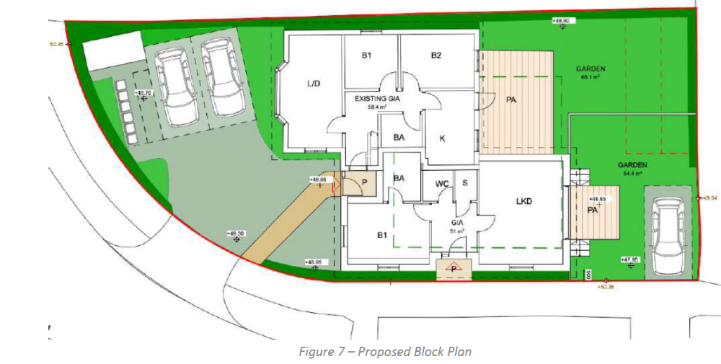

A new vehicular access is proposed to serve the existing dwelling. Visibility splays have been calculated and are illustrated on the submitted plans.

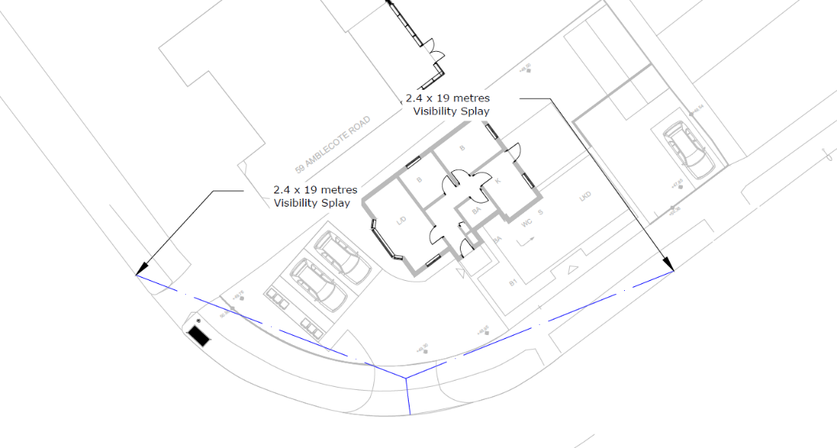

The submitted Technical Note includes ATC calculations supporting visibility splays of 2.4m x 19m. However, the illustrated splays extend across land within the applicant’s control where an existing boundary fence exceeds 0.6m in height. This would result in an obstruction within the required visibility envelope.

To ensure safe and adequate visibility, appropriate measures must be secured to maintain the splays free from obstruction. It is noted that Manual for Streets allows some flexibility, and the ‘X’ distance could be reduced to 2.0m, resulting in a visibility splay of 2.0m x 19m. This relaxation may be acceptable in this location.

Accordingly, revised plans are required showing:
- Updated visibility splays (potentially 2.0m x 19m); and
- Confirmation of boundary treatments within the splay, demonstrating that no obstruction above 0.6m in height will be present.

The creation of the new access, including the partial removal of the grass verge, will require a licence from the Highway Authority.

The Council’s Local Transport Plan 3 (2011–2026) supports the provision of infrastructure to enable low-carbon travel, including electric vehicle (EV) charging. In addition, Policy TR5 of the adopted Local Plan (November 2019) requires all new dwellings to be provided with EV charging facilities. Details of the EV charging point, should be provided and illustrated on the submitted plans.

In accordance with the adopted Parking Standards and Design SPD, the proposed dwelling is required to provide secure cycle parking for a minimum of one cycle. This should comprise a conveniently located, lockable and covered store. No cycle storage provision has been demonstrated on the submitted plans.

Bin storage and collection arrangements must be provided in accordance with Manual for Streets and BS 5906:2005 (Waste Management in Buildings). Bin stores should be located no more than 15m from the collection point to avoid prolonged standing of refuse vehicles on the carriageway. The submitted plans do not illustrate bin storage or collection arrangements for the proposed dwelling.

Conclusion
In principle there are no objections to this application subject to revised plans to address the following:

- Visibility splays and boundary treatments
- EV charging provision
- Cycle parking provision
- Bin storage and collection arrangements

A CMS will be required if this development is approved.

N. Hussain
Transport Development Control Advisor

