
Site: 62B Cockney hill, Tilehurst, Reading, Berks

Local Planning Authority: Reading Borough Council.

Arboricultural Method Statement Methodology.
The Arboricultural method statement provides the means by which areas of construction near to the Root Protection Area (RPA) of retained trees can be achieved whilst minimising the impact of construction. It is important that a method of construction which minimises the impact on the tree roots which appear on the survey as provided on Dwg 04 is put in place before work begins.

Tree Protection Measures.
5 No. trees were identified in the garden of the property. The distances from the host dwelling and the girth of each tree were measured and the RPA`s noted accordingly.
The proposed building works are outside of the RPA of all listed trees however to ensure there is no incursion into this area fencing precautions will be deployed as described below.

Arboricultural Implications Assessment.
The trees listed in the survey will all be retained in their present state and it is considered that the proposal will not affect the amenity value in any way.

Below Ground Constraints
No Services are to be routed through the RPA of any tree.

Precautionary Measures
Heras fencing to be erected as shown on plan. This will be erected before work commences and kept in situ throughout the course of the works. Building Materials will be stored on the current hardstand where car parking currently exists.

~~~ Page 1 ~~~

Heras Railing
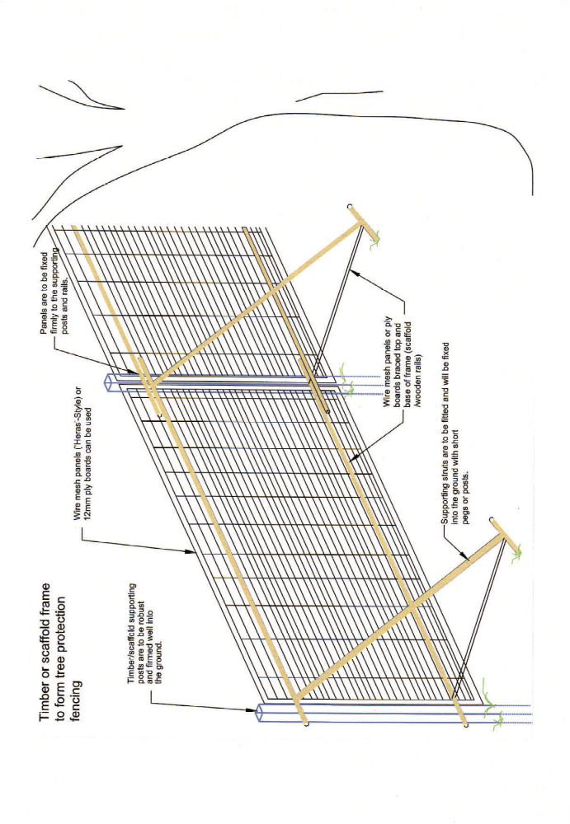

~~~ Page 2 ~~~

