22/06/2026

Planning Application Ref: PL/ 26/0601
Officer: Anthony Scholes
Application Type: Householder planning permission
Address: 28 COLDICUTT STREET, CAVERSHAM, RG4 8DU
Proposal: Retrospective permission for the demolition of an
outbuilding and erection of a replacement outbuilding

The application seeks retrospective planning permission for the demolition of a former outbuilding and the erection of a detached outbuilding located at the rear of the site.
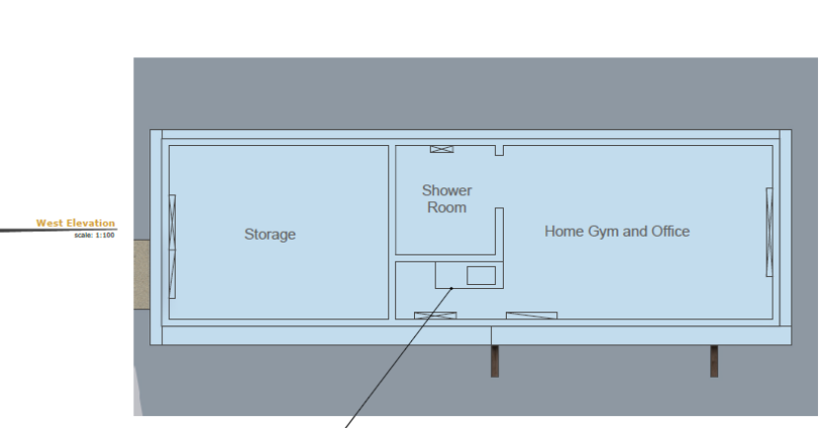1

The submitted Planning Statement indicates that the outbuilding is intended to remain ancillary to the main dwelling. However, it is also acknowledged that independent rear access could be provided, which may facilitate its use as a separate, self-contained unit.

A review of imagery shows an existing area of hardstanding at the rear of the site currently being used for off-street parking.

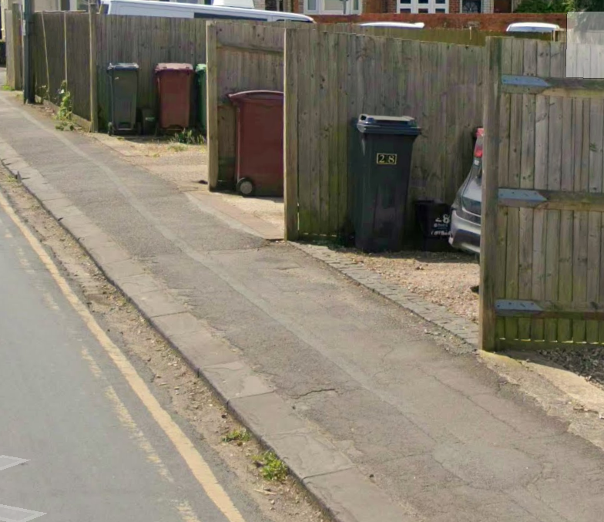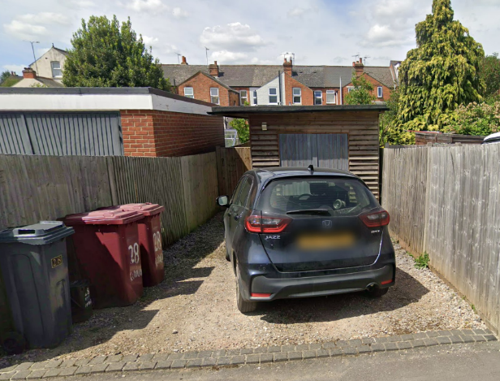

There is no evidence of a formal dropped crossing serving this area. As such, vehicles accessing the site are likely undertaking manoeuvres over the footway, Should this area continue to be used for parking, the applicant will be required to obtain a licence for a dropped crossing from the Council’s Highways Authority.

From a transport perspective, the outbuilding used solely as incidental use, ancillary to the main dwelling, would not be expected to have a material impact on the local highway network. However, it is considered that if the building were to be used independently (e.g. as a separate residential unit or for commercial purposes), this could result in additional trip generation and on-site parking demand. In such circumstances, the current parking provision would likely be inadequate.

To mitigate this risk, it is recommended that the appropriate planning condition be imposed restricting the use of the outbuilding to ancillary use to the main dwelling only.

Suggested conditions and informatives:

PD6 ANCILLARY DOMESTIC USE
The extension/building hereby permitted shall not be occupied at any time other than for purposes ancillary to the residential use of the main dwelling known as 20 Coldicutt Street, RG4 8DU
REASON: To accord with the terms of the application, and to ensure that separate occupation of the extension/building would not detract from the amenities or living conditions of neighbouring residential properties (or the character of the locality) in accordance with Policy H9 of the Reading Borough Local Plan 2019.

IF3 Highways

N. Hussain
Transport Development Control advisor

