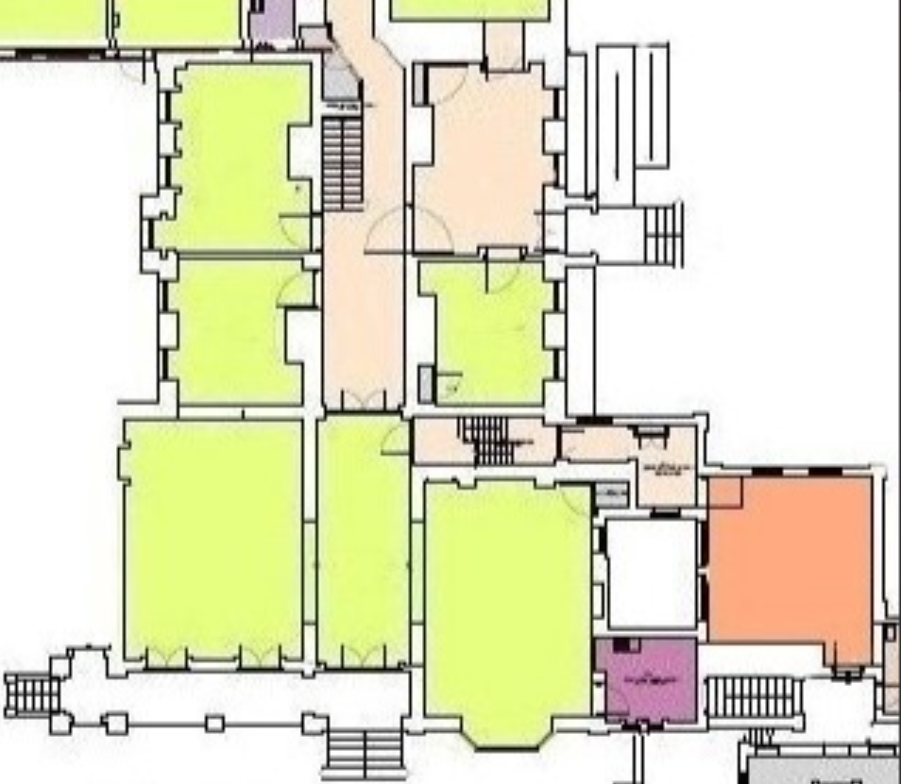
Internal staircase from the ground to first floor of the Manor House where the paint is to be applied.

