
Tree Assessments UK
Arboricultural Consultancy
Lee Garner
Barrow upon Soar
Loughborough
Tel: 07793 986711 | Email: leeUK@hotmail.co.uk
________________________________________________________________________________
To | Reading Borough Council
From | Lee Garner, Tree Assessments UK
Date | 19th April 2026
Subject | TPO Application supporting data – Rosehill House, Peppard Road, Emmer Green RG4 8XB

Please find attached supporting data for TPO application form for the above site covered by TPO 12/003.

Tree TPO Number (refer to TPO plan only) | Species | Tree Works | Notes
T2 | Yew | Crown lift over driveway up to 3m above ground level, pruning only secondary branches | to allow clearance for vehicles entering site
T3 | Cedar | Remove Deadwood | Removing deadwood over targets
T4 | Cedar | - Remove hanging branch at c.6m above ground level. Can be removed from ground level with pole and hook.  - Remove deadwood | Removing deadwood over targets
T5 | Lime spp | Remove all epicormic and sucker growth up to 2m above ground level to allow inspection of lower trunk and basal area. Hand saw only, no chainsaw or other mechanical means. | Inspection purposes
T6 | Lime Spp | Re-coppice in order to alleviate leverage/pressure on old coppice stool – (lapsed coppice) | Central decay visually evident within coppice stool. Outer trunk remaining with coppice regrowth extending from this.
T7, T8 & T9 | Lime spp | Remove all epicormic and sucker growth up to 2m above ground level to allow inspection of lower trunk and basal area. Hand saw only, no chainsaw or other mechanical means. | Inspection purposes

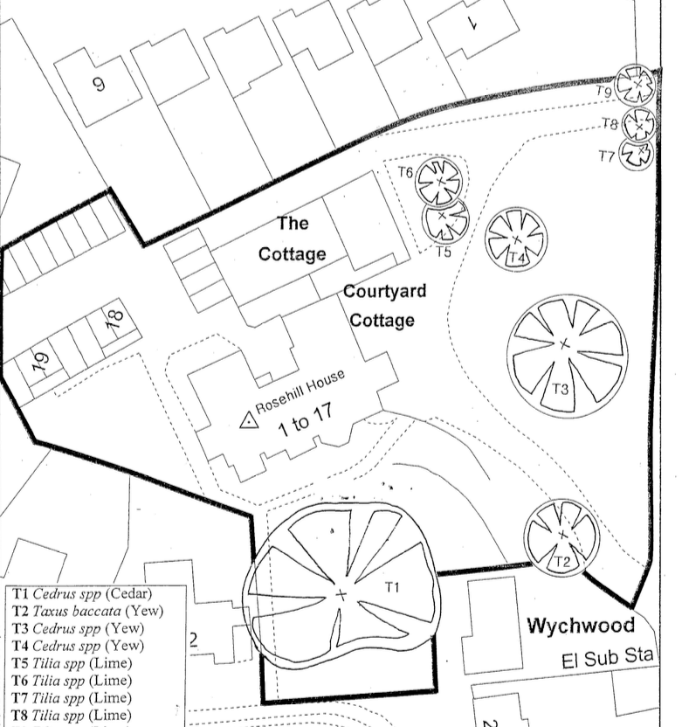

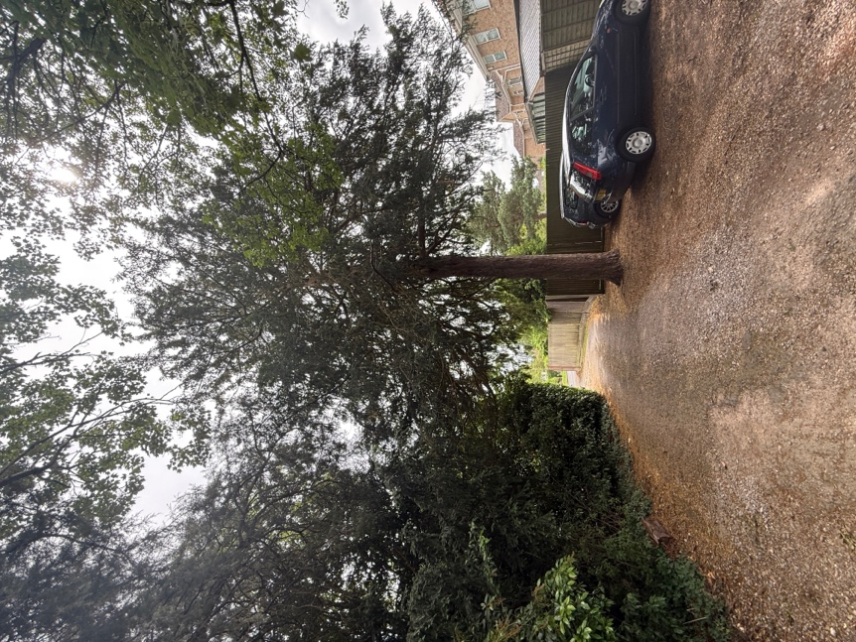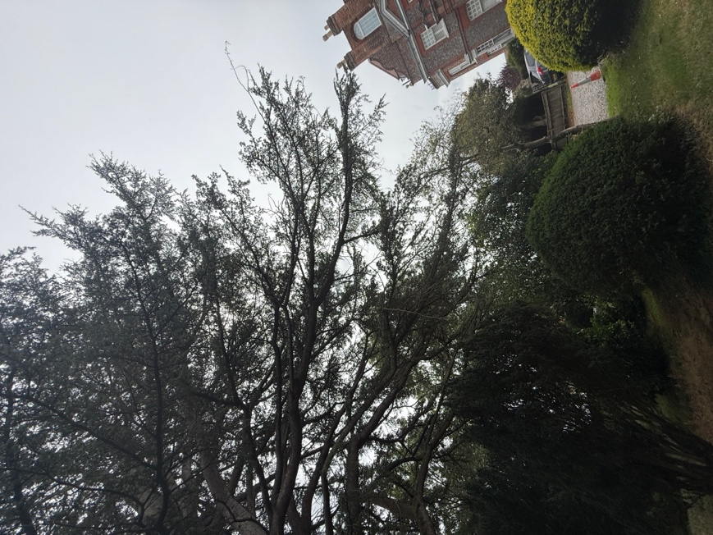
T2 Yew (Crown Lift) T3 Cedar (Deadwood)
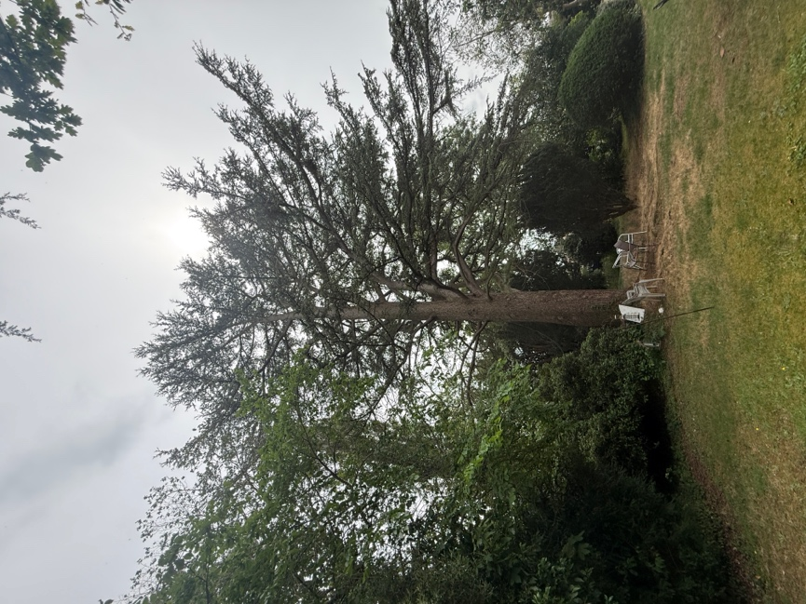
T4 Cedar – (Deadwood)

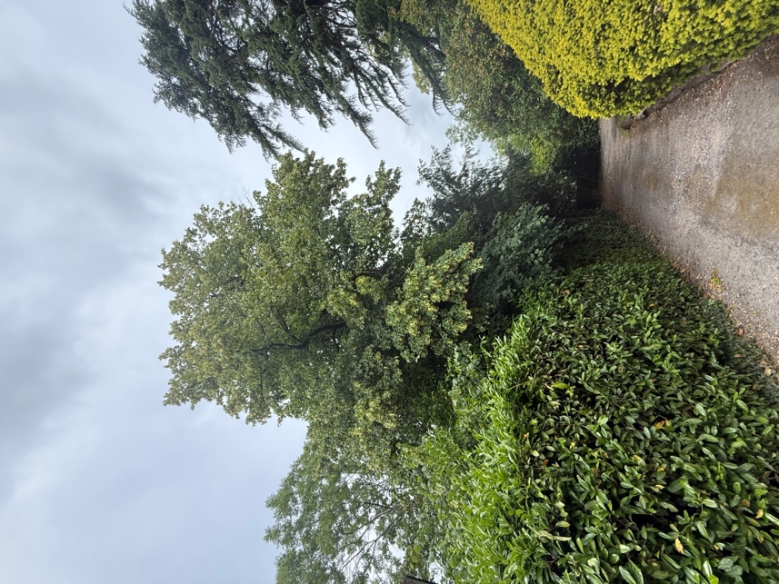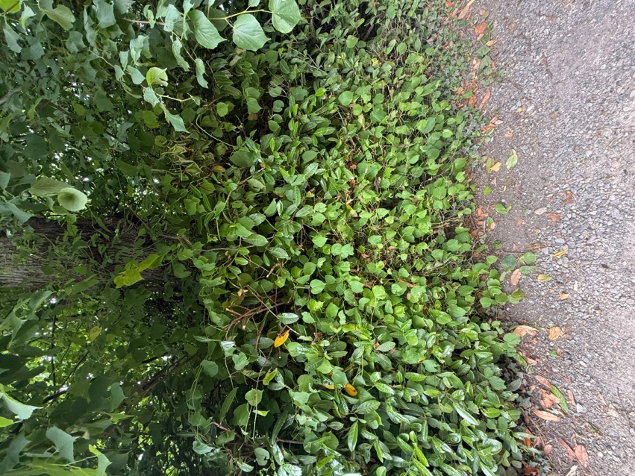
T5 Lime – Remove epicormic and suckers (as per spec)
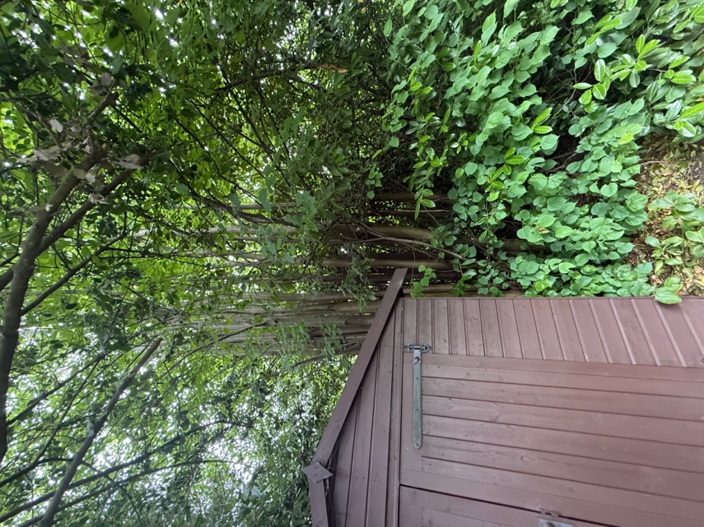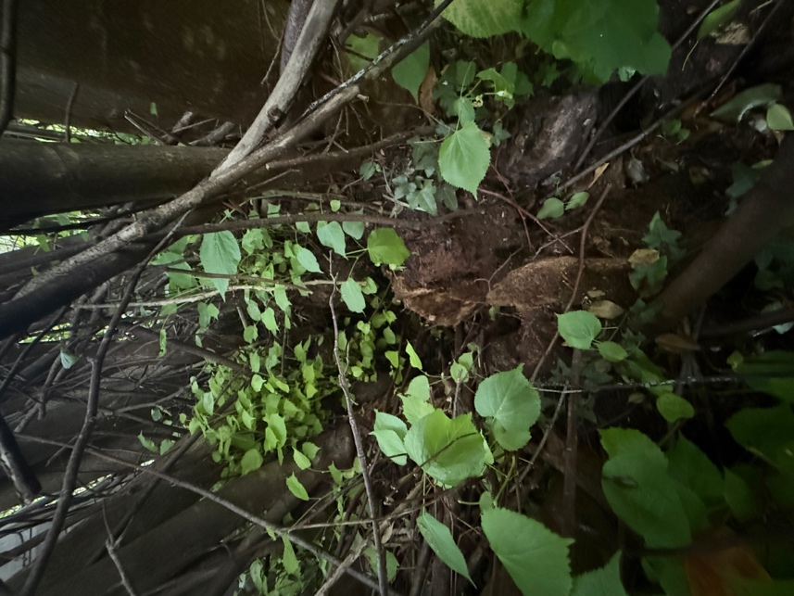
T6 Lime (decayed central base)
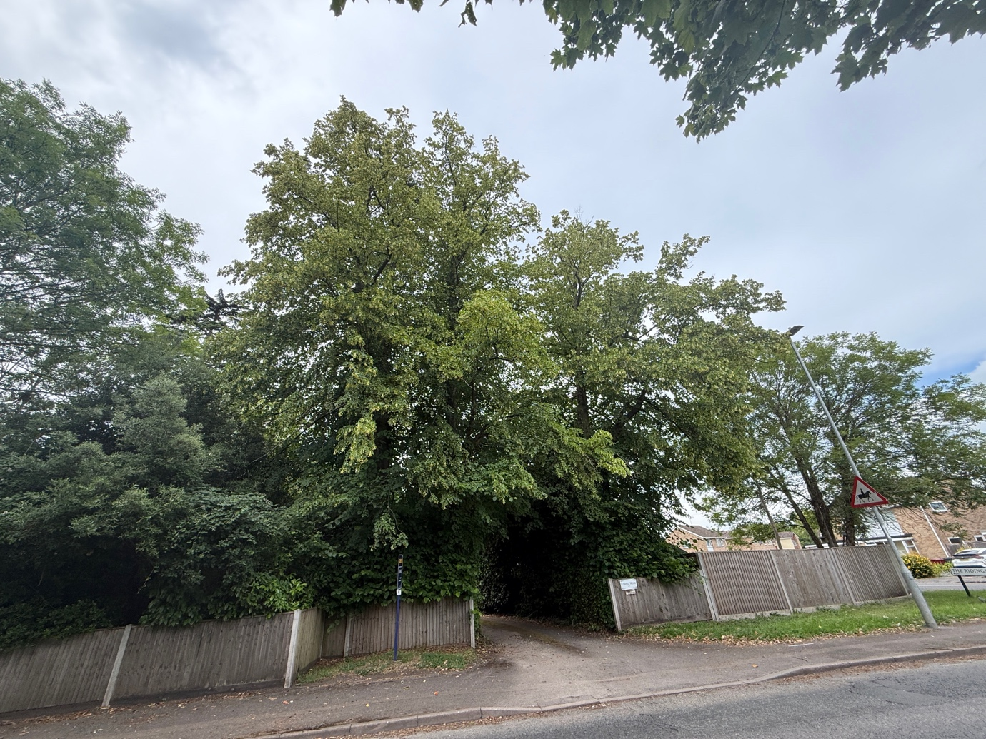
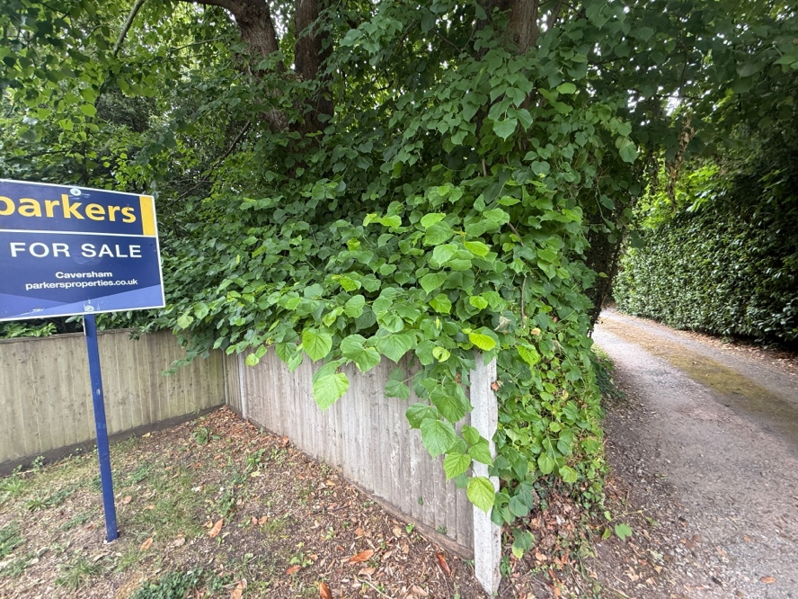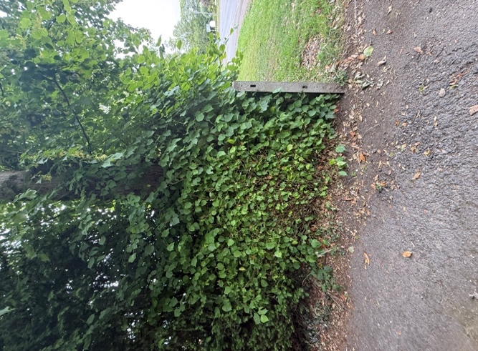 T7-T9 Lime – Remove sucker and epicormic (As per spec)

