12/06/2026

Planning Application Ref: PL/26/0349
Officer: Anthony Scholes
Application Type: Full planning permission
Address: Land adjacent Tilehurst Railway Station, Oxford
Road, Tilehurst, RG31 6TH
Proposal: 3 storey, 2-bed dwelling house (self-build) including
formation of an access to Oxford Road (A329), driveway, landscaping, and associated works

Previous application for this site; 150136.

The site is located within Zone 3 Secondary Core Area, of the Council’s adopted Parking Standards and Design SPD. Typically these areas are within 400m of a Reading Buses high frequency ‘Premier Route’, which provides high quality bus routes to and from Reading town centre and other local centre facilities. The A329 Oxford Road is one of the main routes into Reading from the west, therefore, any proposal needs to comply with the Council’s adopted Design Guidance for Residential Accesses on to Classified Roads.

Although the description of the proposal states a 2 bedroom dwelling plans appear to show a potential of 3 bedrooms:

First Floor 1- Bedroom 1
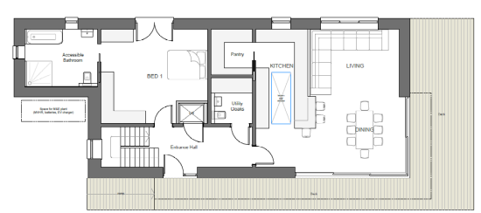

Second Floor: Bedroom 3
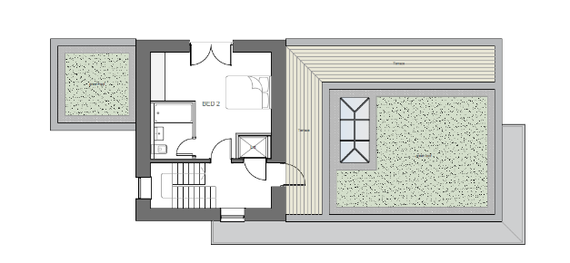

2nd Floor – Bedroom 3/Home working
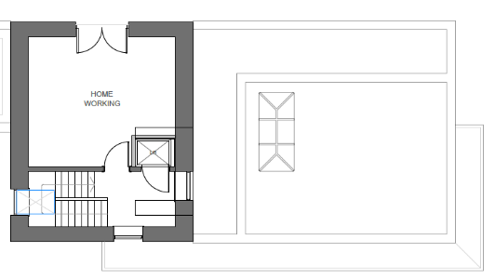
In accordance with the Council current adopted standard a 3 bedroom dwelling would require 2 off street parking spaces. Plans illustrate a parking area that can accommodate 2 vehicles although nt specifically illustrated as well as providing on site turning, therefore proposed provision is deemed acceptable.

The Council’s Local Transport Plan 3 Strategy 2011 – 2026 includes policies for investing in new infrastructure to improve connections throughout and beyond Reading which include a network of publicly available Electric Vehicle (EV) charging points to encourage and enable low carbon or low energy travel choices for private and public transport. The Councils Local Plan was adopted in November 2019 and this includes a requirement at Policy TR5 for each new house to be provided with an electric charging point. It should be noted that installation of the charging point will need to conform with the latest building regulations. Plans will need to illustrate provision for EV charging.

A new access is proposed, and visibility splays have been provided; however, visibility spays of 2.4m x 90m should be provided for a major transport corridor, which Oxford is. Revised plans are required. The width of the proposed access for a single dwelling is excessive and should be reduced to 3m as the number of onsite movements will be minimal given the proposal is for a single dwelling. Revised plans required. A license from the Highways Department will be required to undertake all works on the public highway, this includes the introduction of a new vehicle crossing.

Water run-off from private property onto the public highway is not permitted. An appropriate method of drainage needs to be provided within the property curtilage including the use of suitable permeable surfacing materials.

Cycle storage should be provided inaccordance with the Council current adopted parking standards, proposed cycle storage has not been illustrated on plans; in a development of this nature this can be provided within a lockable shed located in the rear garden. Revised plans required.

Bin storage should not be located further than 15m from the access point of the site to avoid the stationing of service vehicles on the carriageway for excessive periods and should comply with Manual for Streets and British Standard 5906: 2005 for Waste Management in Buildings. A bin collection area has been illustrated; however, this appears to be outside of the red line plan.

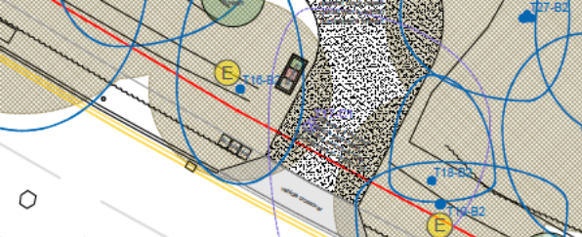

Bins can not be located/stored on any part of the Highway and must be located within the curtilage of the site near the access point to allow for kerb side collection. Revised plans required.

There are a number of trees on site and therefore the Natural Environment Officer will need to be contacted.

A CMS will be required for this development if this application is approved.

Please ask the applicant to submit revised plans to address the comments above.

N. Hussain
Transport Development Control Advisor

