04/06/26

Planning Application Ref: PL/26/0609
Officer: Catrin Davies
Application Type: Full planning permission
Address: 24 BAKER STREET, READING, RG1 7XX
Proposal: Change of use of property from C4 use class (6 bedroom
HMO) to Sui generis use class for seven bedroom HMO
Previous application for this site PL/26/0233.

The site lies within the Castle Hill/Russell Street/Oxford Road Conservation Area. The application site comprises a two storey semi-detached building currently used as a 6 bedroom HMO as established under Certificate of Lawfulness PL/25/1331.

The Council’s Parking SPD requires 0.25 parking spaces per lettable room. Submitted Transport Statement states that this is to be a car free development. Google images do not show a vehicle crossing serving the property therefore there is currently no on-site parking associated with this site, however if at any point the applicant wanted a vehicle crossing, a license would be required for the Councils Highways Department.

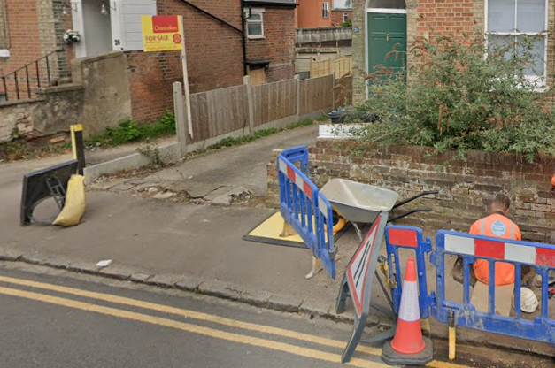

Given there are extensive parking restrictions in place in the vicinity in the form of double yellow lines and the operation of the Councils Residential parking permit scheme of the site preventing unauthorised parking a car free development can be considered in this instance. Under the Borough’s current parking standards, this proposal would generate additional pressure for parking in the area. There should be an assumption that any future occupants of the proposed HMO will not be issued with resident or visitor parking permits which would be covered by condition and an informative applied. This will ensure that the development does not harm the existing amenities of the neighbouring residential properties by adding to the already high level of on street car parking in the area.

Submitted plans also illustrate an outbuilding to be used as a gym, located at the rear of the site; This was permitted under application PL/25/1815.

Bin storage and collection area have not been illustrated on submitted plans although the planning statement does refer to storage at the front of the site. No additional bins are likely needed for the addition of one bedroom; however, it is recommended that the Councils waste and recycling team are contacted to ensure the correct capacity and type of bins are provided. Plans illustrating the location of bins will be required.

In accordance with the Councils current adopted standards a 7 bedroom HMO would require 0.5 storage spaces per room, this equates to 4 spaces (2 Sheffield stands) for the development. Bin bike storage has been illustrated at the rear of the site utilising Sheffield type stands.

Given the location of the site in a residential CPZ area a scaled down version of a CMS is recommended to cover key areas such as storage of material, parking and deliveries etc.

Suggested conditions and informatives:

C2 CONSTRUCTION METHOD STATEMENT (TO BE SUBMITTED)
HM3 HMO REFUSE AND RECYCLING (TO BE SUBMITTED)
HM4 HMO CYCLE STORAGE
The approved bicycle storage spaces shall be provided in accordance with the approved details prior to first occupation and shall not be used thereafter for any purpose other than the storage of bicycles.

HM5 HMO PARKING PERMITS (NOTIFICATION TO LPA)
IF3 Highways

N. Hussain
Transport Development Control Advisor

