05/06/2026

Planning Application Ref: PL/26/0620
Officer: Catrin Davies
Application Type: Full planning permission
Address: 1A, New Road, Reading, RG1 5JD
Proposal: The erection of a dwelling with new vehicle access, parking,
cycle and bin store with associated hard and soft landscaping.

New Rd is located within the Redlands Conservation Area and is located within Zone 2, the primary core area but on the periphery of the central core area which lies at the heart of Reading Borough, consisting primarily of retail and commercial office developments with good transport hubs. Extensive parking restrictions are in force in the surrounding areas including operation of the Councils Residential Permit Parking Scheme.

Parking:
In accordance with the adopted Parking Standards and Design SPD, the proposed 2 bedroom single dwelling would require 1 off road parking space. Parking spaces must be a minimum of 2.4m x 4.8m. Submitted site plan illustrates 1 parking space on the front drive accessed via a newly created 3m wide vehicle crossing directly from New Rd. Parking is being provided in accordance with current standards; however, the vehicle crossing will result in the partial loss of the existing boundary wall. Water run-off from private property onto the public highway is not permitted. An appropriate method of drainage needs to be provided within the property curtilage including the use of suitable permeable surfacing materials.

The Councils Local Transport Plan Strategy 2011 – 2026 includes policies for investing in new infrastructure to improve connections throughout and beyond Reading which include a network of publicly available Electric Vehicle (EV) charging points to encourage and enable low carbon or low energy travel choices for private and public transport. The Councils Local Plan was adopted in November 2019 and this includes a requirement at Policy TR5 for each new house to be provided with an electric charging point. This will need to be illustrated on revised plans.

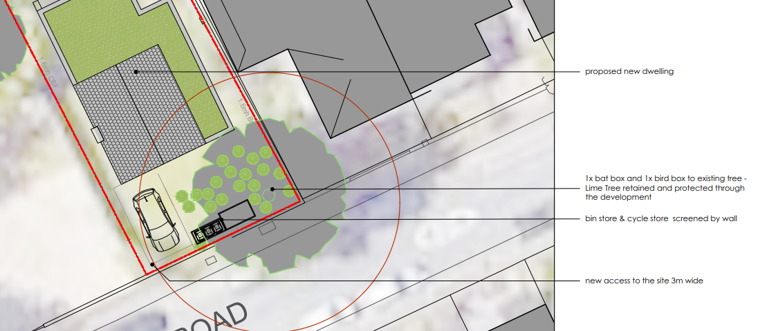

Access:
A newly created 3m wide vehicle crossing with access protection markings is proposed to serve the parking area. Visibility splays of 2.4 x 25m for a 20mph road have been illustrated and are deemed acceptable.

There is a telegraph pole located in the footway which has been illustrated on plans, drawing number 2509033-01, the distance between the telegraph pole and proposed vehicle crossing is more than 1m and therefore deemed acceptable. A license will be required from the Councils Highways Department to undertake all works on the public highway; this includes the creation of a new vehicle crossing and access protection markings.

It is noted that timber gates are proposed, however anyone waiting to open the gate is likely to be protruding out in to the carriageway on a narrow stretch of road, given that parking occurs on both sides of the carriageway, this could result in conflict between vehicles to the detriment of highway safety and therefore a gate could not be supported. Revised plans will be required.

Refuse:
Bin storage should not be located further than 15m from the access point of the site to avoid the stationing of service vehicles on the carriageway for excessive periods, and should comply with Manual for Streets and British Standard 5906: 2005 for Waste Management in Buildings to avoid the stationing of service vehicles on the carriageway. Submitted plans illustrate bins located adjacent to the parking areas this would allow for kerb side collection and is deemed acceptable.

Cycle Storage:

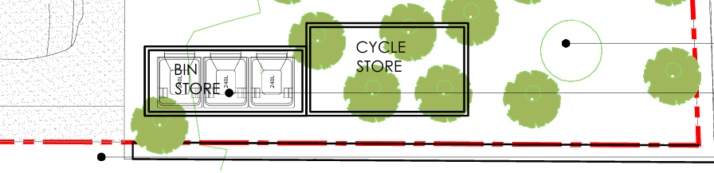

Cycle storage has been illustrated adjacent to the bin store at the front of the site; Provision is deemed acceptable, however for added security the cycle store should be relocated to the private amenity area at the rear.

CMS will be required for his development.

There are a number of trees in site, therefore the Natural Environment Officer should be consulted.

Please ask the applicant to submit revised plans removing the gate and identifying the EV charging point.

N. Hussain
Transport Development Control Advisor

