DESIGN AND ACCESS STATEMENT
Caversham AFC Pavilion
Proposed Internal Alterations and External Improvements
Drawing Reference: 102 / P / 02
Prepared by: DRA Works | Date: May 2026

1. Introduction
This Design and Access Statement has been prepared in support of a full planning application for proposed alterations to the existing pavilion building at Caversham AFC. The application is submitted to Reading Borough Council.
The statement sets out the design principles and concepts underpinning the proposal, explains how issues of access have been addressed, and demonstrates how the scheme responds positively to its context.
The application is accompanied by the following drawings:
- 102 / P / 01 — Existing Floor Plan and Elevations
- 102 / P / 02 — Proposed Floor Plan and Elevations

2. The Site and Existing Building

2.1 Location and Context
The application site is the pavilion building serving Caversham AFC, situated within Caversham, Reading. The building sits within open recreational land and is associated with the football club's pitches and associated facilities.
The surrounding area is characterised by open green space, with residential development beyond. The pavilion is a utilitarian single-storey structure set within its own curtilage, accessed from an existing car park and footpath serving the sports facility.

2.2 The Existing Building
The existing building is a single-storey pavilion of brick construction beneath a pitched, corrugated metal roof. As shown on drawing 102 / P / 01, the existing accommodation comprises:
- Two changing rooms
- WC facilities
- A referee's room
- Goal storage
- A separate storage container to the site
The existing building is functional in character and typical of sports pavilion structures of its type. The elevations feature a brick finish with metal window and door openings under a pitched roof profile. There are no proposed alterations to the roof.

2.3 Photographic Record of Existing Conditions
The following photographs were taken in April 2026 and illustrate the current condition of the existing pavilion building and its facilities. They demonstrate the poor state of repair of the building and the inadequacy of the existing provision, providing context for the proposed improvements.
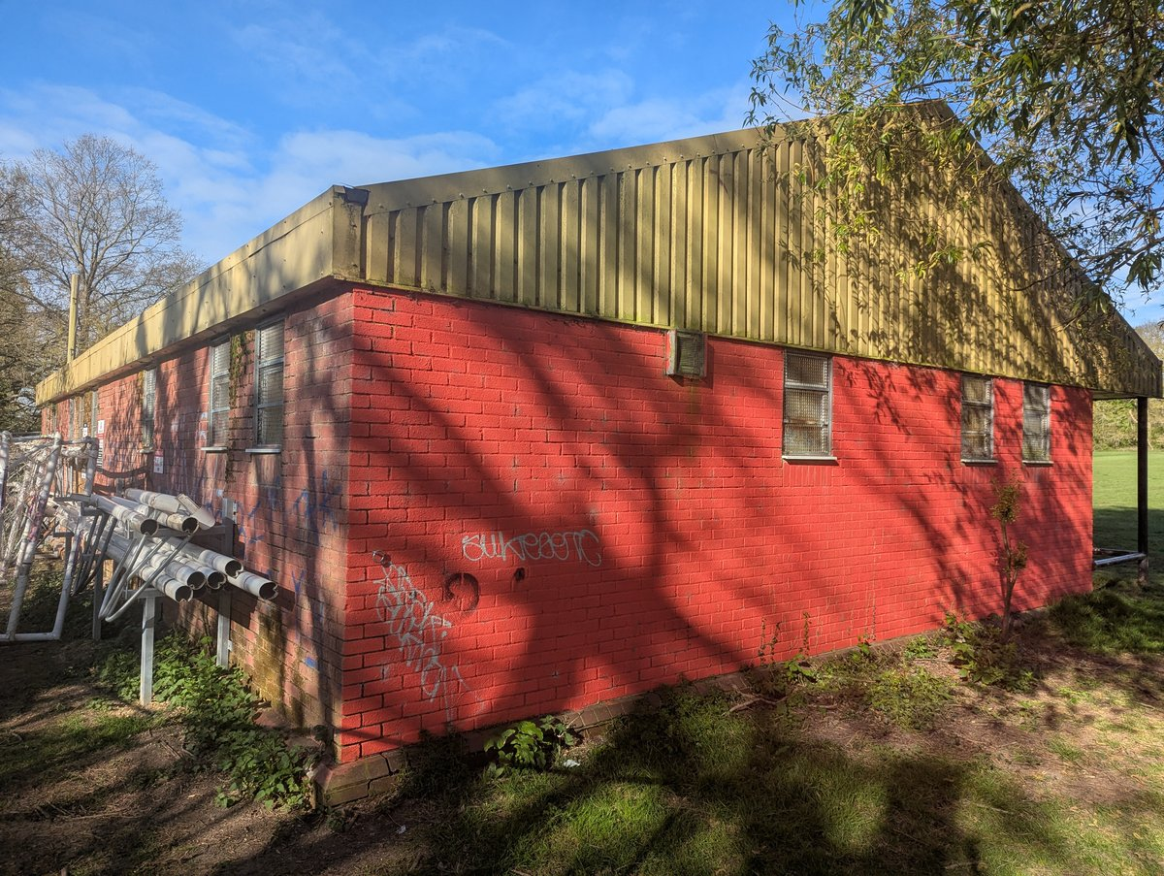
Figure 1: Side elevation of the existing Caversham AFC pavilion, showing the painted brickwork, corrugated metal roof, and covered entrance canopy. Graffiti and general deterioration are evident.
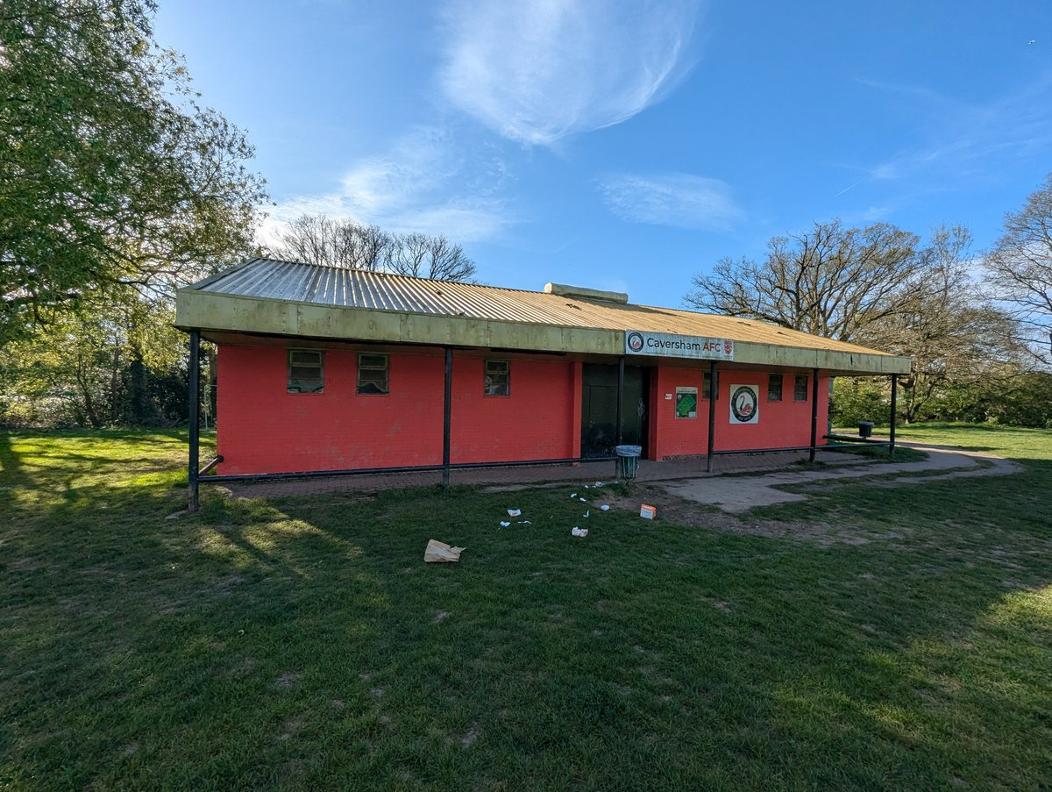
Figure 2: Front elevation of the existing pavilion, illustrating the extent of graffiti on the painted blockwork walls and the general condition of the building fabric.
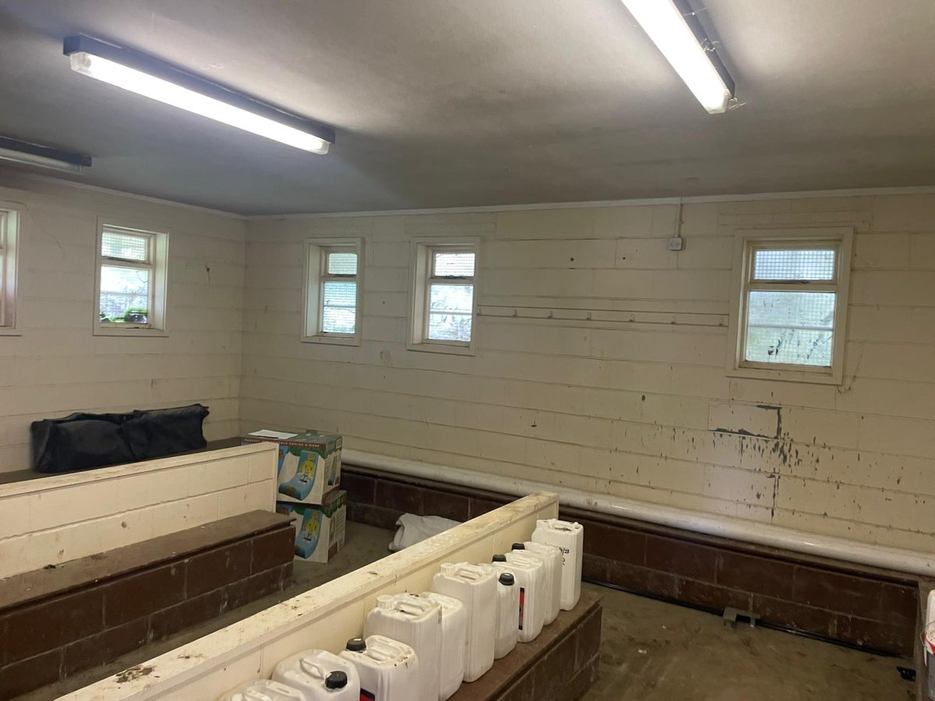
Figure 3: Interior of the left-hand changing room, showing the painted blockwork walls, fixed benching, and high-level windows. The condition of the space is poor, with damaged wall surfaces and makeshift storage.
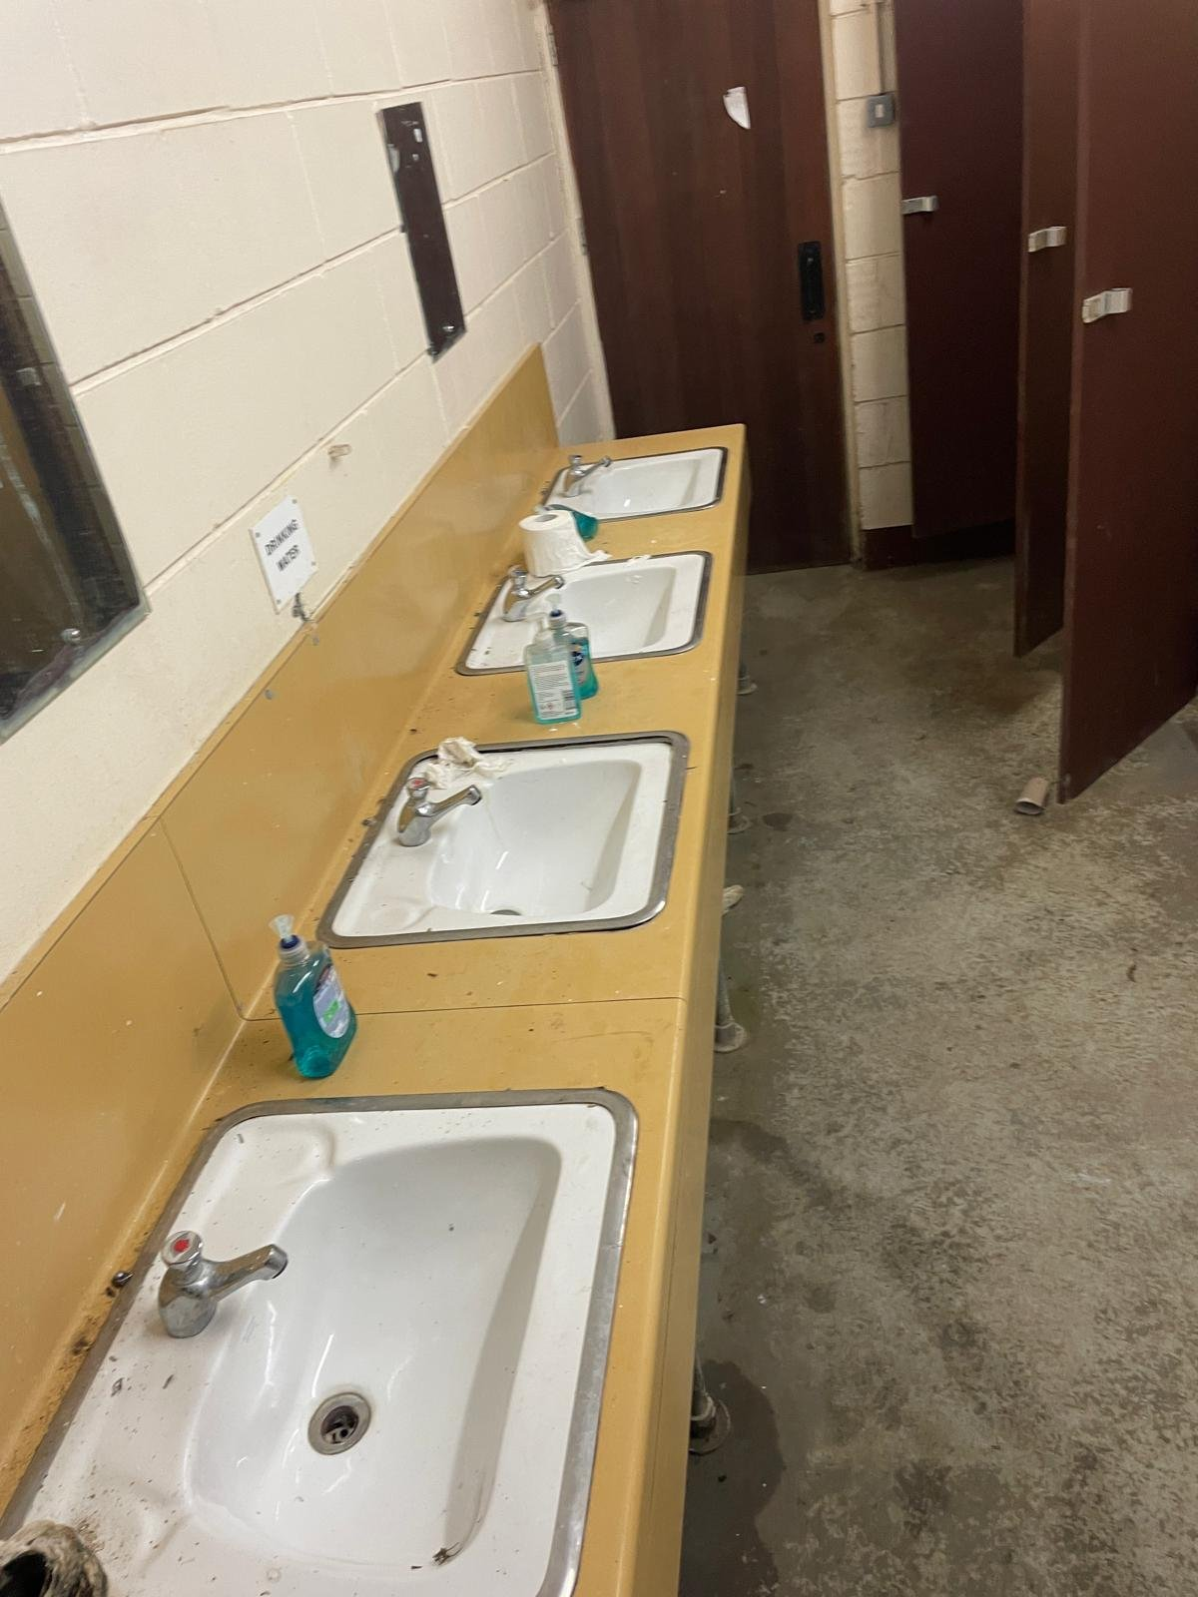
Figure 4: The existing toilet and washing facilities, showing the outdated and worn sanitaryware, stained surfaces, and bare concrete floor. The facilities are inadequate for a modern community sports facility.

3. The Proposed Development

3.1 Overview
The proposal seeks to reconfigure and improve the internal accommodation within the existing building footprint, in order to provide enhanced facilities for the club and its members. No extensions to the building footprint are proposed and the roof form and covering remain unchanged.
As shown on drawing 102 / P / 02, the proposed accommodation includes:
- Entrance lobby
- Social area
- Servery with associated storage
- Kitchen / servery preparation area
- Changing rooms (retained and improved)
- Referee's room (retained)
- Plant room
- Accessible shower and ancillary facilities

3.2 Use
The building will continue in its established use as a community sports pavilion serving Caversham AFC. The proposed internal reorganisation is intended to improve the quality of the facilities available to players, officials, and club members, providing a more functional and welcoming environment.
The servery is a modest, non-commercial facility intended to serve refreshments to club members and visitors in connection with sporting activities. It does not constitute a commercial kitchen or a licensed bar. The social area is ancillary to the primary sporting use of the building.

3.3 External Alterations
External changes are limited and carefully considered. They consist of the following new openings and door replacements, as annotated on drawing 102 / P / 02:
- New aluminium louvred door to the plant room, powder coated red to match the painted brickwork
- New aluminium door to the referee's room, powder coated red to match the painted brickwork
- New aluminium sliding windows, powder coated RAL 9005 black frame, covered with red steel shutters when not in use
The palette of materials — red powder coating to match the existing painted brickwork, and black aluminium framing — is deliberately chosen to complement the existing character of the building. The use of red steel shutters to cover the windows when closed ensures the building presents a tidy, secure appearance outside of operational hours.
No alterations are proposed to the roof. The existing car parking, waste storage arrangements, and external lighting all remain unchanged.

4. Design Principles

4.1 Design Approach
The overarching design principle is one of thoughtful, proportionate improvement. The existing building has served the club for many years and the proposal seeks to enhance its utility without altering its essential character or scale.
The internal reorganisation has been designed to improve the flow and functionality of the building, providing a logical sequence of spaces from entrance through to changing facilities, and creating a comfortable social space for use by club members and visitors.

4.2 Scale and Massing
The scale and massing of the building are entirely unchanged. The proposal works entirely within the existing building envelope, with no extensions or alterations to the roofline. The building will read identically to the existing structure when viewed from the wider setting.

4.3 Materials and Appearance
External materials have been selected to be complementary and cohesive. The use of red powder-coated aluminium for the new door and shutter elements reflects the existing painted brickwork, creating a unified palette across the elevation. The black aluminium window frames provide a crisp, contemporary detail that is appropriate to a sports facility of this type without conflicting with the modest character of the existing building.
The specification of aluminium for the new doors and windows ensures durability and low maintenance, which is appropriate for a community facility of this nature.

4.4 Sustainability
The proposal makes efficient use of the existing building fabric, avoiding demolition and reconstruction. By improving the existing structure rather than replacing it, the scheme inherently limits embodied carbon. The new aluminium windows and doors will offer improved thermal performance compared with the existing openings they replace, contributing to improved energy efficiency within the building.

5. Access

5.1 Approach to Access
The proposal has been designed to ensure that the improved facilities are accessible to all users. The entrance lobby, as shown on the proposed floor plan, provides a clear, level threshold from the existing external approach, establishing an inclusive entry point to the building.

5.2 Vehicular and Pedestrian Access
Vehicular and pedestrian access to the site remains unchanged from the existing arrangement. The existing car park continues to serve the site and no changes to access routes, parking provision, or site layout are proposed.

5.3 Access Within the Building
The internal layout has been organised to minimise barriers to movement through the building. The social area, servery, and entrance lobby are arranged on a single level, consistent with the existing floor level of the building, ensuring step-free access throughout the principal community spaces.
The inclusion of accessible shower facilities within the proposed layout reflects the club's commitment to providing inclusive changing and welfare provision for all players.

5.4 Access for Maintenance
The new plant room, served by the new louvred aluminium door, has been positioned to allow straightforward access for maintenance of building services without requiring entry to the main occupied areas of the building.

6. Policy Compliance
The proposals have been considered against the relevant policies of the Reading Borough Local Plan (2019) and the National Planning Policy Framework (2023). The scheme is considered to be consistent with these policies for the following reasons:
- The proposal involves alterations to an existing community sports facility, consistent with the established use of the site and supportive of the active recreational function of the land.
- The external alterations are modest in scale and carefully detailed to be complementary to the existing building, in accordance with Policy CC7 (Design and the Public Realm).
- The proposal does not affect the amenity of neighbouring properties. There is no new external lighting proposed, no changes to waste storage arrangements, and no intensification of vehicular traffic, consistent with Policy CC8 (Safeguarding Amenity).
- The improved facilities will enhance the social and sporting infrastructure available to the local community, consistent with the Council's broader objectives for community wellbeing and recreational provision.
- The roof is unchanged, avoiding any potential ecological concerns relating to roosting bats or other protected species.

7. The Football Foundation
The Football Foundation who are the primary funder for the project and part of Sport England, have collaborated with the club and signed off on the design as presented. Sport England have also been given a preview of this application and are supportive of the design as is. Our technical partner at the Football Foundation is Joe Cherrington, Technical Project Manager, joe.cherrington@footballfoundation.org.uk

8. Conclusion
The proposed alterations to Caversham AFC Pavilion represent a proportionate and well-considered improvement to an existing community sports facility. The scheme works within the existing building envelope, makes no changes to the roof, and introduces carefully selected external materials that are complementary to the existing character of the building.
The proposal will deliver tangible benefits to the club and its members by providing improved, inclusive, and more functional facilities, while having a negligible impact on the character of the site, the amenity of the surrounding area, or the natural environment.
It is considered that the proposal is consistent with relevant national and local planning policy and should be supported accordingly.

DRA Works | info@DRAWorks.co.uk | www.DRAWorks.co.uk

