CONSERVATION

Memo
To: Marcelina Rejwerska
From: Buju Can Cetin, Conservation Officer
Date: 03/06/2026
Re: Conservation Officer response
Application Number: PL/26/0531
Application Type: Full planning permission
Address: 40 HOWARD STREET, READING, RG1 7XS
Proposal: Retrospective application for the removal of chimney stacks

Summary
Object – Reason for Refusal
The removal of chimney stacks results in the loss of original elements and materially harms the character and appearance of the conservation area. Whilst this is considered to result in less than substantial harm, there are insufficient public benefits to outweigh it. It is a very minor benefit of an increase in the comfort of residents that this does not outweigh the harm to the significance of the conservation area. Therefore, the proposal is contrary to Policies EN1, EN3 and EN6 of the Reading Borough Local Plan 2016, the National Planning Policy Framework, and the Planning (Listed Buildings and Conservation Areas) Act 1990, which seek positive contribution to local character and distinctiveness and enhancement of the significance of the conservation areas.

Relevant policies and legislation
From the point of view of the historic environment, the main statutory tests are set out within the Planning (Listed Buildings and Conservation Areas) Act 1990. Section 72(1) of the Planning (Listed Buildings and Conservation Areas) Act 1990 also requires the Council to pay special attention to the desirability of preserving or enhancing the character and appearance of designated Conservation Areas.

National Planning Policy and Guidance
The NPPF outlines government policy, including its policy in respect of the historic environment. Chapter 16 of the NPPF (2024) 'Conserving and enhancing the historic environment' sets out the Government's high-level policies concerning heritage and sustainable development.
Paragraph 207 states, “In determining applications, local planning authorities should require an applicant to describe the significance of any heritage assets affected, including any contribution made by their setting. “ And Paragraph 208 says, “Local planning authorities should identify and assess the particular significance of any heritage asset that may be affected by a proposal (including by development affecting the setting of a heritage asset) taking account of the available evidence and any necessary expertise. They should take this into account when considering the impact of a proposal on a heritage asset, to avoid or minimise any conflict between the heritage asset’s conservation and any aspect of the proposal.”
Paragraph 212 of the NPPF requires that ‘when considering the impact of a proposed development on the significance of a designated heritage asset, great weight should be given to the asset’s conservation….’ And paragraph 213 says, ‘any harm to, or loss of, the significance of a designated heritage asset (from its alteration or destruction, or from development within its setting) should require clear and convincing justification’.
Paragraph 215 requires that ‘where a development proposal will lead to less than substantial harm to the significance of a designated heritage asset, this harm should be weighed against the public benefits of the proposal…’
National Planning Practice Guidance on Historic Environment provides context to the NPPF.

Local Planning Policy and Guidance
Policy EN1 ‘Protection and enhancement of the historic environment’ of the Reading Borough Local Plan sets out the Council’s aspirations for the historic environment. The policy requires that all proposals to protect and, where possible, enhance the significance of heritage assets and their settings, historic character and local distinctiveness of the area in which they are located. It echoes the NPPF by stating, “Proposals should seek to avoid harm in the first instance. Any harm to or loss of a heritage asset should require clear and convincing justification, usually in the form of public benefits”.
Policy EN3 ‘Enhancement of conservation areas’ of the Reading Borough Local Plan requires that development proposals within Conservation Areas contribute positively to local character and distinctiveness. This policy states, “Development proposals within Conservation Areas must make a positive contribution to local character and distinctiveness. Positive consideration will be given to proposals which take opportunities to enhance the character of conservation areas.”
Policy EN6 ‘New development in a historic context’ also requires “New development will make a contribution to the historic character of the area by respecting and enhancing its architectural and visual qualities and considering how heritage considerations can influence the design of new development. When determining planning applications for new development, the following factors will be taken into consideration:
a. The positive contribution of the development to the existing historic townscape (scale, height, mass, proportion, plot size, street form, materials, significant vistas and views, and open space);
b. Sensitivity to historic context;
c. Reflection of borough-wide major heritage themes that contribute to local distinctiveness (e.g. patterned brickwork or former worker terraced housing);
d. Whether development promotes and/or improves access to previously undiscovered or neglected historic significance.”

Castle Hill/Russell Street/ Oxford Road Conservation Area Appraisal (2020) is also a material consideration in determining applications for development.
Other
Historic England Advice Note 2 – Making changes to Heritage Assets illustrates the application of policies set out in the NPPF in determining applications for Planning Permission and Listed Building Consent.
English Heritage’s “Conservation Principles” provides policy and guidance for the “sustainable
management of the historic environment”.

Relevant heritage assets
The application relates to a three-storey mid-terrace Georgian property, located to the west of Howard Street within the Castle Hill/Russell Street/Oxford Road Conservation Area, as illustrated below. The property is not listed but is historical.
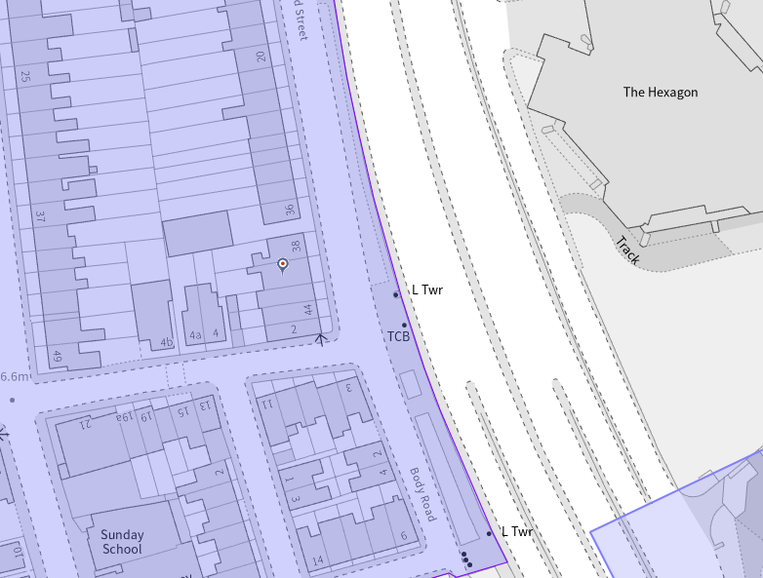
Location of the application site circled within the Castle Hill/Russell Street/Oxford Road Conservation Area (light purple)

Significance of heritage assets
The NPPF defines significance as the “value of a heritage asset to this and future generations because of its heritage interest.”

The interest may be architectural or historic, as set out in the Town and Country Planning (Listed Building and Conservation Areas) Act 1990 Section 1.

“Significance derives not only from a heritage asset’s physical presence, but also from its setting.” (NPPF, 2023)

Historic England assesses significance in a similar manner, referring to evidential, historic, aesthetic and communal values of a place.
Castle Hill/Russell Street/Oxford Road Conservation Area, which is on Historic England’s list of ‘Heritage at Risk’ due to the ongoing loss of character, was designated in 1972.
The subject building appears on the historic map dated 1853, showing a larger footprint compared to other buildings on this terrace. It has a stucco on its ground floor with decorative horizontal banding (as seen in the photo below) that appears more attractive within the group of buildings from Nos. 38 to 44 and No.2 Baker Street (on the corner).

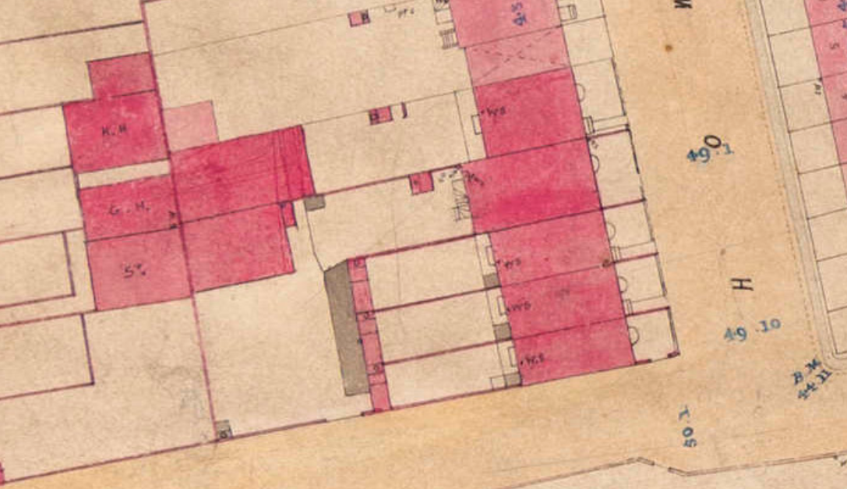
Snip from Reading Board of Health Map, 1853

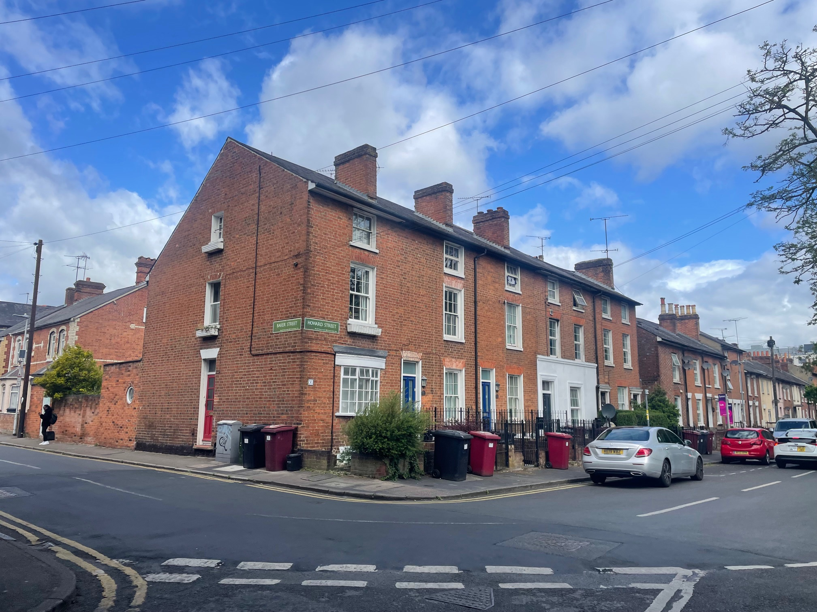
View of the terrace with the subject building circled, May 2026

The terrace that the subject building forms a part of contributes to the significance of the conservation area, deriving from not only its individual features but also an element of consistent and continuous history of architecture with its neighbours. The key positive characteristic of the Castle Hill/Russell Street/Oxford Road Conservation Area could be summarised as a historic environment of Reading’s urban expansion in the 19th century, reflecting the town’s industrial growth and evolving population needs. Distinct streets showcase a range of housing styles from the Georgian, Victorian, and Edwardian eras—spanning upscale residences for wealthy businessmen to modest artisan cottages. Among them, Howard Street, with more modest-scale buildings, exemplifies the richness of the area.
Castle Hill/Russell Street/Oxford Road Conservation Area is on the Heritage at Risk list of Historic England due to the ongoing negative issues and poor condition that make it vulnerable. Among the negative issues and vulnerabilities described by the conservation area appraisal the following should be noted:

- “The on-going degradation of property façades with the loss of historic features and detailing such as traditional doors and windows, roofing materials, and frontage treatments. This is most noticeable along the Oxford Road, Prospect Street, Russell Street and in streets to the east with Waylen Street, Zinzan Street, Howard Street, Anstey Street, Body Road, Carey Street and Baker Street.
- Architecturally unsympathetic extensions and alterations including poor quality dormers, loss of chimney stacks and chimney pots and the loss of front walls onto streets.”

Impact of proposal upon heritage asset(s)
This is a retrospective application for the removal of chimney stacks from both roof slopes of the hipped roof of the historic building at 40 Howard Street. The pre-existing view of the historic Georgian terrace of Nos 44 – 38 Howard Street is seen below.

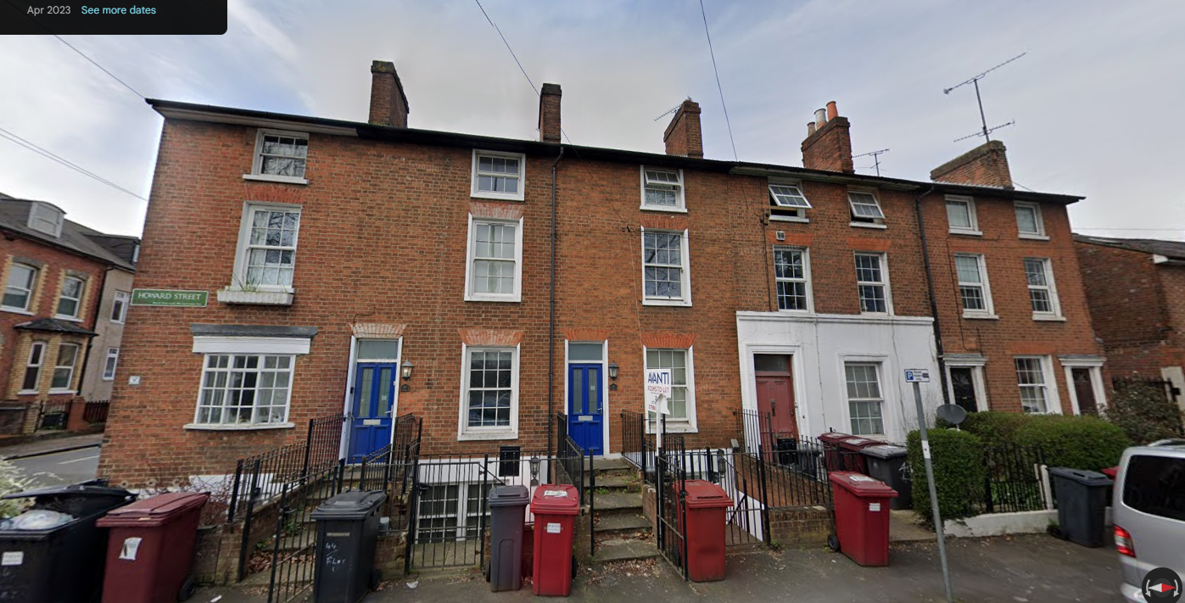
Image from Google Streetview, April 2023

The subject building is/was the only one that retains/has retained its original chimney pots on this terrace. From the junction of Howard Street and Baker Street or the southern end of Howard Street, the façade of buildings presents a strong, consistent appearance and rhythm, with their surviving original elements, including the chimney stacks.
The building’s character has been significantly altered by the loss of its chimney stacks. From the public realm, it is noticeable, and this change is immediately apparent. The chimney stacks are a defining feature of buildings in the conservation area, so their removal represents a clear departure from the structure’s historic external form. As a result, the works have had a material impact on the building character and significance of the conservation area. As stated in the Russell Street/Castle Hill Conservation Area Appraisal and as seen in the historic aerial photograph below, the removal of chimney stacks harms the character and appearance of the area.

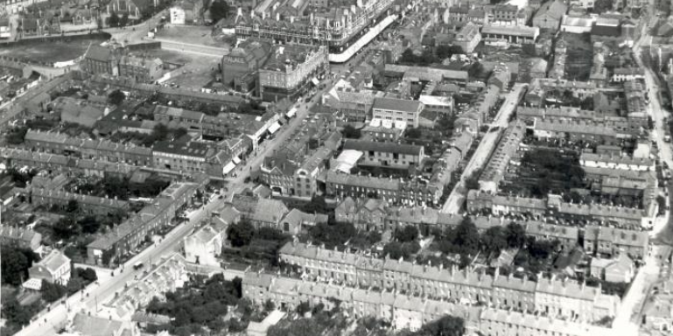
Snip, Howard Street is lined, from Aerial view over central Reading, looking north-eastwards, 1922. In the foreground are Oxford Road, Zinzan Street, Howard Street and Soho Street. The railway crosses the top left-hand corner. 1920-1929 : photograph numbered 1525. There is a smaller print at Dynix 1237997, Reading Library’s Online Archive

From the submitted planning statement, I noted the following and added my comments, most of which cannot be justified only from the “JUSTIFICATION – HEALTH AND AWAAB’S LAW” and my further comments follows.
“The works were undertaken as urgent repair and safety works following significant water penetration and internal damp and mould issues affecting multiple occupiers (see Document H). The removal of the redundant chimney stacks was required to address ongoing structural deterioration and to protect the health and wellbeing of residents. (See Document F).” – From the google street view, I am unable to see any structural cracks supporting this statement. There is no visual evidence provided by the applicant/agent, and as recommended by Historic England, “If there are any concerns about the structural integrity or watertightness of a chimney, a structural engineer, surveyor or architect should investigate.” (Open Fires, Chimneys and Flues | Historic England).
It is not a historic building surveyor’s or heritage consultant's suggestion but a roofer’s opinion that the removal of the chimneys is the only option, which is not. The roofer states ‘complete chimney structures were causing dampness’, but there is no work to the chimney breasts. It is a complete chimney system that provides adequate ventilation for the historic fabric, and its function should be understood in relation to the breathability/permeability and integrity of the historic structure. I find this statement weak and without a ‘conservation approach’.
“This statement demonstrates that the works:
• Preserve the character and appearance of the Russell Street/Castle Hill Conservation Area
• Improve living conditions for occupiers
• Comply with national and local planning policy
• Align with emerging legal obligations under Awaab’s Law, Minimum Energy Efficiency Standards and the Warm Homes Plan” – The removal of original building feature does not preserve the significance of the conservation area. It may have improved the living conditions, but it was not the only option. No complies with the historic environment policies.
Further explanation comes from ‘Conservation Principles, Policies and Guidance’ (English Heritage/Historic England, 2010)
Conservation Principles 4 states:
“Principle 4 - Significant places should be managed to sustain their values
4.3 Conservation is achieved by all concerned with a significant place sharing an understanding of its significance, and using that understanding to:
- judge how its heritage values are vulnerable to change
- take the actions and impose the constraints necessary to sustain, reveal and reinforce those values
- ensure that the place retains its authenticity – those attributes and elements which most truthfully reflect and embody the heritage values attached to it.
Principle 4 further advises
“4.5 Intervention may be justified if it increases understanding of the past, reveals or reinforces particular heritage values of a place, or is necessary to sustain those values for present and future generations, so long as any resulting harm is decisively outweighed by the benefits.
Principle 5 of the conservation principles also states that
“5 Decisions about change must be reasonable, transparent and consistent
5.3 Potential conflict between sustaining heritage values of a place and other important public interests should be minimised by seeking the least harmful means of accommodating those interests.
5.4 If conflict cannot be avoided, the weight given to heritage values in making the decision should be proportionate to the significance of the place and the impact of the proposed change on that significance.”
Regarding ‘New Work and Alteration’, the document adds that this retrospective application fails to meet:
“138 New work or alteration to a significant place should normally be acceptable if:
a. there is sufficient information comprehensively to understand the impacts of the proposal on the significance of the place;”
b. the proposal would not materially harm the values of the place, which, where appropriate, would be reinforced or further revealed;
c. the proposals aspire to a quality of design and execution which may be valued now and in the future;
d. the long-term consequences of the proposals can, from experience, be demonstrated to be benign, or the proposals are designed not to prejudice alternative solutions in the future.”
From the conservation principles, the following sentences of the submitted planning document are also found to be insufficient and irrelevant, with the conclusion not agreed upon.
“The development consists of the removal of redundant and defective chimney stacks above roof level only. The internal chimney breasts remain for structural stability. (See Document A)
The stacks were suffering from:
• Failing mortar joints
• Saturated masonry
• Persistent water ingress
• Penetrating damp
• Mould growth internally
• Falling masonry risk and questionable chimney pot stability
The roof was made good using matching materials appropriate to the age and character of the building.”
“The removal results in a simplified roofscape but maintains the terrace rhythm and proportions. No incongruous features have been introduced. The repair uses matching slates and appropriate ridge detailing ensuring visual continuity.
The visual impact is neutral and consistent with surrounding alterations across the conservation area.”
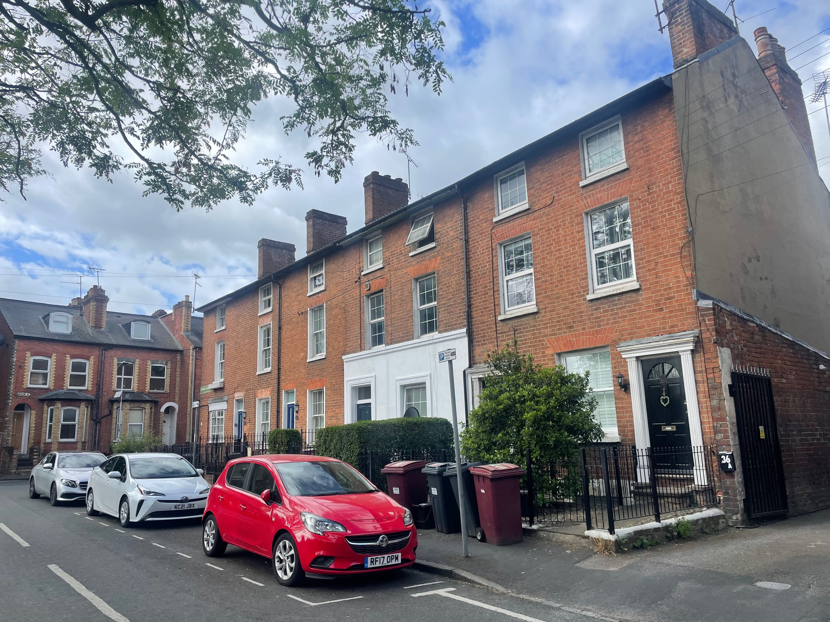
The impact of the removal of the chimney stack is clear when viewed from Howard Road, a public realm, May 2026
I also noted from Document I that many works have been carried out without planning permission in the past, as there is no planning history of the building, including the HMO use. Although some are considered regular maintenance, the suitability of the replacement of original vertical sliding timber sash windows with top hinged double glazed plastic casement windows with false glazing bars and re-rendering is questionable, as this increases the risk of condensation for historic buildings, as widely known in the conservation field of practice.
As general information about energy efficiency performance and related building regulations, Part L clearly states that historic buildings can undergo some retrofitting works provided that they preserve the building’s character and appearance. As such, even building regulations cannot be used for the justification of the removal of chimney stacks for this particular application. The energy efficiency-related works for historic buildings should also be recommended by a qualified building surveyor or a CARE (the Conservation Accreditation Register for Engineers) registered engineer.
I acknowledge that the proposal would enhance the living accommodation within existing residential units, but these are largely private benefits. The removal of chimneys does not cause any benefit to the significance of the conservation area but removes a heritage value from it. As such, removal of chimneys would materially harm the character and appearance of the conservation area, and whilst this is considered to result in less than substantial harm, with no sufficient public benefits to outweigh this harm. It is a very minor benefit of an increase in the comfort of residents that this does not outweigh the harm to the significance of the conservation area. Therefore, the proposal is contrary to Policies EN1, EN3 and EN6 of the Reading Borough Local Plan 2016, the National Planning Policy Framework, and the Planning (Listed Buildings and Conservation Areas) Act 1990, which seek positive contribution to local character and distinctiveness and enhancement of the significance of the conservation areas.

Conservation response
No objections
No objections subject to conditions attached
Clarification required
Object

Contact details
Buju Can Cetin, Conservation Officer
Burcu.CanCetin@reading.gov.uk

