DELEGATED APPLICATION REPORT
Ward: Caversham
App Ref: PL/26/0160 Lawful development: Proposed use
Address: 10 MARSACK STREET, CAVERSHAM, READING, RG4 5AP
Proposal: Garage conversion with roof replacement
Applicant: Miss Cecilia Kelly
Received date: 05/02/2026
Target Decision date: 08/05/2026 (EXT)
Case Officer: Chukwudi Onwudinanti

INTRODUCTION
The proposal site is a terraced dwelling located on Marsack Street within a residential area characterised by similar terraced properties with rear projections and long rear gardens.

The application site is not a listed building nor located in a conservation area. It is not in an area subject to any Article 4 restrictions.

PROPOSAL AND SUPPORTING INFORMATION
This proposal is for a Certificate of Lawfulness for works to the dwellinghouse. The proposals include:
- Garage conversion with associated internal reconfiguration
- Replacement of the existing garage roof and change to pitch
- Alterations to openings on the front and side elevations
- Creation of additional habitable accommodation at ground floor level

Plans and Documents Considered
Drawing No: 25074.PD-07 – Location Plan (Received)
Drawing No: 25074.PD-08 – Block Plan (Received)
Drawing No: 25074.PD-01 – Existing Ground Floor Plan (Received)
Drawing No: 25074.PD-02 – Existing First Floor Plan (Received)
Drawing No: 25074.PD-03 – Existing Elevations (Received)
Drawing No: 25074.PD-04 – Proposed Ground Floor Plan (Received)
Drawing No: 25074.PD-05 – Proposed First Floor Plan (Received)
Drawing No: 25074.PD-06 – Proposed Elevations (Received)

It is relevant to note that the submitted drawings indicate that the works are confined within the existing building envelope with no material enlargement beyond the original footprint.

RELEVANT PLANNING HISTORY
Application No: PL/19/0406
Proposal: Single storey extension rear and two storey side extension
Decision: Permitted
Decision Date: 02/05/2019

Application No: PL/25/0833
Proposal: Construction of Granny annex in rear garden
Decision: Permitted
Decision Date: 18/08/2025

Application No: PL/07/0712
Proposal: Single storey rear and two storey side extension
Decision: Permitted
Decision Date: 17/07/2007

CONSULTATIONS
No consultations required for this application.

Equality Act 2010:
In determining this application the Council is required to have regard to its obligations under the Equality Act 2010. However, there is no indication or evidence that the protected groups identified by the Act have or will have different needs, experiences, issues and priorities in relation to this particular planning application. Therefore in terms of the key equalities protected characteristics it is considered there would be no significant adverse impacts as a result of the development.

Relevant Planning Policy and Guidance
National Planning Practice Guidance
The Town and Country Planning (General Permitted Development) (England) Order 2015 (GPDO)
Permitted development rights for householders – Technical Guidance

ASSESSMENT UNDER CLASS A
A Certificate of Lawfulness for a Proposed Development has been submitted as the applicant considers the proposal falls within the permitted development rights of the property.

The following elements of the proposals are considered under Class A:

- Garage conversion and associated internal alterations,
- Replacement of garage roof,
- Alterations to windows and doors on front and side elevations

The proposal must be assessed to ensure that it complies with the conditions Class A, Part 1, Schedule 2 of the Town and Country Planning (General Permitted Development) (England) Order 2015 (as amended), which relates to ‘The enlargement, improvement or other alteration of a dwellinghouse’.

A.1 Development is not permitted by Class A if:
A.1 (a) permission to use the dwellinghouse has been granted only by virtue of Classes M, N, P or Q Complies – The property is an established C3 dwellinghouse
A.1 (b) total area of ground covered exceeds 50% of curtilage Complies – No enlargement or additional footprint
A.1 (c) height exceeds highest part of roof Complies
A.1 (d) eaves height exceeds existing Complies
A.1 (e) extends beyond a wall forming the principal elevation Complies – No extension; works are alterations only
A.1 (f) single storey rear extension limits exceeded N/A / Complies – No extension proposed
A.1 (g) larger rear extension provisions N/A / Complies
A.1 (h) multi-storey extension limitations N/A / Complies
A.1 (i) eaves height within 2m of boundary exceeds 3m Complies
A.1 (j) side extension must not exceed 4m in height, have more than one storey or have a width greater than half the width of the original dwellinghouse Complies
A.1 (k) includes verandah, balcony or raised platform Complies – No such features proposed

A.2 (Article 2(3) Land Restrictions)
The site is not within Article 2(3) land.
All provisions: N/A / Complies

CONDITIONS UNDER CLASS A
Development is permitted by Class A subject to the following conditions:
A.3 (a) the materials used in any exterior work (other than materials used in the construction of a conservatory) must be of a similar appearance to those used in the construction of the exterior of the dwellinghouse Complies
A.3 (b) any upper-floor window located in a wall or roof slope forming a side elevation of the dwellinghouse must be (i) obscure-glazed, and (ii) non-opening unless the parts of the window which can be opened are more than 1.7 metres above the floor of the room in which the window is installed Complies
A.3 (c) where the enlarged part of the dwellinghouse has more than a single storey, or forms an upper storey on an existing enlargement of the original dwellinghouse, the roof pitch of the enlarged part must, so far as practicable, be the same as the roof pitch of the original dwellinghouse NA

OVERALL RECOMMENDATION

Sufficient evidence has been provided to demonstrate that a Certificate of Lawfulness should be granted for the proposed garage conversion with roof replacement and associated alterations.

The proposal has been assessed against the Town and Country Planning Act 1990 (as amended) and Class A, Part 1, Schedule 2 of the Town and Country Planning (General Permitted Development) (England) Order 2015 (as amended). It can be confirmed that the proposed operations would be lawful for planning purposes on the basis of the following:

Drawing No: 25074.PD-07 – Location Plan
Drawing No: 25074.PD-08 – Block Plan
Drawing No: 25074.PD-01 – Existing Ground Floor Plan
Drawing No: 25074.PD-02 – Existing First Floor Plan
Drawing No: 25074.PD-03 – Existing Elevations
Drawing No: 25074.PD-04 – Proposed Ground Floor Plan
Drawing No: 25074.PD-05 – Proposed First Floor Plan
Drawing No: 25074.PD-06 – Proposed Elevations

Therefore, the Local Planning Authority can issue the applicant with a Certificate of Lawfulness for the proposed development.

Informatives
Building Regulations
Construction and Demolition
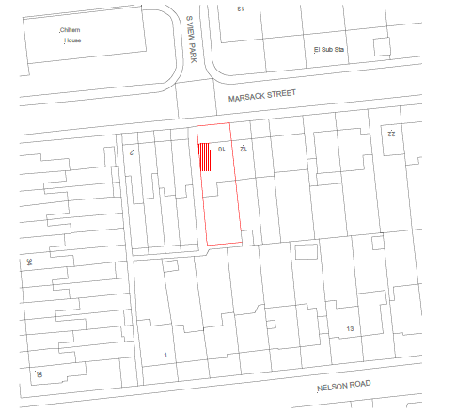
Not To Scale

