To: | Ilaria Sutton  The Blade, Abbey Square, Reading, United Kingdom, RG13BE | Application No: PL/26/0408  Application type: Full planning permission

Applicant: c/o agent c/o agent

Proposal: Full planningfor proposed public realm and highway improvements to Acacia Road and its junction with Redlands Road, to include the partial demolition of one section of existing wall to enable wider access to MERL, the reconfiguration of parking areas, enhancement of pedestrian routes and associated landscaping.

At: Acacia Road, Reading

The above application was WITHDRAWN by the applicant on .

Date: | 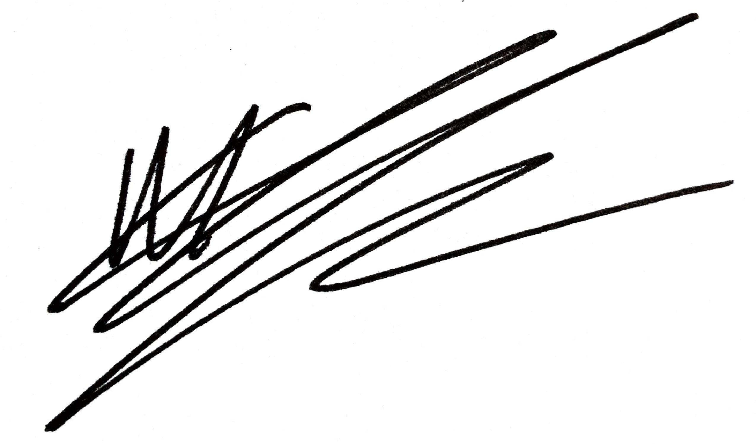
 | Acting Assistant Director, Planning, Transport & Public Protection

